U.S. Department of Health and Human Services
Public Health Service
SF424 (R&R)
Application Guide
for NIH and Other PHS
Agencies
A guide developed and maintained by NIH for preparing and submitting applications via Grants.gov to NIH and other PHS agencies using the SF424 (R&R)
Forms Version C application packages
Updated July 25, 2013
Table of Contents

Part I. Instructions for Preparing and Submitting an Application
1. Foreword 1
1.1 Application Guide Format 3
1.2 NIH Extramural Research and Research Training Programs 4
1.3 Research Grant Activity Codes and Program Guidelines 4
1.4 Interactions with PHS Staff 5
1.5 Grants Policy Statements 8
1.6 References 8
1.7 Authorization 10
1.7.1 Collection of Personal Demographic Data 10
1.8 Paperwork Burden 10
2. Process for Application Submission via Grants.gov 11
2.1 Overview 11
2.2 Registration Processes 12
2.2.1 Grants.gov Registration 12
2.2.2 eRA Commons Registration 12
2.3 Software Requirements 15
2.3.1 Adobe Reader 15
2.3.2 Creating PDFs for Text Attachments 15
2.3.3 Special Instructions for Macintosh Users 15
2.4. Funding Opportunities 16
2.4.1 NIH Guide for Grants and Contracts 16
2.4.2 Funding Opportunity Announcements 16
2.4.3 Finding a Funding Opportunity Announcement (FOA) for Grants.gov Submission 17
2.5 Forms for an Application to NIH or Other PHS Agencies 20
2.6 Format Specifications for Text (PDF) Attachments 22
2.7 “Resubmission” Applications 24
2.8 “Revision” Application 26
2.9 Similar, Essentially Identical, or Identical Applications 26
2.10 Submitting Your Application Via Grants.gov 27
2.11 After You Submit Your Application Via Grants.gov 28
2.12 Correcting Errors 30
2.13 Post-Submission Application Materials 32
2.14 Application Submission Dates 34
2.15 Submission, Review and Award Cycles 35
2.16 Resources for Finding Help 36
2.16.1 Finding Help for Grants.gov Registration or Submissions 36
2.16.2 Finding Help for the eRA Commons Registration or eRA Commons Validation Processes 37
2.16.3 Finding Help for Application Preparation 38
3. Using the Grant Application Package 38
3.1 Verify Grant Information 38
3.2 Enter the Name for the Application 39
3.3 Open and Complete Mandatory Documents 39
3.4 Open and Complete Optional Documents 39
3.5 Submitting the Application via Grants.gov 40
4. Completing the SF424 Research and Related (R&R) Forms 40
4.1 Overview 40
4.2 Cover Form 41
4.3 Project/Performance Site Locations Form 57
4.4 Other Project Information Form 61
4.5 Senior/Key Person Profile (Expanded) Form 68
4.6 Selecting the Appropriate Budget Form 77
4.7 R&R Budget Form 78
4.7.1 Section A and B 78
4.7.2 Sections C through E 84
4.7.3 Sections F through K 86
4.7.4 Cumulative Budget 91
4.8 Special Instructions for Preparing Applications with a Subaward/Consortium 93
5. Completing PHS 398 Form 97
5.1 Overview 97
5.2 (Reserved) 98
5.3 Cover Page Supplement Form 98
5.4 Modular Budget Form 103
5.4.1 Budget Period Form 105
5.4.2 Cumulative Budget Information 107
5.5 PHS 398 Research Plan Form 109
5.6 (Reserved) 121
5.7 (Reserved) 121
5.8 Planned Enrollment Report and Cumulative Inclusion Enrollment Report 121
5.8.1 Planned Enrollment Report 122
5.8.2 Cumulative Inclusion Enrollment Report 124
6. Peer Review Process 127
7. Supplemental Instructions to the SF 424(R&R) for Preparing an Individual Research Career Development Award (CDA) Application (“K” Series) 131
7.1 Introduction 131
7.2 Individual Career Development Award Programs 131
7.3 Letters of Reference (must be submitted electronically through the eRA Commons) 132
7.4 K- Specific Instructions for K Applications using the SF424 (R&R) Application 135
7.4.1 Special Instructions for 4.2 Cover Form 135
7.4.2 Special Instructions for 4.3 Research & Related Project/Performance Site Locations Form 135
7.4.3 Special Instructions for 4.4 Other Project Information Form 135
7.4.4 Special Instructions for 4.5 Senior/Key Person Profile(s) Form 136
7.4.5 Special Instructions for 4.6 Selecting the Appropriate Budget Form 139
7.4.6 Special Instructions for 4.7 R&R Budget Form 139
7.4.7 Special Instructions for 5. Completing PHS 398 Forms 140
7.5 PHS 398 Career Development Award Supplemental Form 141
7.6 Career Development Award Peer Review Process 161
8. Supplemental Instructions to the SF424 (R&R) for Preparing Institutional Ruth L. Kirschstein National Research Service Award (NRSA) Application 162
8.1 Introduction 162
8.2 Institutional Research Training Programs 163
8.3 Reserved 163
8.4 Specific Instructions for Institutional Training Grant Applications using the SF424 (R&R) Application 163
8.4.1 Special Instructions for 4.2 Cover Form 163
8.4.2 Special Instructions for 4.3 Research & Related Project/Performance Site Locations 163
8.4.3 Special Instructions for 4.4 Research & Related Other Project Information Form 163
8.4.4 Special Instructions for 4.5 Senior/Key Person Profile (Expanded) Form 165
8.4.5 Special Instructions for 4.7 Research & Related Budget 166
8.4.6 Special Instructions for 4.6 PHS 398 Cover Page Supplement 166
8.5 PHS 398 Training Budget 166
8.6 PHS 398 Training Subaward Budget Attachment(s) Form 172
8.7 Research Training Program Plan Form 175
8.8 Training Grant Peer Review Process 190
9. Supplemental Instructions to the SF 424 (R&R) for Preparing a Multi-Project Application 192
9.1 Introduction 192
9.2 Multi-Project Applications 192
9.2.1 Collaborating with Other Organizations 193
9.3 Application Submission System & Interface for Submission Tracking (ASSIST) 193
9.4 Special Instructions to the SF424 R&R for Multi-Project Applications 195
9.4.1 Special Instructions for 4.2 Cover Form 195
9.4.2 Special Instructions for 4.3 Project/Performance Site Locations 196
9.4.3 Special Instructions for 4.4 Other Project Information Component 197
9.4.5 Special Instructions for 4.5 Senior/Key Person Profile (Expanded) 198
9.4.6 Special Instructions for 4.7 R&R Budget 199
9.4.7 Special Instructions for 5.3 PHS 398 Cover Page Supplement 199
9.4.8 Special Instructions for 5.5 PHS 398 Research Plan 200

PART I
Instructions for Preparing and Submitting
an Application

1. Foreword

Forms Version C Application Guide — Released July 25, 2013
This application includes changes to SF424 Research & Related (R&R) form instructions necessitated by the OMB renewal and Grants.gov’s subsequent release of updated forms in June 2013. Changes have also been made to various PHS 398 forms and instructions approved by OMB in August 2012 and released by Grants.gov in June 2013. Parts II (Supplemental Instructions for Preparing the Human Subjects Section of the Research Plan) and III (Policies, Assurance, Definitions, and Other Information) of the previous version of the application guide have been moved to a stand-alone document titled, “Supplemental Grant Application Instructions.”
Modifications include the following:

SF424 (R&R) Forms
System for Award Management (SAM) Registration
- A change from the requirement to register with the Central Contractor Registry Database (CCR) to the System for Award Management (SAM).
SF424 (R&R) Cover Form
- A new field for the “Previous Grants.gov Tracking ID” is included. Form behavior will be adjusted so that applications with Submission Type of “Change/Corrected Application” require an entry in the “Previous Grants.gov Tracking ID” field rather than requiring an entry in the “Federal Identifier” field.
- The Person to be contacted section of the Applicant Information has expanded to include the additional contact information we have been including on the PHS 398 Cover Page Supplement form. The additional contact information has been removed from the PHS 398 Cover Page Supplement.
- The label for the “SFLL or other Explanatory Documentation” has been changed to “SFLLL (Disclosure of Lobbying Activities) or other Explanatory Documentation.”
- A new “Cover Letter Attachment” has been added and a separate PHS Cover Letter form will no longer be used. However, NIH will continue to keep the Cover Letter separate from the assembled application image and available only to authorized staff.
SF424 (R&R) Budget Form
- The cumulative Number of Participants/Trainees allowed on the SF424 (R&R) budget form and associated Subaward Budget forms has been expanded from 999 to 9999 to address a form bug. On previous form versions, maxing out the Number of Participants/Trainees on all budget periods caused an application to fail because the forms didn’t allow a bigger number for the cumulative total.
SF 424 (R&R) Sr/Key Person Expanded Form
- The number of Sr/Key Persons that can be entered has been expanded from 40 to 100.
SF 424 (R&R) Project Performance Site Locations Form
- The number of Performance Sites that can be entered has been expanded from 30 to 300.

PHS 398 Forms
Planned Enrollment Report Form & PHS 398 Cumulative Inclusion Enrollment Report Form
- Added optional inclusion forms in application packages to allow for the collection as discrete data rather than .pdf attachments.
- Removed enrollment and inclusion attachment fields from PHS 398 Research Plan, PHS 398 Career Development Award Supplemental Forms.
PHS 398 Career Development Award Supplemental Form
- Removed “Application Type” section.
- Removed “Career Development Award Attachment” header.
- Removed Inclusion and Enrollment attachments (now separate forms in the application package).
- Added a new attachment for “Letters of Support from Collaborators, Contributors, and Consultants.”
- Renamed attachment from “Career Development/Training Activities During Award Period” to “Candidate’s Plan for Career Development/Training Activities During Award Period.”
- Renamed attachment from “Mentoring Plan” to “Candidate's Plan to Provide Mentoring (as applicable).”
- Changed section header from “Statements of Support” to “Statements and Letters of Support.”
- Made adjustments to format and numbering.
PHS 398 Research Plan Form
- Removed “Application Type” section.
- Removed “Research Plan Attachment” header.
- Removed Inclusion and Enrollment attachments (now separate forms in the application package).
- Made adjustments to format and numbering.
PHS 398 Training Program Plan Form
- Removed “Application Type” section.
- Removed “Research Training Program Plan Attachment” header.
- Renamed attachment field from “Introduction to Application (for REVISION or RESUBMISSION applications only)” to “Introduction to Application (for RESUBMISSION or REVISION only).”
- Made adjustments to format and numbering.
PHS 398 Training Subaward Budget Attachment Form
- Limit of subaward budget attachments has increased from 10 to 30.
PHS 398 Cover Page Supplement Form
- Removed Applicant Organization Contact information that will be included on SF424 R&R Cover Form.
- Added fields from PHS 398 Checklist form. The separate PHS 398 Checklist Form will no longer be used.
- Limit of collection of human embryonic stem cell lines has increased from 20 to 200.
- Made adjustments to format and numbering.

Notes
This version of the Application Guide now also includes a separate instruction section for multi-component applications to accommodate their transition to electronic submission effective with submissions on/after September 25, 2013.
For additional details on all the form changes noted above, see NIH Guide Notice NOT-OD-13-074.

This application guide contains instructions and other useful information for preparing grant applications to the National Institutes of Health (NIH) and other Public Health Service (PHS) agencies for:
Public Health Service (PHS) Research Grants
Career Development (K) Awards
Institutional Training (T) Grants
Supplemental Instructions to the SF424 (R&R) for Preparing a Multi-Project Application
This application guide is used as a companion document to the SF424 Research and Related (R&R) application forms. In addition to the SF424 (R&R) forms, applications to NIH and other PHS agencies will include agency-specific forms, titled “PHS 398.” These PHS 398 forms were developed to continue the collection of agency-specific data required for a complete application. While these agency-specific forms are not identical to the PHS 398 application form pages, the PHS 398 reference is used to distinguish these additional data requirements from the data collected in the SF424 (R&R) forms. A complete application to NIH and other PHS agencies will include SF424 (R&R) forms and PHS 398 forms. Instructions for all application forms, SF424 (R&R) and PHS 398, are found in this document.
The use of these forms also involves electronic submission of completed applications through Grants.gov. NIH and other PHS agencies continues to transition all activity codes to the new application forms and Grants.gov submission. NIH will continue to use Requests for Applications (RFAs) and Program Announcements (PAs) as categories of FOAs. See Section 2.4.2 for definitions.
Applicants must carefully review FOAs for guidance on when to use the SF424 (R&R) forms, instructions, and electronic submission for a specific activity code (i.e., P01, P20, P50, etc.). This process will apply to all types of submissions for the announced activity code—new, resubmission, renewal, and revision grant applications. Each FOA will include a link to the most current version of these instructions. Applicants are encouraged to check the website frequently for the most current version.
For purposes of this document, any references to “NIH” may also mean “NIH and other PHS agencies” such as the Agency for Healthcare Research and Quality (AHRQ), the Centers for Disease Control and Prevention (CDC), and the Food and Drug Administration (FDA).

1.1 Application Guide Format
This application guide is organized into three distinct parts:
Part I: Instructions for Preparing and Submitting the Application. Part I includes specific instructions for completing the application forms as well as information on electronically submitting applications through Grants.gov.
The following Parts are incorporated into this application guide by reference. They are in a separate document titled, “Supplemental Instructions.”
Part II: Supplemental Instructions for Preparing the Human Subjects Section of the Research Plan. Part II is to be used if your proposed research will involve human subjects. These instructions assist in determining whether human subjects are involved and include scenarios and detailed instructions for completing the PHS 398 Research Plan form.
Part III: Policies, Assurance, Definitions, and Other Information. Part III includes information on policies, assurances, definitions, and other information relating to submission of applications to the PHS. Applicants should refer to this document as well as the instructional materials, Grants Information (GrantsInfo), and the relevant Grants Policy Statement for additional sources of information. The NIH Grants Policy Statement applies to all NIH awardees; other PHS agencies use the HHS Grants Policy Statement.

1.2 NIH Extramural Research and Research Training Programs
The NIH Office of Extramural Research Grants homepage (http://grants.nih.gov/grants/oer.htm) provides an array of helpful information. Applicants are encouraged to bookmark this site and visit it often.
The Division of Communications and Outreach (DCO) is the central source for general information about NIH extramural research and research training programs, funding activity codes, the peer review system, and application procedures. Grants Information (GrantsInfo) is a communication service within the DCO. Information about the NIH extramural research and research training programs, funding opportunities, and the grant application process, can be obtained by e-mailing your request to: GrantsInfo@nih.gov or by calling (301) 435-0714.

1.3 Research Grant Activity Codes and Program Guidelines
A partial list of research grant activity codes and programs are provided below. As noted in the descriptions in Supplemental Instructions Part III: Policies, Assurances, Definitions, and Other Information, not all awarding components use all activity codes or programs. For a complete listing of program guidelines, visit the OER Grants website http://grants.nih.gov/grants/funding/funding_program.htm.

Research Grants
- Basic Research Grant (R01)
- Small Research Grant (R03)
- Academic Research Enhancement Award (AREA) (R15)
- Exploratory/Developmental Grant (R21, R33, R21/R33)
- Small Business Innovation Research Grant (SBIR) (R43/R44)
- Small Business Technology Transfer Grant (STTR) (R41/R42)
- Program Project Grant (P01)
- Research Center Grant (P50)
- Scientific Meeting Support (R13, U13)
- Research Project Cooperative Agreement (U01)
- Research Grants to Foreign Institutions and International Organizations

Training, Fellowships and Career Development Programs
- NIH Institutional Ruth L. Kirschstein National Research Service Award (T32)
- Individual Ruth L. Kirschstein National Research Service Award Fellowships (NRSA) (F30, F31, F32, F33, F34, etc.)
- Research Career Development Award (K Award)

Applications Available from Other Offices
- Health Services Project Application (5161-1)

1.4 Interactions with PHS Staff
The PHS agencies encourage applicants to communicate with staff throughout the entire application, review and award process. Website addresses and staff phone numbers of relevant NIH awarding components and other PHS agencies are listed in the table below.
Table 1.4-1. PHS Agency Contact Table
phs agency  (link to website) | awarding component  (link to website) | telephone number
National Institutes of Health (NIH) | Eunice Kennedy Shriver National Institute of Child Health and Human Development | 301-496-0104
NIH | Fogarty International Center | 301-496-1653
NIH | National Cancer Institute | 301-496-3428
NIH | National Center for Complementary and Alternative Medicine | 301-496-4792
NIH | National Center for Advancing Translational Sciences | 301-496-6023
NIH | National Eye Institute | 301-451-2020
NIH | National Heart, Lung, and Blood Institute | 301-435-0260
NIH | National Human Genome Research Institute | 301-496-7531
NIH | National Institute on Aging | 301-496-9322
NIH | National Institute on Alcohol Abuse and Alcoholism | 301-443-4375
NIH | National Institute of Allergy and Infectious Diseases | 301-496-7291
NIH | National Institute of Arthritis and Musculoskeletal and Skin Diseases | 301-594-2463
NIH | National Institute of Biomedical Imaging and Bioengineering | 301-451-4792
NIH | National Institute on Deafness and Other Communication Disorders | 301-496-1804
NIH | National Institute of Dental and Craniofacial Research | 301-594-4800
NIH | National Institute of Diabetes and Digestive and Kidney Diseases | 301-594-8834
NIH | National Institute on Drug Abuse | 301-443-2755
NIH | National Institute of Environmental Health Sciences | 919-541-7723
NIH | National Institute of General Medical Sciences | 301-594-4499
NIH | National Institute of Mental Health | 301-443-3367
NIH | National Institute on Minority Health and Health Disparities | 301-402-1366
NIH | National Institute of Neurological Disorders and Stroke | 301-496-9248
NIH | National Institute of Nursing Research | 301-594-6906
NIH | National Library of Medicine | 301-496-4621
NIH | Center For Scientific Review | 301-435-0715
Agency for Healthcare Research and Quality | Agency for Healthcare Research and Quality | 301-427-1447
Centers for Disease Control and Prevention (CDC) | Coordinating Center for Health Information and Services | 404-498-1186
CDC | Office of Infectious Disease | 404-639-3770
CDC | National Center for Environmental Health | 770-488-4668
CDC | National Center for Injury Prevention and Control | 800-232-4636
CDC | National Center for Chronic Disease Prevention and Health Promotion | 770-488-8390
CDC | National Institute for Occupational Safety and Health | 404-498-2530
CDC | Procurement and Grants Office | 770-488-2700
Food and Drug Administration | Food and Drug Administration | 301-827-7185
Indian Health Service | Indian Health Service | 301-443-0578
Agency for Toxic Substances and Disease Registry | Agency for Toxic Substances and Disease Registry | 404-842-6630
Office of Public Health and Science | Office of Population Affairs | 301-594-4004
Office of Public Health and Science | Office of Family Planning | 301-594-4008

Before Submission
You may wish to contact NIH staff with a variety of questions before submitting an application.
Contact GrantsInfo and/or the Division of Receipt and Referral, Center for Scientific Review (CSR), NIH:
- To identify Institutes/Centers (ICs) at NIH or other non-NIH agencies and/or a Scientific Review Group (SRG) that might be appropriate for your application. Note requests for assignment to an Institute/Center and/or a SRG may be made in a cover letter at the time of application submission.
- To learn about grant programs.
- To receive advice on preparing and submitting an application (e.g., format, structure).
Contact program staff in the relevant awarding component:
- To determine whether your proposed application topic would fit into the NIH IC’s or other non-NIH agency’s programmatic area.
- To learn about programmatic areas of interest to the IC or other non-NIH agencies.
- To find out about requesting an assignment to an IC.
- To discuss whether you should respond to an RFA.
Contact Scientific Review Officers in the CSR to discuss requesting assignment to a CSR SRG.

After Submission
If the initial assignment to an IC or SRG seems inappropriate, the Program Director/Principal Investigator (PD/PI) may request reassignment. Such requests should be made in writing to:
Division of Receipt and Referral
Center for Scientific Review
National Institutes of Health
6701 Rockledge Drive, Suite 2030, MSC 7720
Bethesda, MD 20892-7720
Fax requests (301-480-1987) are also acceptable.
Although these requests will be carefully considered, the final determination will be made by the PHS agency.
Applicants must never contact reviewers regarding their applications because discussion of the scientific content of an application or an attempt to influence review outcomes will create serious breaches of confidentiality in the review process. Reviewers are required to notify the Scientific Review Officer if they are contacted by an applicant. Communication by the applicant to a reviewer may delay the review or result in the return of the application without review.
Communications from the Division of Receipt and Referral (DRR) are accessible to applicants and applicant organizations in the eRA Commons in a new “Correspondence” section of the Commons detailed status screen for the application. Applicants will be notified by email to check their Commons account. DRR will notify an applicant when: 1) additional information is required before her/his application can be assigned to a scientific review group (SRG) and NIH Institute or Center (IC) for funding consideration; 2) an applicant’s request for an IC assignment cannot be honored; or 3) it has been determined that the application does not comply with NIH policy. For additional information, see NIH Guide Notice NOT-OD-12-108.

After Assignment
Contact your Scientific Review Officer to discuss the review assignment, to request permission to send additional/corrective materials, and/or to discuss any review concerns (e.g., expertise needed on your SRG, conflicts, reviewers that may have bias).

After Peer Review
Feedback to applicants is very important. Once the PD/PI reviews the Summary Statement in the eRA Commons, the appropriate awarding component program official noted in the Summary Statement may be contacted:
- To discuss the review outcome of the application and obtain guidance.
- To get feedback and answers to any questions about the Summary Statement.
- To find out the meaning of a numerical designation pertaining to human subjects or vertebrate animals in the Summary Statement.
- To find out the funding status of an application.
A paper copy of the Peer Review Outcome Letter and Summary Statement will not be mailed to the PI and may only be accessed through the eRA Commons.

1.5 Grants Policy Statements
- The NIH Grants Policy Statement serves as a term and condition of award and is a compilation of the salient features of policies and various policy issues regarding the administration of NIH awards.
- The HHS Grants Policy Statement serves as a term and condition of award and is a compilation of the salient features of policies and various policy issues regarding the administration of grant awards from other PHS agencies, excluding NIH awards.

1.6 References

Applicants New to NIH: Getting Started
http://grants.nih.gov/grants/useful_links.htm

Award Information and Data
http://report.nih.gov/index.aspx
NIH Research Portfolio Online Reporting Tool (RePORT)

Contact Information for an NIH Staff Person
http://ned.nih.gov
NIH locator: (301) 496-4000

Applying Electronically
For additional information on the electronic submission process, including self-help resources, training material and answers to frequently asked questions, see:
http://grants.nih.gov/grants/ElectronicReceipt/index.htm

eRA Commons
https://commons.era.nih.gov/commons/index.jsp
Institutions and PD/PIs are required to register with the eRA Commons. Registered PD/PIs can check assignment/contact information, review outcome, and other important information. For more details on Commons registration, see Section 2.2.2.
E-mail: commons@od.nih.gov.
Telephone: 1-866-504-9552 (toll-free) or 301-402-7469; 301-451-5939 (TTY). Business hours are M-F 7am-8pm Eastern Time.

Grant Writing Tips and Sample Applications
http://grants.nih.gov/grants/grant_tips.htm

Grants Information
http://grants.nih.gov/grants/giwelcome.htm
E-mail: GrantsInfo@nih.gov
Telephone: (301) 435-0714; (301) 451-5936 (TTY)

Grants.gov User Guide
The Grants.gov User Guide is a comprehensive reference to information about Grants.gov. Applicants can download the User Guide at the following address: http://www.grants.gov/assets/ApplicantUserGuide.pdf.

NIH Office of Extramural Research Human Subjects Website
http://grants.nih.gov/grants/policy/hs/index.htm
This site provides, in one place, DHHS and NIH requirements and resources for the extramural community involved in human subjects research.

Office for Human Research Protections (Department of Health and Human Services)
http://www.hhs.gov/ohrp
Information about human subject protections, Institutional Review Boards, and Federal Wide Assurances
Telephone: 1-866-447-4777 or (301) 496-7005

Office of Laboratory Animal Welfare (OLAW)
http://olaw.nih.gov
Information about animal welfare policy requirements, Institutional Animal Care and Use Committees (IACUC), and Animal Welfare Assurances
Telephone: (301) 496-7163

Receipt/Referral of an Application
http://www.csr.nih.gov/EVENTS/AssignmentProcess.htm
Division of Receipt and Referral
Center for Scientific Review
Telephone: (301) 435-0715
Fax: (301) 480-1987

Specific Application: Before Review
Telephone or e-mail the Scientific Review Officer identified for the application in the eRA Commons.

Specific Application: Post Review
Telephone or e-mail the NIH Program Official named in the Summary Statement for the application.

1.7 Authorization
The PHS requests the information described in these instructions pursuant to its statutory authorities for awarding grants, contained in Sections 301(a) and 487 of the PHS Act, as amended (42 U.S.C. 241a and 42 U.S.C. 288). Therefore, such information must be submitted if an application is to receive due consideration for an award. Lack of sufficient information may hinder the ability of the PHS to review an application and to monitor the grantee’s performance.

1.7.1 Collection of Personal Demographic Data
Federal agencies have a continuing commitment to monitor the operation of its review and award processes to detect, and deal appropriately with, any instances of real or apparent inequities. In addition, section 403 of the 2007 NIH Reform Act requires NIH to report to Congress specifically on postdoctoral individuals supported on research grants, and section 489 of the PHS Act requires NIH to perform a continuing assessment of research personnel needs. Personal demographic data on PD/PIs and those with a postdoctoral role is vital to comply with these requirements.
NIH collects personal data through the eRA Commons Personal Profile. The data is provided one-time by the individual through a secure, electronic system, is confidential, and is maintained under the Privacy Act record system 09-25-0036, “Grants: IMPAC (Grant/Contract Information).” When completing the data entry in the Commons Personal Profile, the individual is responsible for providing true, accurate, and complete data. All analyses conducted on date of birth, citizenship, gender, race, ethnicity, disability, and/or disadvantaged background data will report aggregate statistical findings only and will not identify individuals. Declining to provide information does not affect consideration of an application; however, for some programs (e.g., Ruth L. Kirschstein National Research Service Awards and Research Career Development Awards) citizenship data is required to determine eligibility.
The PHS also requests the last four digits of the Social Security Number (SSN) for accurate identification of individuals and for management of PHS grant programs. Please be aware that no individual will be denied any right, benefit, or privilege provided by law because of refusal to disclose this portion of the SSN. The PHS requests the last four digits of the SSN under Section 301(a) and 487 of the PHS act as amended (42 U.S.C. 241a and U.S.C. 288).

1.8 Paperwork Burden
The PHS estimates that it will take approximately 22 hours to complete this application for a regular research project grant. This estimate excludes time for development of the scientific plan. Other items such as human subjects are cleared and accounted for separately and therefore are not part of the time estimate. An agency may not conduct or sponsor the collection of information unless it displays a currently valid OMB control number. Nor is a person required to respond to requests for the collection of information without this control number. Send comments regarding this burden estimate or any other aspect of this collection of information, including suggestions for reducing this burden, to: NIH, Project Clearance Office, 6705 Rockledge Drive MSC 7974, Bethesda, MD 20892-7974, ATT: PRA (0925-0001). Do not send applications or any materials related to training or career award applications to this address.

2. Process for Application Submission via Grants.gov
Application submission through Grants.gov involves several steps. Some of the steps need only be done one time. Others are ongoing steps that will be necessary for each application submission. Before beginning the application process, you are encouraged to review Grants.gov and all the resources available there.

2.1 Overview
The following steps must be taken in order to submit a grant application through Grants.gov. Please be sure to complete all steps to ensure that NIH receives the application in a timely manner.
1. Register your organization at Grants.gov. (This is a one-time only registration process for all Federal agencies. However, an annual renewal of information provided to the System for Award Management (SAM) is necessary to retain active Grants.gov credentials. If your organization has already completed this step for any Federal agency submission, skip to step #2. If your organization has not completed this step, see Section 2.2 for more details.)
2. Register your organization and Program Director/Principal Investigator (PD/PI) in the eRA Commons. (This is a one-time only registration process. If your organization has already completed this step, skip to step #3. If your organization has not completed this step, see Section 2.2 for more details.)
3. Find a Funding Opportunity Announcement (FOA) of interest using the NIH Guide for Grants and Contracts or Grants.gov’s “Find Grants” feature. (See Section 2.4 for more details.)
4. Download the associated Application Package from Grants.gov. (Adobe Reader required for download. See Section 2.3 for more details.)
5. Complete the appropriate application forms, including all text and PDF attachments. Upload all attachments into the appropriate application form (See Section 2.6 for more details on the requirements for text (PDF) attachments).
6. Review the completed application through your own organizational review process.
7. Coordinate with an Authorized Organization Representative (AOR) at the applicant organization to submit the application by the date and time specified in the FOA. (Keep a copy locally at the Applicant Organization/Institution.)
8. Receive the Grants.gov tracking number.
9. After successfully passing Grants.gov and agency validation, receive the agency tracking number (accession number). Note: Any errors encountered at Grants.gov or eRA Commons must be corrected in order to successfully complete your submission.
10. PD/PI and Signing Official (SO) must view the application in eRA Commons to ensure the assembled application correctly reflects their submission. (See Section 2.11 for detailed information.)
The following sections explain each step in more detail.

2.2 Registration Processes

2.2.1 Grants.gov Registration
Grants.gov requires a one-time registration by the applicant organization in order to submit applications. Registration is not needed to download an application package or to prepare an application for submission. PD/PIs do not have to individually register in Grants.gov unless they also serve as the Authorized Organization Representative (AOR) for their institution/organization. If an applicant organization has already completed Grants.gov registration for another Federal agency, they can skip this section and focus on the eRA Commons registration steps noted below. For those applicant organizations still needing to register with Grants.gov, registration information can be found at the Grants.gov Get Registered tab (http://grants.gov/applicants/get_registered.jsp). While Grants.gov registration is a one-time only registration process, it does involve several steps and will take some time. Applicant organizations needing to complete this process are encouraged to start early allowing at least six (6) weeks to complete all the steps before actually submitting an application through Grants.gov.
All registrations require that applicants be issued a Dun and Bradstreet Universal Numbering System (DUNS) number. After obtaining a DUNS number, applicants can begin both System for Award Management (SAM) (formerly CCR) and eRA Commons registrations. The same DUNS number must be used for all registrations and on the grant application itself.
Note that all applicant and grantee organizations must complete and maintain an active entity registration in SAM which requires renewal at least annually. This requires that you review and update the information at least annually after the initial registration, and more frequently if required by changes in your information or another award term. The renewal process may require as much time as the initial registration. SAM registration includes the assignment of a Commercial and Government Entity (CAGE) Code for domestic organizations which have not already been assigned a CAGE Code. Foreign organizations must obtain a NATO Commercial and Government Entity (NCAGE) code (in lieu of a CAGE code) in order to register in SAM. Use the SAM.gov "Manage Entity" function to manage your entity registrations. See the Grants Registrations User Guide at http://www.sam.gov for additional information.
For additional information regarding maintaining an active SAM registration, please see NIH Guide Notice NOT-OD-11-004.
The AOR is an individual authorized to act for the applicant organization and to assume the obligations imposed by the Federal laws, requirements, and conditions for a grant or grant application, including the applicable Federal regulations. This individual has the authority to sign grant applications and required certifications and/or assurances that are necessary to fulfill the requirements of the application process. Once this individual is registered, the organization can then apply for any government funding opportunity listed in Grants.gov, including NIH and other PHS agencies grants.
Questions regarding Grants.gov registration should be directed to the Grants.gov Contact Center at telephone: 1-800-518-4726 or by e-mail at support@grants.gov. The Contact Center is available 24 hours a day, 7 days a week.

2.2.2 eRA Commons Registration
The applicant organization, all PD/PIs, and all individuals with a postdoctoral role (see definition of postdoctoral scholar in Supplemental Instructions Part III.3) and one month or more of measurable effort must also complete a one-time registration in the eRA Commons. Individuals with a postdoctoral role do not need an eRA Commons ID for application submission. However, individuals with a postdoctoral role must have an eRA Commons ID for reporting on awarded grants. Access to the Commons is vital for all steps in the process after application submission. An organization and PD/PIs must be registered in the Commons before they can take advantage of electronic submission and retrieval of grant information, such as reviewing grant applications, institute/center assignments, review outcomes, and Summary Statements. Applicants must have an active DUNS number in order to complete the eRA Commons registration. Organizations can register with the eRA Commons as they are working through their SAM or Grants.gov registration. eRA Commons requires organizations to identify at least one Signing Official (SO) and at least one Program Director/Principal Investigator (PD/PI) account in order to submit an application. Institutional/organizational officials are responsible for registering PD/PIs and individuals with a postdoctoral role in the eRA Commons. PD/PIs and individuals with a postdoctoral role should work with their AOR (also known as the Signing Official in the eRA Commons) to determine their institutional/organizational process for registration.
IMPORTANT: The eRA Commons registration process should be started at least six (6) weeks prior to the submittal date of a Grants.gov submission. Failure to register in the Commons and to include a valid PD/PI Commons ID in the credential field of the Senior/Key Person Profile Form will prevent the successful submission of an electronic application to NIH. Commons user name IDs for those with a postdoctoral role are not required at the time of application submission, but are required as part of the Non-Competing Continuation Progress Report (RPRR or PHS 2590).

2.2.2.1 Commons Registration for the Organization
Organizations may verify their current registration status by accessing the “List of Grantee Organizations Registered in eRA Commons” (http://era.nih.gov/commons/quick_queries/index.cfm#commons).
To register an Organization in the eRA Commons:
1. Complete the online Institution Registration Form at: https://public.era.nih.gov/commons/public/registration/registrationInstructions.jsp
2. Print and fax the registration page
a. The Signing Official (SO) must sign, date and fax the registration to the number listed on the form
3. Signing Official must verify email address
a. Once the registration is submitted electronically, email verification is sent and the SO must click the link to verify email
b. The above steps must be completed before NIH can process the registration
c. The SO will receive an “Approval” email from NIH
d. The “Approval” email contains a link to information that you must verify as correct before the confirmation process is completed
4. Account Administrator (AA) receives user names and temporary passwords
a. After the completion of the confirmation, the SO and AA will receive two emails that contain the user names and temporary password for the SO and AA accounts created during the registration process
5. Log into Commons
a. The SO and AA log into Commons and administer additional accounts as needed
6. Affiliate your PIs
a. Your Principal Investigators must work with your organization to be registered in eRA Commons if they do not have an existing account. If they have an account, you must affiliate it with your organization. Verify that you’ve selected the correct PI account!
For more information, see http://era.nih.gov/commons/faq_commons.cfm#II2.
This registration is independent of Grants.gov and may be done at any time.
Organizational data elements, such as Institutional Profile Number (IPF), Entity Identification Number (e.g., 5555555555A5) and DUNS Number must be accurately identified. Note the DUNS number must be included in the Institutional Profile for applications to be accepted. In addition, the DUNS number in the Institutional Profile must match that entered in the SF424 (R&R) Cover Form in Section 5, Applicant Information.
Prior to submission, the AOR/SO should verify that their organization’s eRA Commons profile contains the valid DUNS number that will be used for the submission process. The SO has the ability to edit this field in the organization profile in Commons.
To confirm that your organization has a DUNS number or to find out if the DUNS number you have matches the one in Commons, access the List of Grantee Organizations Registered in eRA Commons (http://era.nih.gov/commons/quick_queries/index.cfm#commons). This listing of grantee organizations registered in Commons and their DUNS numbers can be accessed without logging into Commons.

2.2.2.2 Commons Registration for the Program Directors/Principal Investigators (PD/PIs) and Individuals with a Postdoctoral Role
Once the organization is registered in the Commons, individuals can then be registered. All PD(s)/PI(s) must have an eRA Commons account and the PI Role and should work with their organizational officials to either create a new account or to affiliate an existing account with the applicant organization’s eRA Commons account. If the PD/PI is also the organizational signing official, they must have two distinct eRA Commons accounts, one for each role. This registration must be done by an organizational official (or delegate) who is already registered in the Commons. If submitting an application reflecting Multiple PD/PIs, the individual designated as the contact PI must be affiliated with the applicant organization. To register PD/PIs in the Commons, refer to the eRA Commons System Users Guide (http://era.nih.gov/commons/user_guide.cfm). For applications reflecting Multiple PD/PIs, all such individuals must be assigned the PI role, even those at organizations other than the applicant organization.
Once a PD/PI has received e-mail confirming his/her registration within the Commons, the PD/PI must verify that all Personal Information located within the Personal Profile tab in the eRA Commons System is accurate. Please have the PD/PI review and update, as needed, data elements such as first name, middle initial, last name, prefix and/or suffix to PD/PI name (including all embedded punctuation), e-mail, phone, fax, street address, city, state, country, zip and degrees earned. These data must contain the most recent information in order for the application to be processed accurately.
Both PD/PI and SO need separate accounts in Commons since each role enables different features within eRA Commons. For example, an SO can Reject a submitted application to prevent it from being sent on to agency staff. A PI has access to review outcome information (scores and summary statement). If you are the SO for your organization as well as a PD/PI of the grant, you will need two separate accounts with different user names – one with SO authority and one with PI authority. When an organization is registered, an SO account is created. Log on to the account with the SO authority role and create another account with PI authority.
Individuals with a postdoctoral role and one month or more of effort must also be registered in the eRA Commons and should verify that all Personal Information located within the Personal Profile tab in the eRA Commons system is accurate. The Commons user name ID for those with a postdoctoral role is not required at the time of application submission, but will be required as part of the Non-Competing Continuation Progress Report (RPRR or PHS 2590).
For additional information on how to prepare for electronic submission, see: http://grants.nih.gov/grants/ElectronicReceipt/preparing.htm.

2.3 Software Requirements

2.3.1 Adobe Reader
In order to access, complete and submit applications using Grants.gov’s downloadable forms, applicants need to download and install the Adobe Reader, version 8.1.1 or later. For minimum system requirements and download instructions, please see the Grants.gov User Guide or visit http://grants.gov/help/download_software.jsp.

2.3.2 Creating PDFs for Text Attachments
NIH and other PHS agencies require all text attachments to the SF424 (R&R) application forms to be submitted as PDF files.
Applicants should prepare text attachments using any word processing program (following the format requirements in Section 2.6) and then convert those files to PDF before attaching the files to the appropriate form in the application package. (The PDF format is used to preserve document formatting.) Save all files with descriptive file names of 50 characters or less and be sure to only use standard characters in file names: A through Z, a through z, 0 through 9, underscore (_), hyphen (-), space ( ), and period (.). Do not use any other special characters (e.g., “&”, “*”, “%”, “/”, or “#”) in the file name.
Some type of PDF-creation software is necessary to create the PDF. (The free Adobe Reader will not create a PDF.) To assist applicants searching for free PDF-creation software, Grants.gov has published a list of available tools and software, see Grants.gov’s Download Software page at http://www.grants.gov/help/download_software.jsp.
Note that all PDF attachments must be submitted as individual files. Although some software packages allow bundling of multiple PDFs into a single file, eRA systems cannot support “Bundling” or “Portfolio” features at this time. Use of these features may result in delays in the review of an application or an application not being reviewed.
It is recommended that, as much as possible, applicants avoid scanning text documents to produce the required PDFs. Instead, NIH recommends producing the documents electronically using text or word-processing software and then converting documents to PDF. Scanning paper documents, without the proper Optical Character Recognition (OCR) process, will hamper automated processing of your application for NIH analysis and reporting.
DISCLAIMER: References to software packages or Internet services neither constitute nor should be inferred to be an endorsement or recommendation of any product, service, or enterprise by the NIH or other PHS agencies, any other agency of the United States Government, or any employee of the United States Government. No warranties are stated or implied.

2.3.3 Special Instructions for Macintosh Users
With the conversion to Adobe Reader application submissions there are no longer special instructions for Macintosh users.

2.4. Funding Opportunities
Grants for health-related research and research training projects or activities make up the largest category of funding provided by the NIH Institutes/Centers (ICs) and other non-NIH agencies. Most applications for support are unsolicited and originate with individual investigators who develop proposed plans for research or research training within an area that is relevant to the NIH. Research project grants are awarded to organizations/institutions on behalf of PD/PIs to facilitate the pursuit of a scientific objective when the idea for the research is initiated by the investigator. If the funding agency anticipates substantial program involvement during the conduct of the research, a cooperative agreement will be awarded rather than a grant. The NIH typically awards grants and cooperative agreements for terms ranging from one to five years. Organizational/institutional sponsorship assures that the awardee organization will provide the facilities and the financial stability necessary to conduct the research, and be accountable for the funds. For a list and brief description of grant activity codes, see Supplemental Instructions Part III: Policies, Assurances, Definitions, and Other Information.

2.4.1 NIH Guide for Grants and Contracts
The NIH Guide for Grants and Contracts (http://grants.nih.gov/grants/guide), a weekly electronic publication, contains announcements about funding opportunities, such as Requests for Applications (RFAs) and Program Announcements (PAs), including Parent Announcements, from NIH and other PHS agencies. The NIH Guide also contains vital information about policies and procedures. To subscribe to the NIH Guide, visit http://grants.nih.gov/grants/guide/listserv.htm.

2.4.2 Funding Opportunity Announcements
To hasten the development of a program or to stimulate submission of applications in an area of high priority or special concern, an awarding component will encourage applications through the issuance of a PA to describe new, continuing, or expanded program interests, or issuance of an RFA inviting applications in a well-defined scientific area to accomplish a scientific purpose.
Definitions are as follows:
Parent Announcements: Electronic grant applications must be submitted in response to a Funding Opportunity Announcement (FOA). For applicants who wish to submit what were formerly termed “investigator-initiated” or “unsolicited” applications, NIH and other PHS agencies have developed Parent Announcements. Responding to such an omnibus or umbrella Parent FOA ensures that the correct application package is used and enables NIH to receive the application from Grants.gov. Additional information about, as well as links to published Parent Announcements, can be found at: http://grants.nih.gov/grants/guide/parent_announcements.htm.
Program Announcement (PA): A formal statement about a new or ongoing extramural activity or program. It may serve as a reminder of continuing interest in a research area, describe modification in an activity or program, and/or invite applications for grant support. Most applications in response to PAs may be submitted to a standing submission date and are reviewed with all other applications received at that time. NIH may also make funds available through PARs (Program Announcements with special receipt, referral, and/or review considerations) and PASs (Program Announcements with set-aside funds).
Request for Applications (RFA): A formal statement that solicits grant or cooperative agreement applications in a well-defined scientific area to accomplish specific program objectives. An RFA indicates the estimated amount of funds set aside for the competition, the estimated number of awards to be made, and the application submission date(s). Applications submitted in response to an RFA are usually reviewed by a Scientific Review Group (SRG) specially convened by the awarding component that issued the RFA.
PAs (including Parent Announcements) and RFAs are published in the NIH Guide for Grants and Contracts (http://grants.nih.gov/grants/guide) and on Grants.gov under Find Grant Opportunities (http://www.grants.gov/applicants/find_grant_opportunities.jsp). Read the announcement carefully for special instructions. The instructions in the announcement may differ from these general instructions, and the instructions in the announcement always supersede these general instructions. Each announcement published in the NIH Guide for Grants and Contracts, Grants.gov Find, or other public document contains contact information under Inquiries in addition to information specific to the announcement.
While individual announcements will continue to carry an announcement number reference to “PA” or “RFA”, all announcements are “Funding Opportunity Announcements (FOAs).” This general term will be used to reference any type of funding announcement. NIH will continue to use the PA and RFA references in the actual announcement number to distinguish between the various types of announcements.
In reading any FOA in the NIH Guide for Grants and Contracts:
- A “Posted Date” refers to the date the FOA is posted on Grants.gov. An applicant can download the application package on that date and begin filling it out. However, the applicant has to wait until the FOA’s “open date” to submit the application.
- An application can be submitted anytime between the “open date” and the “application due date(s)” noted for AIDS and non-AIDS applications. (Standard dates may apply; check http://grants.nih.gov/grants/funding/submissionschedule.htm for details.)
- When you download an application package from Grants.gov, the “expiration date” is pre-populated. Do not go strictly by this date since it may not apply to your particular situation; for instance, it may reflect the submission date for AIDS applications and you may be submitting a non-AIDS application that is due earlier. In this case, the pre-populated date has no bearing on your application and you should not be concerned by it.
All applications submitted to the NIH must be submitted in response to a FOA published in the NIH Guide for Grants and Contracts.

2.4.3 Finding a Funding Opportunity Announcement (FOA) for Grants.gov Submission
Implementation of the SF424 (R&R) application and electronic submission through Grants.gov will be announced through specific FOAs posted in the NIH Guide for Grants and Contracts and on Grants.gov under “Find Grants” (a.k.a. “Find”) and “Apply for Grants” (a.k.a. “Apply”). From the “For Applicants” section of the Grants.gov home page, select “Apply for Grants” and follow the steps provided. FOAs posted in Grants.gov Apply reflect those the agency is prepared to receive through electronic Grants.gov submission. Applicants are encouraged to read each FOA carefully for specific guidance on the use of Grants.gov submission.
There are several ways a prospective applicant can find a FOA on Grants.gov.

Using the NIH Guide for Grants and Contracts
FOAs in the NIH Guide for Grants and Contracts that reference electronic submission via Grants.gov include a link from the FOA directly to the Grants.gov site where you can download the specific application package. The Apply for Grants Electronically button is found in the NIH Guide FOA directly above the Table of Contents. This link is only provided in those announcements involving electronic submission through Grants.gov.

Using “Find Grants” (Find) Feature
Grants.gov Find provides general search capabilities. From the “Search Grants” page, you will find various options for: providing search criteria (e.g., keyword, Funding Opportunity Number, status, etc.) and identifying FOAs of interest.
Once you find an opportunity for which you wish to apply, you may initiate the application download process by selecting the “Application Package” tab.

Using “Apply for Grants” (Apply) Feature
If you know the specific funding opportunity number, a more direct route is to use the “Apply for Grants” feature. From the Grants.gov home page, select “Apply for Grants” and follow the steps provided. “Step 1” allows you to download an application package by inserting a specific Funding Opportunity Number (FOA). If you do not know the specific Funding Opportunity Number there is a link that will take you back to the Search Grants page.
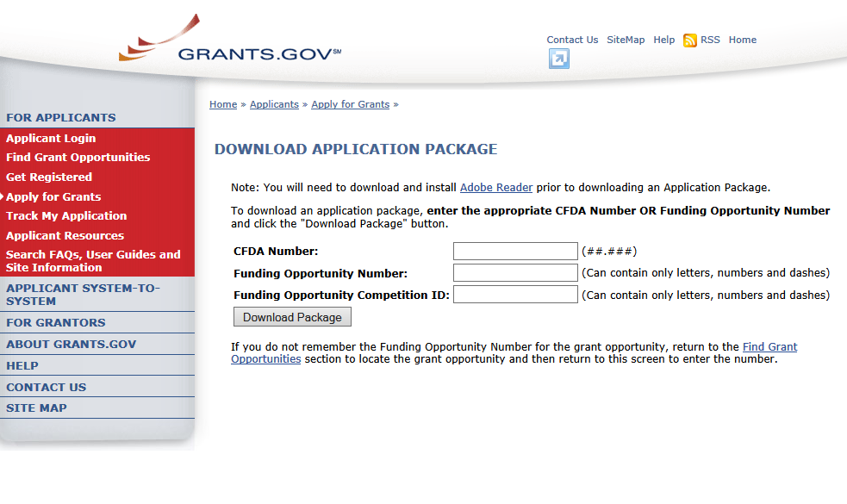
A Funding Opportunity Announcement (FOA) Number is referenced in every announcement. Enter this number in the Funding Opportunity Number field and click Download Package. This takes you to a “Selected Grant Applications for Download” screen.
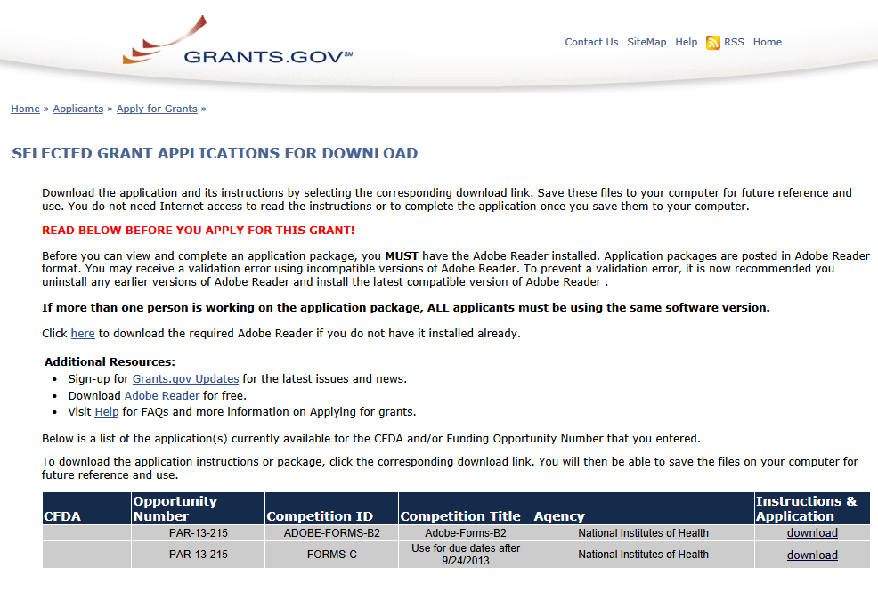
Click the corresponding download link to access the actual application form pages and instruction material. If more than one application package is listed, use the Competition ID and Competition Title to determine the appropriate package to download. The following screens appear:
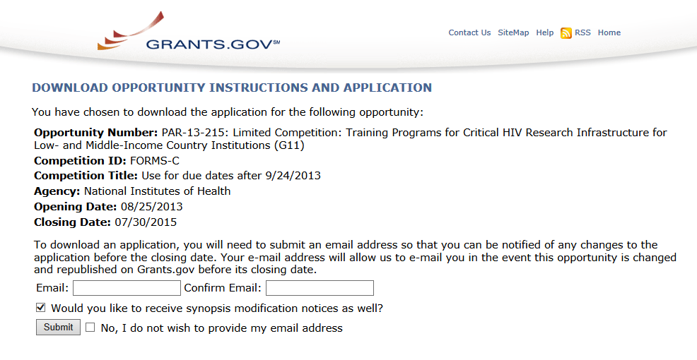

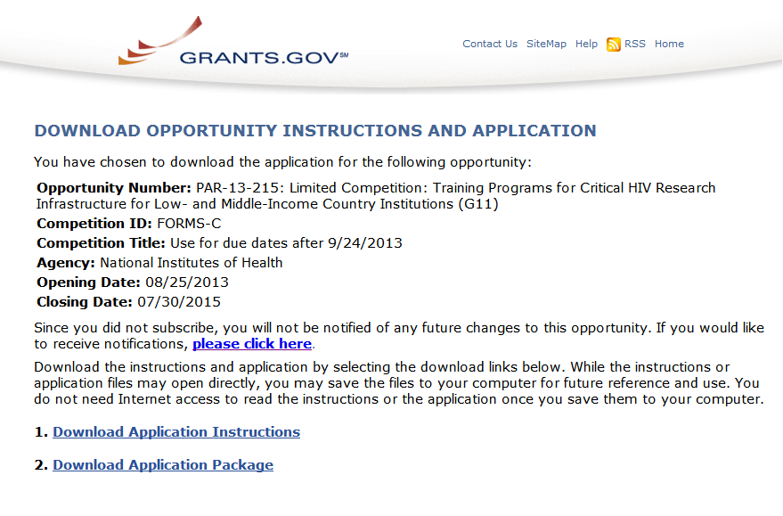
To access the instructions, click Download Application Instructions. For NIH opportunities and other PHS agencies using this Application Guide, this action will download a document containing a link to the NIH website where the most current set of application instructions is available (http://grants.nih.gov/grants/funding/424/index.htm). Applicants are encouraged to check this site regularly for the most current version.
To access the form pages, click Download Application Package. Section 2.5 provides specific information regarding the forms for an Application Package. Section 3 provides additional instructions for properly using a package.
On the Download Opportunity Instructions and Applications screen you will be given an opportunity to provide an e-mail address if you would like to be notified of any changes to this particular opportunity. Applicants to NIH and other PHS agencies are strongly encouraged to complete this information. The agency can then use it to provide additional information to prospective applicants.
Note: The forms may or may not show a CFDA number and the CFDA field is not editable. Do not be concerned. The CFDA number is not used for assignment of the application. Be assured the correct CFDA number will be assigned to the record once the appropriate IC assignment has been made.

2.5 Forms for an Application to NIH or Other PHS Agencies
The SF424 (R&R) form set comprises a number of forms, each listed in the table below as a separate “document.” In addition to these forms, NIH and other PHS agencies applicants will also complete supplemental forms listed as “PHS 398” forms in the table below.
Table 2.5-1. Table 2.5-1. Forms for an NIH or Other PHS Agencies Application
document | required | optional | instructions
SF424 (R&R) Cover | x |  | Section 4.2
SF424 (R&R) Project/Performance Site Locations | x |  | Section 4.3
SF424 (R&R) Other Project Information | x |  | Section 4.4
SF424 (R&R) Senior / Key Person Profile(s) | x |  | Section 4.5
SF424 (R&R) Budget  (Use when required or allowed by the FOA) | * |  | Section 4.7
SF424 (R&R) Subaward Budget Attachment Form  (Use when required or allowed by the FOA) |  | x | Section 4.8
PHS 398 Cover Page Supplement | x |  | Section 5.3
PHS 398 Modular Budget  (Use when required or allowed by the FOA) | * |  | Section 5.4
PHS 398 Research Plan  (Not required for Career Development Award (K) or  Institutional Training Award (T) applications) | x |  | Section 5.5
Planned Enrollment Report |  | x | Section 5.8
PHS 398 Cumulative Inclusion Enrollment Report |  | x | Section 5.8
PHS 398 Career Development Award Supplemental Form  (Required only for Career Development Award (K)  applications) | x |  | Section 7.5
PHS 398 Research Training Program Plan  (Required only for Institutional Training Award (T)  applications) | x |  | Section 8.7
PHS 398 Training Budget  (Use when required or allowed by the FOA) | * |  | Section 8.5
PHS 398 Training Subaward Budget Attachment  (Use when required or allowed by the FOA) |  | * | Section 8.6
* The application forms package associated with most NIH research grant funding opportunities includes two optional budget forms: (1) SF424 (R&R) Budget and (2) PHS 398 Modular Budget. NIH application submissions must include either the SF424 (R&R) Budget Form or the PHS 398 Modular Budget Form, but never both. (Note AHRQ does not accept modular budgets.) Unless otherwise stated in a funding announcement, an application must always be submitted with a budget form. For those programs where either form is a possibility, the budget forms will be considered “optional” by the Grants.gov package. Nonetheless, it is still required that you select and submit one of these budget forms for an application to be accepted by the NIH.
To determine which budget form to use for NIH applications, consult the modular budget guidelines found in Section 5.4. Additional guidance may also be provided in the specific funding opportunity announcement.
Some funding opportunities will explicitly state the use of only one of the budget forms. In this case, the application package will only include the accepted budget form which will appear in the list of “mandatory” forms (not in the optional list).
For a small number of programs (e.g., S10, DP1, DP2, DP3, X01, X02), neither budget form is included and the only budget information required is the Estimated Project Funding section of the SF424 (R&R) cover.

All required and optional forms for electronic submission listed above are available through Grants.gov and should be downloaded from the FOA being applied to. Do not use any forms or format pages from other sources; these may include extraneous headers/footers or other information that could interfere with the electronic application process.

2.6 Format Specifications for Text (PDF) Attachments
Designed to maximize system-enforced validations, multiple separate attachments are required for a complete application. When the application is received by the agency, all submitted forms and all separate attachments are combined into a single document that is used by peer reviewers and agency staff.
NIH and other PHS agencies require all text attachments to the Adobe application forms be submitted as PDFs and that all text attachments conform to the agency-specific formatting requirements noted below. Failure to follow these requirements may lead to rejection of the application during agency validation or delay in the review process. (See Section 2.3.2 for more information on creating PDFs.)
Text attachments should be generated using word processing software and then converted to PDF using PDF generating software. Avoid scanning text attachments to convert to PDF since that causes problems for the agency handling the application. Additional tips for creating PDF files can be found at http://grants.nih.gov/grants/ElectronicReceipt/pdf_guidelines.htm.
When attaching a PDF document to the actual forms, please note you are attaching an actual document, not just pointing to the location of an externally stored document. Therefore, if you revise the document after it has been attached, you must delete the previous attachment and then reattach the revised document to the application form. Use the View Attachment button to determine if the correct version has been attached.
File Name
Save all files with descriptive file names of 50 characters or less and be sure to only use standard characters in file names: A through Z, a through z, 0 through 9, underscore (_), hyphen (-), space ( ), and period (.). Do not use any other special characters (example: “&”, “*”, “%”, “/”, and “#”) or spacing in the file name.
Font
Use an Arial, Helvetica, Palatino Linotype, or Georgia typeface, a black font color, and a font size of 11 points or larger. (A Symbol font may be used to insert Greek letters or special characters; the font size requirement still applies.)
Type density, including characters and spaces, must be no more than 15 characters per inch.
Type may be no more than six lines per inch.
Paper Size and Page Margins
Use standard paper size (8 ½" x 11).
Use at least one-half inch margins (top, bottom, left, and right) for all pages. No information should appear in the margins, including the PI’s name and page numbers.
Page Formatting
Since a number of reviewers will be reviewing applications as an electronic document and not a paper version, applicants are strongly encouraged to use only a standard, single-column format for the text. Avoid using a two-column format since it can cause difficulties when reviewing the document electronically.
Do not include any information in a header or footer of the attachments. A header will be system-generated that references the name of the PD/PI. Page numbers for the footer will be system-generated in the complete application, with all pages sequentially numbered.
Figures, Graphs, Diagrams, Charts, Tables, Figure Legends, and Footnotes
You may use a smaller type size but it must be in a black font color, readily legible, and follow the font typeface requirement. Color can be used in figures; however, all text must be in a black font color, clear and legible.
Grantsmanship
Use English and avoid jargon.
If terms are not universally known, spell out the term the first time it is used and note the appropriate abbreviation in parentheses. The abbreviation may be used thereafter.
Page Limits
Although many of the sections of this application are separate text (PDF) attachments, page limits referenced in these instructions and/or funding opportunity announcement must still be followed. Agency validations will include many checks for page limits. Some accommodation will be made for sections that when combined must fit within a specified limitation. Note that while these computer validations will help minimize incomplete and/or non-compliant applications, they may not address all page limit requirements for a specific FOA and do not replace the validations conducted by NIH staff. Applications found not to comply with the requirements may lead to rejection of the application during agency validation or delay in the review process.
All applications for NIH and other PHS agency funding must be self-contained within specified page limits. Unless otherwise specified in an NIH solicitation, internet website addresses (URLs) may not be used to provide information necessary to the review because reviewers are under no obligation to view the internet sites. Moreover, reviewers are cautioned that they should not directly access an Internet site as it could compromise their anonymity.
Observe the page number limits given in Table 2.6-1. Only when specifically allowed in a FOA will the PHS accept applications that exceed the page number limitations. However, specific page number limits may apply to each subproject. For information pertaining to page number limits for such projects, contact the awarding component to which the application may be assigned. (See Table 1.4-1. Agency Contact Table.) The page number limitations may also be different for other specialized grant applications. Applicants are prohibited from using the Appendix to circumvent page limitations in any section of the application for which a page limit applies. For additional information regarding Appendix material and page limits, please refer to the NIH Guide Notice NOT-OD-11-080.
Table 2.6-1. Page Limits
Please visit http://grants.nih.gov/grants/forms_page_limits.htm for a more detailed Table of Page Limits.

section of application  Also refer to the relevant section of the application instructions and the FOA. | page limits *
Introduction to Resubmission Application  (3 pages for R25 on PHS 398 Research Plan and 3 pages for K12, T and D Training Grants on PHS 398 Training Program Plan) | 1 page
Introduction to Revision Application | 1 page
Specific Aims | 1 page
Research Strategy (Item of Research Plan) | 6 pages  or 12 pages  or Follow FOA instructions
Research Education Program Plan  For R25 Research Education Grant Applications | 25 pages
Plan for Instruction in the Responsible Conduct of Research  Required for all Training Grant Activity Codes  Required for all Individual Career Development Grant Activity Codes | 3 pages  1 page
Biosketch (per person)  (2 pages for DP1 and DP2 Activity Codes) | 4 pages
Career Development Award (K) Application  Upload to PHS 398 Career Development Award Supplemental Form: Combined Candidate Information (Candidate’s Background, Career Goals and Candidate’s Plan for Career Development/Training Activities During Award Period attachments) and Research Strategy attachment | 12 pages
Institutional Research Training and Career Development Applicants, Including Ruth L. Kirschstein NRSA Application  Research Training Program Plan: Combined Sections 8.7.2.2 – 8.7.2.4 (Background, Program Plan, and Recruitment and Retention Plan to Enhance Diversity) | 25 pages
* FOA instructions always supersede these instructions.

2.7 “Resubmission” Applications
For all original new (i.e., never submitted) competing renewal applications submitted for the January 25, 2009 due date and beyond, NIH will accept only a single amendment (A1) to the original application (called a resubmission application). A lengthy hiatus after the initial submission may be marked by significant advances in the scientific field and the comments of the reviewers may no longer be relevant. Therefore, a resubmission application must be submitted within 37 months after the date of receipt ("receipt date") of the initial New, Renewal, or Revision application (see NOT-OD-10-140 and NOT-OD-12-128). After 37 months, you may submit a New application. Any second resubmission will be administratively withdrawn and not accepted for review.
NIH has established policies for application resubmissions of certain categories. See Resubmission of Unpaid RFA Applications and Resubmission of Applications with a Changed Grant Activity Code in Supplemental Instructions Part III, 1.2.
There are five requirements for a Resubmission application:
- The Summary Statement must be available in the eRA Commons (http://commons.era.nih.gov/commons).
- The PD/PI(s) must make significant changes to the application.
- An Introduction must be included that summarizes the substantial additions, deletions, and changes to the application. The Introduction must also include a response to the issues and criticism raised in the Summary Statement. The Introduction is separate from the Cover Letter. Use “ Introduction” of the PHS 398 Research Plan Form to provide this information. The page limit for the Introduction may not exceed one page unless indicated otherwise. Please refer to the relevant section of the application instructions and the FOA.
- The substantial scientific changes must be marked in the text of the application by bracketing, indenting, or change of typography. Do not underline or shade the changes. Deleted sections should be described but not marked as deletions. If the changes are so extensive that essentially all of the text would be marked, explain this in the Introduction. The Preliminary Studies/Progress Report section should incorporate work completed since the prior version of the application was submitted.
- For Mentored Career Development Award applications, new Letters of Reference must be submitted providing an up-to-date evaluation of the applicant’s potential to become an independent researcher, and the continued need for additional supervised research experience.
See NOT-OD-11-057 for special conditions and due dates for new investigator resubmission applications submitted for consecutive review cycles. Note this applies only to new investigator R01s submitted for standard receipt dates and reviewed in recurring study sections in CSR.
Acceptance of a resubmission application will not automatically withdraw the prior version. eRA keeps all versions (e.g., 01, A1) of a grant application active and provides an internal Multiple Active Applications (MAA) flag for each application in an active cluster. The cluster allows applicants to identify quickly all versions of one application. If any version in a cluster is awarded, all other applications within the cluster will be automatically withdrawn without any additional action by applicants or staff.
Investigators who have submitted two versions of an application and have not been successful often ask NIH what constitutes a “new application.” It is recognized that investigators are trained in a particular field of science and are not likely to make drastic changes in their research interests. However, a new application following two reviews is expected to be substantially different in content and scope with more significant differences than are normally encountered in a Resubmission application. Simply rewording the title and Specific Aims or incorporating minor changes in response to comments in the previous Summary Statement does not constitute a substantial change in scope or content. Changes to the Research Strategy should produce a significant change in direction and approach for the research project. Thus, a new application would include substantial changes in all portions of the Specific Aims and Research Strategy. Requests for review by a different review committee or funding consideration by a different NIH IC are not sufficient reasons to consider an application as new.
In the referral process, NIH staff look at all aspects of the application, not just the title and Description (abstract). Requesting review by a different review committee does not affect the implementation of this policy. When necessary, previous applications are analyzed for similarities to the present one. Thus, identical applications or those with only minor changes will not be accepted for review. If identified after assignment or review, identical applications will be withdrawn.

2.8 “Revision” Application
A Revision application (formerly called a competing supplement) may be submitted to request support for a significant expansion of a project’s scope or research protocol. Applications for revisions are not appropriate when the sole purpose is to restore awards to the full SRG-recommended level if they were administratively reduced by the funding agency. A revision application should not be submitted until after the original application has been awarded and must not extend beyond the term of the current award period.
Provide a one-page “Introduction” that describes the nature of the supplement and how it will influence the specific aims, research design, and methods of the current grant. Use Introduction to application, of the PHS 398 Research Plan form to provide this information. The body of the application should contain sufficient information from the original grant application to allow evaluation of the proposed supplement in relation to the goals of the original application. Note that all revision applications must be submitted by the same PD/PI (or Contact PD/PI for multi-PI grants) as listed on the current award and applicants must use the same budget format (i.e. R&R Budget Form or PHS 398 Modular Budget Form) as the current award. Also, any budgetary changes for the remainder of the project period of the current grant should be discussed in the Budget Justification.
If the revision application relates to a specific line of investigation presented in the original application that was not recommended for approval by the SRG, then the applicant must respond to the criticisms in the prior Summary Statement, and substantial revisions must be clearly evident and summarized in the “Introduction.”
Administrative Supplements
An administrative supplement provides additional funding to meet increased costs that are within the scope of an approved application, but that were unforeseen when the new or competing renewal application was submitted. If considering administrative supplement funding, you must consult in advance with your designated Grants Management Officer and Program Official. It is important to submit a request before the grant expires. NIH now publishes all administrative supplement programs as FOAs, not Guide Notices as done previously. Administrative Supplement requests may now be submitted in response to an FOA through either the eRA Commons or Grants.gov, as described in NOT-OD-12-024, or through the existing, paper-based process. If you submit a request in writing, you must submit to the IC (not to the Division of Receipt and Referral, Center for Scientific Review). For additional information, see NIH Guide Notice NOT-OD-12-043. The request must be signed by the authorized Business Official and describe the need for additional funding and the categorical costs. In the letter, point out what will NOT be able to be accomplished if such a request is denied.

2.9 Similar, Essentially Identical, or Identical Applications
Submissions of identical applications to one or more components of the PHS are not allowed.
Submissions of identical applications to one or more components of the PHS are not allowed, and the NIH will not accept similar grant applications with essentially the same research focus from the same applicant organization. This includes derivative or multiple applications that propose to develop a single product, process or service that, with non-substantive modifications, can be applied to a variety of purposes. Likewise, identical or essentially identical grant applications submitted by different applicant organizations will not be accepted. Applicant organizations should ascertain and assure that the materials they are submitting on behalf of the principal investigator are the original work of the principal investigator and have not been used elsewhere in the preparation and submission of a similar grant application. Applications to the NIH are grouped by scientific discipline for review by individual Scientific Review Groups and not by disease or disease state. The reviewers can thus easily identify multiple grant applications for essentially the same project. In these cases, application processing may be delayed or the application(s) may not be reviewed.
Essentially identical applications will not be reviewed except for: 1) individuals submitting an application for an Independent Scientist Award (K02) proposing essentially identical research in an application for an individual research project; 2) individuals submitting an individual research project identical to a subproject that is part of a program project or center grant application; 3) submissions of applications previously submitted to an RFA that were not paid or resubmissions of investigator-initiated applications originally submitted to an RFA (see Grants Policy Statement section 2.3.7.3); and 4) resubmissions of applications with a changed grant activity code.

2.10 Submitting Your Application Via Grants.gov
The Authorized Organization Representatives (AORs) registered in Grants.gov are the only official with the authority to actually submit applications through Grants.gov. Therefore, PD/PIs will need to work closely with their AOR(s) to determine that all the necessary steps have been accomplished prior to submitting an application. This includes any internal review process required by the applicant organization.
Before starting the final submission step, applicants are encouraged to save a copy of the final application locally. Once you have properly completed all required documents and attached any required or optional documentation, click on the Check Package for Errors button to ensure that you have successfully completed all Grants.gov required data fields. If any of the required fields are not completed you will receive an error notice which will indicate where revision is needed within your package. Correct any errors or if none are found, save the application package. Note that the Check Package for Errors button only checks a subset of Grants.gov application checks and does not guarantee that your application will pass subsequent Grants.gov and agency business rule checks done after submission. Only after the package has been saved with no errors will the Save & Submit button become active. Clicking the Save & Submit button will begin the application submission process. The application package must then be saved once more before the submission process begins. Only an AOR will be able to perform the submit action, and they will be taken to the applicant login page to enter the Grants.gov username and password that was established in the Register with Grants.gov process (if not connected to the internet you will be instructed to do so).
Once logged in, the application package will be automatically uploaded to Grants.gov. A confirmation screen will appear once the upload is complete and a Grants.gov Tracking Number will be provided on this screen. Applicants should record this number so that they may refer to it should they need to contact Grants.gov Customer Support or the eRA Commons Help Desk.
For additional information, see http://www.grants.gov/applicants/apply_for_grants.jsp.
Applicants should be aware that on-time submission means that an application is submitted error free (of both Grants.gov and eRA Commons errors) before 5 p.m. on the receipt date, local time of the applicant organization. Applicants are encouraged to submit their applications to Grants.gov several days early to ensure enough time to correct any errors before the deadline.

2.11 After You Submit Your Application Via Grants.gov
Grants.gov’s Track My Application feature for Applicants provides basic status information for a specified Grants.gov Tracking Number. The Authorized Organization Representative (AOR) can also login to Grants.gov with their username and password to obtain a more detailed status of an application by using the Check My Application Status feature.
Once an application has been submitted via Grants.gov, several e-mails are sent to the email address on file with Grants.gov for the AOR (known at NIH/in eRA Commons as the Signing Official [SO]) who submitted the application. Each email notification will reference a Grants.gov tracking number that is assigned to the submission:
1) Submission Receipt: An e-mail is sent indicating your application has been received by Grants.gov and is currently being validated.
2) Submission Validation Receipt: An e-mail is sent indicating your application has been received and validated by Grants.gov and is being prepared for Grantor agency retrieval.
3) Grantor Agency Retrieval Receipt: An e-mail is sent indicating your application has been retrieved by the Grantor agency.
4) Agency Tracking Number Assignment for Application: An e-mail is sent indicating your application has been assigned an Agency Tracking Number.
If the AOR/SO has not received a confirmation message from Grants.gov within 48 hours of submission, please contact:
Grants.gov Contact Center
Telephone: 1-800-518-4726
E-mail: support@grants.gov
At that point, the application will be scheduled for download into the eRA system for agency validation. It is imperative that the e-mail address provided for the PD/PI and for the AOR/SO on the SF424 (R&R) Cover form be current and accurate. Once agency validation is completed, an agency notification (not Grants.gov) will be e-mailed to the PD/PI, AOR/SO, and the Applicant Contact e-mail (if provided) named in the application.
This e-mail notification will inform the PD/PI, AOR/SO, and the Applicant Contact (if named) that the application has been received and processed by the agency and will indicate whether any errors or warnings resulted during the validation process. The PD/PI, AOR/SO, and the Applicant Contact will be invited to log on the eRA Commons to view the assembled application or review the list of warnings/errors that were encountered during the validation process. SOs for the applicant organization, the PD/PI for the application and any Assistants that have been delegated in eRA Commons to view the PD/PIs status information will have access to the submission results in eRA Commons.
If there were no validation errors, this e-mail notification will also inform the PD/PI, AOR/SO, and the Applicant Contact of an agency accession number, which represents the “agency tracking number.” This number replaces the Grants.gov tracking number that was assigned when the application was first submitted. The Grants.gov system will indicate that the agency tracking number has been assigned, and will reflect both numbers.
The eRA system will make every effort to send an e-mail to the PD/PI, AOR/SO, and the Applicant Contact summarizing download and validation results. However, since e-mail can be unreliable, applicants are responsible for checking on their application status in the Commons.
Once an application package has been successfully submitted through Grants.gov, any encountered errors have been corrected by the applicant, and an application image has been assembled by the eRA Commons, PD/PIs and AORs/SOs will have two business days (Monday – Friday, excluding Federal holidays) to check the assembled application before it automatically moves forward to NIH staff for further processing and consideration. Once the application has moved forward, no additional changes to the application will be accepted through Grants.gov or eRA Commons. This window is known as the application viewing window.
Within the viewing window, SOs have the authority to reject an application to stop it from completing the submission process. After an application is rejected, a changed/corrected application can be submitted to address warnings or other issues if it is still before the submission deadline. However, changed/corrected applications submitted after the submission deadline will be subject to the NIH Late Policy and may not be accepted.
Remember, warnings do not stop further application processing. If an application submission results in warnings (but not errors), the application will automatically move forward after the application viewing window if no action is taken. Some warnings may need to be addressed later in the process.
It is your responsibility to view the entire assembled application in eRA Commons and notify the eRA Commons Help Desk within this window if the assembled application does not correctly reflect the information submitted to Grants.gov (e.g., submitted information is missing in image, graph/chart appears upside-down). The eRA Commons Help Desk will provide guidance on appropriate corrective actions.
If you encounter a system issue beyond your control that threatens your ability to complete the submission process on-time, you must follow the Guidelines for Applicants Experiencing System Issues.
Only the eRA Help Desk can confirm whether a system issue has taken place and provide instructions on how to resolve the issue. Applications affected by confirmed system issues will not be considered late as long as the applicant works diligently with the eRA Help Desk on a resolution. If the application needs to be Rejected and resubmitted, applicants should follow the instructions for correcting errors in Section 2.12, including the requirement for cover letters on late applications.
PIs should work with their AOR/SO to determine when the “Reject” feature is appropriate.
To view the assembled application the AOR/SO should:
1. Login to the eRA Commons (https://commons.era.nih.gov/commons/) with your Signing Official (SO) account.
2. Click the Status tab on the Commons menu bar.
3. Click Recent/Pending eSubmissions on the left-hand side of the screen.
4. Search for your application by date received, Grants.gov tracking number, or accession number, to view a hit list of available applications.
5. When you find the appropriate application, click the accession number in the Application ID column to view the Status Information screen.
6. Click e-Application from the Other Relevant Documents section to view the assembled application.
Note: The SO can Reject the application by clicking on the Reject eApplication hypertext link from the Action column of the search hit list.
To view the assembled application the PD/PI should:
1. Login to the eRA Commons (https://commons.era.nih.gov/commons/) with your Principal Investigator (PI) account.
2. Click the Status tab on the Commons menu bar.
3. Click Recent/Pending eSubmissions near the top of the screen to view a hit list of available applications.
4. When you find the appropriate application, click the accession number in the Application ID column to view the status information screen.
5. Click e-Application from the Other Relevant Documents section to view the assembled application.

2.12 Correcting Errors
Prior to a specified application due date, applicants may make corrections and resubmit an application through Grants.gov. If applicants make corrections and resubmit the application after the due date, the application will be considered late. In this case, applicants must include a cover letter explaining the reasons for the delay and acceptance will be considered on a case-by-case basis. Also see Section 2.14 for additional information on submission dates.
If errors or warnings result from the validation process, the PD/PI, AOR/SO and Applicant Contact will be issued an e-mail instructing them to log on to the eRA Commons to review the list of warnings/errors that were encountered during the validation process. The eRA system will make every effort to send an e-mail to the PD/PI, AOR/SO and Applicant Contact indicating whether errors or warnings were detected. However, since e-mail can be unreliable, applicants are responsible for periodically checking on their application status in the eRA Commons, so that any errors or warnings can be resolved in the timeliest manner possible, before the deadline. SOs for the applicant organization, the PD/PI for the application and any Assistants that have been delegated in eRA Commons to view the PD/PIs status information will have access to the submission results in eRA Commons.
Please be aware of the distinction between errors and warnings. The word error is used to characterize any condition which causes the application to be deemed unacceptable for further consideration. Generally, errors will indicate significant inaccuracies, inconsistencies, omissions, or incorrect formatting that have been identified in the body of the application. Conversely, the word warning characterizes any condition that is acceptable, at least for the time being, but worthy of bringing to the applicant’s attention. It is at the applicant’s discretion whether a warning condition requires any action, but some warnings may need to be addressed later in the process.
Failure to comply with stated NIH policies can also result in a submitted application being returned to the applicant without being reviewed. For this reason, applicants are strongly encouraged to review all warnings, to ensure that they require no further attention and that they are satisfied with the validation results. If desired, warnings can be corrected in the same manner as errors.
A Changed/Corrected application may also be submitted if the PDF image, as viewed in the eRA Commons, is incomplete or inaccurate from that submitted.
Submitting a Changed/Corrected application will overwrite the previous submission and the previous application cannot be reinstated.
Errors and warnings may be reviewed in the Commons by performing the following steps:
1. After the application has been downloaded from Grants.gov and validated by the system, login to the eRA Commons (https://commons.era.nih.gov/commons/) using your username and password.
2. Click the Status tab on the Commons menu bar.
3. Click Recent/Pending eSubmissions.
4. Search for your application by date received, Grants.gov tracking number, or accession number, if you are the SO. If you are the PI, clicking Recent/Pending eSubmissions will automatically display a hit list of your applications.
5. A hit list of applications is displayed. If the application was validated with warnings only, or without encountering any problems whatsoever, then it is identified in the hit list by its NIH accession number (e.g., “AN:2911064”). This is the same number that Grants.gov displays, and refers to as the “agency tracking number.”
If any errors were identified during validation, then the application still appears in the hit list, but in this case it is identified by its Grants.gov tracking number (e.g., “GRANT87654321”). This is the number that Grants.gov assigned to your application at the time of submission.
6. When you find the appropriate application in the hit list (Application Status will read “eSubmission Error” if errors were received), click its Application ID link to view the list of errors/warnings.
7. The error/warning page appears, and you are then able to review all conditions that were identified during validation. If only warnings were identified, you may elect to take action and resubmit; however you may also disregard the warnings and proceed to view the application, as described earlier.
To correct errors and resubmit the application:
1. Make whatever corrections are necessary, wherever appropriate, to your local copy of the application. Most often this means that you have to edit the data within the application forms to correct whatever problem or inconsistency that was noted. Be as careful as possible when correcting your application; NIH’s post-submission materials policy does not allow for applicants to correct oversights in their application after the due date.
2. Check the “Changed/Corrected Application” box in the Type of Submission field of the SF424 (R&R) Cover form.
  - If you are submitting this Changed/Corrected application after the due date, be sure to document the reason for the late submission in the form of a cover letter. NIH makes no guarantees that applications submitted after the due date will be accepted. See the NIH late policy for more information.
  - When you check the Changed/Corrected Application box, Previous Grants.gov Tracking ID field becomes required.
  - When you have made all of your corrections, save the Changed/Corrected application to your computer.
3. The AOR will have to submit the Changed/Corrected application package to Grants.gov. A new Grants.gov tracking number will be assigned and the applicant will have to follow the Changed/Corrected application through Grants.gov to the eRA Commons to view the application image or the list of errors/warnings received during the validation process. It is the applicant’s responsibility to track the application through to the eRA Commons. If you cannot view your application image in the Commons, NIH can’t review your application! Successful submission may take several rounds of Changed/Corrected applications, since correcting one error may reveal or create an additional error.
The same e-mail notifications will be issued once the agency has downloaded and validated the re-submitted application and the PD/PI, AOR/SO, and Applicant Contact will once again be required to log on to the Commons either to view the application or to review the errors that were encountered during validation.
The application will only be assigned for scientific review once errors are resolved.
In addition to the validations performed by the eRA system, further administrative review will be conducted by agency staff. The PD/PI and/or the applicant organization may be contacted for further corrections/clarifications.

2.13 Post-Submission Application Materials
Grant application materials will only be accepted after submission of the application but before the initial peer review if they result from unforeseen administrative issues. Exceptions to this policy are indicated below. See NOT-OD-10-091 and NOT-OD-13-030 for additional information.
The materials should be sent as a PDF attachment to an e-mail. E-mail communication is preferred. If e-mail is not feasible, please send in a hard copy.
The original application is kept intact; any application material sent post-submission is sent separately to reviewers. Updated or supplemental grant application materials used in the peer review process will be retained as part of the official grant file and remain part of the permanent record for that application.
Acceptable post-submission materials include:
- Revised budget page(s) (e.g., change in budget request due to new funding or institutional acquisition)
- Biographical sketches (e.g., change in senior/key personnel due to the loss of an investigator)
- Letters of support or collaboration resulting from a change in senior/key personnel due to the loss of an investigator
- Adjustments resulting from natural disasters (e.g., loss of an animal colony)
- Adjustments resulting from change of institution (e.g., PI moved to another university)
- News of an article accepted for publication
- News of a professional promotion or positive tenure decision for any Program Directors/Principal Investigators and Senior/Key Personnel also will be accepted as post-submission application material. The news must be received by the Scientific Review Officer one month (30 calendar days) prior to the peer review meeting, and demonstrate concurrence from the Authorized Organization Representative (AOR) of the applicant organization.
- If an application proposed to use a human embryonic cell line(s) that is approved by the NIH Stem Cell Registry at least 30 days prior to the peer review meeting, the SRO can include this update to the reviewers as part of the post-submission materials (see NOT-OD-12-111).
- Videos, within defined limits, (see, NOT-OD-12-141). Devices and other non-traditional materials will not be accepted after submission, unless the application is submitted for a Funding Opportunity Announcement that specifies other types of allowable post-submission materials.
- For institutional training and training-related grants [not fellowships (F series) or career (K series)] applications, the following types of information will be accepted:
  - News of a trainee's or former trainee's graduation, employment, promotion, funding, publication or other professional achievement since the training grant was submitted;
  - News of a faculty member's promotion, funding, publication, or other professional achievement since the training grant was submitted; and
  - News of an additional faculty member who will be involved in the training activity.
Unacceptable post-submission materials [for all applications but those under Exceptions below] include:
- Updated Specific Aims or Research Strategy pages
- Late-breaking research findings
- Supplemental pages - information not contained in the existing application
- New letters of support or collaboration that do not result from a change in senior/key personnel due to the loss of an investigator
Exceptions to this policy include:
- Applications submitted in response to Requests for Applications (RFAs) that have only one due date. Post-submission materials for these applications will be accepted as outlined in NOT-OD-10-070
- Applications submitted in response to Requests for Applications (RFAs) that have multiple due dates, the exception to this policy applies to applications submitted for the last due date of an RFA (see NOT-OD-13-030)
- Applications for training grants (see NOT-OD-10-104)
- Certain NIH Funding Opportunity Announcements (FOAs) may allow certain other types of post-submission materials to facilitate the goals of the program. Such stipulations must be explained in the FOA in the NIH Guide for Grants and Contracts
Page limits for post-submission materials under the new policy:
- All post-submission materials must conform to NIH policy on font size, margins, and paper size as referenced in Part I.2.6 of the applicable application instructions
- NIH additional form pages such as budget, biographical sketches, and other required forms must follow NIH standards for required NIH form pages.
- If post-submission material is not required on a form page, each explanation or letter is limited to one page (see Acceptable post-submission materials above)
- If the application has subprojects or cores, each subproject or core is allowed explanations or letters (see Acceptable post-submission materials above), but each explanation or letter is limited to one page
The additional materials must be submitted to the NIH SRO with the concurrence of the applicant organization’s designated AOR/SO. Although the content of post-submission materials may originate from the PD/PI, Contact PD/PI for multiple PD/PI applications, or organizational officials, the AOR must send the materials directly to the SRO, or must send his/her concurrence to the PD/PI who will forward the materials and concurrence to the SRO. A communication from the PD/PI only or with a “cc” to the AOR will not be accepted.
The deadline for receipt of additional materials is one month (30 calendar days) prior to the peer review meeting.
After the initial peer review phase is completed, the NIH Chief Grants Management Officer is the NIH official responsible for accepting additional materials. Most of the materials submitted after the initial peer review can be submitted as part of the Just-In-Time process (see Supplemental Instructions Part III.1.7).

2.14 Application Submission Dates
For submission of applications to NIH, each FOA includes an Opportunity Open Date and an Opportunity Close Date. Many announcements, including those using the “Standard Submission Dates, include multiple submission/receipt dates and are active for several years. These announcements are posted in Grants.gov and the NIH Guide to Grants and Contracts showing an Open/Close period that spans the entire active period of the announcement. Applicants should read the Funding Opportunity Announcement carefully for specific submission/receipt dates. If specific dates are not referenced in the announcement, applicants should refer to the Standard Submission Dates for Competing Applications at this website: http://grants.nih.gov/grants/funding/submissionschedule.htm
Applications submitted for the Standard Submission Dates listed are considered on time if they are submitted to Grants.gov on or before 5 p.m. local time on the appropriate date listed. Applications submitted to FOAs with a single submission date are considered on time if they are submitted to Grants.gov on or before 5 p.m. local time on the appropriate date listed. Applications submitted for Special Receipt Dates are considered on time if they are submitted to Grants.gov on or before 5 p.m. local time on the specified Application Due Date(s). Requests for Applications (RFAs) and Program Announcements with Special Referral Considerations (PARs) with special receipt dates always must be received by Grants.gov on the dates designated in the announcement.
Weekend/Federal Holiday Submission Dates. When a postmark/submission date falls on a weekend or Federal holiday, the application deadline is automatically extended to the next business day. If the submission deadline shifts beyond the expiration date of the FOA, applicants submitting electronically may receive a warning message from Grants.gov. This warning will not keep your application from processing through Grants.gov. As always, applicants must check the eRA Commons to view their application and to ensure they have addressed any errors (instances of non-compliance with NIH business rules) identified by NIH systems.
Modified Application Submission and Review Policy. A continuous submission process is available to appointed members of chartered standing NIH Study Sections, Boards of Scientific Counselors, Advisory Boards or Councils, Program Advisory Committees, and peer reviewers who have served as regular or temporary members of peer review committees six times in 18 months. This alternative submission and review process is limited to R01, R21, and R34 application that would normally be received on standard submission dates. See the Peer Review Policies & Practices, Continuous Submission web page for additional information on the continuous submission process and eligibility requirements.
Late Applications. Permission for a late submission is not granted in advance. In rare cases, late applications will be accepted but only when accompanied by a cover letter that details the compelling reasons for the delay. While the reasons are sometimes personal in nature, an objective evaluation of their merit requires that some details be provided. Late applications have been accepted for reasons such as: death of an immediate family member of the PD/PI, sudden acute severe illness of the PD/PI or immediate family member, or large scale natural disaster.
NIH will consider accepting late applications based on the acceptability of the explanation and the processing time required for two different kinds of submission/receipt dates.
- Regular Standard Submission/Receipt Dates: To be considered applications must be received at the NIH within two weeks of the standard submission date.
- Expedited Standard Submission/Receipt Dates: To be considered applications must be received at the NIH within one week of the standard submission date.
- NIH will not consider late applications for the Special Receipt Dates for RFAs and PARs. This includes the special receipt dates (March 20, July 20, and November 20) for resubmission applications that are part of the New Investigator Initiative (http:grants.nih.gov/grants/guide/notice-files/NOT-OD-07-083.html).
- NIH does not expect to accept any applications received beyond the window of consideration.
The windows of time for consideration of late applications have been carefully chosen so that the late applications can be processed with the cohort of on-time applications. In all cases, when the regular standard submission date or expedited submission date falls on a weekend or federal holiday and is extended to the next business day, the window of consideration for late applications will be calculated from that business day. Note that the late window always ends in a receipt (not submission) date.
If an application is submitted late, attach a Cover Letter to the SF424 (R&R) cover form using the Cover Letter Attachment field to provide specific information on the timing and nature of the cause of the delay. No other documentation is expected. Late applications are evaluated on an individual basis considering the reasons provided. Contacting the Division of Receipt and Referral, Center for Scientific Review (CSR), NIH in advance will not influence the acceptance of a late application.
Related Guide Notices include:
- NOT-OD-12-001 Update of NIH Late Application Policy to Reflect Change in Due Dates for New Investigator R01 Resubmission Applications at http://grants.nih.gov/grants/guide/notice-files/NOT-OD-12-001.html;
- NOT-OD-11-035 NIH Policy on Late Submission of Grant Applications at http://grants.nih.gov/grants/guide/notice-files/NOT-OD-11-035.html; and
- NOT-OD-11-093 Change in the NIH Continuous Submission Policy for Reviewers with Recent Substantial Service at http://grants.nih.gov/grants/guide/notice-files/NOT-OD-11-093.html.

2.15 Submission, Review and Award Cycles
The PHS submission, review, and award schedule is provided at this website: http://grants.nih.gov/grants/dates.htm. For specialized grant applications, consult with the appropriate PHS agency prior to the preparation of an application.
The SF424 (R&R) should only be used for those activity codes where the Application Form is identified as the SF424 (R&R). Applicants should refer to the OER Applying Electronically website: http://grants.nih.gov/grants/ElectronicReceipt/ for details on the transition to electronic submission.

Application Assignment Information
Competing grant applications that have been successfully submitted through Grants.gov (including correcting all errors and the grant application assembled by the eRA Commons system) will be processed through the Division of Receipt and Referral, CSR, NIH unless otherwise stated. The application will be assigned to an appropriate Scientific Review Group and awarding component(s). Assignment is based on the scientific content of the application using established referral guidelines. Business rule validations are conducted by the system as well as NIH staff.
Assignment to Review Group. The Center for Scientific Review (CSR) will assign appropriately completed applications to the Scientific Review Groups (commonly referred to as “SRGs” or “study sections”) that will perform the scientific/technical merit review. The CSR lists the recurring review panels (http://cms.csr.nih.gov/PeerReviewMeetings/CSRIRGDescription/), and you may suggest a specific group in the PHS Cover Letter form. See Part I, Section 5.2 of this Guide for a suggested format for requesting a specific SRG in the Cover Letter.
Assignment to Relevant Potential Awarding Component(s) (ICs). In addition, CSR will assign each application to the agency awarding component that is the potential funding component. When the scientific areas and the research proposed in a grant application are sufficiently relevant to the program responsibilities of two or more awarding components, CSR may assign your application to all such components. The component that has the most relevant program responsibility is designated as the primary assignee. The other components that have an interest in your application are designated as secondary assignees. If your application is eligible for funding and the primary assignee does not intend to make an award, the secondary assignees will be given the opportunity to do so. Although these suggestions will be taken into consideration, the final determination will be made by the agencies participating in this solicitation.
After the submission date, usually within two (2) weeks, the PD/PI and the applicant organization will be able to access in the eRA Commons and view the following information regarding the grant application:
- Application assignment number;
- Name, address, and telephone number of the Scientific Review Officer (if the review takes place in CSR) of the Scientific Review Group to which the application has been assigned for peer review; and
- Assigned Institute/Center information.
Review outcome and other important information are also available in the Commons.
If assignment information is not available in the eRA Commons within two weeks of the submission date, contact the Division of Receipt and Referral, Center for Scientific Review (CSR), National Institutes of Health, Bethesda, MD 20892-7720, (301) 435-0715; TTY (301) 451-5936. If there is a change in assignment, you will receive a notification and the change will be reflected in the eRA Commons.
Applicant investigators must not communicate directly with any review group member about an application either before or after the review. Failure to strictly observe this policy will create serious breaches of confidentiality and conflicts of interest in the peer review process. From the time of assignment to the time the review of your application is complete, applicant investigators must direct all questions to the Scientific Review Officer. This individual is in charge of the review group and is identified in the eRA Commons.

2.16 Resources for Finding Help

2.16.1 Finding Help for Grants.gov Registration or Submissions
If help is needed with the Grants.gov registration process or with the technical aspects of submitting an application through the Grants.gov system, check first the resources available at Grants.gov (http://grants.gov/).
Grants.gov customer support is also provided by the following office:
Grants.gov Program Management Office
200 Independence Avenue, SW
HHH Building, Room 739F
Washington, DC 20201
Grants.gov Self-Service Web Portal: https://grants-portal.psc.gov/Welcome.aspx?pt=Grants
Grants.gov Help Desk: support@grants.gov
Grants.gov Contact Center Phone Number: 800-518-4726 (Toll Free)
606-545-5035 (Local or International)
The Contact Center is available 24 hours a day, 7 days a week (except Federal holidays).

2.16.2 Finding Help for the eRA Commons Registration or
eRA Commons Validation Processes
If help is needed with the eRA Commons registration process for the applicant organization and PD/PIs; with using ASSIST for the preparation and submission of multi-project applications; or with the application validation process in the Commons after submission through Grants.gov, check first the resources available at the Applying Electronically website: (http://grants.nih.gov/grants/ElectronicReceipt/).
eRA Commons customer support is also provided by the eRA Commons Help Desk:
eRA Website: http://era.nih.gov
eRA Commons Website: https://commons.era.nih.gov/commons/index.jsp
eRA Commons On-line Resources and Web Ticketing: http://era.nih.gov/help/
eRA Commons Help Desk E-mail: commons@od.nih.gov
eRA Commons Phone: 301-402-7469
866-504-9552 (Toll Free)
301-451-5939 (TTY)
The eRA Commons Help Desk hours of operation are Monday-Friday from 7:00 a.m. to 8:00 p.m. Eastern Time (except Federal holidays).
NOTE: To help expedite your Help Desk request, we recommend that you have the following information readily available (NOTE: Additional details may be required depending upon the type of issue/request):
- Full Name of Affected User
- Full Name of Institution/Organization
- Grants.gov Tracking Number
- Submission Date
- Funding Opportunity Announcement (FOA)
- Principal Investigator’s (PI) Username
- Signing Official’s (SO) Username

2.16.3 Finding Help for Application Preparation
If after reviewing this application instruction guide, help is still needed in preparing the application, contact GrantsInfo:
GrantsInfo Phone: 301-435-0714
301-451-5936 (TTY)
GrantsInfo E-mail: GrantsInfo@nih.gov

3. Using the Grant Application Package
This section describes the steps an applicant takes once the appropriate FOA (see Section 2.4) has been located and the corresponding grant application package has been successfully downloaded.

3.1 Verify Grant Information
When you select a funding opportunity in Grants.gov Apply, verify that the information shown in the Grant Application Package screen corresponds to the funding opportunity for which you wish to apply. Grants.gov auto-populates the following information:
- Opportunity Title
- Offering Agency
- CFDA Number
- CFDA Description
- Opportunity Number
- Competition ID
- Opportunity Open Date
- Opportunity Close Date
- Agency Contact
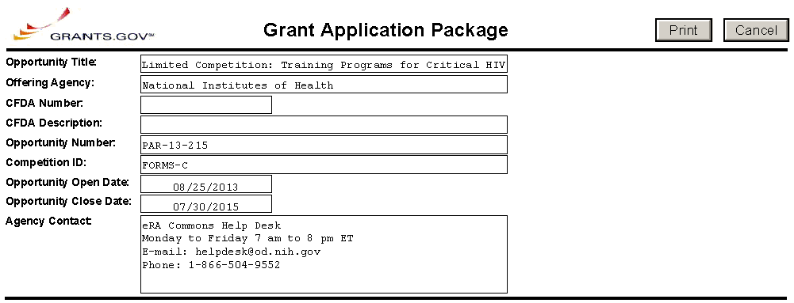
CFDA Number Field: Many FOAs include multiple CFDA (Catalog for Domestic Assistance) numbers. When this is the case, the CFDA Number and CFDA Description fields will appear blank in the Grants.gov Grant Application Package screen shown above. The appropriate CFDA number will be automatically assigned once the application is assigned to the appropriate agency awarding component.
Opportunity Open Date & Close Date Fields: Many FOAs posted by NIH and other PHS agencies include multiple submission/receipt dates and are active for several years. These announcements are posted in Grants.gov showing an Open/Close period that spans the entire active period of the announcement. Applicants should read the funding opportunity announcement carefully for specific submission/receipt dates. If specific dates are not referenced in the announcement, applicants should refer to the PHS submission, review, and award schedule at http://grants.nih.gov/grants/dates.htm. Applications submitted after a posted submission date will normally not be held over into the next review cycle. Instead, the PD/PI will be notified and will have to submit the application again. See Part I, Section 2.14 of this Guide for more information on the late application policy.

3.2 Enter the Name for the Application
Enter a name for the application in the Application Filing Name field (this is a required field). This name is for use solely by the applicant for tracking the application through the Grants.gov submission process. It is not used by the receiving agency.
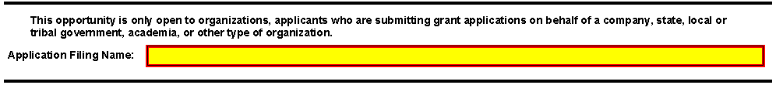

3.3 Open and Complete Mandatory Documents
Click the form name to navigate to the form in the application package and complete all of the Mandatory forms. Complete the form titled SF424 (R&R) first. Data entered in this form populates other mandatory and optional forms where applicable.

3.4 Open and Complete Optional Documents
These documents can be used to provide additional information for the application or may be required for specific types of grant activities. Information on each of these documents is found later in these instructions. In some application packages applicants will see two budget options; e.g., Research & Related Budget and PHS 398 Modular Budget in the Optional Documents section. While both appear as Optional Documents, one or the other will always be required. See Section 4.6 Selecting the Appropriate Budget Form for additional details.
Click the check box next to the form name to add the form to the application package. To navigate to the form, click on the form name. To remove an optional form from the application package, uncheck the box next to the form name.

3.5 Submitting the Application via Grants.gov
Once you have properly completed all required documents and attached any required or optional documentation, click on the Check Package for Errors button to ensure that you have successfully completed all required data fields. If any of the fields required by Grants.gov are not completed you will receive an error notice which will indicate where revision is needed within your package. Correct any errors or if none are found, save the application package. The Save & Submit button will now become active and clicking this button will begin the application submission process. Only after the package has been saved with no errors will the Save & Submit button become active. The application package must then be saved once more before the submission process begins. Only an AOR will be able to perform the submit action, and they will be taken to the applicant login page to enter the Grants.gov username and password that was established in the Grants.gov registration process (if not connected to the internet you will be instructed to do so).

4. Completing the SF424 Research and Related (R&R) Forms

4.1 Overview
This section contains all of the instructions you will need to complete the SF424 (R&R) forms.
Any agency-specific instructions on SF424 (R&R) forms used federal-wide are denoted by the DHHS logo displayed to the left of the paragraph, as illustrated here.
Conformance to all instructions is required and strictly enforced. Agencies may withdraw any applications from the review process that are not consistent with these instructions.
As you navigate through the Grants.gov forms, required fields are highlighted and outlined in red. Optional fields and completed fields are displayed in white. Data entered into a specific field is not accepted until you have navigated to the next field. If you enter invalid or incomplete information in a field, you will receive an error message.
Note the highlighted fields required for submissions, and the Check Package for Errors button, only refer to Grants.gov requirements and errors. They do not reflect all agency requirements or PHS business processes. Agency validations will be performed by the eRA Commons system after the application has been submitted.
For those forms that are more than one page, click the Next button at the top of the form or scroll down (using the scroll bar on the right hand side of the screen) to navigate to a subsequent page. Once all data have been entered scroll up using the scroll bar to return to the Grant Application Package Screen.

4.2 Cover Form
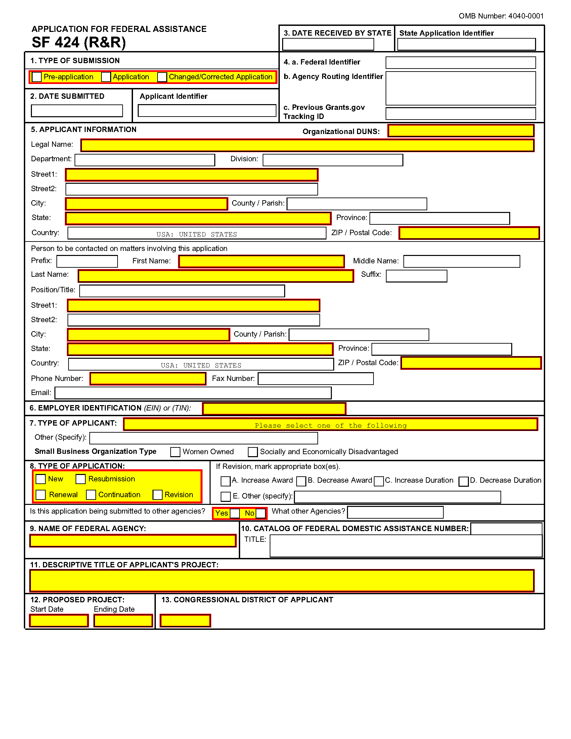
1. Type of Submission
Check one of the Type of Submission boxes. If this submission is to change or correct a previously submitted "New", "Resubmission", "Renewal", or "Revision" application, click the Changed/Corrected Application box and enter the Grants.gov tracking number in the Previous Grants.gov Tracking ID field.
Unless requested by the agency, applicants may not use this to submit changes after the closing date. This field is required.
Pre-Application: Unless specifically noted in a program announcement, the Pre-application option is not used by NIH and other PHS agencies.
Changed/Corrected Application: This box must be used if you need to submit the same application again to correct system validation errors, application assembly problems, or to incorporate other changes. When submitting a Changed/Corrected Application:
- If submitting after the submission date, include an explanation in the Cover Letter Form.
- Submitting a Changed/Corrected application replaces the previous submission and removes the previous submission from consideration. Once an application has moved forward to agency staff following the two-day application viewing window, subsequent Changed/Corrected applications will not be accepted unless the application is withdrawn. Note that if you are submitting additional grant application materials after the submission date some special guidelines may apply. See NIH Guide Notice NOT-OD-10-115 (http://grants.nih.gov/grants/guide/notice-files/NOT-OD-10-115.html) for the NIH Policy on Post-Submission Application Materials.
- When you check the Changed/Correct Application box the Previous Grants.gov Tracking ID becomes a required field.
- Do not use the Changed/Corrected Application box to denote a submission of a resubmission or amended application. That will be indicated in the Type of Application.
2. Date Submitted and Applicant Identifier
Enter the date the application is submitted to Federal agency (or State if applicable). In the applicant identifier field enter the applicant’s control number (if applicable).
Note the Applicant Identifier field is a control number created by the applicant organization, not the Federal agency.
3. Date Received by State and State Application Identifier
Enter the date received by state (if applicable). In the State Application Identifier field, enter the state application identifier, if applicable.
For submissions to NIH and other PHS agencies, leave these fields blank.

4.a. Federal Identifier
When a New Application is being submitted following a Pre-Application, enter the agency-assigned pre-application number, if applicable. If this is a continuation, revision, or renewal application, enter the assigned Federal Identifier number (for example, award number)--even if submitting a Changed/Corrected application.
For submissions to NIH and other PHS agencies, include only the IC and serial number of the previously assigned application/award number (e.g., use CA987654 from 1R01CA987654-01A1). The Federal Identifier is required for Resubmission, Renewal, and Revision applications.
Existing definitions for NIH and other PHS agencies applications are somewhat different:
- New is the same; i.e., an application that is submitted for the first time. See also the policy Resubmission of Unpaid RFA Applications and Resubmission of Applications with a Changed Grant Activity Code.
- Resubmission is equivalent to NIH and other PHS agencies Revision. Check this option when submitting a revised (altered or corrected) or amended application. See also the NIH Policy on Resubmission Applications. Institutions submitting revision or renewal applications that are also resubmissions (A1 or A2 if allowed, see NIH Grant Notice NOT-OD-09-003, http://grants.nih.gov/grants/guide/notice-files/not-od-09-003.html) are instructed to select “Resubmission.” For additional information, see NIH Guide Notice NOT-OD-10-052, http://grants.nih.gov/grants/guide/notice-files/not-od-10-052.html).
- Renewal is equivalent to NIH and other PHS agencies Competing Continuation.
  - Continuation is equivalent to NIH and other PHS agencies Progress Report. For the purposes of NIH and other PHS agencies, the box for Continuation will not be used and should not be checked.
- Revision is somewhat equivalent to NIH and other PHS agencies Competing Supplement, but proposes a change in 1) the Federal Government’s financial obligations or contingent liability from an existing obligation, or 2) any other change in the terms and conditions of the existing award. In general, changes to the “terms and conditions of the existing award” would not require the submission of another application through Grants.gov. Applicants should contact the awarding agency for advice on submitting any revision/supplement application.
Applicants to NIH and other PHS agencies should complete this field when submitting a resubmission, renewal or revision application. When submitting a “New” application, this field should remain blank
4.b. Agency Routing Identifier
Enter the agency-assigned routing identifier per the agency-specific instructions. This is an optional field. Unless specifically noted in a program announcement, the Agency Routing Identifier is not used by NIH or other PHS agencies.
4.c. Previous Grants.gov Tracking ID
Enter the previous Grants.gov tracking number, if applicable.
5. Applicant Information
This information is for the Applicant Organization, not a specific individual.

Field Name | Instructions
Organizational DUNS | Enter the DUNS or DUNS+4 number of the applicant organization. This field is required.  For submission to NIH and other PHS agencies, this DUNS must match the number entered in the eRA Commons Institutional Profile for the applicant organization. The applicant AOR is encouraged to confirm that a DUNS has been entered in the eRA Commons Institutional Profile (IPF) prior to submitting an application. If your organization does not already have a DUNS number, you will need to go to the Dun & Bradstreet website at http://fedgov.dnb.com/webform to obtain the number. The same DUNS should be used in the eRA Commons IPF, Grants.gov registration and in the DUNS field in the application.
Legal Name | Enter the legal name of the applicant which will undertake the assistance activity, enter the complete address of the applicant (including county/parish and country), and name, telephone number, e-mail, and fax of the person to contact on matters related to this application.
Department | Enter the name of the primary organizational department, service, laboratory, or equivalent level within the organization that will undertake the assistance activity.
Division | Enter the name of the primary organizational division, office, or major subdivision which will undertake the assistance activity.
Street1 | Enter the first line of the street address for the applicant in “Street1” field. This field is required.
Street2 | Enter the second line of the street address for the applicant in “Street2” field. This field is optional.
City | Enter the city for address of applicant. This field is required.
County/Parish | Enter the county/parish for address of applicant.
State | Enter the State where the applicant is located. This field is required if the applicant is located in the United States.
Province | Enter the Province.  If “Country” is not Canada, please leave blank.
Country | Select the country for the applicant address. This field is required.
ZIP Code | Enter the nine-digit Postal Code (e.g., ZIP code) of applicant. This field is required if the applicant is located in the United States. This field is required if a State is selected; optional for Province.

Person to be contacted on matters involving this application:
This information is for the Administrative or Business Official, not the PD/PI. This person is the individual to be notified if additional information is needed and/or if an award is made. To avoid potential errors and delays in processing, please ensure that the information provided in this section is identical to the AO profile information contained in the eRA Commons.
Field Name | Instructions
Prefix | The Project Director/Principal Investigator (PD/PI) is the individual responsible for the overall scientific and technical direction of the project. Enter the prefix (e.g., Mr., Mrs., Rev.) for the name of the PD/PI.
First Name | Enter the first (given) name of the person to contact on matters related to this application. This field is required.
Middle Name | Enter the middle name of the person to contact on matters related to this application.
Last Name | Enter the last (family) name of the person to contact on matters related to this application. This field is required.
Suffix | Enter the suffix (e.g., Jr., Sr., Ph.D.) for the person to contact on matters related to this application.
Position/Title | Enter the Position/Title for the person to contact on matters related to this application.
Street 1 | Enter the first line of the street address for the applicant in “Street1” field. This field is required.
Street 2 | Enter second line of the street address of the person to contact on matters related to this application. This field is optional.
City | Enter the city of the person to contact on matters related to this application. This field is required.
County/Parish | Enter the county/parish of the person to contact on matters related to this application.
State | Enter the State where the applicant is located. This field is required if the applicant is located in the United States.
Province | Enter the Province.  If “Country” is not Canada, please leave blank.
County | Select the country for the applicant address. This field is required.
ZIP Code | Enter the nine-digit Postal Code (e.g., ZIP code) of applicant. This field is required if the applicant is located in the United States. This field is required if a State is selected; optional for Province.
Phone Number | Enter the daytime phone number for the person to contact on matters related to this application. This field is required
Fax | Enter the fax number for the person to contact on matters related to this application.
Email | Enter the e-mail address for the person to contact on matters related to this application
6. Employer Identification
Enter either TIN or EIN as assigned by the Internal Revenue Service. If your organization is not in the U.S., enter 44-4444444. This field is required.
If you have a 12-digit EIN established for grant awards from NIH or other PHS agencies, enter all 12 digits (e.g., 1123456789A1); this includes non-U.S. organizations.
7. Type of Applicant
This information is for the Applicant Organization, not a specific individual AOR or PD/PI.
Field Name | Instructions
Type of Applicant | Select the appropriate applicant type code. If Small Business is selected as Type of Applicant, then note if the organization is Woman-owned and/or Socially and Economically Disadvantaged. This field is required.  For eligible Agencies of the Federal Government, select X: Other (specify), and then indicate the name of the appropriate Federal agency in the space below.
Other (Specify) | Complete only if “Other” is selected as the Type of Applicant.
Woman Owned | Check if you are a woman-owned small business – a small business that is at least 51% owned by a woman or women, who also control and operate it.
Socially and Economically Disadvantaged | Check if you are a socially and economically disadvantaged small business, as determined by the U.S. Small Business Administration pursuant to Section 8(a) of the Small Business Act U.S.C. 637(a).
8. Type of Application
Field Name | Instructions
Type of Application | Select the type from the following list. Check only one. This field is required.  - New: An application that is being submitted to an agency for the first time.  - Resubmission: An application that has been previously submitted, but was not funded, and is being resubmitted for new consideration.  - Renewal: An application requesting additional funding for a period subsequent to that provided by a current award. A renewal application competes with all other applications and must be developed as fully as though the applicant is applying for the first time.  - Continuation: A non-competing application for an additional funding/budget period within a previously approved project period.  - Revision: An application that proposes a change in  1) the Federal Government’s financial obligations or contingent liability from an existing obligation, or  2) any other change in the terms and conditions of the existing award.  Existing definitions for NIH and other PHS agencies Type of Application are somewhat different:  - New is the same. Check this option when submitting an application for the first time. See also the policy Resubmission of Unpaid RFA Applications and Resubmission of Applications with a Changed Grant Activity Code.  - Resubmission is equivalent to NIH and other PHS agencies Revision. Check this option when submitting a revised (altered or corrected) or amended application. See also the NIH Policy on Resubmission Applications. Institutions submitting revision or renewal applications that are also resubmissions (A1 or A2 if allowed, see NIH Grant Notice NOT-OD-09-003, http://grants.nih.gov/grants/guide/notice-files/not-od-09-003.html) are instructed to select “Resubmission.” For additional information, see NIH Guide Notice NOT-OD-10-052, http://grants.nih.gov/grants/guide/notice-files/not-od-10-052.html).  - Renewal is equivalent to NIH and other PHS agencies Competing Continuation.  - Continuation is equivalent to NIH and other PHS agencies Progress Report. For the purposes of NIH and other PHS agencies, the box for Continuation will not be used and should not be checked.  - Revision is somewhat equivalent to NIH and other PHS agencies Supplement, but would also include other changes as noted in the definition above. In general, changes to the “terms and conditions of the existing award” (as noted in example 2 above) would not require the submission of another application through Grants.gov. Applicants should contact the awarding agency for advice on submitting any revision/supplement application.  This field also affects how you complete the Federal Identifier. If “Type of Application” is “New”, you can leave the Federal Identifier field blank unless otherwise specified in the funding opportunity announcement.  If “Type of Application” is “Renewal,” “Revision,” or “Resubmission,” enter the IC and serial number of the previously assigned application/award number (e.g., use CA987654 from 1R01CA987654-01A1).
If Revision, mark appropriate box(es) | If Revision, mark appropriate box(es). May select more than one:  A. Increase Award  B. Decrease Award  C. Increase Duration  D. Decrease Duration  E. Other  If “Other” is selected, please specify in the text box provided.  For the purposes of NIH and other PHS agencies, the boxes for options B, C, D, and E will generally not be used and should not be selected unless specifically addressed in a particular FOA.
Other | If “Other” is selected for Revision, add text to explain.
Is this application being submitted to other agencies? | Check box if applicable. One selection is required.  In the field “Is this application being submitted to other agencies?,” please check the box “yes” if one or more of the specific aims submitted in your application are also contained in a similar, identical, or essentially identical application submitted to another Federal agency. Indicate the agency or agencies to which the application has been submitted. For additional information, please see NIH Guide Notice NOT-OD-09-100, Reminder and Clarification of NIH Policies on Similar, Identical, or Essentially Identical Applications, Submission of Applications Following RFA Review, and Submission of Applications with a Changed Activity Code, http://grants.nih.gov/grants/guide/notice-files/NOT-OD-09-100.html.
What Other Agencies? | Enter Agency name.
9. Name of Federal Agency
Name the Federal agency from which assistance is being requested with this application. This field is pre-populated from the opportunity package.
10. Catalog of Federal Domestic Assistance (CFDA) Number and Title (CFDA)
This is the Catalog of Federal Domestic Assistance number of the program under which assistance is requested. This field is pre-populated from the opportunity package.
This field may be blank if you are applying to an opportunity that references multiple CFDA numbers. When this field is blank, leave it blank; the field will not allow any data entry. The appropriate CFDA number will be automatically assigned by the agency once the application is assigned to the appropriate awarding component.
11. Descriptive Title of Applicant’s Project
Enter a brief descriptive title of the project. This field is required.
A “new” application must have a different title from any other PHS project with the same PD/PI. A “resubmission” or “renewal” application should normally have the same title as the previous grant or application. If the specific aims of the project have significantly changed, choose a new title.
A “revision” application must have the same title as the currently funded grant.
NIH and other PHS agencies limit title character length to 81 characters, including the spaces between words and punctuation. Titles in excess of 81 characters will be truncated. Be sure to only use standard characters in the descriptive title: A through Z, a through z, 0 through 9, space ( ), and underscore (_).
12. Proposed Project
Start Date: Enter the proposed start date of the project. This field is required.
Ending Date: Enter the proposed end date of the project. This field is required.
13. Congressional District of Applicant
Enter the Congressional District in the format: 2 character State Abbreviation – 3 character District Number. Examples: CA-005 for California’s 5th district, CA-012 for California’s 12th district.
If outside the U.S., enter 00-000.
To locate your congressional district, visit the Grants.gov website.
For States and U.S. territories with only a single congressional district enter “001” for the district code. For jurisdictions with no representative, enter “099”. For jurisdictions with a nonvoting delegate, enter “098” for the district number. Example: DC-098, PR-098.
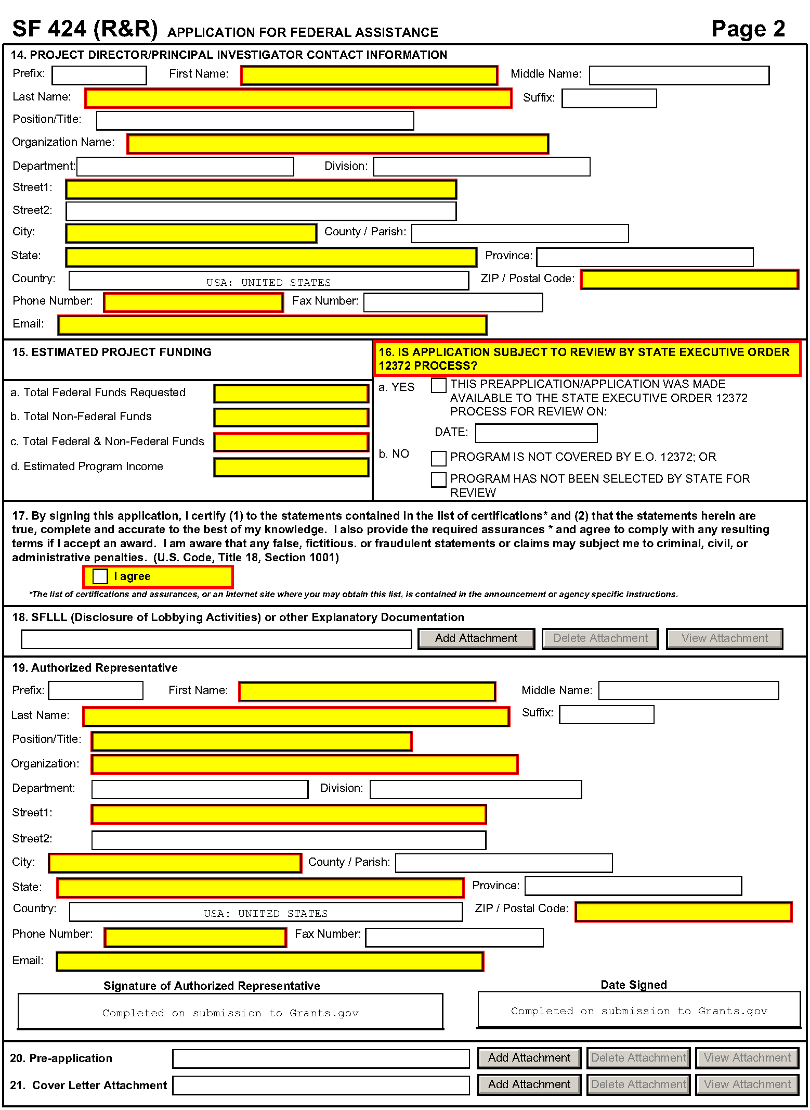
14. Program Director/Principal Investigator (PD/PI) Contact Information
If submitting an application reflecting Multiple PD/PIs, the individual designated as the Contact PI must be affiliated in the Commons with the applicant organization and should be entered here. See Section 4.5 Senior/Key Person Profile Forms for additional instructions for Multiple PD/PIs. To avoid potential errors and delays in processing, please ensure that the information provided in this section is identical to the PD/PI profile information contained in the eRA Commons.
Field Name | Instructions
Prefix | The Project Director/Principal Investigator (PD/PI) is the individual responsible for the overall scientific and technical direction of the project. Enter the prefix (e.g., Mr., Mrs., Rev.) for the name of the PD/PI.
First Name | Enter the first name of the PD/PI. This field is required.
Middle Name | Enter the middle name of the PD/PI.
Last Name | Enter the last (family) name of the PD/PI. This field is required.
Suffix | Enter the suffix (e.g., Jr., Sr., Ph.D) of the PD/PI.  Do not use this field to record degrees. Degrees for the PD/PI are requested separately in the Senior/Key Person Profile.
Position/Title | Enter the position/title of the PD/PI.
Organization Name | Enter the name of organization for the PD/PI. This field is required.
Department | Enter the name of primary organizational department, service, laboratory, or equivalent level within the organization of the PD/PI.
Division | Enter the name of primary organizational division, office, or major subdivision of the PD/PI.
Street1 | Enter first line of the street address for the PD/PI in the “Street1” field. This field is required.
Street2 | Enter the second line of the street address for the PD/PI in the “Street2” field. This field is optional.
City | Enter the City for address of the PD/PI. This field is required.
County/Parish | Enter the county/parish for address of the PD/PI.
State | Enter the State where the PD/PI is located. This field is required if the PD/PI is located in the United States.
Province | Enter the province for PD/PI.  If “Country” is not Canada, please leave blank.
Country | Select the country for the PD/PI address.
ZIP/Postal Code | Enter the Postal Code (e.g., ZIP code) of the PD/PI. This field is required if the PD/PI is located in the United States.  A nine-digit Zip code is required.
Phone Number | Enter the daytime phone number for the PD/PI. This field is required.
Fax Number | Enter the fax number for the PD/PI.
E-mail | Enter the e-mail address for the PD/PI. This field is required.
15. Estimated Project Funding
Field Name | Instructions
a. Total Federal Funds Requested | Enter total Federal funds requested for the entire project period. This field is required.  Please ensure number(s) complies with application requirements.
b. Total Non-Federal Funds | Enter total non-Federal funds proposed for the entire project period. This field is required.  For NIH and other PHS agencies, enter “0” in this field unless cost sharing is a requirement for the specific announcement.
c. Total Federal & Non-Federal Funds | Enter total estimated funds for the entire project period, including both Federal and non-Federal funds. This field is required.  For NIH and other PHS agencies applicants, this field will be the same as Total Federal Funds Requested above unless the specific announcement indicates that cost sharing is a requirement.
d. Estimated Program Income | Identify any Program Income estimated for this project period if applicable. This field is required.
16. Is Application Subject to Review by State Executive Order 12372 Process?
If yes, check box. If the announcement indicates that the program is covered under Executive Order 12372, applicants should contact the State Single Point of Contact (SPOC) for Federal Executive Order 12372. If no, check appropriate box. One selection is required.
If block 16a is checked, insert date application was submitted to State.
For NIH and other PHS agencies submissions using the SF424 (R&R), applicants should check “No, Program is not covered by E.O. 12372.”
17. Certification
Check “I agree” to provide the required certifications and assurances. This field is required.
The list of NIH and other PHS agencies Assurances, Certifications, and other Policies is found in Supplemental Instructions Part III, Policies, Assurances, Definitions, and Other Information.
The applicant organization is responsible for verifying its eligibility and the accuracy, validity, and conformity with the most current institutional guidelines of all the administrative, fiscal, and scientific information in the application, including the Facilities and Administrative rate. Deliberate withholding, falsification, or misrepresentation of information could result in administrative actions, such as withdrawal of an application, suspension and/or termination of an award, debarment of individuals, as well as possible criminal penalties. The signer further certifies that the applicant organization will be accountable both for the appropriate use of any funds awarded and for the performance of the grant-supported project or activities resulting from this application. The grantee institution may be liable for the reimbursement of funds associated with any inappropriate or fraudulent conduct of the project activity.
18. SFLLL (Disclosure of Lobbying Activities) or Other Explanatory Documentation
If applicable, attach the SFLLL or other explanatory document per agency instructions.
If unable to certify compliance in with the Certification above attach an explanation. Additionally, as applicable, attach the SFLLL (Standard Form LLL, Disclosure of Lobbying Activities) or other documents in this item. A fillable version of the SFLLL form is available at http://www.whitehouse.gov/omb/assets/omb/grants/sflllin.pdf.
19. Authorized Representative
This is equivalent to the individual with the organizational authority to sign for an application; otherwise known as the Authorized Organization Representative or the Signing Official.
Field Name | Instructions
Prefix | Enter the prefix (Mr., Mrs., Rev.) for the name of the Authorized Representative.
First Name | Enter the first (given) name of the Authorized Representative. This field is required.
Middle Name | Enter the middle name of the Authorized Representative.
Last Name | Enter the last (family) name of the Authorized Representative. This field is required.
Suffix | Enter the suffix (e.g., Jr., Sr., Ph.D.) for the name of the Authorized Representative.
Position/Title | Enter the title of the Authorized Representative. This field is required.
Organization | Enter the name of the organization for the Authorized Representative. This field is required.
Department | Enter the name of the primary organizational department, service, laboratory, or equivalent level within the organization of the Authorized Representative.
Division | Enter the name of the primary organizational division, office, or major subdivision of the Authorized Representative.
Street1 | Enter the first line of the street address for the Authorized Representative in the “Street1” field. This field is required.
Street2 | Enter the second line of the street address for the Authorized Representative in the “Street2” field. This field is optional.
City | City for address of the Authorized Representative. This field is required.
County/Parish | Enter the county/parish for address of the Authorized Representative.
State | Enter the state where the Authorized Representative is located. This field is required if the Authorized Representative is located in the United States.
Province | Enter the Province for the Authorized Representative.  If “Country” is not Canada, please leave blank.
Country | Select the country for the Authorized Representative address.
ZIP/Postal Code | Enter Postal Code (e.g., ZIP code) of the Authorized Representative. This field is required if the Authorized Representative is located in the United States.  A nine-digit Zip code is required.
Phone Number | Enter the daytime phone number for the Authorized Representative. This field is required.
Fax Number | Enter the fax number for the Authorized Representative.
E-mail | Enter the e-mail address for the Authorized Representative. This field is required.
Signature of Authorized Representative | It is the organization’s responsibility to assure that only properly authorized individuals sign in this capacity and/or submit the application to Grants.gov. If this application is submitted through Grants.gov, leave blank. If a hard copy is submitted, the AOR must sign this block.
Date Signed | If this application is submitted through Grants.gov, the system will generate this date. If submitting a hard copy, enter the date the AOR signed the application.
20. Pre-Application
If submitting a pre-application, provide a summary description of the project in accordance with the announcement and/or agency specific instructions, and save the file in a location you remember. Click Add Attachment, browse to where you saved the file, select the file, and then click Open.
Unless specifically noted in a program announcement, NIH and other PHS agencies do not use Pre-applications.
21. Cover Letter Attachment
Attach the cover letter in accordance with the announcement and/or the agency specific instructions.
Applicants are encouraged to include a cover letter with the application. The cover letter is only for internal use and will not be shared with peer reviewers. The letter should contain any of the following information that applies to the application:
- Application title.
- Funding Opportunity (PA or RFA) title of the NIH initiative.
- Request of an assignment (referral) to a particular awarding component(s) or Scientific Review Group (SRG). The PHS makes the final determination.
- List of individuals (e.g., competitors) who should not review your application and why.
- Disciplines involved, if multidisciplinary.
- For late applications (see Late Application policy in Section 2.14) include specific information about the timing and nature of the cause of the delay.
- When submitting a Changed/Corrected Application after the submission date, a cover letter is required explaining the reason for the Changed/Corrected Application. If you already submitted a cover letter with a previous submission and are now submitting a Changed/Corrected Application, you must include all previous cover letter text in the revised cover letter attachment. The system does not retain any previously submitted cover letters; therefore, you must repeat all information previously submitted in the cover letter as well as any additional information.
- Explanation of any subaward budget components that are not active for all periods of the proposed grant.
- Statement that you have attached any required agency approval documentation for the type of application submitted. This may include approval for applications $500,000 or more, approval for Conference Grant or Cooperative Agreement (R13 or U13), etc.
Suggested Cover Letter Format
The Division of Receipt and Referral (DRR), Center for Scientific Review (CSR) is responsible for assigning applications to ICs and to Scientific Review Groups (SRGs). DRR will be utilizing knowledge management approaches as an adjunct to the work of referral experts as part of an overall plan to shorten the time from submission to review. Analysis has shown that requests made by investigators are a valuable source of information in this process. In order to facilitate the use of these requests in conjunction with knowledge management analysis of the content of the application, applicants are requested to use the following format when assignment requests are contained in a cover letter.
- List one request per line.
- Place Institute/Center (IC) and SRG review requests (if both are made) on separate lines.
- Place positive and negative requests (if both are made) on separate lines.
- Include name of IC or SRG, followed by a dash and the acronym. Do not use parentheses.
- Provide explanations for each request in a separate paragraph.
Examples:
Please assign this application to the following:
Institutes/Centers
National Cancer Institute - NCI
National Institute for Dental and Craniofacial Research – NIDCR
Scientific Review Groups
Molecular Oncogenesis Study Section – MONC
Cancer Etiology Study Section – CE
Please do not assign this application to the following:
Scientific Review Groups
Cancer Genetics Study Section – CG
The reasons for this request are [provide a narrative explanation for the request(s)].

4.3 Project/Performance Site Locations Form
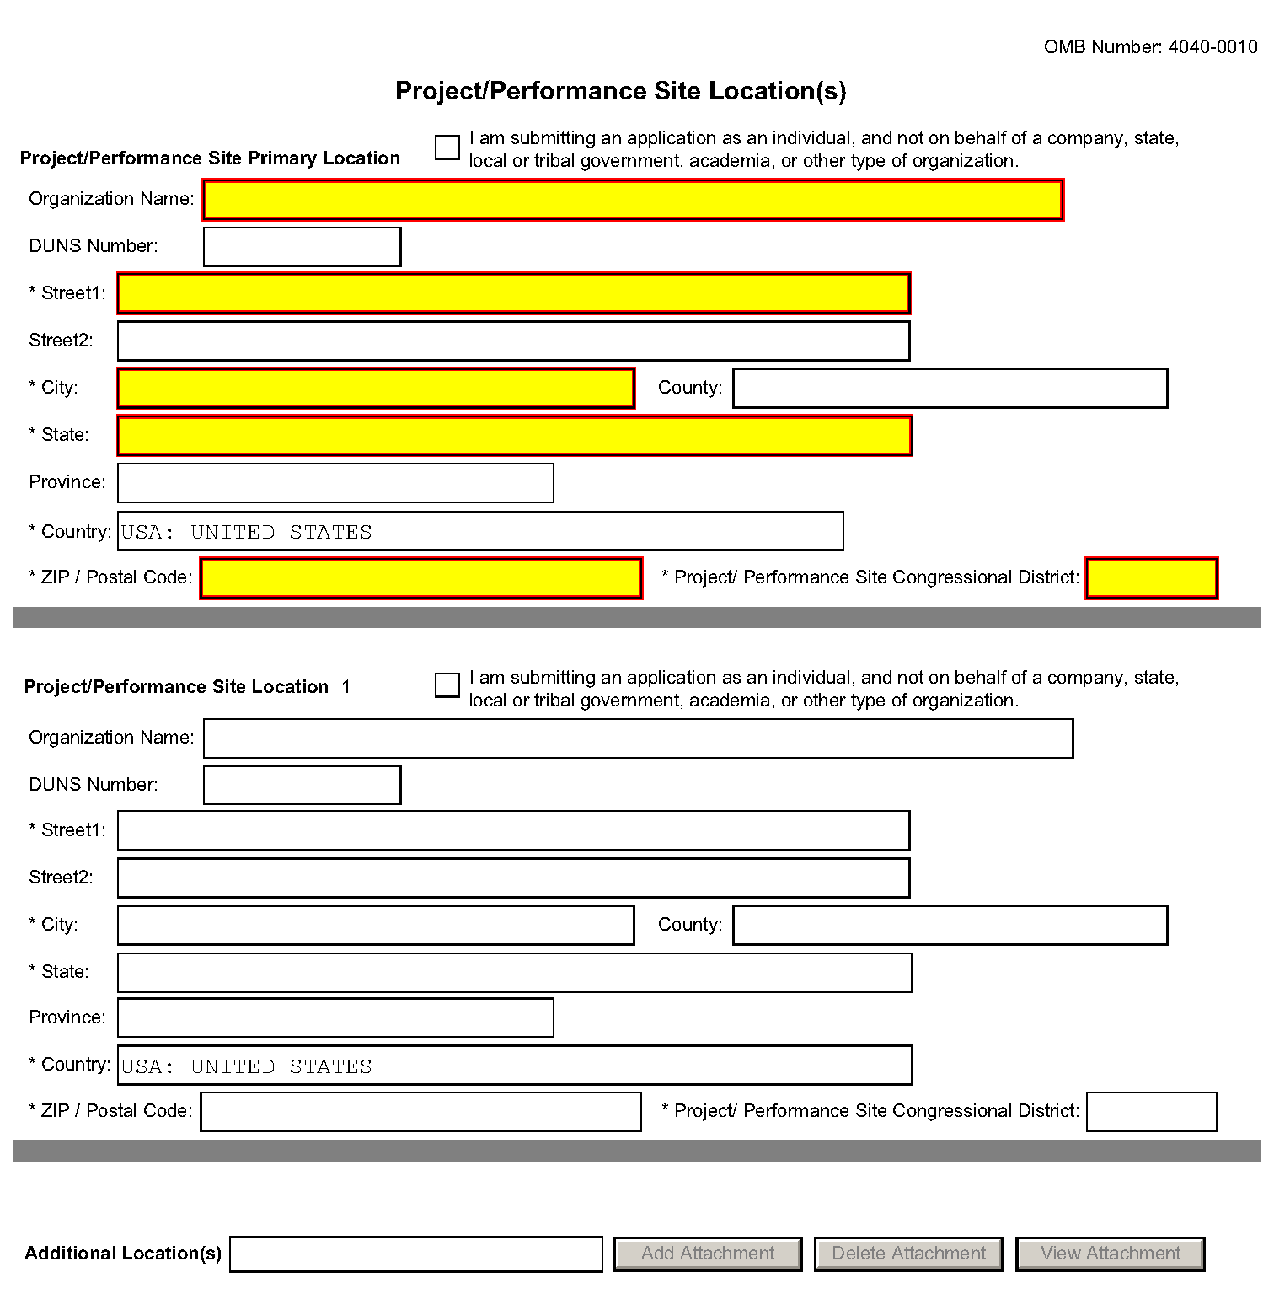
Indicate the primary site where the work will be performed. If a portion of the project will be performed at any other site(s), identify the site location(s) in the blocks provided.
Project/Performance Site Primary Location
Generally, the Primary Location should be that of the applicant organization or identified as off-site in accordance with the conditions of the applicant organization’s negotiated Facilities and Administrative (F&A) agreement. This information must agree with the F&A information on the Cover Page Supplement Form of the application. If there is more than one performance site, including any Department of Veterans Affairs (VA) facilities and foreign sites, list them in the fields provided for Location 1 - # below. Applicants should also provide an explanation of resources available from each Project/Performance Site, the Facilities and Resources attachment of the Other Project Information form, and describe any consortium/contractual arrangements in the Consortium/Contractual Arrangements attachment of the PHS 398 Research Plan.
Unless otherwise instructed in a FOA, do not check the “I am submitting an application as an individual, and not on behalf of a company, state, local or tribal government, academia, or other type of organization” box.
If a Project/Performance Site is engaged in research involving human subjects, the applicant organization is responsible for ensuring that the Project/Performance Site operates under an appropriate Federal Wide Assurance for the protection of human subjects and complies with 45 CFR part 46 and other NIH human subject related policies described in Supplemental Instructions Part II of this Application Guide and in the NIH Grants Policy Statement.
For research involving live vertebrate animals, the applicant organization must ensure that all Project/Performance Sites hold an OLAW-approved Animal Welfare Assurance. If the applicant organization has neither an animal care and use program, facilities to house animals and conduct research on site, nor an IACUC, and the animal work will be conducted at an institution with an Animal Welfare Assurance, the applicant must obtain an Inter-institutional Assurance from OLAW prior to an award.
Field Name | Instructions
Organization Name | Indicate the organization name of the primary site where the work will be performed. If a portion of the project will be performed at any other sites(s), identify the site location(s) in the block(s) provided.
DUNS Number | Enter the DUNS number associated with the organization where the project will be performed.  The DUNS Number is a required field for the Primary Performance Site.
Street1 | Enter first line of the street address in "Street 1" field of the primary performance site location. This field is required.
Street2 | Enter second line of the street address in "Street 2" field for the primary performance site location. This field is optional.
City | Enter the City for address of the primary performance site location. This field is required.
County | Enter the County of the primary performance site location.
State | Enter the State where the primary performance site location is located. This field is required if the Project Performance Site is located in the United States..
Province | Enter the province of the primary performance site location.  If “Country” is not Canada, please leave blank.
Country | Select the Country of the Primary Performance Site location. This field is required.
ZIP Code | Enter the nine-digit Postal Code (e.g., ZIP code) of the performance site location. This field is required if the performance site location is in the United States.  A nine-digit Zip code is required.
Project/Performance Site Congressional District | Enter the Congressional District in the format: 2 character State Abbreviation – 3 character District Number. Examples: CA-005 for California’s 5th district, CA-012 for California’s 12th district.  If all districts in a state are affected, enter “all” for the district number. Example MD-all for all congressional districts in Maryland.  If nationwide (all districts in all states), enter US-all.  If the program/project is outside the U.S., enter 00-000.  To locate your congressional district, visit the Grants.gov website. Note it is likely this field will be identical to the “Congressional District of Applicant” field provided elsewhere in the application.  For States and U.S. territories with only a single congressional district enter “001” for the district code. For jurisdictions with no representative, enter “099”. For jurisdictions with a nonvoting delegate, enter “098” for the district number. Example: DC-098, PR-098.
Project/Performance Site Location 1
Field Name | Instructions
Organization Name | Indicate the organization name of the primary site where the work will be performed. If a portion of the project will be performed at any other sites(s), identify the site location(s) in the block(s) provided.
DUNS Number | Enter the DUNS number associated with the organization where the project will be performed. This field is optional.
Street1 | Enter first line of the street address in "Street 1" field of the primary performance site location. This field is required.
Street2 | Enter second line of the street address in "Street 2" field for the primary performance site location. This field is optional.
City | Enter the City of the performance site location. This field is required.
County | Enter the County of the performance site location.
State | Enter the State where the primary performance site location is located. This field is required if the Project Performance Site is located in the United States.
Province | Enter the Province where the primary performance site location is located.  If “Country” is not Canada, please leave blank.
Country | Select the name of the country for the primary project performance site.
ZIP Code | Enter the nine-digit Postal Code (e.g., ZIP code) of the primary performance site location. This field is required if the Project Performance Site is located in the United States.
Project/Performance Site Congressional District | Enter the Congressional District in the format: 2 character State Abbreviation – 3 character District Number. Examples: CA-005 for California’s 5th district, CA-012 for California’s 12th district.  If all districts in a state are affected, enter “all” for the district number. Example MD-all for all congressional districts in Maryland.  If nationwide (all districts in all states), enter US-all.  If the program/project is outside the U.S., enter 00-000.  To locate your congressional district, visit the Grants.gov website. Note it is likely this field will be identical to the “Congressional District of Applicant” field provided elsewhere in the application.  For States and U.S. territories with only a single congressional district enter “001” for the district code. For jurisdictions with no representative, enter “099”. For jurisdictions with a nonvoting delegate, enter “098” for the district number. Example: DC-098, PR-098.
For additional performance site locations, click Next Site to display the fields for Project/Performance Site Locations 2 through 300.
If you need to add more than 300 locations, enter the information in a separate file. In the Additional Locations section at the bottom of the form, click Add Attachment, select the file, and then click Open. A sample Additional Performance Sites format page for greater than eight locations is found under “Additional Format Pages” at: http://grants.nih.gov/grants/funding/424/index.htm.

4.4 Other Project Information Form
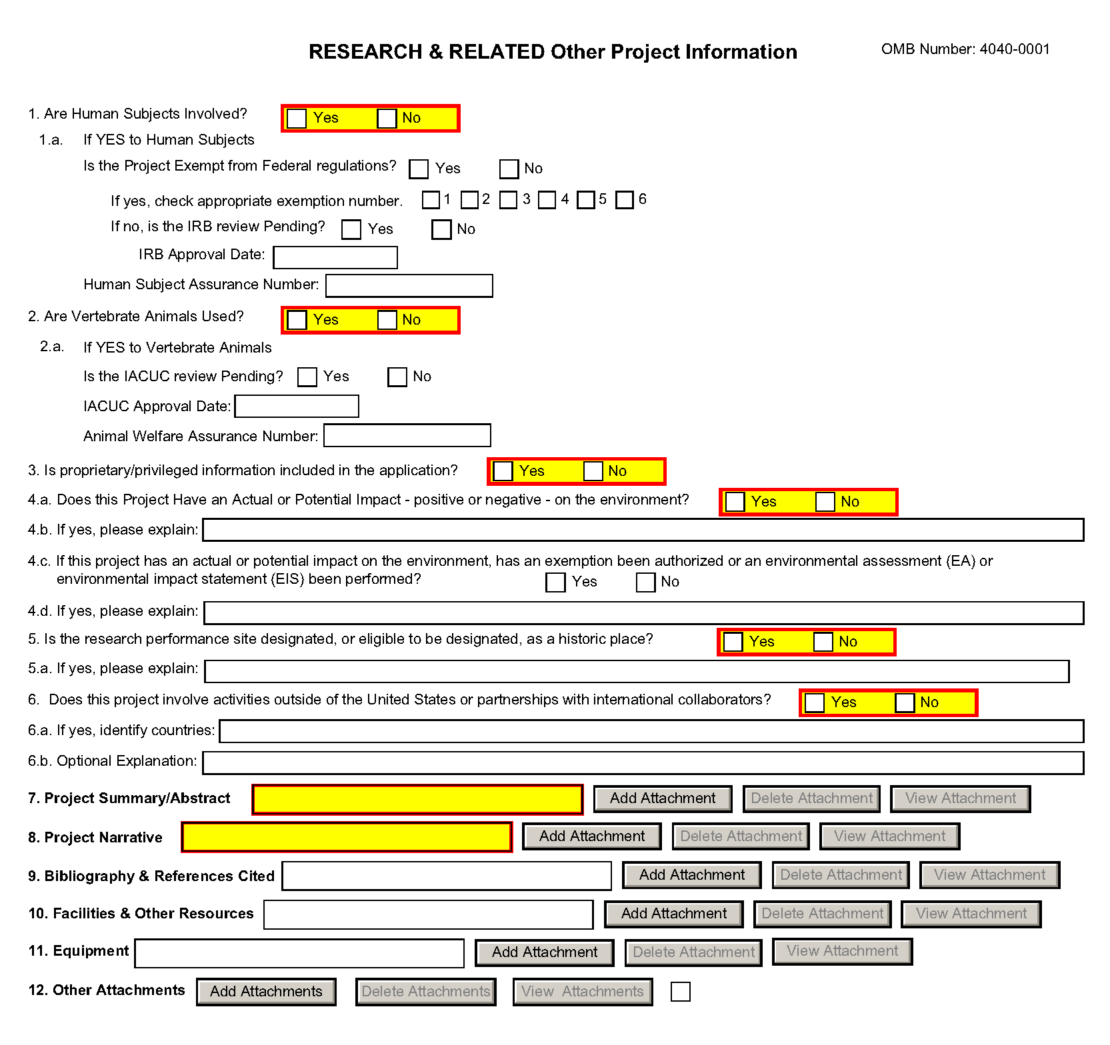
1. Are Human Subjects Involved?
If activities involving human subjects are planned at any time during the proposed project at any performance site, check yes. Check yes even if the proposed project is exempt from Regulations for the Protection of Human Subjects. If no, skip the rest. This field is required.
Applications proposing human subjects research may be required to submit additional information, forms, or attachments with the application, in accordance with NIH and PHS policies covering human subjects research. Refer to Part II, Supplemental Instructions for Preparing the Human Subjects Section of the Research Plan.
1.a. If YES to Human Subjects
Is the Project Exempt from Federal Regulations? Yes/No
Yes: If the project is exempt from Federal regulations, check Yes.
No: If the project is not exempt from Federal regulations, check No.
If yes, check appropriate exemption number 1, 2, 3, 4, 5, 6
Select the appropriate exemption number from 1, 2, 3, 4, 5, 6.
If human subject activities are exempt from Federal regulations, provide the exemption numbers corresponding to one or more of the exemption categories. The six categories of research that qualify for exemption from coverage by the regulations are defined in the Common Rule for the Protection of Human Subjects. These regulations can be found at http://www.hhs.gov/ohrp/humansubjects/guidance/45cfr46.html.
OHRP guidance states that appropriate use of Exemptions described in 45 CFR 46 should be determined by an authority independent from the investigators (http://answers.hhs.gov/ohrp/categories/1564). Institutions often designate their IRB to make this determination. Because NIH does not require IRB approval at the time of application, the exemptions designated often represent the opinion of the PD/PI, and the justification provided for the exemption by the PD/PI is evaluated during peer review.
Proposed research may include more than one research project; thus the application may include individual projects that meet the requirements for non-exempt or exempt human subjects research, or are not defined as human subjects research. Human subjects research should be designated as exempt if all of the proposed research meets the criteria for one or more of the six exemptions.
If no, is the IRB review Pending? Yes/No
If IRB review is pending, check Yes. If IRB review is not pending, check No.
IRB Approval Date
Enter the latest Institutional Review Board (IRB) approval date (if available). Leave blank if Pending.
Applicants should check “Yes” to the question “Is the IRB review Pending?” even if the IRB review/approval process has not yet begun at the time of submission. Also note that an IRB Approval Date is not required at the time of submission. This may be requested later in the pre-award cycle as a Just-In-Time requirement.
Human Subject Assurance Number
Enter the approved Federal Wide Assurance (FWA), Multiple Project Assurance (MPA), Single Project Assurance (SPA) Number or Cooperative Project Assurance Number that the applicant has on file with the Office for Human Research Protections, if available. If the applicant has a FWA number, enter the 8-digit number. Do not enter the FWA before the number.
Insert “None” if the applicant organization does not have an approved assurance on file with OHRP. In this case, the applicant organization, by the signature in the Certification signature section on the SF424 (R&R) Cover form, is declaring that it will comply with 45 CFR part 46 and proceed to obtain a human subjects assurances (see http://www.hhs.gov/ohrp). Do not insert the human subjects assurance number of any collaborating institution in the space provided.
2. Are Vertebrate Animals Used?
If activities involving vertebrate animals are planned at any time during the proposed project at any performance site, check yes. If no, skip the rest of block 2. This field is required.
Note that the generation of custom antibodies constitutes an activity involving vertebrate animals. If animal involvement is anticipated within the period of award but plans are indefinite, check "Yes" and add a Vertebrate Animals attachment to, provide an explanation and indicate when it is anticipated that animals will be used. If an award is made, prior to the involvement of animals the grantee must provide all of the information required by adding a Vertebrate Animals attachment in the Research Plan and verifying of IACUC approval to the awarding component.
2.a. If YES to Vertebrate Animals
Is the IACUC review Pending?
Indicate if an Institutional Animal Care and Use Committee (IACUC) review is pending.
Click Yes if an IACUC review is pending. Click No, if no review is pending.
Check “Yes” even if the IACUC review and approval process has not yet begun.

IACUC Approval Date
Enter the latest IACUC approval date (if available). Leave blank if Pending.
IACUC approval must have been granted within three years to be valid. Note that an IACUC Approval Date is not required at the time of submission. NIH does not require verification of review and approval of the proposed research by the IACUC before peer review of the application. However, this information is required under Just-In-Time Policy.
Animal Welfare Assurance Number
Enter the Federally approved assurance number, if available.
Enter “None” if the applicant organization does not have an OLAW-approved Animal Welfare Assurance. To determine if the applicant organization holds an Animal Welfare Assurance, see the lists of Domestic and Foreign Assured institutions. Do not enter the Animal Welfare Assurance number for a Project/Performance Site of a collaborating institution. When an applicant organization does not have an Animal Welfare Assurance, the Authorized Organization Representative’s signature on the application constitutes declaration that the applicant organization will submit an Animal Welfare Assurance when requested by OLAW.
3. Is proprietary/privileged information included in the application?
Patentable ideas, trade secrets, privileged or confidential commercial or financial information, disclosure of which may harm the applicant, should be included in applications only when such information is necessary to convey an understanding of the proposed project. If the application includes such information, check yes and clearly mark each line or paragraph on the pages containing the proprietary/privileged information with a legend similar to: "The following contains proprietary/privileged information that (name of applicant) requests not be released to persons outside the Government, except for purposes of review and evaluation. " This field is required.
If a grant is awarded as a result of or in connection with the submission of this application, the Government shall have the right to use or disclose the information to the extent authorized by law. Although the grantee institution and the PD/PI will be consulted about any such disclosure, the PHS will make the final determination. Any indication by the applicant that the application contains proprietary or privileged information does not automatically shield the information from release in response to a Freedom of Information Act (FOIA) request should the application result in an award (see 45 CFR Part 5). If an applicant fails to identify proprietary information at the time of submission as instructed in the application guide, a significant substantive justification will be required to withhold the information if requested under FOIA.
4. Environmental Questions
Most NIH research grants are not expected to individually or cumulatively have a significant effect on the environment, and NIH has established several categorical exclusions allowing most applicants to answer “No” to this question unless a specific FOA indicates that the National Environmental Policy Act (NEPA) applies. However, if an applicant expects that the proposed project will have an actual or potential impact on the environment, or if any part of the proposed research and/or project includes one or more of the following categorical exclusions listed below, the box marked “Yes” should be checked and an explanation provided.
1. The potential environmental impacts of the proposed research may be of greater scope or size than other actions included within a category.
2. The proposed research threatens to violate a Federal, State, or local law established for the protection of the environment or for public health and safety.
3. Potential effects of the proposed research are unique or highly uncertain.
4. Use of especially hazardous substances or processes is proposed for which adequate and accepted controls and safeguards are unknown or not available.
5. The proposed research may overload existing waste treatment plants due to new loads (volume, chemicals, toxicity, additional hazardous wasted, etc.)
6. The proposed research may have a possible impact on endangered or threatened species.
7. The proposed research may introduce new sources of hazardous/toxic wastes or require storage of wastes pending new technology for safe disposal.
8. The proposed research may introduce new sources of radiation or radioactive materials.
9. Substantial and reasonable controversy exists about the environmental effects of the proposed research.
4.a. Does the project have an actual or perceived impact—positive or negative—on the environment?
Indicate if this project has an actual or perceived impact on the environment? Click No here if this is not the case. This field is required.
4.b. If yes, please explain
Explanation of the actual or perceived impact - positive or negative - on the environment.
4.c. If this project has an actual or perceived impact on the environment, has an exemption been authorized or an Environmental Assessment (EA) or an Environmental Impact Statement (EIS) been performed?
Check yes or no. This field is required.
4.d. If yes, please explain
Enter additional details about the EA or EIS.
5. Is the research performance site designated, or eligible to be designated, as a historic place? Yes/No
If any research performance site is designated, or eligible to be designated, as a historic place, if Yes, check the Yes box and then provide an explanation in the box provided in 5.a. Otherwise, check the No box. This field is required.
5.a. If yes, please explain:
If you checked the Yes box indicating any performance site is designated, or eligible to be designated, as a historic place, provide the explanation here.
6. Does this project involve activities outside of the United States or partnerships with International Collaborators?
Indicate whether this project involves activities outside of the United States or partnerships with international collaborators. Check yes or no. This field is required.
Applicants to NIH and other PHS agencies must check “Yes” if the applicant organization is a foreign institution or if the project includes a foreign component. For a definition of a foreign component, see “Definitions” section of Supplemental Instructions Part III: Policies, Assurances, Definitions, and Other Information.
6.a. If yes, identify countries
Enter the countries with which international cooperative activities are involved.
6.b. Optional Explanation
Enter an explanation for involvement with outside entities (optional).
If you have checked “Yes” to 6, applicants to the NIH and other PHS agencies must describe special resources or characteristics of the research project (e.g., human subjects, animals, disease, equipment, and techniques), whether similar research is being done in the United States and whether there is a need for additional research in this area. Provide this information in a separate file, attaching it on the Other Project Information form. In the body of the text, begin the section with a heading indicating “Foreign Justification.” When saving this file, please name it “Foreign Justification” as well.
7. Project Summary/Abstract
The Project Summary must contain a summary of the proposed activity suitable for dissemination to the public. It should be a self-contained description of the project and should contain a statement of objectives and methods to be employed. It should be informative to other persons working in the same or related fields and insofar as possible understandable to a scientifically or technically literate lay reader. This Summary must not include any proprietary/confidential information. Please click the Add Attachment button to the right of this field to complete this entry.
The Project Summary is meant to serve as a succinct and accurate description of the proposed work when separated from the application. State the application’s broad, long-term objectives and specific aims, making reference to the health relatedness of the project (i.e., relevance to the mission of the agency). Describe concisely the research design and methods for achieving the stated goals. This section should be informative to other persons working in the same or related fields and insofar as possible understandable to a scientifically or technically literate reader. Avoid describing past accomplishments and the use of the first person. Finally, please make every effort to be succinct. This section must be no longer than 30 lines of text, and follow the required font and margin specifications. An abstract which exceeds this allowable length may be flagged as an error by the agency upon submission. This would require a corrective action before the application will be accepted.
As noted above, do not include proprietary, confidential information or trade secrets in the description section. If the application is funded, the Project Description will be entered into an NIH database and made available on the NIH Research Portfolio Online Reporting Tool (RePORT, available at http://report.nih.gov) and will become public information.
The attachment must be in PDF format. (See Section 2.6 for additional information on preparing attachments.)
8. Project Narrative
Provide Project Narrative in accordance with the announcement and/or agency-specific instructions. Please click the Add Attachment button to the right of this field to complete this entry.
For NIH and other PHS agencies applications, using no more than two or three sentences, describe the relevance of this research to public health. In this section, be succinct and use plain language that can be understood by a general, lay audience.
A separate Research Plan form is required for NIH and other PHS agencies applications. Refer to Section 5.5, Research Plan Form, for separate file uploads and instructions.
9. Bibliography & References Cited
Provide a bibliography of any references cited in the Project Narrative. Each reference must include the names of all authors (in the same sequence in which they appear in the publication), the article and journal title, book title, volume number, page numbers, and year of publication. Include only bibliographic citations. Applicants should be especially careful to follow scholarly practices in providing citations for source materials relied upon when preparing any section of the application. To attach a document for Bibliography and References Cited, click Add Attachment.
Unless otherwise noted in an FOA, this section is required for submissions to NIH and other PHS agencies. This section (formerly “Literature Cited”) should include any references cited in the PHS 398 Research Plan form (see Section 5.5 for details on completing that form). When citing articles that fall under the Public Access Policy, were authored or co-authored by the applicant and arose from NIH support, provide the NIH Manuscript Submission reference number (e.g., NIHMS97531) or the PubMed Central (PMC) reference number (e.g., PMCID234567) for each article. If the PMCID is not yet available because the Journal submits articles directly to PMC on behalf of their authors, indicate “PMC Journal – In Process.” A list of these journals is posted at: http://publicaccess.nih.gov/submit_process_journals.htm.
Citations that are not covered by the Public Access Policy, but are publicly available in a free, online format may include URLs or PubMed ID (PMID) numbers along with the full reference (note that copies of publicly available publications are not accepted as appendix material). The references should be limited to relevant and current literature. While there is not a page limitation, it is important to be concise and to select only those literature references pertinent to the proposed research.
10. Facilities & Other Resources
This information is used to assess the capability of the organizational resources available to perform the effort proposed. Identify the facilities to be used (Laboratory, Animal, Computer, Office, Clinical and Other). If appropriate, indicate their capacities, pertinent capabilities, relative proximity and extent of availability to the project. Describe only those resources that are directly applicable to the proposed work. Provide any information describing the Other Resources available to the project (e.g., machine shop, electronic shop) and the extent to which they would be available to the project. Please click the Add Attachment button to the right of this field to complete this entry.
No special form is required but this section must be completed and attached for submissions to NIH and other PHS agencies unless otherwise noted in an FOA. Describe how the scientific environment in which the research will be done contributes to the probability of success (e.g., institutional support, physical resources, and intellectual rapport). In describing the scientific environment in which the work will be done, discuss ways in which the proposed studies will benefit from unique features of the scientific environment or subject populations or will employ useful collaborative arrangements.
For Early Stage Investigators (ESIs), describe institutional investment in the success of the investigator, e.g., resources for classes, travel, training; collegial support such as career enrichment programs, assistance and guidance in the supervision of trainees involved with the ESI’s project, and availability of organized peer groups; logistical support such as administrative management and oversight and best practices training; and financial support such as protected time for research with salary support. See, http://grants.nih.gov/grants/new_investigators/.
If there are multiple performance sites, describe the resources available at each site.
Describe any special facilities used for working with biohazards or other potentially dangerous substances. Note: Information about select agents must be described in the Research Plan, Section 11 (Select Agent Research).
11. Equipment
List major items of equipment already available for this project and, if appropriate identify location and pertinent capabilities. Please click the Add Attachment button to the right of this field to complete this entry.
12. Other Attachments
Attach a file only to provide any other project information not provided above or in accordance with the announcement and/or agency-specific instruction.

4.5 Senior/Key Person Profile (Expanded) Form
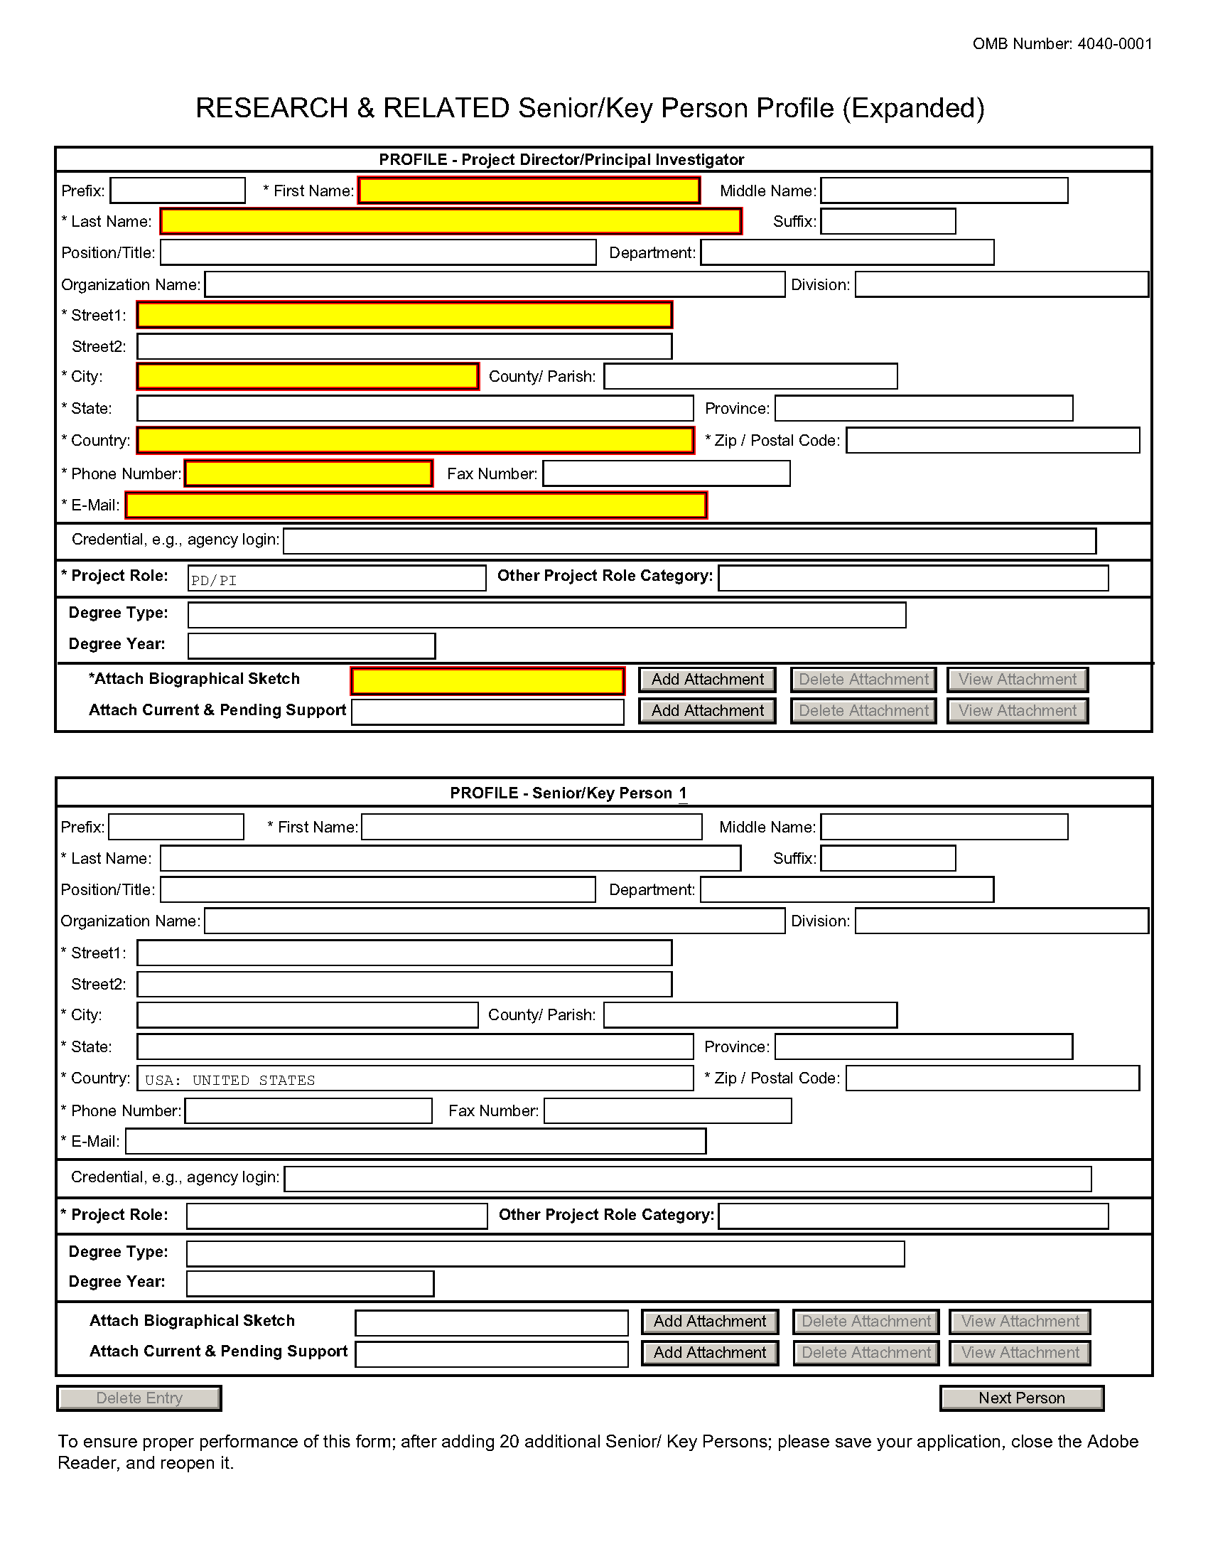
This form provides the ability to collect structured data for up to 100 senior/key persons. Data must be entered for the first 100 individuals (PD/PI + 99 others) before the Additional Senior/Key Person Form Attachments section becomes available. The information for the PD/PI continues to be pre-populated from the SF424 (R&R) Cover form. See instructions in section 4.2 Cover Form if these fields are empty. Unless otherwise specified in an agency announcement, senior/key personnel are defined as all individuals who contribute in a substantive, meaningful way to the scientific development or execution of the project, whether or not salaries are requested. Consultants should be included if they meet this definition.
Multiple PD/PIs
NIH is now accepting applications reflecting Multiple PD/PIs for all grant activity codes using the SF424 (R&R) application. When submitting an application involving Multiple PD/PIs, the Contact PD/PI must be affiliated in the Commons with the applicant organization and should be listed as the PD/PI in the SF424 R&R Cover Form (see Section 4.2.14). That information automatically prepopulates the first senior/key person profile record in this form. For the additional PD/PIs, complete all the requested information. Each PD/PI must be assigned the PD/PI role, even those at subaward/consortium sites when applicable. (Do not use the “Co-PD/PI” or Co-Investigator role.) For more information, please see Section 4.8 Special Instructions for Preparing Applications with a Subaward/Consortium.
Each PD/PI must also be registered in the eRA Commons and must be assigned the PI Role in that system (note other roles such as SO or IAR will not give PD/PIs the appropriate access to the application records). Each PD/PI must include their respective eRA Commons ID in the Credential field. For more information on NIH Implementation of Multiple PD/PIs, see: http://grants.nih.gov/grants/multi_pi/index.htm.
When completing the detailed budget form for either the prime organization or a subaward/consortium organization, the project roles listed in the budget form should be consistent with those used in the Senior/Key Person Form.
Profile – Program Director/Principal Investigator (PD/PI)
Field Name | Instructions
Prefix | Pre-populated from the SF 424 (R&R). The prefix (e.g., Mr., Mrs., Rev.) for the name of the PD/PI.
First Name | Pre-populated from the SF 424 (R&R). The first (given) name of the PD/PI. This field is required.
Middle Name | Pre-populated from the SF 424 (R&R). The middle name of the PD/PI.
Last Name | Pre-populated from the SF 424 (R&R). The last (family) name of the PD/PI. This field is required.
Suffix | Pre-populated from the SF 424 (R&R). The suffix (e.g., Jr, Sr, PhD) for the name of the PD/PI.
Position/Title | Pre-populated from the SF 424 (R&R). The title of the PD/PI.
Department | Pre-populated from the SF 424 (R&R). The name of primary organizational department, service, laboratory, or equivalent level within the organization of the PD/PI.
Organization Name | Pre-populated from the SF 424 (R&R). The name of organization of the PD/PI.
Division | Pre-populated from the SF 424 (R&R). The name of primary organizational division, office, or major subdivision of the PD/PI.
Street1 | Pre-populated from the SF 424 (R&R). The first line of the street address for the PD/PI in the "Street 1" field. This field is required.
Street2 | Pre-populated from the SF 424 (R&R). The second line of the street address for the PD/PI in the "Street 2" field. This field is optional.
City | Pre-populated from the SF 424 (R&R). The city for address of PD/PI. This field is required.
County/Parish | Pre-populated from the SF 424 (R&R). The county/parish for address of PD/PI.
State | Pre-populated from the SF 424 (R&R). The state where the PD/PI is located. This field is required if the PD/PI is located in the United States.
Province | Pre-populated from the SF 424 (R&R). The Province where the PD/PI is located.  If “Country” is not Canada, this will be blank.
Country | Pre-populated from the SF 424 (R&R). The country for the PD/PI address. This field is required.
ZIP Code | Pre-populated from the SF 424 (R&R). The postal Code (e.g., ZIP code) of PD/PI. This field is required if the PD/PI is located in the United States.  A nine-digit Zip code is required.
Phone Number | Pre-populated from the SF 424 (R&R). The daytime phone number for the PD/PI. This field is required.
Fax Number | Pre-populated from the SF 424 (R&R). The fax number for the PD/PI.
E-mail | Pre-populated from the SF 424 (R&R). The e-mail address for the PD/PI. This field is required for PD/PI.
Credential, e.g., agency login | If you are submitting to an agency (e.g., NIH) where you have an established personal profile, enter the agency ID. If not, leave blank.  For NIH and other PHS agencies, registration in the eRA Commons for all PD/PIs is required. The assigned Commons UserName (the unique name used to log into the system) for anyone assigned the PD/PI role must be entered here and must have the PI role in eRA Commons. This is a required field for applications submitted to NIH and other PHS agencies. Applications will not pass agency validation requirements without this field.
Project Role | Select one. Use "Other" if a category is not listed in the pick list.  Select PD/PI for this person.
Other Project Role Category | Complete if you selected “Other Professional” or “Other” as a project role; e.g., Engineer, Chemist.
Degree Type | Enter the highest academic or professional degree or other credentials (e.g., R.N.). This is optional information.
Degree Year | Enter the year the highest degree or other credential was obtained. This is optional information.
Attach Biographical Sketch | Provide a biographical sketch for the senior/key person. Recommended information includes: Education and Training, Research and Professional Experience, Collaborators and Affiliations (for conflicts of interest), Publications and Synergistic Activities. Save the information in a single file and attach here. This is required information.  Biographical sketches should follow the format described below.
Attach Current & Pending Support | Provide a list of all current and pending support for the PD/PI (even if they receive no salary support from the project(s)) for ongoing projects and pending applications. Show the total award amount for the entire award period (including indirect costs) as well as the number of person-months per year to be devoted to the project by the senior/key person, regardless of source of support. Concurrent submission of an application to other organizations for simultaneous consideration will not prejudice its review.  Unless otherwise required in a specific FOA, do not use this attachment upload for NIH and other PHS agency submissions. This information is no longer required at the time of application submission. This information may be requested later in the pre-award cycle. When this occurs, you will be instructed to refer to Other Support in Supplemental Instructions Part III, Policies, Assurances, Definitions and Other Information.
Profile – Senior/Key Person [n]
The remaining senior/key person profiles should be listed in alphabetical order. While alphabetical order is preferred, it is not required. However, be aware that these profiles will appear in the application in the order provided by the applicant. Therefore, peer reviewers will see them in the order presented. Those with a postdoctoral role should be included if they meet the definition of senior/key personnel. Also use this section to list any Other Significant Contributors (OSCs). OSCs should be listed after all senior/key persons. OSCs are individuals who have committed to contribute to the scientific development or execution of the project, but are not committing any specified measurable effort (in person months) to the project. These individuals are typically presented at “effort of zero person months” or “as needed” (individuals with measurable effort cannot be listed as Other Significant Contributors). Consultants should be included if they meet this definition.
A biosketch, including Research Support information, will be required for these individuals as this highlights their accomplishments as scientists. Reviewers use these pages to address the “investigator” review criterion. However, if an award is to be made, Other Support information will not be required or accepted since considerations of overlap do not apply to these individuals.
Should the level of involvement change for an individual listed as an OSC, the individual should be redesignated as “senior/key personnel.” This change should be made before any compensation is charged to the project.
After providing data for each individual senior/key person, click the Next Person button at the bottom of the form to enter data for the next senior/key person. Continue in this manner until data has been provided for up to 100 senior/key persons. To ensure proper performance of this form, after adding 20 additional senior/key persons please save your application, close the Adobe reader, and reopen it. For applications involving more than 100 senior/key persons, the “Additional Senior/Key Person Profiles” fields will become available once data for the first 100 senior/key persons has been provided.
Field Name | Instructions
Prefix | Enter the prefix (e.g., Mr., Mrs., Rev.) for the name of the Senior/Key Person.
First Name | Enter the first (given) name of the Senior/Key Person. This field is required.
Middle Name | Enter the middle name of the Senior/Key Person, if applicable.
Last Name | Enter the last (family) name of the Senior/Key Person. This field is required.
Suffix | Enter the suffix (e.g., Jr., Sr., Ph.D.) for the name of the Senior/Key Person.
Position/Title | Enter the title of the Senior/Key Person.
Department | Enter the name of primary organizational department, service, laboratory, or equivalent level within the organization of the Senior/Key Person.
Organization Name | Enter the name of organization of the Senior/Key Person.  This is a required field for applications submitted to NIH and other PHS agencies.
Division | Enter the name of primary organizational division, office, or major subdivision of the Senior/Key Person.
Street1 | Enter first line of the street address for the Senior/Key Person in the "Street 1" field. This field is required.
Street2 | Enter second line of the street address for the Senior/Key Person in the "Street 2" field. This field is optional.
City | City for address of Senior/Key Person. This field is required
County/Parish | County/ Parish for address of Senior/Key Person.
State | Enter the State where the Senior/Key Person is located. This field is required if the senior/key person is located in the United States.
Province | Enter the Province where the Senior/Key Person is located.  If “Country” is not Canada, please leave blank.
Country | Select the country for the Senior/Key Person address. This field is required.
ZIP Code | Enter the Postal Code (e.g., ZIP code) of Senior/Key Person. This field is required if the Senior/Key Person is located in the United States.  A nine-digit Zip code is required.
Phone Number | Enter the daytime telephone number for the Senior/Key Person. This field is required.
Fax Number | Enter the fax number for the Senior/Key Person.
E-mail | Enter the e-mail address for the Senior/Key Person. This field is required for the Senior/Key Person.
Credential, e.g., agency login | If you are submitting to an agency (e.g., NIH) where you have an established personal profile, enter the agency ID. If not, leave blank.  For NIH and other PHS agencies, registration in the eRA Commons for all PD/PIs is required. The assigned Commons UserName (the unique name used to log into the system) for anyone assigned the PD/PI role must be entered here and must have the PI role in eRA Commons. This is a required field for applications submitted to NIH and other PHS agencies. Applications will not pass agency validation requirements without this field.  Note for applications reflecting Multiple PD/PIs, the Commons UserName must be provided for all individuals assigned the PD/PI Role on the application.
Project Role | Select one. Use "Other" if a category is not listed in the pick list.  For applications reflecting Multiple PD/PIs, all such individuals must be assigned the PD/PI role, even those at organizations other than the applicant organization. The role of “Co-PD/PI” is not currently used by NIH and other PHS agencies. Assigning an individual(s) the role of "Co-PD/PI" will not identify the application as a Multiple PD/PI application. If applicants wish to use a different role, select “Other” for the Project Role field and then insert the appropriate role descriptor in the Other Project Role Category field.  If including individuals classified as “Other Significant Contributors (OSCs),” use the “Other” category and indicate “Other Significant Contributor” as the role in the “Other Project Role Category.” OSCs should be listed last after all other senior/key persons have been listed.
Other Project Role Category | Complete if you selected “Other Professional” or “Other” as a project role; e.g., Engineer, Chemist.
Degree Type | Enter the highest academic or professional degree or other credentials (e.g., R.N.). This is optional information.
Degree Year | Enter the year the highest degree or other credential was obtained. This is optional information.  Applicants should ensure that their degree information is current in their Commons Profile.
Attach Biographical Sketch | Provide a biographical sketch for the Senior/Key Person. Recommended information includes: Education and Training, Research and Professional Experience, Collaborators and Affiliations (for conflicts of interest), Publications and Synergistic Activities. Save the information in a single file and attach here. This field is required.  Biographical sketches should follow the format described below.
Attach Current & Pending Support | Provide a list of all current and pending support for the senior/key person (even if they receive no salary support from the project(s)) for ongoing projects and pending proposals. Show the total award amount for the entire award period (including indirect costs) as well as the number of person-months per year to be devoted to the project by the senior/key person, regardless of source of support. Concurrent submission of a proposal to other organizations will not prejudice its review.  Unless otherwise required in a specific FOA, do not use this attachment upload for NIH and other PHS agency submissions. This information is no longer required at the time of application submission. This information may be requested later in the pre-award cycle. When this occurs, refer to Other Support in Supplemental Instructions Part III, Policies, Assurances, Definitions, and Other Information.
Additional Senior/Key Person Profile(s)
If more than 99 senior/key person profiles are proposed, enter the information in a separate file and attach it here.
A sample Additional Senior/Key Person Profiles format page for greater than 100 profiles is found under “Additional Format Pages” at: http://grants.nih.gov/grants/funding/424/index.htm.
Additional Biographical Sketch(es) (Senior/Key Person)
Provide a biographical sketch for each senior/key person. Recommended information includes: Education and Training, Research and Professional Experience, Collaborators and Affiliations (for conflicts of interest), Publications and Synergistic Activities. Save the information in a single file and attach here.
Biographical Sketches should follow the format described below.

Additional Current and Pending Support(s)
Provide a list of all current and pending support for the PD/PI and each senior/key person (even if they receive no salary support from the project(s) for ongoing projects and pending proposals). Show the total award amount for the entire award period (including indirect costs) as well as the number of person months per year to be devoted to the project by the senior/key person, regardless of source of support. Concurrent submission of a proposal to other organizations will not prejudice its review.
Unless otherwise required in a specific FOA, do not use this attachment upload for NIH and other PHS agency submissions. This information is no longer required at the time of application submission. This information may be requested later in the pre-award cycle. When this occurs, refer to Other Support in Supplemental Instructions Part III, Policies, Assurances, Definitions, and Other Information.
Additional NIH and Other PHS Agencies Instructions for a Biographical Sketch
Use the sample format on the Biographical Sketch Format Page to prepare this section for all (modular and other) grant applications. Include biographical sketches of all senior/key personnel and Other Significant Contributors. The Biographical Sketch may not exceed four pages per person. This 4-page limit includes the table at the top of the first page. See the sample of a completed Biographical Sketch. If the individual is registered in the eRA Commons, include the Commons User Name. This data item is required for the PD/PI but is currently optional for all other senior/key persons. In other federal forms this information is referred to as “Credential, e.g., agency login.” For information on the eRA Commons, see https://commons.era.nih.gov/commons/index.jsp.
Complete the educational block at the top of the format page beginning with baccalaureate or other initial professional education, such as nursing, and include postdoctoral training, separately referencing residency training when applicable. For each entry provide the name and location of the institution; the degree received (if applicable); the month and year the degree was received, and the field of study. For residency entries, the field of study section should reflect the area of residency.
Following the educational block, complete sections A, B, C, and D as described below.
A. Personal Statement. Briefly describe why your experience and qualifications make you particularly well-suited for your role (e.g., PD/PI, mentor, participating faculty) in the project that is the subject of the application. Within this section you may, if you choose, briefly describe factors such as family care responsibilities, illness, disability, and active duty military service that may have affected your scientific advancement or productivity.
B. Positions and Honors. List in chronological order previous positions, concluding with your present position. List any honors. Include present membership on any Federal Government public advisory committee.
C. Selected Peer-reviewed Publication and Patent Citations. NIH encourages applicants to limit the list of selected peer-reviewed publications, manuscripts in press, and patent citations to no more than 15. Do not include manuscripts submitted or in preparation. The individual may choose to include selected publications based on recency, importance to the field, and/or relevance to the proposed research. When citing articles that fall under the Public Access Policy, were authored or co-authored by the applicant and arose from NIH support, provide the NIH Manuscript Submission reference number (e.g., NIHMS97531) or the PubMed Central (PMC) reference number (e.g., PMCID234567) for each article. If the PMCID is not yet available because the Journal submits articles directly to PMC on behalf of their authors, indicate “PMC Journal – In Process.” A list of these journals is posted at: http://publicaccess.nih.gov/submit_process_journals.htm. Citations that are not covered by the Public Access Policy, but are publicly available in a free, online format may include URLs or PubMed ID (PMID) numbers along with the full reference (note that copies of publicly available publications are not acceptable as appendix material).
D. Research Support. List both selected ongoing and completed (during the last three years) research projects (Federal or non-Federal support). Begin with the projects that are most relevant to the research proposed in this application. Briefly indicate the overall goals of the projects and responsibilities of the senior/key person identified on the Biographical Sketch. Do not include number of person months or direct costs.
Don’t confuse “Research Support” with “Other Support.” Though they sound similar, these parts of the application are very different. As part of the biosketch section of the application, “Research Support” highlights your accomplishments, and those of your colleagues, as scientists. This information will be used by the reviewers in the assessment of each individual’s qualifications for a specific role in the proposed project, as well as to evaluate the overall qualifications of the research team. In contrast, “Other Support” information is required for all applications that are selected to receive grant awards. NIH staff will request complete and up-to-date “other support” information from you after peer review. This information will be used to check that the proposed research has not already been Federally-funded.

4.6 Selecting the Appropriate Budget Form
The application forms package associated with most NIH funding opportunities includes two optional budget forms—(1) R&R Budget Form; and, (2) PHS 398 Modular Budget Form. NIH applications will include either the R&R Budget Form or the PHS 398 Modular Budget Form, but not both. (Note AHRQ does not accept modular budgets.)
To determine which budget form to use for NIH applications, consult the modular budget and foreign grantee guidelines below. Additional guidance may also be provided in the specific funding opportunity announcement.
Modular Budget Guidelines. Modular budgets are applicable to certain research grant applications requesting $250,000 or less per year for direct costs. Note, consortium/contractual F&A costs are not factored into the direct cost limit. Consortium F&A costs may be requested in addition to the $250,000 limit. Modular budgets are simplified; therefore, detailed categorical information is not to be submitted with the application. The modular budget is applicable only to applications for R01, R03, R15, R21, and R34 and their corresponding cooperative agreement activity codes.
Instructions for completing a Modular Budget Form can be found in Section 5.4. Instructions for completing the R&R Budget Form are provided in the next section.
Foreign Grantee Budget Guidelines. All competing (new, renewal, resubmission, and revision) grant applications from foreign (non-U.S.) institutions must include only detailed (non-modular) budgets. For additional information, see NIH Guide Notice NOT-OD-06-096, http://grants.nih.gov/grants/guide/notice-files/NOT-OD-06-096.html.
Applications from foreign (non-U.S.) institutions submitted via Grants.gov must follow the Research & Related Budget Form instructions and must complete and submit the Research & Related Budget forms. Applications from foreign organizations must request budgets in U.S. dollars.

4.7 R&R Budget Form
The R&R Budget form includes three separate data entry screens: (1) Sections A and B; (2) Sections C through E; and (3) Sections F through K. To navigate between the various screens, use the Previous and Next buttons at the top of the form or use the scroll bar on the side of the screen. Complete the R&R Budget form following the instructions provided. You must complete a separate detailed budget for each year of support requested. The form will generate a cumulative budget for the total project period. You must complete all the required information (i.e., those fields that are highlighted and outlined in red) before the Next Period button is activated. If no funds are requested for a required field, enter “0.”
While the dollar fields allow cents to be entered, all dollar fields should be presented in whole numbers. Please round to the nearest whole number.
NIH and other PHS agencies use the concept of person months as a metric for determining percent of effort. To assist applicants unfamiliar with this concept, resources are available on the web at: http://grants.nih.gov/grants/policy/person_months_faqs.htm. Frequently asked questions and a conversion calculator are available.
If funds are being requested for more than one budget period, click the Next Period button at the top of the third budget screen (Sections F through K) to navigate to screens for the next budget period.
Revision (Supplemental) Application. For a “Revision” (Supplemental) application, show only those items for which additional funds are requested. If the initial budget period of the supplementation application is less than 12 months, prorate the personnel costs and other appropriate items of the detailed budget.

4.7.1 Section A and B
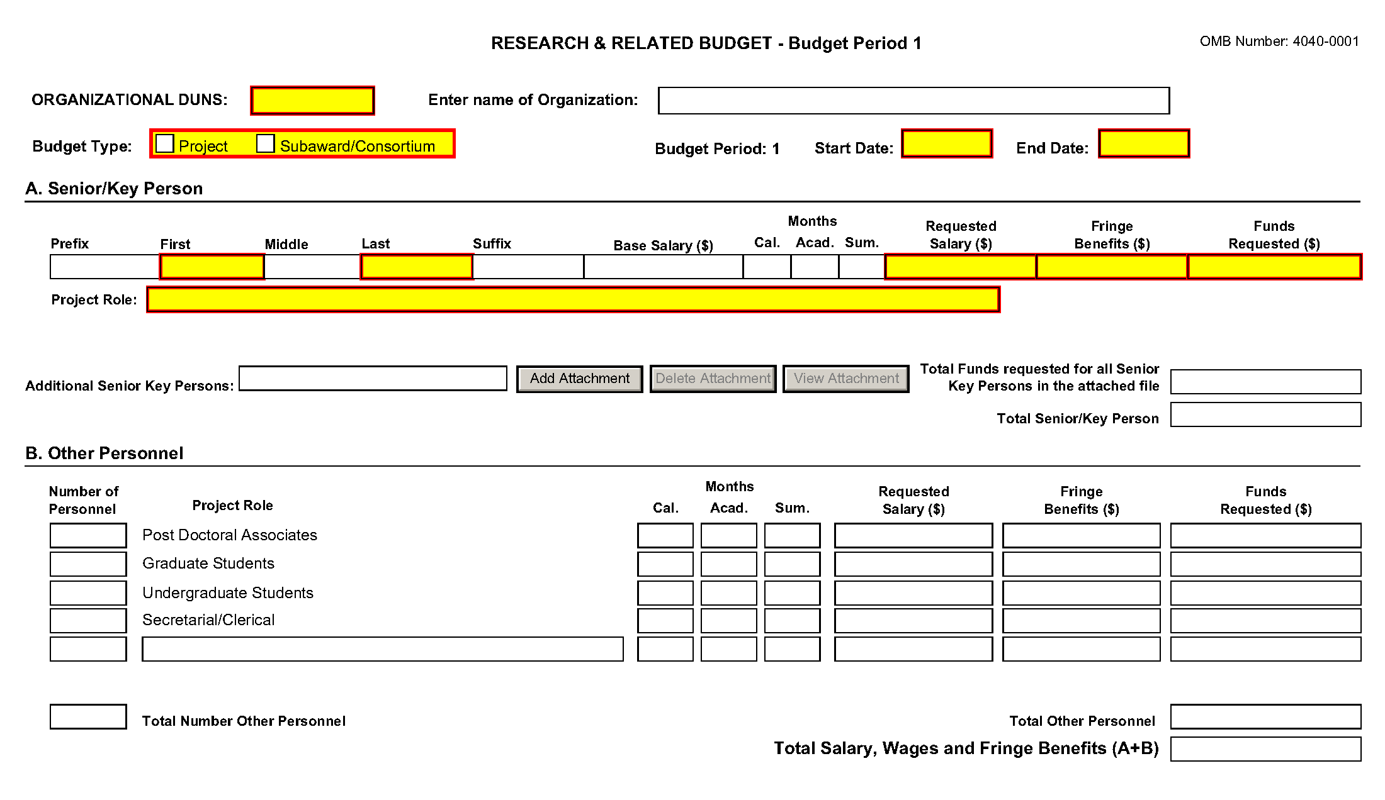
Organizational DUNS
Enter the DUNS or DUNS+4 number of the applicant organization. For project applicant, this field is pre-populated from the R&R SF424 Cover Page. For subaward applicants, this field is a required enterable field.
Enter name of Organization
Pre-populated from the R&R SF424. Enter the name of the organization.
Budget Type
Project, Subaward/Consortium: Check the appropriate block. This field is required.
Project: The budget requested for the primary applicant organization.
Subaward/Consortium: The budget requested for subawardee/consortium organization(s). Note, separate budgets are required only for subawardee/consortium organizations that perform a substantive portion of the project.
If creating Subaward Budget, use the R&R Subaward Budget Attachment and attach as a separate file on the R&R Budget Attachment(s) form.
If you are preparing an application that includes a subaward/consortium, see Section 4.8 Special Instructions for Preparing Applications with a Subaward/Consortium.

Start Date
Pre-populated from the R&R SF424. Enter the requested/proposed start date of each budget period. This field is required.
End Date
Enter the requested/proposed end date of each budget period. This field is required.
Budget Period
Identify the specific budget period (for example, 1, 2, 3, 4, 5). If submitting through Grants.gov, the system will automatically generate a cumulative budget for the total project period. This is a required field.
(If the Reset Entries button is pressed, please navigate to previous year to enable the submission of the form.)
A. Senior/Key Person
This section should include the names of all senior/key persons at the applicant organization who are involved on the project in a particular budget year. Include all collaborating investigators, and other individuals meeting the senior/key person definition if they are from the applicant organization. Details of collaborators at other institutions will be provided in the Subaward budget for each subaward/consortium organization. Personnel listed as Other Significant Contributors who are not committing any specific measurable effort to the project should not be included in the Personnel section of the budget since no associated salary and/or fringe benefits should be requested for their contribution. Consultants designated as senior/key persons in the Senior/Key Person Profile Form can be included in Budget Section A only if they are also employees of the applicant organization. Otherwise, consultant costs should be included in Consultant Services.
Field Name | Instructions
Prefix | Enter the prefix (e.g., Mr., Mrs., Rev.) for the name of each Senior/Key Person.
First Name | Enter the first (given) name of each senior/key person. Senior/Key Person.
Middle Name | Enter the middle name of each Senior/Key Person, if applicable.
Last Name | Enter the last (family) name of each Senior/Key Person. This field is required.
Suffix | Enter the suffix (e.g., Jr., Sr., PhD) of each Senior/Key Person.
Base Salary ($) | Enter the annual compensation paid by the employer for each Senior/Key Person. This includes all activities such as research, teaching, patient care, or other. You may choose to leave this column blank.  An applicant organization may choose to leave this blank; however, PHS staff will request this information prior to award.
Cal. Months | Identify the number of months devoted to the project for each senior/key person (i.e., calendar, academic, summer).  If effort does not change throughout the year, it is OK to use only the calendar months column. However, you may use both academic and summer months columns if your institutional business process requires noting each separately even if effort remains constant. If effort varies between academic and summer months, leave the calendar months column blank and use only the academic and summer months columns. Please use either calendar months OR a combination of academic and summer months. Some measurable effort is required for every Senior/Key Person entry.
Acad. Months | Identify the number of months devoted to the project for each senior/key person (for example, calendar, academic, summer).  If your institution does not use a 9-month academic year, indicate your institution’s definition of academic year in the budget justification. Some measurable effort is required for every Senior/Key Person entry.
Sum. Months | Identify the number of months devoted to the project for each senior/key person (for example, calendar, academic, summer).  If your institution does not use a 3-month summer period, indicate your institution’s definition of summer in the budget justification. Some measurable effort is required for every Senior/Key Person entry.
Requested Salary ($) | Regardless of the number of months being devoted to the project, indicate only the amount of salary being requested for this budget period for each senior/key person. This field is required.  Some PHS grant programs are currently subject to a legislatively imposed salary limitation. Any adjustment for salary limits will be made at the time of award; therefore requested salary should be based on institutional base salary at the time the application is submitted and not adjusted for any limitation. For guidance on current salary limitations, see the Salary Cap Summary on the NIH grants website or contact your office of sponsored programs.  NIH grants also limit the compensation for graduate students. Compensation includes salary or wages, fringe benefits and tuition remission. While actual institutional-based compensation should be requested and justified, this may be adjusted at the time of the award. For more guidance on this policy, see: http://grants.nih.gov/grants/ guide/notice-files/NOT-OD-02-017.html.
Fringe Benefits ($) | Enter applicable fringe benefits, if any, for each senior/key person.
Funds Requested ($) | The requested salary and fringe benefits for each senior/key person. This field is auto-calculated.
Project Role | Identify the project role of each senior/key person in this section. This section could also include such roles as Co-PD/PI, Postdoctoral Associates, and Other Professionals.  Roles should correspond to the roles included on the Senior/Key Person Profile (Expanded) Form.
Additional Senior/Key Persons | If funds are requested for more than eight senior/key persons, include all pertinent budget information as identified in this section and attach as a file here. Enter the total funds requested for all additional senior/key persons in line 9 of Section A. This attachment is required if funds are entered in line 9 of Section A.  Use the same format as the budget form and include all required information.
Total Funds requested for all persons in the attached file | Enter the total funds requested for all senior/key persons. This is required information.
Total Senior/Key Persons | The total funds requested for all senior/key persons.
Special Instructions: Joint University and Department of Veterans Affairs (V.A.) Appointments
Individuals with joint university and V.A. appointments may request the university’s share of their salary in proportion to the effort devoted to the research project. The individual’s salary with the university determines the base for computing that request. Signature by the institutional official on the application certifies that: (1) the individual is applying as part of a joint appointment specified by a formal Memorandum of Understanding between the university and the V.A.; and (2) there is no possibility of dual compensation for the same work, or of an actual or apparent conflict of interest regarding such work. Additional information may be requested by the awarding components.
B. Other Personnel
Field Name | Instructions
Number of Personnel | For each project role category identify the number of personnel proposed.  In most circumstances, the salaries of administrative or clerical staff at educational institutions and nonprofit organizations are included as part of indirect costs. Examples, however, of situations where direct charging of administrative or clerical staff salaries may be appropriate may be found at: http://www.whitehouse.gov/omb/circulars/a021/a21_2004.html#exc. The circumstances for requiring direct charging of these services must be clearly described in the budget justification.  For all Postdoctoral Associates and Graduate Students not already named in Section A. Senior/Key Person, individually list names, roles (e.g., PostDoc or Graduate Student), associated months, and salary & fringe benefits requested in the Budget Justification.
Project Role | For each project role category identify the number of personnel proposed.  List any additional project role(s) in the blank(s) provided, e.g., Engineer, IT Professionals, etc.  Do not include consultants in this section. Consultants are included below in Section F. Other Direct Costs.
Cal. Months | Identify the number of months devoted to the project in the applicable box for each project role category (i.e., calendar, academic, summer).
Acad. Months | Identify the number of months devoted to the project in the applicable box for each project role category (i.e., calendar, academic, summer).  If your institution does not use a 9-month academic year, indicate your institution’s definition of academic year in the budget justification.
Sum. Months | Identify the number of months devoted to the project in the applicable box for each project role category (i.e., calendar, academic, summer).  If your institution does not use a 3-month summer period, indicate your institution’s definition of summer in the budget justification.
Requested Salary ($) | Regardless of the number of months being devoted to the project, indicate only the amount of salary/wages being requested for each project role.  Some PHS grant programs are currently subject to a legislatively imposed salary limitation. Any adjustment for salary limits will be made at the time of award. For guidance on current salary limitations, see the Salary Cap Summary on the NIH grants website or contact your office of sponsored programs.  NIH grants also limit the compensation for graduate students. Compensation includes salary or wages, fringe benefits and tuition remission. While actual institutional-based compensation should be requested and justified, this may be adjusted at the time of the award. For more guidance on this policy, see: http://grants.nih.gov/grants/ guide/notice-files/NOT-OD-02-017.html.
Fringe Benefits ($) | Enter applicable fringe benefits, if any, for this project role category.
Funds Requested | This field is auto-calculated.
Total Number of Other Personnel | This total will auto-calculate. Total Number of Personnel.
Total Other Personnel | Total Funds requested for all other Personnel.
Total Salary, Wages and Fringe Benefits (A+B) | Total Funds requested for all Senior/Key persons and all Other Personnel. This total will auto-calculate.
To navigate to the next page (Sections C through E), click the Next button at the top of the form or use the scroll bar on the left-hand side of the screen.

4.7.2 Sections C through E
The information for Organizational DUNS, Budget Type, Name of Organization, and Start and End Dates is automatically filled in based on the information entered on the first budget screen. To edit this information, return to the initial budget screen (Sections A and B) by clicking the Previous button.
C. Equipment Description
List of items and dollar amount for each item exceeding $5,000.
Field Name | Instructions
Equipment Item | Equipment is defined as an item of property that has an acquisition cost of $5,000 or more (unless the organization has established lower levels) and an expected service life of more than one year. List each item of equipment separately and justify each in the budget justification section. Allowable items ordinarily will be limited to research equipment and apparatus not already available for the conduct of the work. General-purpose equipment, such as a personal computer, is not eligible for support unless primarily or exclusively used in the actual conduct of scientific research.
Funds Requested | List the estimated cost of each item of equipment including shipping and any maintenance costs and agreements. This is required information.
Additional Equipment | If this section cannot accommodate all the equipment proposed, attach a file in the block provided. List each additional item and the funds requested. For all additional items in the attached file, list the total funds requested in the following field
Total funds requested for all equipment listed in the attached file | Total funds requested for all equipment listed in the attached file. Dollar amount for each item should exceed $5000.
Total Equipment | Total Funds requested for all equipment.
D. Travel
Field Name | Instructions
Domestic Travel Costs (Incl. Canada, Mexico, and U.S. Possessions) | Identify the total funds requested for domestic travel. Domestic travel includes Canada, Mexico, and U.S. possessions. In the budget justification section, include the purpose, destination, dates of travel (if known), and number of individuals for each trip. If the dates of travel are not known, specify estimated length of trip (e.g., 3 days).
Foreign Travel Costs | Identify the total funds requested for foreign travel. Foreign travel includes any travel outside of North America and/or U.S. possessions. In the budget justification section, include the purpose, destination, dates of travel (if known) and number of individuals for each trip. If the dates of travel are not known, specify estimated length of trip (e.g., 3 days).
Total Travel Cost | Total Funds requested for all travel.
E. Participant/Trainee Support Costs
Unless specifically stated otherwise in an announcement, NIH and other PHS agencies applicants should leave blank Section E. Note: Tuition remission for graduate students should continue to be included in Section F. Other Direct Costs when applicable.
Field Name | Instructions
Tuition/Fees/Health Insurance | List total funds requested for Participant/Trainee Tuition / Fees / Health insurance.
Stipends | List total funds requested for Participant/Trainee stipends.
Travel | List total funds requested for Participant/Trainee travel.
Subsistence | List total funds requested for Participant/Trainee subsistence.
Other | Describe any other participant trainee funds requested. List total funds requested for any other Participant/Trainee costs described.
Number of Participants/Trainees | List total number of proposed Participants/Trainees. Value cannot be greater than 999.
Total Participant/Trainee Support Costs | Total Funds requested for all trainee costs. This field is required if any data has been entered in section E.

4.7.3 Sections F through K
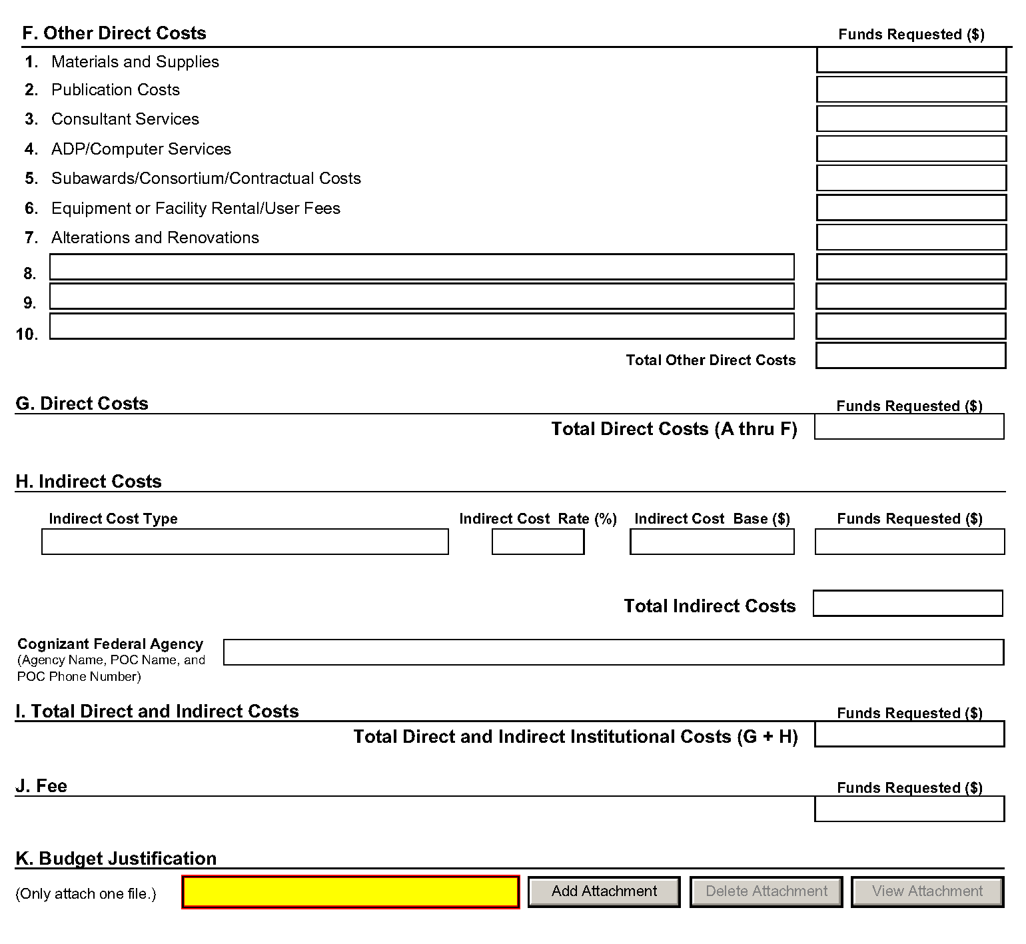
The information for Organizational DUNS, Budget Type, Name of Organization, and Start and End Dates is automatically filled in based on the information entered on the first budget screen. To edit this information, return to the initial budget screen (Sections A and B) by clicking the Previous button.
Special Instructions: Foreign Organizations (Non-domestic [non-U.S. Entities])
Foreign institutions and international organizations may request funds for limited F&A costs (8 percent of modified total direct costs less equipment) to support the costs of compliance with DHHS and NIH requirements including, but not limited to, protection of human subjects, animal welfare, invention reporting, financial conflict of interest and research misconduct.
Foreign organizations may not include any charge-back of customs and import fees, such as consular fees, customs surtax, value-added taxes (VAT) and other related charges.
F. Other Direct Costs
Field Name | Instructions
1. Materials and Supplies | List total funds requested for materials and supplies. In the budget justification, indicate general categories such as glassware, chemicals, animal costs, including an amount for each category. Categories less than $1,000 are not required to be itemized.
2. Publication Costs | List the total publication funds requested. The proposal budget may request funds for the costs of documenting, preparing, publishing, or otherwise making available to others the findings and products of the work conducted under the award. In the budget justification include supporting information.
3. Consultant Services | List the total costs for all consultant services. In the budget justification, identify each consultant, the services he/she will perform, total number of days, travel costs, and the total estimated costs.  In the budget justification also provide the names and organizational affiliations of all consultants, other than those involved in consortium/contractual arrangements. Include consultant physicians in connection with patient care and persons who are confirmed to serve on external monitoring boards or advisory committees to the project. Describe the services to be performed.
4. ADP/Computer Services | List total funds requested for ADP/computer services. The cost of computer services, including computer-based retrieval of scientific, technical and education information may be requested. In the budget justification, include the established computer service rates at the proposing organization if applicable.
5. Subawards/Consortium/ Contractual Costs | List total funds requested for 1) all subaward/consortium organization(s) proposed for the project and 2) any other contractual costs proposed for the project.  This line item should include both direct and indirect costs for all subaward/consortium organizations. Contractual costs for support services, such as the laboratory testing of biological materials, clinical services, or data processing, are occasionally sufficiently high to warrant a categorical breakdown of costs. When this is the case, provide detailed information as part of the budget justification.  NIH policy provides for exclusion of consortium/contractual F&A costs when determining if an applicant is in compliance with a direct cost limitation. Please see the Supplemental Instructions, Part III, Section 1.1 for additional information regarding this exclusion Policy
6. Equipment or Facility Rental/User Fees | List total funds requested for equipment or facility Rental/Use fees. In the budget justification, identify each rental user fee and justify.
7. Alterations and Renovations | List total funds requested for alterations and renovations. In the budget justification, itemize by category and justify the costs of alterations and renovations including repairs, painting, removal or installation of partitions, shielding, or air conditioning. Where applicable, provide the square footage and costs.  Under certain circumstances the public policy requirements that apply to construction activities may also apply to A&R activities. Please refer to the NIH Grants Policy Statement section on “Construction Grants – Public Policy Requirements and Objectives” for more information.  Note, costs for any Alterations and Renovations (A&R) were previously unallowable on applications from foreign institutions, international organizations and domestic applications with foreign subawards. However, an HHS policy change now allows for minor A&R (≤$500,000) on these applications.  When requesting minor A&R costs under this policy, please provide detailed information on the planned A&R in the budget justification.
8-10 Other | Add text to describe any “other” direct costs not requested above. Use the budget justification to further itemize and justify.  List total funds requested for items 8-10 “Other.”  Use lines 8-10 for such costs as patient care and tuition remission. If requesting patient care costs, request inpatient and outpatient costs separately using lines 8 and 9.
Total Other Direct Costs | Total Funds requested for all other direct costs.

Special Instructions for Patient Care Costs
If inpatient and/or outpatient costs are requested, provide the names of any hospitals and/or clinics and the amounts requested for each in the budget justification.
State whether each hospital or clinic has a currently effective DHHS-negotiated research patient care rate agreement and, if not, what basis is used for calculating costs. If an applicant does not have a DHHS-negotiated rate, the PHS awarding component can approve a provisional rate. Indicate, in detail, the basis for estimating costs in this category, including the number of patient days, estimated cost per day, and cost per test or treatment. If both inpatient and outpatient costs are requested, provide information for each separately. If multiple sites are to be used, provide detailed information by site.
Include information regarding projected patient accrual for the project/budget periods and relate this information to the budget request for patient care costs. If patient accrual is anticipated to be lower at the start or during the course of the project, plan budget(s) accordingly.
Provide specific information regarding anticipated sources of Other Support for patient care costs, e.g., third party recovery or pharmaceutical companies. Include any potential or expected utilization of General Clinical Research Centers.
G. Total Direct Costs (A through F)
Total Funds requested for all direct costs.
H. Indirect Costs
Field Name | Instructions
Indirect Cost Type | Indicate the type of cost e.g.; Salary & Wages, Modified Total Direct Costs, or Other explain. Also indicate if Off-site. If more than one rate/base is involved, use separate lines for each. If you do not have a current indirect rate(s) approved by a Federal agency, indicate, “None—will negotiate” and include information for a proposed rate. Use the budget justification if additional space is needed.
Indirect Cost Rate (%) | Indicate the most recent indirect cost rate(s) (also known as Facilities & Administrative Costs [F&A]) established with the cognizant Federal office, or in the case of for-profit organizations, the rate(s) established with the appropriate agency. If you have a cognizant/oversight agency and are selected for an award, you must submit your indirect rate proposal to that office for approval. If you do not have a cognizant/oversight agency, contact the awarding agency.  If this field does not allow a figure greater than 100% to be entered, use two lines to show the entire calculation. This field should be entered using a rate such as “55.5.”
Indirect Cost Base ($) | Enter the amount of the base for each indirect cost type.
Funds Requested | Enter funds requested for each indirect cost type.
Total Indirect Costs | Total Funds requested for indirect costs.
Cognizant Federal Agency | Enter the name of the cognizant Federal Agency, name and phone number of the individual responsible for negotiating your rate. If no cognizant agency is known, enter “None.”
I. Total Direct and Indirect Institutional Costs (G + H)
Total Funds requested for direct and indirect costs.
J. Fee
Generally, a fee is not allowed on a grant or cooperative agreement. Do not include a fee in your budget, unless the program announcement specifically allows the inclusion of a “fee” (e.g., SBIR/STTR). If a fee is allowable, enter the requested fee.
K. Budget Justification
Use the budget justification to provide the additional information requested in each budget category identified above and any other information the applicant wishes to submit to support the budget request. The following budget categories must be justified, where applicable: equipment, travel, participant/trainee support and other direct cost categories. Only one file may be attached. The attachment is required.
Use this section to list the names, role (e.g., PostDoc or Graduate Student), associated months, salary and fringe benefits for all Postdoctoral Associates and Graduate Students included in Budget Section B. Other Personnel.
Include a justification for any significant increases or decreases from the initial year budget. Justify budgets with more than a standard escalation from the initial to the future year(s) of support. Also use this section to explain any exclusions applied to the F&A base calculation.
If the application includes a subaward/consortium budget, a separate budget justification is submitted for that budget. See Section 4.8 Special Instructions for Preparing Applications with a Subaward/Consortium.
Completing Budget Periods 2-5
If funds are being requested for more than one budget period, you must complete a separate detailed budget for each year of support requested. To navigate to screens for the next budget period, click the Next Period button at the top of the 3rd budget screen (Sections F through K). You must complete all the required information (i.e., those fields that are highlighted and outlined in red) before the Next Period button is activated. If no funds are requested for a required field, enter “0.” Note the Budget Justification is also a required item and must be attached before the Next Period button is activated.
Supplemental/Revision Application
For a supplemental/revision application, show only those items for which additional funds are requested. If the initial budget period of the supplemental/revision application is less than 12 months, prorate the personnel costs and other appropriate items of the detailed budget.
Submitting Budgets With More Than 5 Budget Periods
When authorized or requested by the appropriate NIH IC, applicants may submit applications with more than 5 budget periods. In these situations complete the detailed budget for periods 1-5 as usual. However, include the same level of detail for Period 6 in the Budget Justification along with an explanation of the situation. Also, be sure to include a cover letter that addresses these extra budget periods, and include the IC Program Official’s preapproval as part of the Cover Letter PDF.

4.7.4 Cumulative Budget
All values on this form are calculated automatically. They present the summations of the amounts that you have entered previously, under Sections A through K, for each of the individual budget periods. Therefore, no data entry is allowed or required, in order to complete this “Cumulative Budget” section.
If any of the amounts displayed on this form appears to be incorrect, you may correct it by adjusting one or more of the values that contribute to that total. To make any such adjustments, you will need to revisit the appropriate budget period form(s), to enter corrected values.
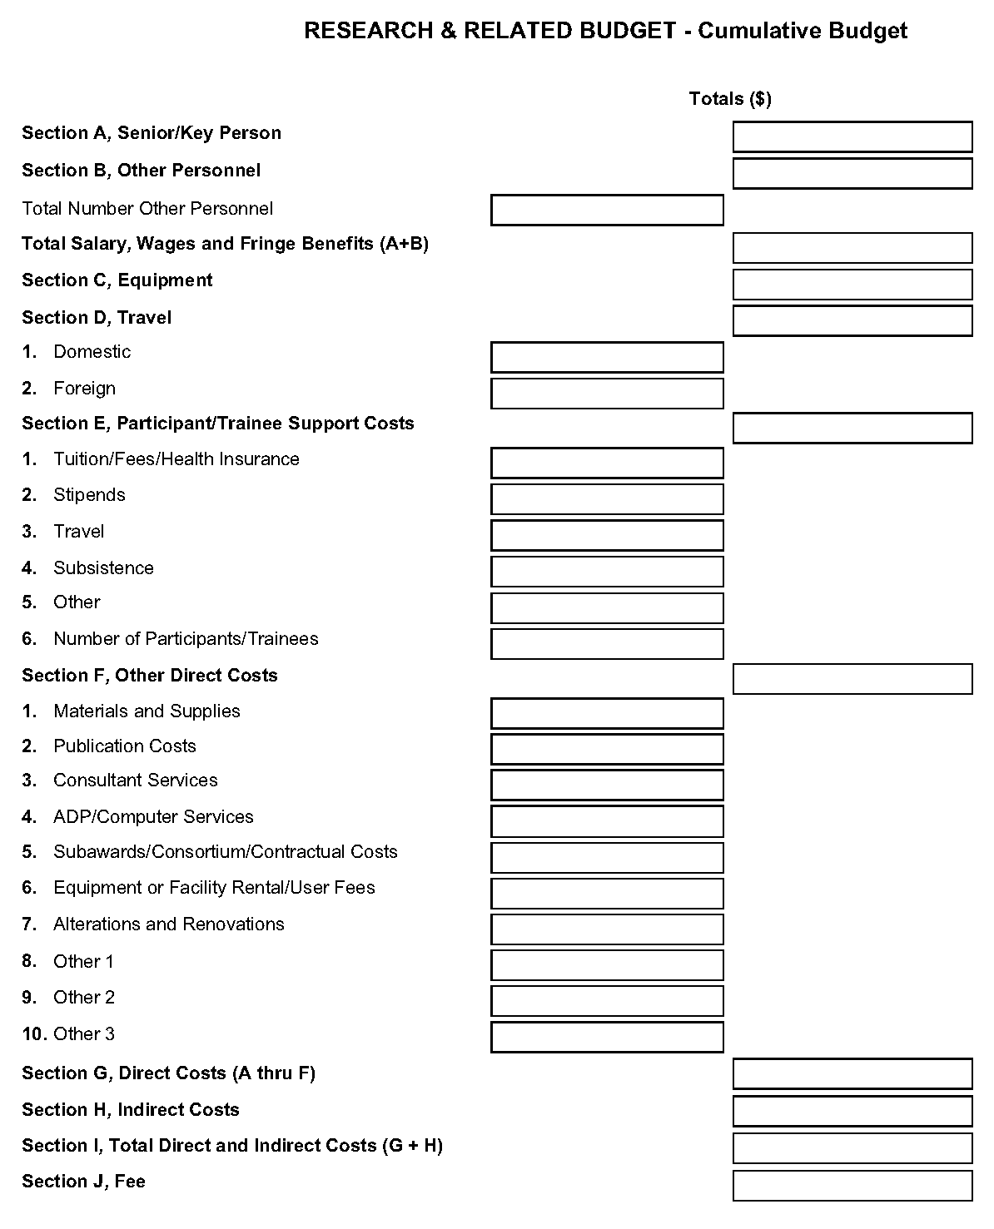

4.8 Special Instructions for Preparing Applications with a Subaward/Consortium
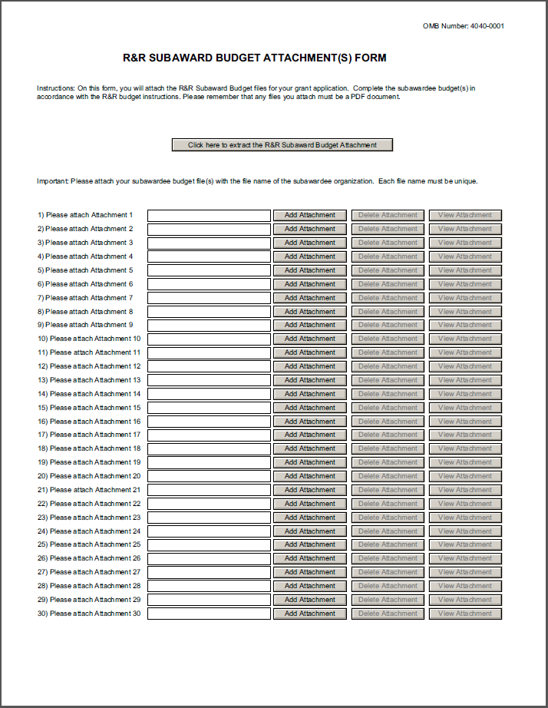
A complete subaward/consortium budget form (including the budget justification section) should be completed by each consortium grantee organization. Separate budgets are required only for subawardee/consortium organizations that perform a substantive portion of the project.
Note, a complete subaward/consortium budget form is only required when the prime grantee is submitting a detailed budget using the R&R Budget Form. Do not use this subaward/consortium budget form for applications using the PHS 398 Modular Budget Form. Applicants using the Modular Budget Form should see Section 5.4 for instructions concerning information on consortium budgets.
For any subaward or consortium sites, it is appropriate and expected that someone may be designated as the consortium lead investigator responsible for ensuring proper conduct of the project or program at that site. However, when completing the Project Role for the consortium lead investigator, the project role of “PD/PI” should only be used if the entire application is being submitted under the Multiple PI policy. Otherwise, this individual should be assigned some other project role in the senior/key personnel section of the application. Also, the role of Co-PD/PI is not currently used by NIH and other PHS agencies. Assigning an individual(s) the role of "Co-PD/PI" will not identify the application as a Multiple PD/PI application. Although NIH now recognizes the role of “Co-Investigator,” if applicants wish to use the role of “Consortium PI” or some other similar role, select “Other” for the Project Role field and then insert the appropriate role descriptor in the Other Project Role Category field.
NIH continues to support the policy established in April 2004, (revised in November 2004) regarding applications that involve consortium/contractual F&A costs (See NOT-OD-05-004). This policy allows applicants to exclude consortium/contractual F&A costs when determining compliance for any application where a direct cost limit applies. The use of the SF424 (R&R) application with separately submitted subaward/consortium budgets allows NIH to take advantage of a system validation for this policy. When an application is submitted in response to a program with a direct cost limit, the eRA system will perform the calculation by taking the total direct costs requested by the prime/parent organization in their detailed budget, and subtracting all subaward/consortium F&A from each and every subaward budget attached. When the validation calculation equals or exceeds the respective direct cost limit, the application will receive a warning. There are circumstances, when the system does not have sufficient information to exclude all allowable F&A costs. Applicants should document in their budget justification, how their budget falls below the direct cost limit.
This form accommodates a set number of separate subaward budgets (30). If you are submitting an application with more subaward budgets than the form allows, the remaining budgets should be converted to PDF and included as part of Section K. Budget Justification of the parent budget. Reminder, the sum of all subaward budgets; e.g., those attached separately and those provided as part of the budget justification, must be included in Line F.5 Subawards/Consortium/Contractual Costs of the parent budget.
To start the process, the applicant organization should:
- Select the Subaward Budget Attachment Form from the Optional Documents in the Grant Application Package.
- Open the form, and click the Click here to extract the R&R Subaward Budget Attachment button in the middle of the form. A “SAVE” dialog box appears.
- Save the file locally using the first ten letters of the consortium organization’s name and use “.pdf” as the file extension. (The extracted file is an Adobe PDF file.) Once you have saved the file there is no need to extract another budget attachment. Doing so may cause you to lose any data already stored in the saved file.
- E-mail the extracted, saved form to the consortium grantee. Note: consortium grantees must have installed a compatible version of Adobe Reader before they can complete the form. The consortium grantee should complete all the budget information as instructed in the R&R Budget form instructions in Section 4.7. The Budget Type should be set to Subaward/Consortium. Organizational DUNS and Name of Organization fields must reflect that of the subaward/consortium grantee.
- The consortium grantee must complete the budget form and e-mail it back to the applicant organization.
- Return to the Subaward Budget Attachment Form and attach the consortium grantee’s budget to one of the blocks provided on the form.
Submitting Subaward Budgets that are not Active for all Periods of the Prime Grant
When submitting subaward budgets that are not active for all periods of the prime grant, fill out the subaward R&R Budget form and include only the number of periods for which the subaward is active. The budget period start/end dates reflected in each period should reflect the corresponding prime budget period start/end dates. This approach is the most workable solution to the limitations in existing forms that do not allow an “empty” budget period and do not allow submission of a subaward budget with zero effort to skip a budget period.
For example, suppose the prime has filled out a budget form with the following periods:
- period 1 Jan 1, 2013 – Dec 31, 2013
- period 2 Jan 1, 2014 – Dec 31, 2014
- period 3 Jan 1, 2015 – Dec 31, 2015
- period 4 Jan 1, 2016 – Dec 31, 2016
- period 5 Jan 1, 2017 – Dec 31, 2017
Now, suppose there is a subaward that performs in support year 1 and does not become active again until support year 4. The subaward can fill out the first two periods of their budget form as follows:
- period 1 Jan 1, 2013 – Dec 31, 2013 (dates correspond to prime period 1)
- period 2 Jan 1, 2016 – Dec 31, 2016 (dates correspond to prime period 4)
It is not necessary that the budget period numbers between the prime and subaward match; the correlation is reflected in the dates. Do be careful, however, that the dates exactly match what is listed for the period in the prime budget.
Note this approach may cause a validation warning regarding the NIH $500,000 per year limit on direct costs, therefore you should document in both the cover letter and the subaward budget justification that the subaward is only active for specific periods of the prime. Appropriate NIH staff has access to the cover letter and reviewers have access to the budget justification. This documentation will make the date correlation immediately apparent and will help avoid any confusion.

Once all data have been entered use the scroll bar to scroll up. You will be returned to the Grant Application Package screen. To remove a form from your application, uncheck the box next to the form name in the Optional document section.

5. Completing PHS 398 Form

5.1 Overview
In conjunction with the SF424 (R&R) forms, NIH and other PHS agencies grants applicants should also complete and submit additional forms titled “PHS 398.” Note the PHS 398 forms include additional data required by the agency for a complete application. While these are not identical to the PHS 398 application form pages, the PHS 398 reference is used to distinguish these additional data requirements from the data collected in the SF424 (R&R) forms. A complete application to NIH and other PHS agencies will include SF424 (R&R) and PHS 398 forms. The PHS 398 forms include:
- PHS 398 Cover Page Supplement (this supplements the data requirements in the R&R Cover form)
- PHS 398 Modular Budget Form (use only when a modular budget is submitted instead of a detailed budget)
- PHS 398 Research Plan Form
- Planned Enrollment Report
- PHS 398 Cumulative Inclusion Enrollment Report
Complete each form using the instructions provided below.

5.2 (Reserved)

5.3 Cover Page Supplement Form
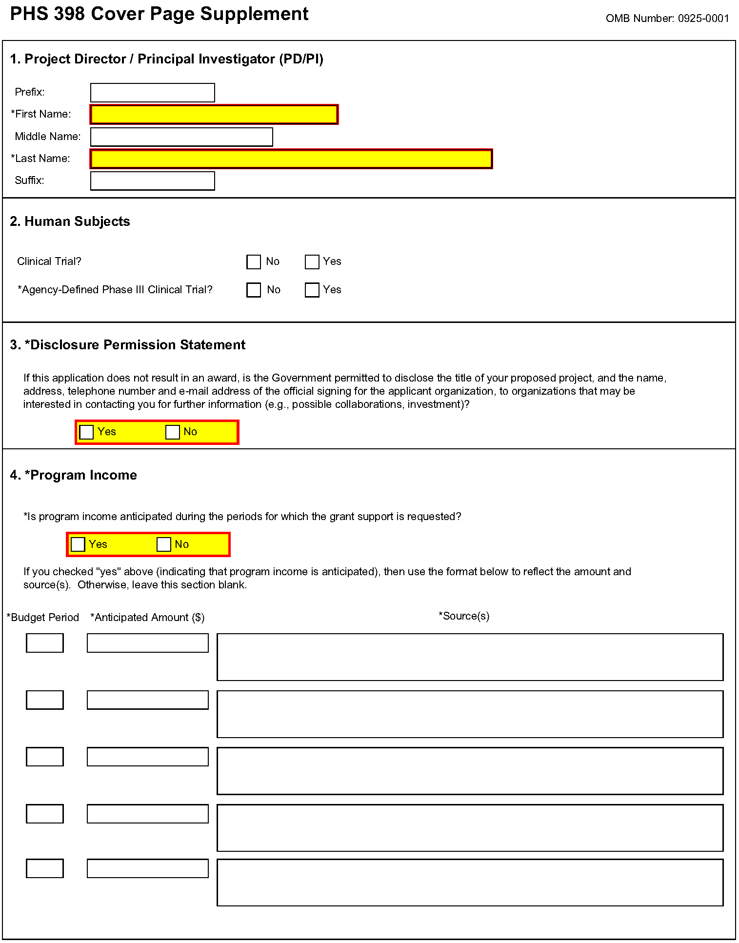
1. Program Director/Principal Investigator (PD/PI)
Field Name | Instructions
Prefix | Pre-populated from the SF424 (R&R). The prefix (for example, Mr., Mrs., Rev.) for the name of the PD/PI.
First Name | Pre-populated from the SF424 (R&R). The first (given) name of the PD/PI. This field is required.
Middle Name | Pre-populated from the SF424 (R&R). The middle name of the PD/PI.
Last Name | Pre-populated from the SF424 (R&R). The last (family) name of the PD/PI. This field is required.
Suffix | Pre-populated from the SF424 (R&R). The suffix (for example, Jr., Sr., PhD) for the name of the PD/PI.
2. Human Subjects
Field Name | Instructions
Clinical Trial? | Check "yes" or "no" to indicate whether the project includes a clinical trial. See Supplemental Grant Application Instructions, Part III.3. for the specific definition.
Agency-Defined Phase III Clinical Trial | Check “Yes” or “No” to indicate whether the project is an NIH-defined Phase III clinical trial.  An NIH-defined Phase III clinical trial is a broadly based prospective Phase III clinical investigation, usually involving several hundred or more human subjects, for the purpose of either evaluating an experimental intervention in comparison with a standard or control intervention or of comparing two or more existing treatments. Often the aim of such investigation is to provide evidence leading to a scientific basis for consideration of a change in health policy or standard of care. The definition includes pharmacologic, non-pharmacologic, and behavioral interventions given for disease prevention, prophylaxis, diagnosis, or therapy. Community trials and other population-based intervention trials are also included.
3. *Disclosure Permission Statement
Field Name | Instructions
If this application does not result in an award, is the Government permitted to disclose the title of your proposed project, and the name, address, telephone number and e-mail address of the official signing for the applicant organization, to organizations that may be interested in contacting you for further information (e.g., possible collaborations, investment)? | Select "yes" or "no" to indicate whether disclosure permission is granted. This field is required.  Your response will not affect any peer review or funding decisions.
4. Program Income
Field Name | Instructions
Is program income anticipated during the periods for which the grant support is requested? | If program income is anticipated during the periods for which the grant support is requested, check “Yes,” and then complete the section below. If no program income is anticipated, check “No” and leave the following section blank.
Budget Period | If program income is anticipated, enter the budget periods in this column. If the application is funded, the Notice of Grant Award will provide specific instructions regarding the use of such income.
Anticipated Amount ($) | If program income is anticipated, enter the amount anticipated for each budget period listed.
Source(s) | If program income is anticipated, enter the source for each budget period listed.
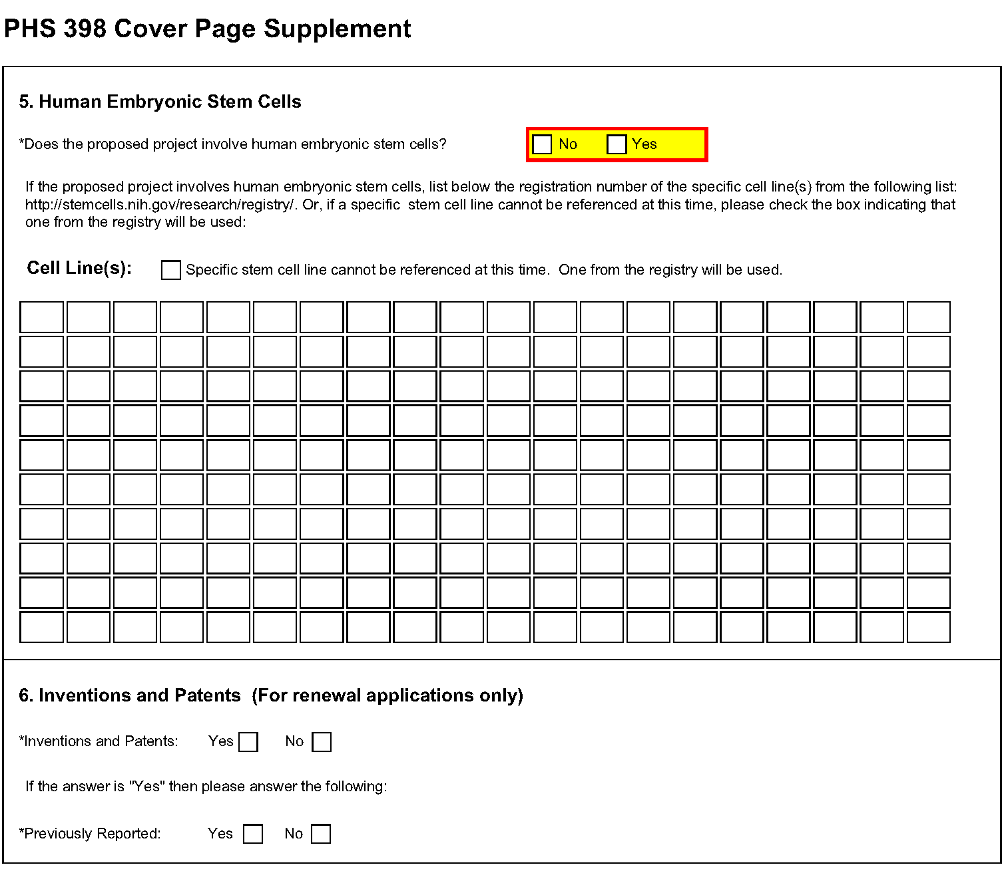
5. Human Embryonic Stem Cells
Field Name | Instructions
Does the proposed project involve human embryonic stem cells? | If the proposed project involves human embryonic stem cells, check Yes and complete the section below.  If the proposed project does not involve human embryonic stem cells, check No.
Specific stem cell line cannot be referenced at this time. One from the registry will be used. | If a specific line cannot be referenced at the time of application submission, check this box. Additionally, provide a strong justification for why an appropriate cell line is not available from the Registry at this time. The justification should be included as part of the Research Strategy or Program Plan as appropriate..
Cell Line(s) | List in this section the registration number of the specific cell line(s) from the NIH Human Embryonic Stem Cell Registry
6. Inventions and Patents (For renewal applications only)
Field Name | Instructions
Inventions and Patents | This block need only be completed if submitting an R&R “Renewal” application or a Resubmission of a Renewal application. If no inventions were conceived or reduced to practice during the course of work under this project, check “No.” The remaining parts of the item are then not applicable. If any inventions were conceived or reduced to practice during the previous period of support, check “Yes.”  Note: NIH recipient organizations must promptly report inventions to the Extramural Inventions and Technology Resources Branch of the Office of Policy for Extramural Research Administration, OER, NIH, Bethesda, MD 20892-2750, (301) 435-1986. Invention reporting compliance according to regulations at 37 CFR 401.14 is described at http://www.iedison.gov. The grantee is encouraged to submit reports electronically using Interagency Edison (http://www.iedison.gov).
Previously Reported | If the item above is checked "Yes", indicate whether this information has been reported previously to the PHS or to the applicant organization official responsible for patent matters.
7. Change of Investigator/Change of Institution Questions
Field Name | Instructions
Change of Program Director/Principal Investigator | Check here, if this application reflects a change in principal investigator/program director from that indicated on a previous application. This is not generally applicable to a "New" application
Prefix | If this application reflects a change in PD/PI, enter the name prefix (for example, Mr., Mrs., Rev.) of the former PD/PI.
First Name | If this application reflects a change in PD/PI, enter the first name of the former PD/PI.
Middle Name | If this application reflects a change in PD/PI, enter the middle name of the former PD/PI.
Last Name | If this application reflects a change in PD/PI, enter the last name of the former PD/PI.
Suffix | If this application reflects a change in PD/PI, provide the suffix (for example, Jr., Sr., PhD) of the former PD/PI.
Change of Grantee Institution | Check here, if this application reflects a change in grantee institution from that indicated on a previous application. This is not generally applicable to a "New" application.
Name of Former Institution | If this application reflects a change in grantee institution, insert the name of the former institution here.

5.4 Modular Budget Form
Selecting the Appropriate Budget Form
The application forms package associated with most NIH funding opportunities includes two optional budget forms—(1) R&R Budget Form; and, (2) PHS 398 Modular Budget Form. NIH applications will include either the R&R Budget Form or the PHS 398 Modular Budget Form but not both. (Note AHRQ does not accept modular budgets.)
To determine which budget form to use for NIH applications, consult the modular budget guidelines below. Additional guidance may also be provided in the specific funding opportunity announcement.
Modular Budget Guidelines
Modular budgets are applicable to certain research grant applications from domestic organizations requesting $250,000 or less per year for direct costs. International organizations and others that do not fall under this definition should use the detailed budget forms described in Section 4.7. Note, consortium/contractual F&A costs are not factored into the direct cost limit. They may be requested in addition to the $250,000 limit. Modular budgets are simplified; therefore, detailed categorical information is not to be submitted with the application.
For all modular budgets, request total direct costs (in modules of $25,000), reflecting appropriate support for the project. There will be no future year escalations. A typical modular grant application will request the same number of modules in each year. Provide an additional narrative budget justification for any variation in the number of modules requested.
NIH may request (prior to award) additional budget justification in exceptional circumstances. For further information, see http://grants.nih.gov/grants/funding/modular/modular.htm and http://grants.nih.gov/grants/funding/modular/modular_review.htm.
Using the Modular Budget Form
The Modular Budget Form provides budget fields for up to 5 years of support (e.g., budget periods 1 - 5). If requesting less than 5 years of support, complete only those years requested and leave the others blank.

5.4.1 Budget Period Form
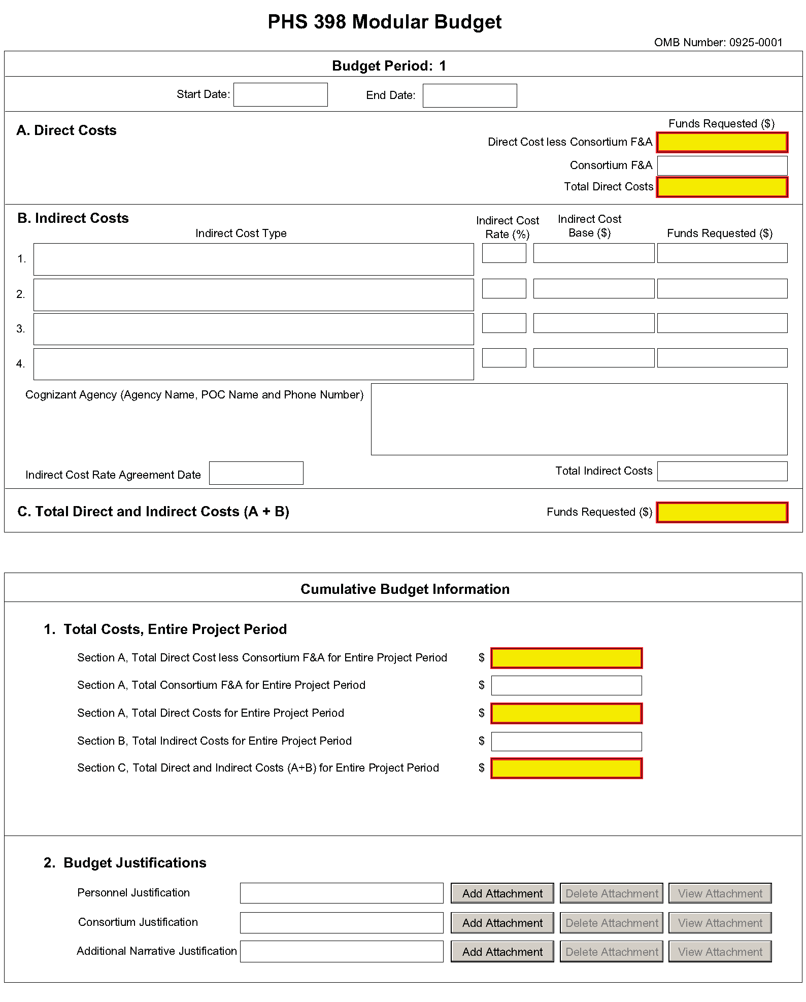
NOTE: The form allows for up to five budget periods followed by a cumulative budget for all budget periods. The fields are the same for all budget periods. The following instructions can be used for each.
Budget Period
Field Name | Instructions
Start Date | Enter the requested/proposed start date of the budget period. Use the following format: MM/DD/YYY.
End Date | Enter the requested/proposed end date of the budget period. Use the following format: MM/DD/YYY.
A. Direct Costs
Field Name | Instructions
Direct Cost less Consortium F&A | Enter the amount of Direct Costs, less actual consortium F&A costs for this budget period. This figure must be in $25,000 increments, and it may not exceed $250,000. Any consortium F&A costs are excluded from this figure. This field is required.
Consortium F&A | If this project involves a consortium, enter the actual consortium F&A costs for this budget period. If this project does not involve a consortium, leave blank.
Total Direct Costs | This field auto-calculates.
B. Indirect Costs
Field Name | Instructions
Indirect Cost Type | Indicate the type of base (for example, Salary & Wages, Modified Total Direct Costs, Other [explain]), and indicate if Off-site. If more than one rate/base is involved, use separate lines for each. If you do not have a current indirect rate(s) approved by a Federal agency, indicate, “None—will negotiate” and include information for a proposed rate. Use the budget justification if additional space is needed.
Indirect Cost Rate (%) | Indicate the most recent Indirect Cost rate(s) (also known as Facilities & Administrative Costs [F&A]) established with the cognizant Federal office, or in the case of for-profit organizations, the rate(s) established with the appropriate agency. If you have a cognizant/oversight agency and are selected for an award, you must submit your indirect rate proposal to that office for approval. If you do not have a cognizant/oversight agency, contact the awarding agency.
Indirect Cost Base ($) | Enter the amount of the base for each indirect cost type.
Funds Requested ($) | Enter funds requested for each indirect cost type.
Cognizant Agency (Agency Name, POC Name and Phone Number) | Enter the name of the cognizant Federal Agency, name, and phone number of the individual responsible for negotiating your rate. If no cognizant agency is known, enter “None.”
Indirect Cost Rate Agreement Date | If you have a negotiated rate agreement, enter the agreement date.
Total Indirect Costs | This field auto-calculates.
C. Total Direct and Indirect Costs (A+B) Funds Requested ($)
The total funds requested for direct and indirect costs. This field is required.

Once you have entered all required information for budget period 1, press the Next Period button to enter information for the subsequent budget period.

5.4.2 Cumulative Budget Information
Cumulative Budget Information
All values for the Cumulative Budget Information are calculated automatically. They equal the summations of the amounts that you have entered previously for each of the individual budget periods. Therefore, no data entry is allowed or required, in order to complete this “Cumulative Budget” section.
If any of the amounts displayed on this form appears to be incorrect, you may correct it by adjusting one or more of the values that contribute to that total. To make any such adjustments, you will need to revisit the appropriate budget period form(s), to enter corrected values.
Modular Budget Justifications
Field Name | Instructions
Personnel Justification | List all personnel, including names, percent of effort and roles on the project. No individual salary information should be provided. Since the modules should be a reasonable estimate of costs allowable, allocable, and appropriate for the proposed project, applicants must use the current legislatively imposed salary limitation when estimating the number of modules. For guidance on current salary limitations contact your office of sponsored programs.  NIH grants also limit the compensation for graduate students. Compensation includes salary or wages, fringe benefits and tuition remission. This limit should also be used when estimating the number of modules. See: http://grants1.nih.gov/grants/guide/notice-files/NOT-OD-02-017.html  Save the information in a single file and click the add attachment button to complete this entry.
Consortium Justification | Provide an estimate of total costs (direct plus Facilities and Administrative) for each year, rounded to the nearest $1,000. List the individuals/ organizations with whom consortium or contractual arrangements have been made. List all personnel, including percent of effort and roles on the project. No individual salary information should be provided. Indicate whether the collaborating institution is foreign or domestic. While only the direct cost for a consortium/contractual arrangement is factored into eligibility for using the modular budget format, the total consortium/contractual costs must be included in the overall requested modular direct cost amount.  Save this information in a single file in a location you remember. Click Add Attachment, browse to where you saved the file, select the file, and then click Open.
Additional Narrative Justification | If the requested budget requires any additional justification; e.g, variations in the number of modules requested, save the information in a single file and click the add attachment button to complete this entry.

Once all data have been entered use the scroll bar to scroll up. You will be returned to the Grant Application Package screen. To remove a form from your application, uncheck the box next to the form name in the Optional document section.

5.5 PHS 398 Research Plan Form
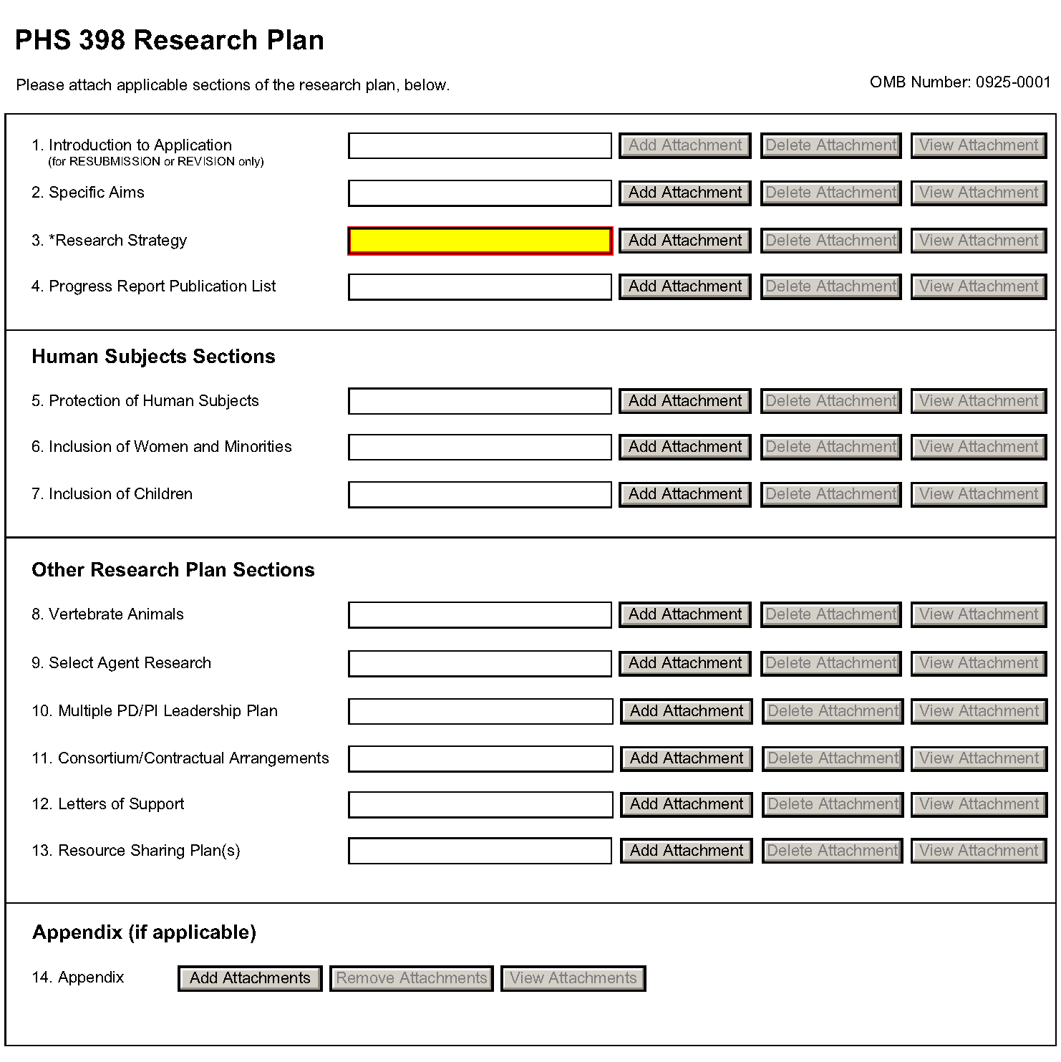
The Research Plan should include sufficient information needed for evaluation of the project, independent of any other document (e.g., previous application). Be specific and informative, and avoid redundancies.
Research Plan Attachments (See also Section 2.3.2 Creating PDFs for Text Attachments)
Text attachments should be generated using word processing software and then converted to PDF using PDF generating software. Avoid scanning text attachments to convert to PDF since that causes problems for the agency handling the application. In addition, be sure to save files with descriptive file names.
Do not include any information in a header or footer of the attachments. A header will be system-generated that references the name of the PD/PI. Page numbers for the footer will be system-generated in the complete application, with all pages sequentially numbered.
Since a number of reviewers will be reviewing applications as an electronic document and not a paper version, applicants are strongly encouraged to use only a standard, single-column format for the text. Avoid using a two-column format since it can cause difficulties when reviewing the document electronically.
Full-sized glossy photographs of material such as electron micrographs or gels must only be included within the page limits of the Research Strategy. The maximum size of images to be included should be approximately 1200 x 1500 pixels using 256 colors. Figures must be readable as printed on an 8.5 x 11 inch page at normal (100%) scale.
Investigators must use image compression such as JPEG or PNG. Do not include figures or photographs as separate attachments either in the Appendix or elsewhere in the application.

Separate Attachments
Separate attachments have been designed for the Research Plan sections to maximize automatic validations conducted by the eRA system. When the application is received by the agency, all of the Research Plan sections will be concatenated in the appropriate order so that reviewers and agency staff will see a single cohesive Research Plan.
When attaching a PDF document to the actual forms, please note you are attaching an actual document, not just pointing to the location of an externally stored document. Therefore, if you revise the document after it has been attached, you must delete the previous attachment and then reattach the revised document to the application form. Use the View Attachment button to determine if the correct version has been attached.

Page Limits
Applicants must follow the page limits described in table 2.6.1 unless the FOA specifies otherwise. All tables, graphs, figures, diagrams, and charts must be included within the Research Strategy page limit. If PAs or RFAs contain specific page limits, those instructions always supersede these instructions.
All applications and proposals for NIH funding must be self-contained within specified page limits. Agency validations will include many checks for page limits. Note that while these computer validations will help minimize incomplete and/or non-compliant applications, they may not address all page limit requirements for a specific FOA and do not replace the validations conducted by NIH staff. Applications found not to comply with the requirements may be delayed in the review process. Unless otherwise specified in an NIH solicitation, internet website addresses (URLs) may not be used to provide information necessary to the review because reviewers are not obligated to view the internet sites. Moreover, reviewers are cautioned that they should not directly access an website (except to review publications cited in the Biographical Sketch or Progress Report publication list) as it could compromise their anonymity.
Applicants are prohibited from using the Appendix to circumvent page limitations in any section of the application for which a page limit applies. For additional information regarding Appendix material and page limits, please refer to the NIH Guide Notice NOT-OD-11-080, http://grants.nih.gov/grants/guide/notice-files/NOT-OD-11-080.html.

Notice of Proprietary Information
Applicants are discouraged from submitting information considered proprietary unless it is deemed essential for proper evaluation of the application. However, when the application contains information that constitutes trade secrets, or information that is commercial or financial, or information that is confidential or privileged, make sure you have checked “Yes” for the proprietary/privileged information question in the Other Project Information form.
When information in the application constitutes trade secrets or information that is commercial or financial, or information that is confidential or privileged, it is furnished to the Government in confidence with the understanding that the information shall be used or disclosed only for evaluation of this application. However, if a grant is awarded as a result of or in connection with the submission of this application, the Government shall have the right to use or disclose the information to the extent authorized by law. This restriction does not limit the Government’s right to use the information if it is obtained without restriction from another source.
Although the grantee institution and the PD/PI will be consulted about any such release, the PHS will make the final determination. Any indication by the applicant that the application contains proprietary or privileged information does not automatically shield the information from release in response to a Freedom of Information Act (FOIA) request should the application result in an award (see 45 CFR Part 5). If an applicant fails to identify proprietary information at the time of submission as instructed in the application guide, a significant substantive justification will be required to withhold the information if requested under FOIA.
Begin each text section of the Research Plan with a section header (e.g., Introduction, Specific Aims, Research Strategy, etc).
Field Name | Instructions
1. Introduction to Application (for Resubmission or Revision only) | Use only if Type of Application is Resubmission or Revision. See specific instructions in Part I Section 2.7, Resubmission Applications and Part I Section 2.8, Revision Applications on the content of the Introduction. First time (new) applications should not include an Introduction.  The Introduction is a required attachment for Resubmissions and Revisions. Follow the page limits for the Research Strategy in the table of page limits (Table 2.6-1), unless specified otherwise in the FOA.  Save this information in a single file in a location you remember. Click Add Attachment, browse to where you saved the file, select the file, and then click Open.
2. Specific Aims | State concisely the goals of the proposed research and summarize the expected outcome(s), including the impact that the results of the proposed research will exert on the research field(s) involved.  List succinctly the specific objectives of the research proposed, e.g., to test a stated hypothesis, create a novel design, solve a specific problem, challenge an existing paradigm or clinical practice, address a critical barrier to progress in the field, or develop new technology.  The Specific Aims attachment is required unless otherwise specified in the FOA. Follow the page limits for the Research Strategy in the table of page limits (Table 2.6-1), unless specified otherwise in the FOA.  Save this information in a single file in a location you remember. Click Add Attachment, browse to where you saved the file, select the file, and then click Open.
3. Research Strategy | Organize the Research Strategy in the specified order and using the instructions provided below. Start each section with the appropriate section heading – Significance, Innovation, Approach. Cite published experimental details in the Research Strategy section and provide the full reference in the Bibliography and References Cited section (Part I Section 4.4.9).  Follow the page limits for the Research Strategy in the table of page limits (Table 2.6-1), unless specified otherwise in the FOA. Note that the page limit for this attachment will be validated as a single file.  - Significance  - Explain the importance of the problem or critical barrier to progress in the field that the proposed project addresses.  - Explain how the proposed project will improve scientific knowledge, technical capability, and/or clinical practice in one or more broad fields.  - Describe how the concepts, methods, technologies, treatments, services, or preventative interventions that drive this field will be changed if the proposed aims are achieved.  - Innovation  - Explain how the application challenges and seeks to shift current research or clinical practice paradigms.  - Describe any novel theoretical concepts, approaches or methodologies, instrumentation or interventions to be developed or used, and any advantage over existing methodologies, instrumentation, or interventions.  - Explain any refinements, improvements, or new applications of theoretical concepts, approaches or methodologies, instrumentation, or interventions.  - Approach  - Describe the overall strategy, methodology, and analyses to be used to accomplish the specific aims of the project. Unless addressed separately the Resource Sharing Plan, attachment include how the data will be collected, analyzed, and interpreted as well as any resource sharing plans as appropriate.  - Discuss potential problems, alternative strategies, and benchmarks for success anticipated to achieve the aims.  - If the project is in the early stages of development, describe any strategy to establish feasibility, and address the management of any high risk aspects of the proposed work.  - Point out any procedures, situations, or materials that may be hazardous to personnel and precautions to be exercised. A full discussion on the use of select agents should appear in the Select Agent Research attachment, below.  - If research on Human Embryonic Stem Cells (hESCs) is proposed but an approved cell line from the NIH hESC Registry cannot be identified, provide a strong justification for why an appropriate cell line cannot be chosen from the Registry at this time.  If an applicant has multiple Specific Aims, then the applicant may address Significance, Innovation and Approach for each Specific Aim individually, or may address Significance, Innovation and Approach for all of the Specific Aims collectively.  As applicable, also include the following information as part of the Research Strategy, keeping within the three sections listed above: Significance, Innovation, and Approach.  Preliminary Studies for New Applications: For new applications, include information on Preliminary Studies. Discuss the PD/PI’s preliminary studies, data, and or experience pertinent to this application. Except for Exploratory/Developmental Grants (R21/R33), Small Research Grants (R03), and Academic Research Enhancement Award (AREA) Grants (R15), preliminary data can be an essential part of a research grant application and help to establish the likelihood of success of the proposed project. Early Stage Investigators should include preliminary data (however, for R01 applications, reviewers will be instructed to place less emphasis on the preliminary data in application from Early Stage Investigators than on the preliminary data in applications from more established investigators).  Progress Report for Renewal and Revision Applications. For renewal/revision applications, provide a Progress Report. Provide the beginning and ending dates for the period covered since the last competitive review. Summarize the specific aims of the previous project period and the importance of the findings, and emphasize the progress made toward their achievement. Explain any significant changes to the specific aims and any new directions including changes to the specific aims and any new directions including changes resulting from significant budget reductions. A list of publications, patents, and other printed materials should be included in the Progress Report Publication List attachment; do not include that information here.  Save this information in a single file in a location you remember. Click Add Attachment, browse to where you saved the file, select the file, and then click Open.
4. Progress Report Publication List (Renewal Applications Only) | List the titles and complete references to all appropriate publications, manuscripts accepted for publication, patents, and other printed materials that have resulted from the project since it was last reviewed competitively. When citing articles that fall under the Public Access Policy, were authored or co-authored by the applicant and arose from NIH support, provide the NIH Manuscript Submission reference number (e.g., NIHMS97531) or the PubMed Central (PMC) reference number (e.g., PMCID234567) for each article. If the PMCID is not yet available because the Journal submits articles directly to PMC on behalf of their authors, indicate “PMC Journal – In Process.” A list of these journals is posted at: http://publicaccess.nih.gov/submit_process_journals.htm.  Citations that are not covered by the Public Access Policy, but are publicly available in a free, online format may include URLs or PubMed ID (PMID) numbers along with the full reference (note that copies of these publications are not accepted as appendix material, see Part I Section 5.5.15 for more information).
Human Subjects Sections
Field Name | Instructions
5. Protection of Human Subjects | Refer to Part II, Supplemental Instructions for Preparing the Human Subjects Section of the Research Plan.  Complete this section if you answered “yes” to the question “are human subjects involved?” on the R&R Other Project Information Form. If you answered “no” to the question but your proposed research involves human specimens and/or data from subjects you must provide a justification in this section or your claim that no human subjects are involved. Follow the instructions provided in the Application Guide and the FOA regarding the Protection of Human Subject attachment.  Do not use the protection of human subjects section to circumvent the page limits of the Research Strategy.  Save this information in a single file in a location you remember. Click Add Attachment, browse to where you saved the file, select the file, and then click Open.
6. Inclusion of Women and Minorities | Refer to Part II, Supplemental Instructions for Preparing the Human Subjects Section of the Research Plan. Complete this section if you answered “yes” to the question “are human subjects involved?” on the R&R Other Project Information Form and the research does not fall under Exemption 4.  Save this information in a single file in a location you remember. Click Add Attachment, browse to where you saved the file, select the file, and then click Open.
7. Inclusion of Children | Refer to Supplemental Instructions for Preparing the Human Subjects Section of the Research Plan, Sections 4.4 and 5.7 Complete this section if you answered “yes” to the question “are human subjects involved?” on the R&R Other Project Information Form and the research does not fall under Exemption 4.  Save this information in a single file in a location you remember. Click Add Attachment, browse to where you saved the file, select the file, and then click Open.
Other Research Plan Sections
Field Name | Instructions
8. Vertebrate Animals | Complete this section if you answered “yes” to the question “are Vertebrate Animals Used?” on the R&R Other Project Information Form.  If Vertebrate Animals are involved in the project, address each of the five points below. This section should be a concise, complete description of the animals and proposed procedures. While additional details may be included in the Research Strategy, the responses to the five required points below must be cohesive and include sufficient detail to allow evaluation by peer reviewers and NIH staff. If all or part of the proposed research involving vertebrate animals will take place at alternate sites (such as project/performance or collaborating site(s)), identify those sites and describe the activities at those locations. Although no specific page limitation applies to this section of the application, be succinct. Failure to address the following five points will result in the application being designated as incomplete and will be grounds for the PHS to defer the application from the peer review round. Alternatively, the application’s impact/priority score may be negatively affected.  If the involvement of animals is indefinite, provide an explanation and indicate when it is anticipated that animals will be used. If an award is made, prior to the involvement of animals the grantee must submit to the NIH awarding office detailed information as required in points 1-5 below and verification of IACUC approval. If the grantee does not have an Animal Welfare Assurance, then an applicable Animal Welfare Assurance will be required (see Part III Section 2.2 Vertebrate Animals for more information).  The five points are as follows:  1. Provide a detailed description of the proposed use of the animals in the work outlined in the Research Strategy section. Identify the species, strains, ages, sex, and numbers of animals to be used in the proposed work.  2. Justify the use of animals, the choice of species, and the numbers to be used. If animals are in short supply, costly, or to be used in large numbers, provide an additional rationale for their selection and numbers.  3. Provide information on the veterinary care of the animals involved.  4. Describe the procedures for ensuring that discomfort, distress, pain, and injury will be limited to that which is unavoidable in the conduct of scientifically sound research. Describe the use of analgesic, anesthetic, and tranquilizing drugs and/or comfortable restraining devices, where appropriate, to minimize discomfort, distress, pain, and injury.  5. Describe any method of euthanasia to be used and the reasons for its selection. State whether this method is consistent with the recommendations of the American Veterinary Medical Association (AVMA) Guidelines on Euthanasia. If not, include a scientific justification for not following the recommendations.  For additional information, see http://grants.nih.gov/grants/olaw/VASchecklist.pdf.  Do not use the vertebrate animal section to circumvent the page limits of the Research Strategy.  Save this information in a single file in a location you remember. Click Add Attachment, browse to where you saved the file, select the file, and then click Open.
9. Select Agent Research | Select agents are hazardous biological agents and toxins that have been identified by DHHS or USDA as having the potential to pose a severe threat to public health and safety, to animal and plant health, or to animal and plant products. CDC and the Animal APHIS Select Agent Programs jointly maintain a list of these agents. See http://www.selectagents.gov/.  If the activities proposed in the application involve only the use of a strain(s) of select agents which has been excluded from the list of select agents and toxins as per 42 CFR 73.3, the select agent requirements do not apply. Use this section to identify the strain(s) of the select agent that will be used and note that it has been excluded from this list. The list of exclusions is available at http://www.selectagents.gov/Select%20Agents%20and%20Toxins%20Exclusions.html.  If the strain(s) is not currently excluded from the list of select agents and toxins but you have applied or intend to apply to DHHS for an exclusion from the list, use this section to indicate the status of your request or your intent to apply for an exclusion and provide a brief justification for the exclusion.  If any of the activities proposed in your application involve the use of select agents at any time during the proposed project period, either at the applicant organization or at any other performance site, address the following three points for each site at which select agent research will take place. Although no specific page limitation applies to this section, be succinct.  1. Identify the select agent(s) to be used in the proposed research.  2. Provide the registration status of all entities* where select agent(s) will be used.  - If the performance site(s) is a foreign institution, provide the name(s) of the country or countries where select agent research will be performed.  *An “entity” is defined in 42 CFR 73.1 as “any government agency (Federal, State, or local), academic institution, corporation, company, partnership, society, association, firm, sole proprietorship, or other legal entity.”  3. Provide a description of all facilities where the select agent(s) will be used.  - Describe the procedures that will be used to monitor possession, use and transfer of the select agent(s).  - Describe plans for appropriate biosafety, biocontainment, and security of the select agent(s).  - Describe the biocontainment resources available at all performance sites.  If you are responding to a specific funding opportunity announcement (e.g., PA or RFA), address any requirements specified by the FOA.  Reviewers will assess the information provided in this Section, and any questions associated with select agent research will need to be addressed prior to award.  Save this file in a location you remember. Click Add Attachment, browse to where you saved the file, select the file, and then click Open.
10. Multiple PD/PI Leadership Plan | For applications designating multiple PD/PIs, a leadership plan must be included. For applications designating multiple PD/PIs, all such individuals must be assigned the PD/PI role on the Senior/Key Profile form, even those at organizations other than the applicant organization. A rationale for choosing a multiple PD/PI approach should be described. The governance and organizational structure of the leadership team and the research project should be described, including communication plans, process for making decisions on scientific direction, and procedures for resolving conflicts. The roles and administrative, technical, and scientific responsibilities for the project or program should be delineated for the PD/PIs and other collaborators. Do not submit a leadership plan if you are not submitting a Multiple PD/PI application.  If budget allocation is planned, the distribution of resources to specific parts of the project or the individual PD/PIs should be delineated in the Leadership Plan. In the event of an award, the requested allocations may be reflected in a footnote on the Notice of Grant Award.  Save this file in a location you remember. Click Add Attachment, browse to where you saved the file, select the file, and then click Open.
11. Consortium/Contractual Arrangements | Explain the programmatic, fiscal, and administrative arrangements to be made between the applicant organization and the consortium organization(s). If consortium/contractual activities represent a significant portion of the overall project, explain why the applicant organization, rather than the ultimate performer of the activities, should be the grantee. The signature of the Authorized Organization Representative on the SF424 (R&R) cover form signifies that the applicant and all proposed consortium participants understand and agree to the following statement:  The appropriate programmatic and administrative personnel of each organization involved in this grant application are aware of the agency’s consortium agreement policy and are prepared to establish the necessary inter-organizational agreement(s) consistent with that policy.  Save this information in a single file in a location you remember. Click Add Attachment, browse to where you saved the file, select the file, and then click Open.
12. Letters of Support  (e.g., Consultants) | Provide all appropriate letters of support, including any letters necessary to demonstrate the support of consortium participants and collaborators such as Senior/Key Personnel and Other Significant Contributors included in the grant application. Letters are not required for personnel (such as research assistants) not contributing in a substantive, measurable way to the scientific development or execution of the project. Letters should stipulate expectations for co-authorship, and whether cell lines, samples or other resources promised in the letter are freely available to other investigators in the scientific community or will be provided to the particular investigators only. For consultants, letters should include rate/charge for consulting services and level of effort/number of hours per year anticipated. In addition, letters ensuring access to core facilities and resources should stipulate whether access will be provided as a fee-for-service. Do not place these letters in the Appendix. Consultant biographical sketches should be in the Biographical Sketch section.  Save this information in a single file in a location you remember. Click Add Attachment, browse to where you saved the file, select the file, and then click Open.
13. Resource Sharing Plan(s) | NIH considers the sharing of unique research resources developed through NIH-sponsored research an important means to enhance the value and further the advancement of the research. When resources have been developed with NIH funds and the associated research findings published or provided to NIH, it is important that they be made readily available for research purposes to qualified individuals within the scientific community. See Supplemental Instructions Part III, 1.5 Sharing Research Resources.  1. Data Sharing Plan: Investigators seeking $500,000 or more in direct costs (exclusive of consortium F&A) in any year are expected to include a brief 1-paragraph description of how final research data will be shared, or explain why data-sharing is not possible. Specific Funding Opportunity Announcements may require that all applications include this information regardless of the dollar level. Applicants are encouraged to read the specific opportunity carefully and discuss their data-sharing plan with their program contact at the time they negotiate an agreement with the Institute/Center (IC) staff to accept assignment of their application. See Data-Sharing Policy or http://grants.nih.gov/grants/guide/notice-files/NOT-OD-03-032.html.  2. Sharing Model Organisms: Regardless of the amount requested, all applications where the development of model organisms is anticipated are expected to include a description of a specific plan for sharing and distributing unique model organisms or state why such sharing is restricted or not possible. See Sharing Model Organisms Policy, and NIH Guide NOT-OD-04-042.  3. Genome Wide Association Studies (GWAS): Applicants seeking funding for a genome-wide association study are expected to provide a plan for submission of GWAS data to the NIH-designated GWAS data repository, or an appropriate explanation why submission to the repository is not possible. GWAS is defined as any study of genetic variation across the entire genome that is designed to identify genetic associations with observable traits (such as blood pressure or weight) or the presence or absence of a disease or condition. For further information see Policy for Sharing of Data Obtained in NIH Supported or Conducted Genome-Wide Association Studies, NIH Guide NOT-OD-07-088, and http://gwas.nih.gov/.  Save this information in a single file in a location you remember. Click Add Attachment, browse to where you saved the file, select the file, and then click Open.
15. Appendix | Only one copy of appendix material is necessary. Use the Add Attachments button to the right of this field to complete this entry.  A maximum of 10 PDF attachments is allowed in the Appendix. If more than 10 appendix attachments are needed, combine the remaining information into attachment #10. Note that this is the total number of appendix items, not the total number of publications. When allowed there is a limit of 3 publications that are not publicly available (see below for further details and check the FOA for any specific instructions), though not all grant activity codes allow publications to be included in the appendix.  Do not use the appendix to circumvent the page limits of the Research Strategy or any other section of the application for which a page limit applies. For additional information regarding Appendix material and page limits, please refer to the NIH Guide Notice NOT-OD-11-080, http://grants.nih.gov/grants/guide/notice-files/NOT-OD-11-080.html.  Appendix material may not appear in the assembled application in the order attached, so it is important to use filenames for attachments that are descriptive of the content. A summary sheet listing all of the items included in the appendix is also encouraged but not required. When including a summary sheet, it should be included in the first appendix attachment. Applications that do not follow the appendix requirements may be delayed in the review process.  New, resubmission, renewal, and revision applications may include the following materials in the Appendix (note, however, that some FOAs do not permit publications):  - Publications – No longer allowed as appendix materials except in the circumstances noted below. Applicants may submit up to 3 of the following types of publications:  - Manuscripts and/or abstracts accepted for publication but not yet published: The entire article should be submitted as a PDF attachment.  - Manuscripts and/or abstracts published, but a free, online, publicly available journal link is not available: The entire article should be submitted as a PDF attachment.  - Patents directly relevant to the project: The entire document should be submitted as a PDF attachment.  (Do not include unpublished theses, or abstracts/manuscripts submitted (but not yet accepted) for publication.)  - Surveys, questionnaires, and other data collection instruments; clinical protocols and informed consent documents may be submitted in the Appendix as necessary.  - For materials that cannot be submitted electronically or materials that cannot be converted to PDF format (e.g., medical devices, prototypes, DVDs, CDs), applicants should contact the Scientific Review Officer for instructions following notification of assignment of the application to a SRG. Applicants are encouraged to be as concise as possible and submit only information essential for the review of the application.  Items that must not be included in the appendix:  - Photographs or color images of gels, micrographs, etc., are no longer accepted as Appendix material. These images must be included in the Research Strategy PDF. However, images embedded in publications are allowed.  - Publications that are publicly accessible. For such publications, the URL or PMC submission identification numbers along with the full reference should be included as appropriate in the Bibliography and References cited section, the Progress Report Publication List section, and/or the Biographical Sketch section.

Once all data have been entered use the scroll bar to scroll up. You will be returned to the Grant Application Package screen. To remove a form from your application, uncheck the box next to the form name in the Optional document section.

5.6 (Reserved)

5.7 (Reserved)

5.8 Planned Enrollment Report and Cumulative Inclusion Enrollment Report
NOTE: These report formats should NOT be used for collecting data from study participants. To ensure proper performance, please save frequently.

5.8.1 Planned Enrollment Report
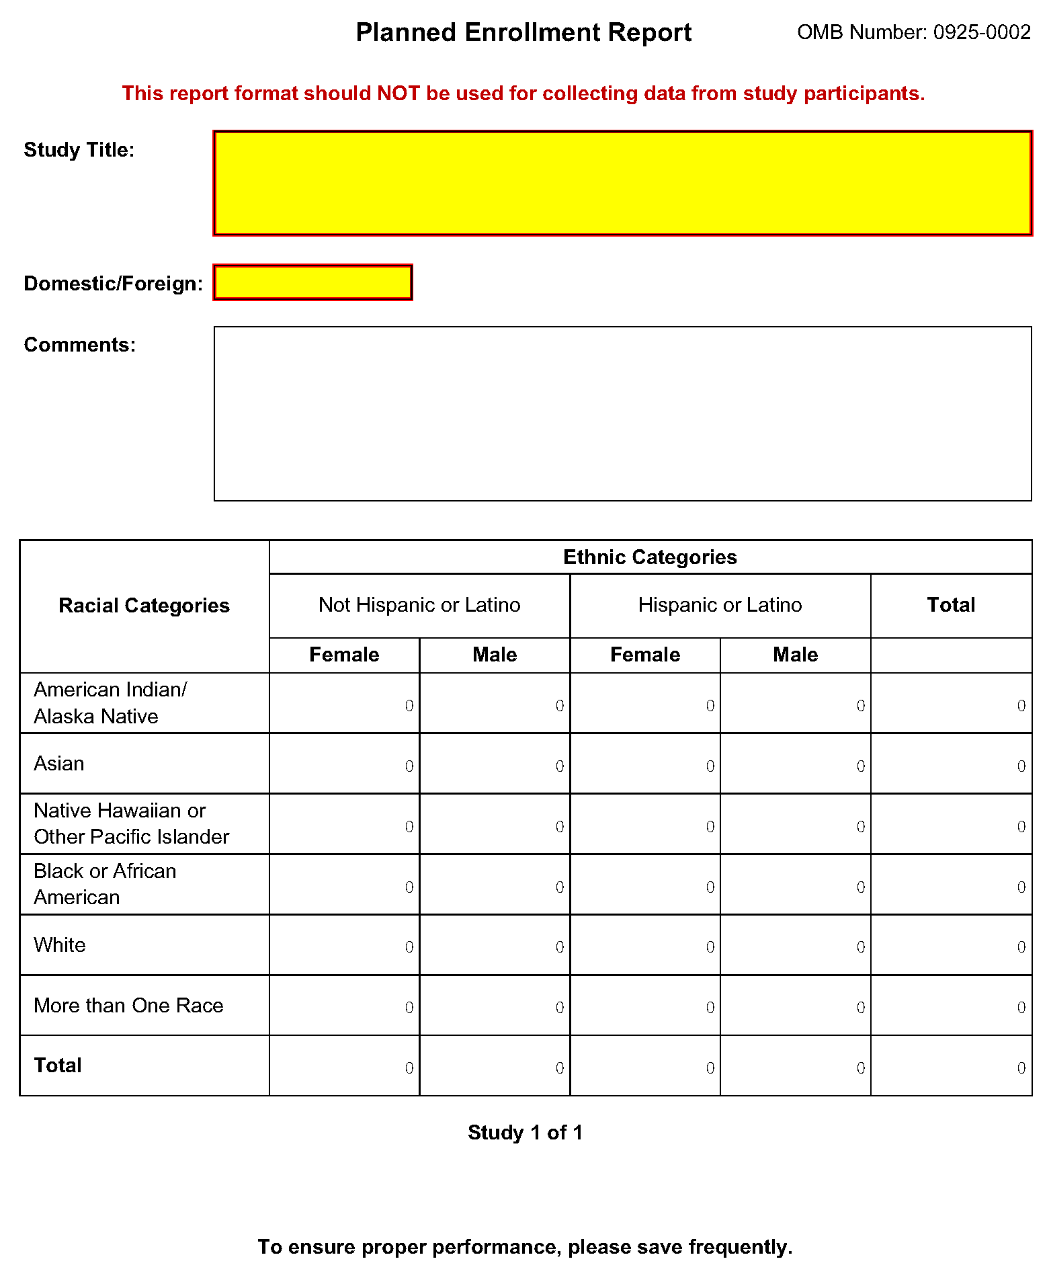

Field Name | Instructions
Study Title | Enter a unique title that describes the study that the participants will be involved in. If there is more than one study, provide a separate Study Title for each. Follow the instructions provided in the Application Guide and the FOA regarding the Inclusion of Women and Minorities. Maximum 250 characters. This is a required field.
Domestic/Foreign | Select whether the participants described in the planned enrollment report are domestic or foreign. At a minimum, domestic and foreign participants must be reported separately even if for the same study. This is a required field.
Comments | Enter information you wish to provide about this planned enrollment report. This includes but is not limited to addressing information about distinctive subpopulations if relevant to the scientific hypotheses being studied and/or a study that will have a delayed onset. Maximum 500 characters.
American Indian/Alaska Native | Enter the expected number of females and males (in the respective fields) who are American Indian/Alaska Native and Not Hispanic or Latino, and; enter the expected number of females and males (in the respective fields) who are American Indian/Alaska Native and Hispanic or Latino. These are required fields.
Asian | Enter the expected number of females and males (in the respective fields) who are Asian and Not Hispanic or Latino, and; enter the expected number of females and males (in the respective fields) who are Asian and Hispanic or Latino. These are required fields.
Native Hawaiian or Other Pacific Islander | Enter the expected number of females and males (in the respective fields) who are Native Hawaiian or Other Pacific Islander and Not Hispanic or Latino, and; enter the expected number of females and males (in the respective fields) who are Native Hawaiian or Other Pacific Islander and Hispanic or Latino. These are required fields.
Black or African American | Enter the expected number of females and males (in the respective fields) who are Black or African American and Not Hispanic or Latino, and; Enter the expected number of females and males (in the respective fields) who are Black or African American and Hispanic or Latino. These are required fields.
White | Enter the expected number of females and males (in the respective fields) who are White and Not Hispanic or Latino, and; enter the expected number of females and males (in the respective fields) who are White and Hispanic or Latino. These are required fields.
More than One Race | Enter the expected number of females and males (in the respective fields) who identify with more than one racial category and are Not Hispanic or Latino, and; enter the expected number of females and males (in the respective fields) who identify with more than one racial category and are Hispanic or Latino. These are required fields.
Total | The total fields at the bottom are auto-calculated to total all racial categories for females and males who are Not Hispanic or Latino and all racial categories for females and males who are Hispanic or Latino. The total fields at the right are auto-calculated to total all males and females of both Not Hispanic or Latino and Hispanic or Latino ethnicity in each racial category.

5.8.2 Cumulative Inclusion Enrollment Report
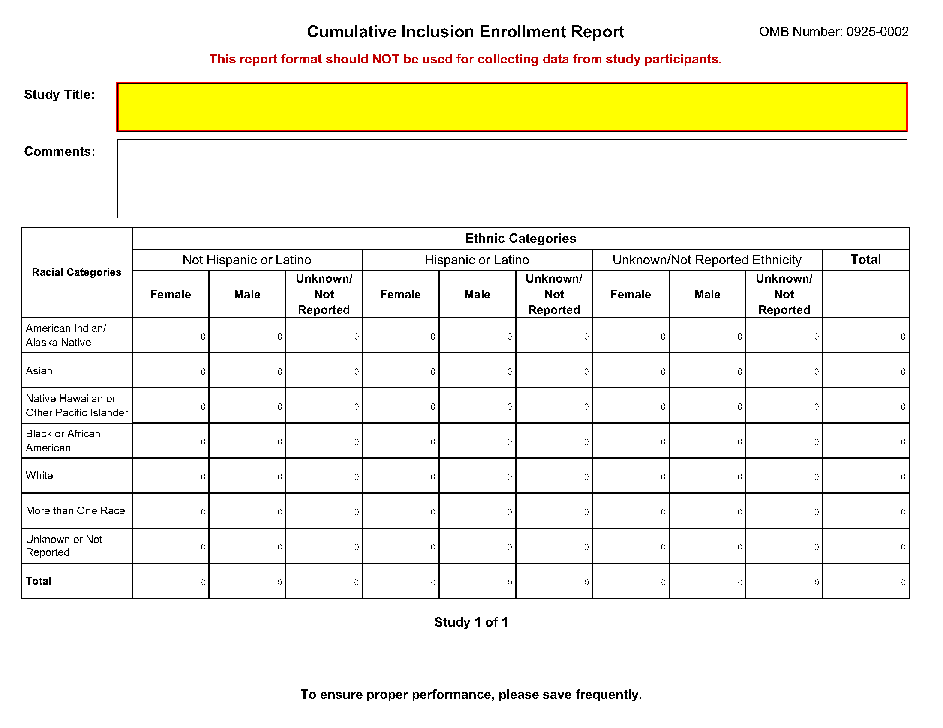
Field Name | Instructions
Study Title | Enter a unique title that describes the study that the participants will be involved in. The title should be the same as submitted on the original Planned Enrollment form for this study. Follow the instructions provided in the Application Guide and the FOA regarding the Inclusion of Women and Minorities. Maximum 250 characters. This is a required field.
Comments | Enter information you wish to provide about this Cumulative Inclusion Enrollment Report. This includes but is not limited to information if distinctive subpopulations are relevant to the scientific hypotheses being studied. Maximum 500 characters.
American Indian/Alaska Native | Enter the number of females, males, and individuals of unknown/not reported sex/gender (in the respective fields) who are American Indian/Alaska Native and Not Hispanic or Latino, and; enter the number of females, males, and individuals of unknown/not reported sex/gender (in the respective fields) who are American Indian/Alaska Native and Hispanic or Latino; and enter the number of females, males, and individuals of unknown/not reported sex/gender (in the respective fields) who are American Indian/Alaska Native and of unknown/not reported ethnicity. These are required fields.
Asian | Enter the number of females, males, and individuals of unknown/not reported sex/gender (in the respective fields) who are Asian and Not Hispanic or Latino, and; enter the number of females, males, and individuals of unknown/not reported sex/gender (in the respective fields) who are Asian and Hispanic or Latino; and enter the number of females, males, and individuals of unknown/not reported sex/gender (in the respective fields) who are Asian and of unknown/not reported ethnicity. These are required fields.
Native Hawaiian or Other Pacific Islander | Enter the number of females, males, and individuals of unknown/not reported sex/gender (in the respective fields) who are Native Hawaiian or Other Pacific Islander and Not Hispanic or Latino, and; enter the number of females, males, and individuals of unknown/not reported sex/gender (in the respective fields) who are Native Hawaiian or Other Pacific Islander and Hispanic or Latino; and enter the number of females, males, and individuals of unknown/not reported sex/gender (in the respective fields) who are Native Hawaiian or Other Pacific Islander and of unknown/not reported ethnicity. These are required fields.
Black or African American | Enter the number of females, males, and individuals of unknown/not reported sex/gender (in the respective fields) who are Black or African American and Not Hispanic or Latino, and; enter the number of females, males, and individuals of unknown/not reported sex/gender (in the respective fields) who are Black or African American and Hispanic or Latino; and enter the number of females, males, and individuals of unknown/not reported sex/gender (in the respective fields) who are Black or African American and of unknown/not reported ethnicity. These are required fields.
White | Enter the number of females, males, and individuals of unknown/not reported sex/gender (in the respective fields) who are White and Not Hispanic or Latino, and; enter the number of females, males, and individuals of unknown/not reported sex/gender (in the respective fields) who are White and Hispanic or Latino; and enter the number of females, males, and individuals of unknown/not reported sex/gender (in the respective fields) who are White and of unknown/not reported ethnicity. These are required fields.
More than One Race | Enter the number of females, males, and individuals of unknown/not reported sex/gender (in the respective fields) who identify with more than one racial category and are Not Hispanic or Latino, and; enter the number of females, males, and individuals of unknown/not reported sex/gender (in the respective fields) who identify with more than one racial category and are Hispanic or Latino; and enter the number of females, males, and individuals of unknown/not reported sex/gender (in the respective fields) who identify with more than one racial category and of unknown/not reported ethnicity. These are required fields.
Unknown or Not Reported | Enter the number of females, males, and individuals of unknown/not reported sex/gender (in the respective fields) whose race is unknown/not reported and who are Not Hispanic or Latino, and; enter the number of females, males, and individuals of unknown/not reported sex/gender (in the respective fields) whose race is unknown/not reported and who are Hispanic or Latino; and enter the number of females, males, and individuals of unknown/not reported sex/gender (in the respective fields) who are of unknown/not reported race and of unknown/not reported ethnicity. These are required fields.
Total | The total fields at the bottom are auto-calculated to total all racial categories for females, males, and individuals of unknown/not reported sex/gender who are Not Hispanic or Latino; all racial categories for females, males, and individuals of unknown/not reported sex/gender who are Hispanic or Latino, and all racial categories for females, males, and individuals of unknown/not reported sex/gender who are of unknown/not reported ethnicity. The total fields at the right are auto-calculated to total all individuals in a given racial category.

6. Peer Review Process

Overview
NIH policy is intended to ensure that applications for funding submitted to the NIH are evaluated on the basis of a process that is fair, equitable, timely, and conducted in a manner free of bias. The NIH dual peer review system is mandated by statute in accordance with section 492 of the Public Health Service Act and federal regulations governing "Scientific Peer Review of Research Grant Applications and Research and Development Contract Projects" (42 CFR part 52h).
The first level of review is carried out by a Scientific Review Group (SRG) composed primarily of non-federal scientists who have expertise in relevant scientific disciplines and current research areas. The second level of review is performed by Institute and Center (IC) National Advisory Councils or Boards. Councils composed of both scientific and lay members are chosen for their expertise, interest, or activity in matters related to health and disease. Only applications that are favorably recommended by both the SRG and the Advisory Council (or the IC in the case of fellowships) are considered for funding. Only the NIH Institute or Center may make funding decisions.
NIH has implemented Special Council Review procedures for the additional review of grant and cooperative agreement applications from Program Director(s)/Principal Investigator(s) [PD(s)/PI(s)] who already receive in excess of $1 million per year in total costs to determine if additional funds should be provided to already well-supported investigators. It is important to note that the Special Council Review does not represent a cap on total NIH funding for any one investigator. For additional information, please see NOT-OD-12-110 and NOT-OD-12-140.
A detailed description of what happens to a research project grant application at NIH after it is received for peer review can be found at the following location: http://grants.nih.gov/grants/peer_review_process.htm.
Additional information about charters and membership of SRGs, Councils, and Boards can be obtained from the appropriate Institute, Center, or Office. Information on CDC review procedures is located at http://www.cdc.gov/phpr/science/erp_policies.htm.

Streamlining
The initial scientific peer review of most applications will also include a process in which only those applications deemed by the reviewers to have the highest scientific and technical merit, generally the better half of the applications under review, will be discussed at the SRG meeting, assigned an impact score, and receive a second level review. Applications in the lower half are reviewed by SRG members but they are not discussed or assigned overall impact scores at the SRG meeting. This process allows the reviewers to focus their discussion on the most meritorious applications.
Before the review meeting, each reviewer and discussant assigned to an application will give a separate score for each of (at least) five review criteria and a preliminary impact score for that application (see below). The preliminary impact scores help the SRG to determine which applications will be discussed.

Scoring
Each FOA specifies all of the review criteria and considerations that will used in the evaluation of applications submitted for that FOA; RFAs and other types of funding opportunities (e.g., for construction or fellowship applications) may include different and/or additional review criteria and considerations. SRG members are instructed to evaluate research applications by addressing the scored review criteria (see below) and additional review criteria as applicable for the application.
For each application that is discussed, a final overall impact/priority score will be given by each eligible committee member (without conflicts of interest) following the panel discussion. Each member’s impact score will reflect his/her evaluation of the potential overall impact of the project in its entirety, rather than an arithmetic formula applied to the reviewer’s scores given to each criterion. The final impact score for each discussed application will be determined by calculating the arithmetic average of all the eligible members’ impact scores, and multiplying the average by 10.
As part of the initial merit review, and regardless of whether an application is discussed or not discussed (streamlined), all applicants will receive a written critique, called a Summary Statement. Unless stated otherwise in the FOA, the Summary Statement represents a combination of the reviewers' written comments and scores for individual criteria. The Summary Statement for discussed applications includes the Scientific Review Officer's summary of the members' discussion during the SRG meeting; the final impact score; the recommendations of the SRG, including budget recommendations; and administrative notes of special considerations. For applications that are not discussed by the full committee, the scores of the assigned reviewers and discussants for the five scored criteria will be reported individually on the Summary Statement. Final, numerical impact scores are not given for applications that are not discussed.

Research Project Evaluation Criteria
Overall Impact. Reviewers will provide an overall impact/priority score to reflect their assessment of the likelihood for the project to exert a sustained, powerful influence on the research field(s) involved, in consideration of the following scored review criteria, and additional review criteria (as applicable for the project proposed).
Scored Review Criteria. Reviewers will consider each of the five review criteria below in the determination of scientific and technical merit, and give a separate score for each. An application does not need to be strong in all categories to be judged likely to have major scientific impact. For example, a project that by its nature is not innovative may be essential to advance a field.
Significance: Does the project address an important problem or a critical barrier to progress in the field? If the aims of the project are achieved, how will scientific knowledge, technical capability, and/or clinical practice be improved? How will successful completion of the aims change the concepts, methods, technologies, treatments, services, or preventative interventions that drive this field?
Investigator(s): Are the PD/PIs, collaborators, and other researchers well suited to the project? If Early Stage Investigators or New Investigators, or in the early stages of independent careers, do they have appropriate experience and training? If established, have they demonstrated an ongoing record of accomplishments that have advanced their field(s)? If the project is collaborative or multi-PD/PI, do the investigators have complementary and integrated expertise; are their leadership approach, governance and organizational structure appropriate for the project?
Innovation: Does the application challenge and seek to shift current research or clinical practice paradigms by utilizing novel theoretical concepts, approaches or methodologies, instrumentation, or interventions? Are the concepts, approaches or methodologies, instrumentation, or interventions novel to one field of research or novel in a broad sense? Is a refinement, improvement, or new application of theoretical concepts, approaches or methodologies, instrumentation, or interventions proposed?
Approach: Are the overall strategy, methodology, and analyses well-reasoned and appropriate to accomplish the specific aims of the project? Are potential problems, alternative strategies, and benchmarks for success presented? If the project is in the early stages of development, will the strategy establish feasibility and will particularly risky aspects be managed?
If the project involves human subjects and/or NIH-defined clinical research, are the plans to address 1) the protection of human subjects from research risks, and 2) inclusion (or exclusion) of individuals on the basis of sex/gender, race, and ethnicity, as well as the inclusion or exclusion of children, justified in terms of the scientific goals and research strategy proposed?
Environment: Will the scientific environment in which the work will be done contribute to the probability of success? Are the institutional support, equipment and other physical resources available to the investigators adequate for the project proposed? Will the project benefit from unique features of the scientific environment, subject populations, or collaborative arrangements?
Additional Review Criteria. As applicable for the project proposed, reviewers will consider the following additional items in the determination of scientific and technical merit, and in providing an overall impact/priority score, but will not give separate scores for these items.
Appropriate Representation (for Conference Grant Applications): How well do the plans for inclusion of women, racial/ethnic minorities, persons with disabilities, and other individuals who traditionally have been underrepresented in science provide for their appropriate representation in the planning, organization, and execution of the proposed conference/scientific meeting? For more information, visit Inclusion of Women, Minorities and Persons with Disabilities in NIH-Supported Conference Grants
Protections for Human Subjects: For research that involves human subjects but does not involve one of the six categories of research that are exempt under 45 CFR part 46, the committee will evaluate the justification for involvement of human subjects and the proposed protections from research risk relating to their participation according to the following five review criteria: 1) risk to subjects, 2) adequacy of protection against risks, 3) potential benefits to the subjects and others, 4) importance of the knowledge to be gained, and 5) data and safety monitoring for clinical trials.
For research that involves human subjects and meets the criteria for one or more of the six categories of research that are exempt under 45 CFR part 46, the committee will evaluate: 1) the justification for the exemption, 2) human subjects involvement and characteristics, and 3) sources of materials. For additional information on review of the Human Subjects section, please refer to the Human Subjects Protection and Inclusion Guidelines.
Inclusion of Women, Minorities, and Children: When the proposed project involves human subjects and/or NIH-defined clinical research, the committee will evaluate the proposed plans for the inclusion (or exclusion) of individuals on the basis of sex/gender, race, and ethnicity, as well as the inclusion (or exclusion) of children to determine if it is justified in terms of the scientific goals and research strategy proposed. For additional information see the Human Subjects Protection and Inclusion Guidelines.
Vertebrate animals: The committee will evaluate the involvement of live vertebrate animals as part of the scientific assessment according to the following five points: 1) proposed use of the animals, and species, strains, ages, sex, and numbers to be used; 2) justifications for the use of animals and for the appropriateness of the species and numbers proposed; 3) adequacy of veterinary care; 4) procedures for limiting discomfort, distress, pain and injury to that which is unavoidable in the conduct of scientifically sound research including the use of analgesic, anesthetic, and tranquilizing drugs and/or comfortable restraining devices; and 5) methods of euthanasia and reason for selection if not consistent with the AVMA Guidelines on Euthanasia. For additional information, see http://grants.nih.gov/grants/olaw/VASchecklist.pdf.
Biohazards: Reviewers will assess whether materials or procedures proposed are potentially hazardous to research personnel and/or the environment, and if needed, determine whether adequate protection is proposed.
Resubmission Applications: When reviewing a Resubmission application the committee will evaluate the application as now presented, taking into consideration the response to comments from the previous scientific review group and changes made to the project.
Renewal Applications: When reviewing a Renewal application, the committee will consider the progress made in the last funding period.
Revision Applications: When reviewing a Revision application, the committee will consider the appropriateness of the proposed expansion of the scope of the project. If the Revision application relates to a specific line of investigation presented in the original application that was not recommended for approval by the committee, then the committee will consider whether the responses to comments from the previous scientific review group are adequate and whether substantial changes are clearly evident.
Additional Review Considerations. As applicable for the project proposed, reviewers will address each of the following items, but will not give scores for these items and should not consider them in providing an overall impact score.
Provision of Family Care Facilities (for Conference Grant Applications). Are the plans to inform attendees about family care resources adequate?
Applications from Foreign Organizations. Reviewers will assess whether the project presents special opportunities for furthering research programs through the use of unusual talent, resources, populations, or environmental conditions that exist in other countries and either are not readily available in the United States or augment existing U.S. resources.
Select Agent Research. Reviewers will assess the information provided in this section of the application, including 1) the select agent(s) to be used in the proposed research, 2) the registration status of all entities where select agent(s) will be used, 3) the procedures that will be used to monitor possession use and transfer of select agent(s), and 4) plans for appropriate biosafety, biocontainment, and security of the select agent(s).
Resource Sharing Plans. Reviewers will comment on whether the following Resource Sharing Plans, or the rationale for not sharing the following types of resources, are reasonable: 1) Data Sharing Plan (http://grants.nih.gov/grants/policy/data_sharing/data_sharing_guidance.htm); 2) Sharing Model Organisms (http://grants.nih.gov/grants/guide/notice-files/NOT-OD-04-042.html); and 3) Genome Wide Association Studies (GWAS) (http://grants.nih.gov/grants/guide/notice-files/NOT-OD-07-088.html).
Budget and Period of Support. Reviewers will consider whether the budget and the requested period of support are fully justified and reasonable in relation to the proposed research

Dual-Level Peer Review
The second level of review will usually be performed by the Advisory Council or Board of the potential awarding component (Institute, Center, or other unit). Council or Board recommendations are based not only on considerations of scientific merit, as judged by the SRGs, but also on the relevance of the proposed study to an Institute/Center’s mission, programs and priorities.
NIH has implemented Special Council Review procedures for the additional review of grant and cooperative agreement applications from Program Director(s)/Principal Investigator(s) [PD(s)/PI(s)] who already receive in excess of $1 million per year in total costs to determine if additional funds should be provided to already well-supported investigators. It is important to note that the Special Council Review does not represent a cap on total NIH funding for any one investigator. For additional information, please see NOT-OD-12-110 and NOT-OD-12-140.

7. Supplemental Instructions to the SF 424(R&R) for Preparing an Individual Research Career Development Award (CDA) Application
(“K” Series)

7.1 Introduction
All applicants must use the SF 424 R&R Application for Federal Assistance, following the instructional information in this Application Guide. The supplemental instructions found in this section (I.7) are for Individual Career Development Award (CDA) series applications and include guidance and instructional information only when there is a difference in the required information to be submitted or there is a need for more specificity for the individual K program. Therefore, these supplemental instructions must be used along with the information found in Parts I.1 – I.6 of this document.
These instructions do not cover applications for K12 and other institutional career development programs. Institutions planning such applications should consult the applicable Funding Opportunity Announcement (FOA) concerning eligibility, award criteria, and application procedures. Some K-series funded through Requests for Applications (RFAs) may have special instructions.
It is imperative that applicants become familiar with the K activity code for which support is being requested. Before applying for a K award, applicants should carefully review the applicable FOA for the career award of interest, noting especially the eligibility requirements, requirements for a mentor, review criteria, award provisions, and any special application instructions. Each FOA contains more specific information associated with the award mechanism and includes names of individuals that may be contacted prior to submission of an application for additional or clarifying information.
The eligibility criteria, support levels, and other important aspects of specific career awards, including availability, may vary among NIH Institutes or Centers and other PHS agencies. For this reason, it is strongly recommended that applicants consult with the NIH Scientific/Research contact of the appropriate awarding component prior to submitting an application. FOAs and other guidelines are available on the NIH K-Kiosk website http://grants.nih.gov/training/careerdevelopmentawards.htm. Announcements for various career award opportunities are issued periodically in the NIH Guide for Grants and Contracts, a weekly electronic publication (http://grants.nih.gov/grants/guide/index.html).
Note: A few individual K-series programs supported by the NIH include a delayed-award activation and/or two award phases (e.g., K22, K99/R00). NIH intramural researchers may be eligible to apply for these awards. The FOA will include any additional and/or specific instructions that must be followed when applying for such support.

7.2 Individual Career Development Award Programs
The following chart provides a summary of the existing Career Development programs. Since this information is subject to change, prospective applicants are encouraged to review the K-Kiosk for the most current program information. The K-Kiosk includes information on NIH-wide Parent FOAs as well as IC-specific FOAs for a particular K program.

Summary of Research Career Development Award Programs
program | description | mentor | reference letters
K01 | Mentored Research Scientist Development Award (see K Kiosk) | Yes | Yes
K02 | Independent Scientist Award (see K Kiosk) | No | No
K05 | Senior Scientist Award (see K Kiosk) | No | No
K07 | Academic Career Award (see K Kiosk) | * | *
K08 | Mentored Clinical Scientist Development Award (see K Kiosk) | Yes | Yes
K18 | Career Enhancement Award (see K Kiosk) | Yes | Yes
K22 | Career Transition Award (see K Kiosk) | * | Yes
K23 | K23 Mentored Patient-Oriented Research Career Development Award (see K Kiosk) | Yes | Yes
K24 | Mid-Career Investigator Award in Patient Oriented Research (see K Kiosk) | No | No
K25 | Mentored Quantitative Research Career Development Award (see K Kiosk) | Yes | Yes
K26 | Midcareer Investigator Award in Mouse Pathobiology Research (see K Kiosk) | No | No
K99/R00 | NIH Pathways to Independence (PI) Award (see K Kiosk) | Yes | Yes
*Varies with career status and source of award. Check the Funding Opportunity Announcement (FOA).

7.3 Letters of Reference (must be submitted electronically through the eRA Commons)
At least three (but no more than 5) Letters of Reference are required for all applications defined as New and Resubmissions (see Note below) for mentored support as indicated in the table above. The letters should be from individuals not directly involved in the application, but who are familiar with the applicant’s qualifications, training, and interests. The mentor/co-mentor(s) of the application cannot be counted toward the three required references. It is important for the applicant to include the names of those individuals in the application so that the NIH staff will be aware of planned reference letter submissions. Within the application, the list of referees (including name, departmental affiliation, and institution) is included in Other Attachments on the Other Project Information Form (see special K instructions in Section 7.4.3). In addition, applicants must include the same list and information on the SF424 (R&R) Cover Form in the Cover Letter Attachment.
The reference letters are critically important and should address the candidate's competence and potential to develop into an independent biomedical or behavioral investigator. Only those individuals who can make the most meaningful comments about the candidate's professional training and qualifications for a research career should be used as referees. Where possible, some referees who are not from the candidate's current department or organization, but are knowledgeable about their qualifications, should be selected.
Letters of Reference are due by the application receipt deadline date. Although previously NIH provided a 5 business days grace period for the receipt of letters of reference after the application receipt due date, the new policy eliminates the grace period. More information can be found in NIH Guide Notice NOT-OD-11-079.
The candidate should request reference letters only from individuals who will be able to submit them to the NIH at the time of the application submission due date (see NOT-OD-11-079).
Applications that are missing the required letters of reference may be delayed in review or may not be accepted.
Note: For resubmission applications, it is critical that NEW Letters of Reference be submitted providing up-to-date evaluation of the applicant’s potential to become an independent researcher, and the continued need for additional supervised research experience.
Electronic submission of a letter of reference is a separate process from submitting an application electronically. Reference letters are submitted directly through the eRA Commons and do not use Grants.gov. Therefore, this process requires that the referee be provided information including (a) the PI’s (candidate’s) eRA Commons user name, (b) the PI’s first and last name as they appear on the PI’s eRA Commons account, and (c) the number assigned to this Funding Opportunity Announcement.
Confirmation e-mails will be sent to both the referee and the candidate following reference letter submission. The confirmation sent to the candidate will include the referee’s name and the date the letter was submitted. The confirmation sent to the referee will include the referee and applicant’s names, a confirmation number, and the date the letter was submitted.
The candidate may check the status of submitted letters by logging into their Commons account and accessing the “check status” screen for this application. The candidate is responsible for reviewing the status of submitted reference letters and contacting referees to ensure that letters are submitted by the receipt deadline. While the candidate is able to check on the status of the submitted letters, the letters are confidential and he/she will not have access to the letters themselves. Note: Because e-mail can be unreliable, it is the candidate’s responsibility to check the status of his/her letters of reference in the Commons.
Candidates should provide the following instructions to their referees.
Instructions for Referees: (these instructions are also found at: http://grants.nih.gov/grants/funding/424/Referee_Instructions_Mentored_Career_Awards.doc)
Name of Candidate (First & Last Name as shown in the eRA Commons): _______________
Candidate’s eRA Commons UserName: _______________
FOA Number: __________________________
The candidate is applying to the NIH for a Career Development Award. The purpose of this award is to develop the research capabilities and career of the candidate. These awards provide salary support and guarantee them the ability to devote at least 9 person months (75% of their total professional effort) to research for the duration of the award. Many of these awards also provide funds for research and career development costs. The award is available to persons who have demonstrated considerable potential to become independent researchers, but who need additional supervised research experience in a productive scientific setting, as well as to newly independent researchers.
In two pages or less (PDF format), describe the qualities and potential of the candidate for the career development award program for which support is being requested. This should include your evaluation with special reference to:
- potential to become an independent research scientist;
- evidence of originality;
- adequacy of scientific background;
- quality of research endeavors or publications to date, if any;
- commitment to health-oriented research; and
- need for further research experience and training
- any additional related comments that the referee may wish to provide
Please put the name of the candidate at the top of the letter. Also, be sure to include your name and title in the letter.
Submitting Reference Letters
Letters must be submitted directly to the eRA Commons at: https://public.era.nih.gov/commons/public/reference/submitReferenceLetter.do?mode=new and must be submitted by the application receipt deadline date. More information can be found in NIH Guide Notice NOT-OD-11-079.
You will be requested to enter the following information on-line at the time of submission:
Referee Information:
- Referee First Name (Required)
- Referee Last Name Required)
- Referee MI Name (Not Required)
- Referee e-mail (Required)
- Referee institution/affiliation (Required)
- Referee department (Required)
Candidate Information:
- PI Commons User ID (Required)
- PI’s last name, as it appears on the PI’s Commons account (Required) (will be validated to ensure they match)
- Funding Opportunity Announcement (FOA) Number (Required)
- Reference letter confirmation number (Required only if resubmitting a letter; not required otherwise)
- Reference letter – two pages maximum; PDF format
After you have submitted your letter, both you and the candidate will receive a confirmation of receipt by e-mail. The confirmation sent to the candidate will include your name and the date your letter was submitted. However, the letters are confidential and the candidate will not be able to access the letters themselves. Your e-mail confirmation will include a Reference Letter Submission Confirmation Number. The Confirmation Number will be required when resubmitting letters for the current round. Please print the confirmation e-mail for your records.
Revised reference letters may be submitted at the time of the application receipt date.

7.4 K- Specific Instructions for K Applications using the SF424 (R&R) Application
Standard Instructions found in Parts I.1 – I.6 should be followed with the exceptions found in this section. Section numbers referenced below (e.g. 4.2 – 5.6) reflect those found in Part I.

7.4.1 Special Instructions for 4.2 Cover Form
Type of Application: Unless stated in the applicable FOA, individual K awards are usually not renewable nor are they supplemented/revised (contact awarding form staff if clarification is needed). Therefore, the applicant should generally check “new” or “resubmission.” “Renewal” applications are accepted only for a few K programs; thus this value should only be checked if a specific FOA states Renewals are accepted.
Proposed Project (Start and Ending Dates): The requested period of support must be within specified limits for the type of K award requested.
Project Director/Principal Investigator (PD/PI) Contact Information: Provide the name of the individual candidate (considered the PD/PI for K award programs). If the candidate is not located at the applicant organization at the time the application is submitted, the information should reflect where the candidate can be reached prior to the requested award start date. If the PD/PI is not located at the applicant organization at the time of submission, the Commons account for the PD/PI must be affiliated with the applicant organization. For additional information on creating affiliations for users in the eRA Commons, see: https://commons.era.nih.gov/commons-help/175.htm.
Note: For some career transition award programs (e.g., K22) the applicant may apply WITHOUT an institutional affiliation. These individuals should refer to the specific funding opportunity announcement (FOA) for application instructions.

Cover Letter Attachment
Mentored CDA applicants must include a cover letter. Applicants for independent CDAs are encouraged to include a cover letter with the application. The cover letter is only for internal use and will not be shared with peer reviewers. For mentored CDA applications, the cover letter must contain the same list of Referees (including name, departmental affiliation, and institution) that is included in the Other Project Information Form. Other Attachment (see Part I Section 7.4.3).
For both mentored and non-mentored K applications, the cover letter can also include the information found in Part I.4.2.

7.4.2 Special Instructions for 4.3 Research & Related Project/Performance Site Locations Form
Indicate where the work described in the Research and Career Development Plans will be conducted.

7.4.3 Special Instructions for 4.4 Other Project Information Form
Project Summary/Abstract (Do not exceed 1 page): Provide an abstract of the entire application (candidate, environment, and research). Include the candidate's immediate and long-term career goals, key elements of the research career development plan, and a description of the research project, as indicated in Part I.4.4.6.
Facilities & Other Resources: Provide in the Attachment a detailed description of the institutional facilities and resources available to the candidate, following the instructions in Part I.4.4.10. The information provided is of major importance in establishing the feasibility of the goals of the career development plan.
Other Attachments: All mentored K applications must include a list of Referees here. The list should include the name of the referee, departmental affiliation and institution. This same list must also be provided in the Cover Letter.

7.4.4 Special Instructions for 4.5 Senior/Key Person Profile(s) Form

7.4.4.1 The Candidate
For all K applications the K candidate is considered the Project Director/Principal Investigator (PD/PI). Therefore the candidate must be registered in the eRA Commons and be assigned the PI role within the Commons. Follow the instructions in Part I.2 which provides information regarding required registration in the eRA Commons.
Note that agency policies concerning “Multiple PIs” are not applicable to K applications. Therefore, do not use the PD/PI role for any other senior/key personnel.

Candidate’s Biographical Sketch
A biographical sketch attachment is required for the K candidate. Follow the page limits for the biosketch in the table of page limits (Table 2.6-1), unless specified otherwise in the FOA.
A biosketch for the K applicant should follow the instructions below:
Position Title: If the candidate is not currently located at the applicant organization, include both “current” and “projected” position titles, labeling each accordingly.
Education: Complete the educational block at the top of the format page beginning with the baccalaureate or other initial professional education, such as nursing, and include postdoctoral training; separately referencing residency training when applicable. For each entry provide the name and location of the institution;, the degree received (if applicable); the month and year the degree was received, and the field of study. For residency entries, the Field of Study section should reflect the area of residency. For non-degree education, indicate the time period covered. List professional certifications received within the last 10 years.
Personal Statement: Briefly describe why your experience and qualifications make you particularly well-suited to receive the K award for which you are applying.

Research and/or Professional Experience:
Use the headings given below instead of the instructions on the Biographical Sketch Format Page. Identify each heading.

Employment
Start with the first position held following the baccalaureate and give a consecutive record to date. Indicate the department and organization, department head or supervisor, rank, tenured or non-tenured, status (full- or part-time), and inclusive dates (month and year). When applicable, include information on military service, and, if not referenced under Education above, internships, residencies, research assistantships, fellowships, etc. If the candidate is not currently located at the applicant organization, include the projected employment position in this section as well.

Honors
List academic and professional honors chronologically, including research grants and competitive fellowships awarded to the candidate.

Professional Societies and Public Advisory Committees
Identify professional societies and related organizations in which membership has been held within the last 10 years, giving dates. Include present membership on any Federal Government public advisory committee.

Publications and Patent Citations
NIH encourages applicants to limit the list of selected peer-reviewed publications or manuscripts in press to no more than 15. The individual may choose to include selected publications based on recency, importance to the field, and/or relevance to the candidate’s proposed research. Candidates without 15 publications may substitute the following in lieu of publications:
  - Original research and theoretical treatises;
  - Non-experimental articles, e.g., review of literature in field, book chapters, etc.;
  - Books, pamphlets, etc.
For each publication, list the authors in published sequence, full title of article, journal, volume number, page numbers, and year of publication. Indicate if you previously used another name that is reflected in any of the citations. URLs or NIH PubMed Central (PMC) submission identification numbers may be included along with the full reference. While there is no limit to the number of URLs or PMC submission identification numbers that can be cited, applicants should be both judicious and concise.
Do not include manuscripts submitted or in preparation.
When citing articles that fall under the Public Access Policy, were authored or co-authored by the applicant and arose from NIH support, provide the NIH Manuscript Submission reference number (e.g., NIHMS97531) or the PubMed Central (PMC) reference number (e.g., PMCID234567) for each article. If the PMCID is not yet available because the Journal submits articles directly to PMC on behalf of their authors, indicate "PMC Journal - In Process." A list of these Journals is posted at: http://publicaccess.nih.gov/submit_process_journals.htm. Citations that are not covered by the Public Access Policy, but are publicly available in a free, online format may include URLs or PubMed ID (PMID) numbers along with the full reference (note that copies of publicly available publications are not accepted as appendix material.)

Research Support
List both selected ongoing and completed (during the last three years) research projects (Federal or non-Federal support). Begin with the projects that are most relevant to the research proposed in this application. Briefly indicate the overall goals of the projects and responsibilities of the senior/key person identified on the Biographical Sketch. Do not include number of person months or direct costs.
Don’t confuse “Research Support” with “Other Support.” Though they sound similar, these parts of the application are very different. As part of the biosketch section of the application, “Research Support” highlights your accomplishments, and those of your colleagues, as scientists. This information will be used by the reviewers in the assessment of each individual’s qualifications for a specific role in the proposed project, as well as to evaluate the overall qualifications of the research team. In contrast, “Other Support” information is required for all applications that are selected to receive grant awards. NIH staff will request complete and up-to-date “other support” information from you after peer review. This information will be used to check that the proposed research has not already been Federally-funded.

7.4.4.2 Mentor, Co-mentor, and Other Senior/Key Persons
The mentored K awards require a primary mentor, and there may be co-mentor(s), consultants and contributors. All individuals who have committed to contribute to the scientific development and execution of the project, including mentors and co-mentors, should be identified as senior/key personnel, even if they are not committing any specified measurable effort to the proposed project. Mentors and co-mentors should be assigned the Project Role of “Other Professional” and then enter “Mentor” or “Co-mentor” in the Other Project Role Category field.
Consultants should also be assigned the “Other Professional” role even if they are not committing any specified measurable effort. Then, enter the specific project role under “Other Project Role Category.”
Any individuals identified as senior/key personnel who are committing specified measurable effort should be appropriately assigned under Project Role (and Other Project Role Category, if necessary). Additional information can be found in Section 4.5.1.
Current and Pending Support for Mentors/Co-mentors: For Mentored Career Development Awards, as part of the application submission modified Current and Pending Support pages must be submitted for the mentor and co-mentor(s), but not for the candidate, on the R&R Senior/Key Person Profile (Expanded) page. Provide information on the following selected items for the mentor’s and co-mentor’s current and pending research support relevant to the candidate’s research plan. Each attachment is limited to 4 pages. Note, Current and Pending Support for the Candidate will be requested on a Just-In-Time basis.
Special Instructions for Selected Items of Current & Pending Support for Mentor/Co-Mentors
Project Number: If applicable, include a code or identifier for the project.
Source: Identify the agency, institute, foundation, or other organization that is providing the support.
Major Goals: Provide a brief statement of the overall objectives of the project, subproject, or subcontract.
Dates of Approved/Proposed Project: Indicate the inclusive dates of the project as approved/proposed. For example, in the case of NIH support, provide the dates of the approved/proposed competitive segment.
Annual Direct Costs: In the case of an active project, provide the current year’s direct cost budget. For a pending project, provide the proposed direct cost budget for the initial budget period.
Do not include information on overlap and level of effort.
For non-mentored CDAs: Candidates for non-mentored CDAs should not submit Other Support Pages at the time of application unless specified to do so in the applicable FOA.
Updated information on all active support for the candidate, mentor(s), co-mentor(s), and senior/key personnel may be requested by the awarding component prior to award.
Biographical Sketch for Mentor/Co-mentor and Other Senior/Key Person: For the biographical sketch for all individuals other than the candidate, follow the biographical sketch instructions found in Part I.4.5.
Note: K22 and K99/R00 candidates should follow instruction in the specific FOA regarding senior/key personnel.

7.4.5 Special Instructions for 4.6 Selecting the Appropriate Budget Form
K award mechanisms are not modular; therefore, only the R&R budget form is applicable and only a few budget categories are actually used. Information regarding allowable costs for the candidate and any allowable research development or other costs is included in each K program FOA. Candidates are advised to contact the targeted awarding component if uncertain about allowable amounts for the applicable K award mechanism, keeping in mind that amounts vary with awarding components. The application forms package associated with CDA funding opportunities includes the R&R Budget Form.
Instructions for completing the R&R Budget Form are provided below. Additional guidance may also be provided in the specific funding opportunity announcement.
Note: NIH intramural candidates applying for transitional career award support (e.g., K22, K99/R00) should follow instructions in the applicable FOA. For the mentored phase of these awards, budgets are negotiated with the sponsoring intramural laboratory. For awardees who receive approval to transition to the extramural phase, a budget will be required as part of the extramural sponsored application.

7.4.6 Special Instructions for 4.7 R&R Budget Form
Follow the instructions provided in Part I.4.7 with the following exceptions:
4.7.1. A. Senior/Key Person: In general this section should include the name of the candidate only. Do not include the mentor(s) or any other senior/key persons. For the candidate, provide the base salary, person months, and requested salary and fringe benefits. For person months, be reminded that K programs include a minimum effort requirement, usually 75% or 9 academic person months. For the salary column, most NIH ICs limit the amount of salary provided for K programs. However, applicants should include information on actual institutional base salary and the actual amount of salary and fringe being requested. ICs may request updated salary information prior to award. Any adjustments based on policy limitations will be made at the time of the award.
4.7.1. B. Other Personnel: In general, leave this section blank.
4.7.2. C – E: Leave these sections blank.
4.7.3 F. Other Direct Costs: In the Material and Supplies field (F.1), enter the total research development support being requested for the initial year of the K award. Usually, a specific total amount is allowed for research development and other costs (tuition, fees, research supplies, equipment, computer time, travel, etc) that do not require individual cost category identification. Unless instructed differently in the applicable FOA, applicants should enter only the total requested research development support amount in this box. All remaining budget fields in this section should be left blank.
Please note that while this method of entering only the total requested research development support (RDS) costs in section F will be simplest for most applicants, some applicants, including some system-to-system applicants, may instead choose to enter those costs in the applicable detailed budget categories. Please note that when choosing this option it is still the applicant’s responsibility to make certain the total RDS costs do not exceed the allowable total. If there are no costs within the research development support costs that affect the Indirect Cost Base calculation, the total RDS should be entered in total in F.1.
4.7.3. H. Indirect Costs: For all K applications, F&A/indirect costs are reimbursed at 8% of modified total direct costs (exclusive of tuition and fees and expenditures for equipment) rather than on the basis of a negotiated rate agreement. Follow the instructions in the chart below for completing this section.

Field Name | Instructions
Indirect Cost Type | Indicate the Indirect Cost type as Modified Total Direct Costs.
Indirect Cost Rate (%) | Indicate the indirect cost rate (also known as Facilities & Administrative Costs [F&A]) as 8%.
Indirect Cost Base ($) | Enter the amount of the base for the indirect cost type.
Funds Requested | Enter the funds requested for the indirect cost type.
Total Indirect Costs | The total funds requested for indirect costs.
Cognizant Federal Agency | Enter “Not Applicable.” Alternatively, applicants may provide the name of the cognizant Federal agency, name, and phone number of the individual responsible for negotiating your rate. Either response is acceptable since indirect costs will be reimbursed as 8% of modified total direct costs rather than on the basis of a negotiated rate agreement.
4.7.3.K Budget Justification: Use this to provide a detailed description and justification for specific items within the Research Development Support costs; e.g., all equipment, supplies, and other personnel that will be used to help achieve the career development and research objectives of this award.

7.4.7 Special Instructions for 5. Completing PHS 398 Forms

5.1 Overview
In conjunction with the SF424 (R&R) forms, NIH and other PHS agencies grants applicants should also complete and submit additional forms titled “PHS 398.” Note the PHS 398 forms include additional data required by the agency for a complete application. While these are not identical to the PHS 398 application form pages, the PHS 398 reference is used to distinguish these additional data requirements from the data collected in the SF424 (R&R) forms. A complete application to NIH and other PHS agencies will include SF424 (R&R) and PHS 398 forms. The PHS 398 forms for the individual K programs include:
- PHS 398 Cover Page Supplement (I.5.3): this supplements the data requirements in the R&R Cover Form. Follow the instructions found in Part I.5.3 and in the K specific instructions below.
- PHS 398 Career Development Award Supplemental Form (I.7.5)
Complete each form using the instructions found in Part I.5 and the K specific instructions provided below.

5.3 Cover Page Supplement Form
7. Change of Investigator / Change of Institution Questions: A change in PD/PI is not allowed for K awards.

7.5 PHS 398 Career Development Award Supplemental Form
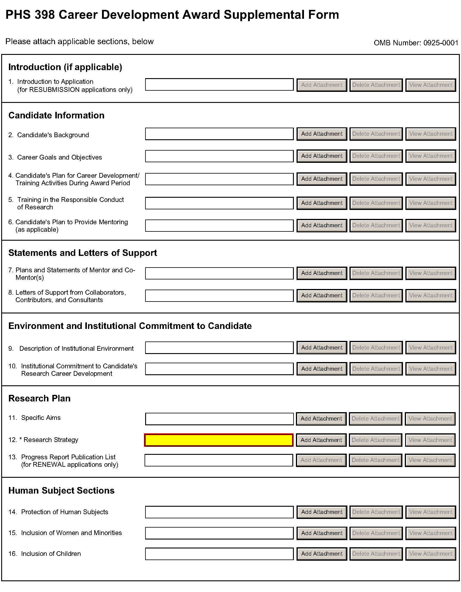
The PHS 398 Career Development Award Supplemental Form should include sufficient information needed for evaluation of the project, independent of any other document (e.g., previous application). Be specific and informative, and avoid redundancies. Some sections are required for all K award applications and some sections are only to be used when required by the FOA. Be sure to read all instructions in the FOA before completing this section since errors could lead to incomplete or rejected applications.
Career Development Award Attachments (See also Section 2.3.2 Creating PDFs for Text Attachments)
Although many of the sections of this application are separate PDF attachments, page limits referenced in the instructions and/or funding opportunity announcement must still be followed. Agency validations will include checks for page limits (and use of appropriate font). Some accommodation will be made for sections that, when combined, must fit within a specified limitation.
Text attachments should be generated using word processing software and then converted to PDF using PDF generating software. Avoid scanning text attachments to convert to PDF since that causes problems for the agency handling the application. In addition, be sure to save files with descriptive file names.
Do not include any information in a header or footer of the attachments. A header will be system-generated that references the name of the PD/PI. Page numbers for the footer will be system-generated in the complete application, with all pages sequentially numbered.
Since a number of reviewers will be reviewing applications as an electronic document and not a paper version, applicants are strongly encouraged to use only a standard, single-column format for the text. Avoid using a two-column format since it can cause difficulties when reviewing the document electronically.
Full-sized glossy photographs of material such as electron micrographs or gels must only be included within the page limits of the Career Development Award application. The maximum size of images to be included should be approximately 1200 x 1500 pixels using 256 colors. Figures must be readable as printed on an 8.5 x 11 inch page at normal (100%) scale.
Candidates must use image compression such as JPEG or PNG. Do not include figures or photographs as separate attachments either in the Appendix or elsewhere in the application.

Separate Attachments
Separate attachments have been designed for the Career Development Award Supplemental Form sections to maximize automatic validations conducted by the eRA system. When the application is received by the agency, all of the CDA Supplemental Form sections will be concatenated in the appropriate order so that reviewers and agency staff will see a single cohesive application.
When attaching a PDF document to the actual forms, please note you are attaching an actual document, not just pointing to the location of an externally stored document. Therefore, if you revise the document after it has been attached, you must delete the previous attachment and then reattach the revised document to the application form. Use the View Attachment button to determine if the correct version has been attached.

Page Limits
Follow the page limits for the Career Development Award Supplemental Form in the table of page limits (Table 2.6-1), unless specified otherwise in the FOA. All tables, graphs, figures, diagrams, and charts must be included within the 12-page limit (note that this may span to 15 pages in the eRA Commons application image due to white space inserted at the end of sections when separating files).
Follow page limitations as specified in Funding Opportunity Announcements (FOAs).
All applications and proposals for NIH funding must be self-contained within specified page limits. Agency validations will include checks for page limits. Note that while these computer validations will help minimize incomplete and/or non-compliant applications, they do not replace the validations conducted by NIH staff. Applications found not to comply with the requirements may be delayed in the review process. Unless otherwise specified in an NIH solicitation, internet website addresses (URLs) may not be used to provide information necessary to the review because reviewers are under no obligation to view the internet sites. Moreover, reviewers are cautioned that they should not directly access an internet site as it could compromise their anonymity.
Applicants are prohibited from using the Appendix to circumvent page limitations in any section of the application for which a page limit applies.” For additional information regarding Appendix material and page limits, please refer to the NIH Guide Notice NOT-OD-11-080, http://grants.nih.gov/grants/guide/notice-files/NOT-OD-11-080.html.

Notice of Proprietary Information
Applicants are discouraged from submitting information considered proprietary unless it is deemed essential for proper evaluation of the application. However, when the application contains information that constitutes trade secrets, or information that is commercial or financial, or information that is confidential or privileged, make sure you have checked “Yes” for proprietary/privileged information question in the Other Project Information form.
When information in the application constitutes trade secrets or information that is commercial or financial, or information that is confidential or privileged, it is furnished to the Government in confidence with the understanding that the information shall be used or disclosed only for evaluation of this application. However, if a grant is awarded as a result of or in connection with the submission of this application, the Government shall have the right to use or disclose the information to the extent authorized by law. This restriction does not limit the Government’s right to use the information if it is obtained without restriction from another source.
Although the grantee institution and the PD/PI will be consulted about any such release, the PHS will make the final determination. Any indication by the applicant that the application contains proprietary or privileged information does not automatically shield the information from release in response to a Freedom of Information Act (FOIA) request should the application result in an award (see 45 CFR Part 5). If an applicant fails to identify proprietary information at the time of submission as instructed in the application guide, a significant substantive justification will be required to withhold the information if requested under FOIA.

Research Plan
A Research Plan is required for all types of individual K awards. The Research Plan is a major part of the research career development plan. It is important to relate the research to the candidate's scientific career goals. Describe how the research, coupled with other developmental activities, will provide the experience, knowledge, and skills necessary to achieve the objectives of the career development plan and launch and conduct an independent research career, or enhance an established research career. For mentored K awards, explain the relationship between the candidate’s research on the CDA and the mentor’s ongoing research program.
For most types of research, the plan should include: a specific hypothesis; a list of the specific aims and objectives that will be used to examine the hypothesis; a description of the methods/approaches/techniques to be used in each aim; a discussion of possible problems and how they will be managed; and, when appropriate, alternative approaches that might be tried if the initial approaches do not work.
The Research Plan of a CDA is expected to be appropriate for, and tailored to the experience level of the candidate, and allow him/her to develop the necessary skills needed for further career advancement, and reviewers will evaluate the plan accordingly. The plan should be achievable within the requested time period. Pilot or preliminary studies and routine data gathering are generally not appropriate as the sole part(s) of a CDA research plan. Although candidates for mentored K awards are expected to write the Research Plan, the mentor should review a draft of the plan and discuss it in detail with the candidate. Review by other knowledgeable colleagues is also helpful. Although it is understood that CDA applications do not require the extensive detail usually incorporated into regular research applications, a fundamentally sound Research Plan and a reasonably detailed Approach section should be provided.
In general, less detail will be expected in descriptions of research planned for the future years of the proposed CDA. However, sufficient detail should be provided to enable the peer reviewers to determine that the plans for those years, including the approach to be used, are worthwhile and are likely to enable the candidate to achieve the objectives of the Research Plan.
The PHS 398 Career Development Award Supplemental Form is comprised of sections for: Candidate Information; Statement of Support (Mentors); Environment & Institutional Commitment to the Candidate; and the Research Plan (including Human Subjects and Other Research Plan Sections).
Begin each text section of the Candidate Information and Research Plan with a section header (e.g., Introduction, Specific Aims, Background & Significance, etc). See Specific FOA for additional information.
Field Name | Instructions
1. Introduction to Application (for RESUBMISSION applications only) | NIH policy allows a thirty-seven month window for resubmissions (A1 applications) following the submission of a New, Renewal, or Revision application (A0 application). See NIH Notice NOT-OD-12-128 for additional information/clarification of NIH policy.  Use only if Type of Application is Resubmission. Resubmission applications must include an Introduction to Resubmission Application, not to exceed one page. The Introduction must include responses to the criticisms and issues raised in the Summary Statement. Summarize the substantial additions, deletions, and changes. In the body of the application, highlight paragraphs with significant changes by bracketing and changing typography.  Save this information in a single file in a location you remember. Click Add Attachment, browse to where you saved the file, select the file, and then click Open.

Candidate Information
Field Name | Instructions
2. Candidate’s Background | This attachment is required. Follow the page limits for the Career Development Award Supplemental Form in the table of page limits (Table 2.6-1), unless specified otherwise in the FOA.  Use this section to provide any additional information not described in the Biographical Sketch Format Page such as research and/or clinical training experience.  Save this information in a single file in a location you remember. Click Add Attachment, browse to where you saved the file, select the file, and then click Open.
3. Career Goals and Objectives | This attachment is required. Follow the page limits for the Career Development Award Supplemental Form in the table of page limits (Table 2.6-1), unless specified otherwise in the FOA.  Describe your past scientific history, indicating how the award fits into past and future research career development. If there are consistent themes or issues that have guided previous work, these should be made clear; if your work has changed direction, the reasons for the change should be indicated. It is important to justify the award and how it will enable you to develop or expand your research career. You may include a timeline, including plans to apply for subsequent grant support.  Save this information in a single file in a location you remember. Click Add Attachment, browse to where you saved the file, select the file, and then click Open.
4. Candidate’s Plan for Career Development/ Training Activities During Award Period | This attachment is required. Follow the page limits for the Career Development Award Supplemental Form in the table of page limits (Table 2.6-1), unless specified otherwise in the FOA.  Stress the new enhanced research skills and knowledge you will acquire as a result of the proposed award. If you have considerable research experience in the same areas as the proposed research, reviewers may determine that the application lacks potential to enhance your research career. For mentored awards, describe structured activities, such as course work or technique workshops, which are part of the developmental plan. If course work is included, provide course numbers and descriptive titles. Briefly discuss each of the activities, except research, in which you expect to participate. Include a percentage of time involvement for each activity by year, and explain how the activity is related to the proposed research and the career development plan.  Note that recipients of mentored K awards may receive concurrent support from an NIH research grant award or cooperative agreement only under certain conditions (see NIH Notice NOT-OD-08-065).  Save this information in a single file in a location you remember. Click Add Attachment, browse to where you saved the file, select the file, and then click Open.
5. Training in the Responsible Conduct of Research | This attachment is required. Follow the page limits for the Career Development Award Supplemental Form in the table of page limits (Table 2.6-1), unless specified otherwise in the FOA.  For mentored career development awards, describe a plan to acquire instruction in the responsible conduct of research. For independent career awards, describe a plan to obtain or provide instruction in the responsible conduct of research. See Supplemental Instructions Part III Section 1.16 for information on the NIH Policy on Training in the Responsible Conduct of Research (RCR).  Attach a description of plans for obtaining instruction in the responsible conduct of research. This section should document prior instruction or participation in RCR training during the applicant’s current career stage (including the date instruction was last completed) and propose plans to either receive instruction or participate as a course lecturer, etc., in order to meet the once every four-year requirement. The plan should address how applicants plan to incorporate the five instructional parts outlined in the NIH Policy on Instruction in the Responsible Conduct of Research: format, subject matter, faculty participation, duration, and frequency. The plan may include career stage-appropriate individualized instruction or independent scholarly activities that will enhance the applicant’s understanding of ethical issues related to their specific research activities and the societal impact of that research. The role of the mentor in RCR instruction must be described.  Where applicable, Renewal applications must describe the RCR instruction activities undertaken during the project period as well as future plans.  Save this information in a single file in a location you remember. Click Add Attachment, browse to where you saved the file, select the file, and then click Open.
6. Candidate’s Plan to Provide Mentoring  (Include only when required by the specific FOA, e.g., K24 and K05) | The plan should provide information about the candidate’s commitment to serve as a mentor to other investigators, and describe previous mentoring activities. The plan should describe the setting and provide information about the available pool of mentees with appropriate backgrounds and interests in the same field of science. It should also include information on the candidate’s past and proposed mentees sufficient to evaluate the quality of prior mentoring experiences, including the professional levels of mentees, and the frequency and kinds of mentoring interactions between the candidate and the mentees. Describe the productivity of the mentoring relationship for the scientific development of the new scientists as judged by their publications and current research activities. Senior level (K05) candidates should describe any financial and material support from their own funded research and research resources that will be available to their mentees. The candidate’s proposed percent effort commitment to the mentoring plan should also be stated.  Follow the page limits for the Career Development Award Supplemental Form in the table of page limits (Table 2.6-1), unless specified otherwise in the FOA. Save this information in a single file in a location you remember. Click Add Attachment, browse to where you saved the file, select the file, and then click Open.

Statements and Letters of Support
Field Name | Instructions
7. Plans and Statements of Mentor and Co-mentor(s) | This section is to be completed by the mentor and co-mentor(s), as appropriate. The letters must be appended together and uploaded as a single pdf file. Follow the page limits for the Career Development Award Supplemental Form in the table of page limits (Table 2.6-1), unless specified otherwise in the FOA.  For mentored awards (see Summary of Career Development Award Mechanisms table), the mentor must explain how they will contribute to the development of the candidate's research career. This statement should include all of the following:  1. The plan for the candidate's training and research career development. This description must include not only research, but also other developmental activities, such as seminars, scientific meetings, training in the responsible conduct of research, and presentations. It should discuss expectations for publications over the entire period of the proposed project and define what aspects of the proposed research project the candidate will be allowed to take with him/her to start their own research program.  2. The source of anticipated support for the candidate’s research project for each year of the award period.  3. The nature and extent of supervision and mentoring of the candidate, and commitment to the candidate's development that will occur during the award period.  4. The candidate's anticipated teaching load for the period of the award (number and types of courses or seminars), clinical responsibilities, committee and administrative assignments, and the portion of time available for research.  5. A plan for transitioning the candidate from the mentored stage of his/her career to the independent investigator stage by the end of the project period of the award. The mentor should describe previous experience as a mentor, including type of mentoring (e.g., graduate students, career development awardees, postdoctoral students), number of persons mentored, and career outcomes.  All mentored career development applications should identify any and all co-mentors involved with the proposed research and career development program. Co-mentors must specifically address the nature of their role in the career development plan and how the responsibility for the candidate’s development is shared with the mentor. Describe respective areas of expertise and how they will be combined to enhance the candidate’s development. Also describe the nature of any resources that will be committed to this CDA. Letters from the mentor(s) and co-mentor(s) documenting their role and willingness to participate in the project must be included in this section of the application. Do not place these letters in the Appendix.  Save this information in a single file in a location you remember. Click Add Attachment, browse to where you saved the file, select the file, and then click Open.
8. Letters of Support from Collaborators, Contributors, and Consultants | Attach all appropriate letters of support. Letters are not required for personnel (such as research assistants) not contributing in a substantive, measurable way to the scientific development or execution of the project. For consultants, letters should include rates/charges for consulting services.  All mentored career development award applications should identify any and all collaborators, contributors, and consultants involved with the proposed research and career development program not already included in Item 7. Letters should briefly describe their anticipated contributions and document their role and willingness to participate in the project.  Additionally, non-mentored career development award applications should include letters from collaborators, consultants and contributors listing their proposed roles and documenting their willingness to participate in the project. The letters should also briefly describe research materials, data, guidance, or advice each person will provide.  Save this information in a single file in a location you remember. Click Add Attachment, browse to where you saved the file, and the click Open.

Environment and Institutional Commitment to the Candidate
Field Name | Instructions
9. Description of Institutional Environment | The sponsoring institution must document a strong, well-established research program related to the candidate's area of interest, including the names of key faculty members relevant to the candidate's proposed developmental plan. Referring to the resources description (See section 4.4.10 Facilities and Other Resources), indicate how the necessary facilities and other resources will be made available for career enhancement as well as the research proposed in this application. Describe opportunities for intellectual interactions with other investigators, including courses offered, journal clubs, seminars, and presentations. This attachment is required and is limited to one page.  Save this information in a single file in a location you remember. Click Add Attachment, browse to where you saved the file, select the file, and then click Open.
10. Institutional Commitment to Candidate’s Research Career Development | Introduction  The institution should provide a document on institutional letterhead that describes its commitment to the candidate and the candidate’s career development, independent of the receipt of the CDA. The document should include the institution’s agreement to provide adequate time and support for the candidate to devote the proposed protected time to research and career development for the entire period of the proposed award. The institution should provide the equipment, facilities, and resources necessary for a structured research career development experience. It is essential to document the institution's commitment to the retention, development and advancement of the candidate during the period of the award.  Because of the diverse types of K awards, applicants should contact the appropriate awarding component Scientific/Research contact listed in the specific FOA to determine the level of commitment required for this application.  Agreement  The applicant organization must:  a. Agree to release the candidate from other duties and activities to devote the required percentage of time for development of a research career. For most K awards, commitment of at least 75 percent of time is required. Describe actions that will be taken to ensure this; e.g., reduction of the candidate's teaching load, committee and administrative assignments, and clinical or other professional activities for the current academic year. (For example, describe the actions that will be taken to compensate for the reduction in clinic responsibilities of the candidate, e.g., hiring of additional staff). Describe the candidate's academic appointment, bearing in mind that it must be full-time, and that the appointment (including all rights and privileges pertaining to full faculty status if in an academic setting) and the continuation of salary should not be contingent upon the receipt of this award. Describe the proportion of time currently available for the candidate's research experience and what the candidate's institutional responsibilities will be if an award is made.  b. Provide the candidate with appropriate office and laboratory space, equipment, and other resources and facilities (including access to clinical and/or other research populations) to carry out the proposed Research Plan.  c. Provide appropriate time and support for any proposed mentor(s) and/or other staff consistent with the career development plan.  Signatures  The institutional commitment must be dated and signed by the person who is authorized to commit the institution to the agreements and assurances listed above. In most cases, this will be the dean or the chairman of the department. The signature must appear over the signer's name and title at the end of the statement. If the candidate will be working away from the home institution, signatures from both the home and the host institution are required.  The sponsoring institution, through the submission of the application and in the institutional commitment section, certifies that all items outlined above will be provided and that the institution will abide by the applicable assurances and PHS policies. See: NOT-OD-06-054.  This attachment is required and is limited to one page. Create a single file of the institutional letter and save it in a location you remember. Click Add Attachment, browse to where you saved the file, select the file, and then click Open.

Research Plan
Field Name | Instructions
11. Specific Aims | State precisely the goals of the proposed research and summarize the expected outcome(s) including the impact that the results of the proposed research will exert on the research field(s) involved.  List succinctly the specific objectives of the research proposed, e.g., to test a stated hypothesis, create a novel design, solve a specific problem, challenge an existing paradigm or clinical practice, address a critical barrier to progress in the field, or develop new technology.  The Specific Aims attachment is required. Follow the page limits for the Career Development Award Supplemental Form in the table of page limits (Table 2.6-1), unless specified otherwise in the FOA.  Save this information in a single file in a location you remember. Click Add Attachment, browse to where you saved the file, select the file, and then click Open.
12. Research Strategy | Follow the page limits for the Career Development Award Supplemental Form in the table of page limits (Table 2.6-1), unless specified otherwise in the FOA.  Organize the Research Strategy in the specified order and using the instructions provided below. Start each section with the appropriate section heading – Significance, Innovation, Approach. Cite published experimental details in the Research Strategy section and provide the full reference in the Bibliography and References Cited section (Part I Section 4.4.9).  - Significance  - Explain the importance of the problem or critical barrier to progress in the field that the proposed project addresses.  - Explain how the proposed project will improve scientific knowledge, technical capability, and/or clinical practice in one or more broad fields.  - Describe how the concepts, methods, technologies, treatments, services, or preventative interventions that drive this field will be changed if the proposed aims are achieved.  - Innovation  - Explain how the application challenges current research or clinical practice paradigms.  - Describe any novel theoretical concepts, approaches or methodologies, instrumentation or interventions to be developed or used, and any advantage over existing methodologies, instrumentation, or interventions.  - Approach  - Describe the overall strategy, methodology, and analyses to be used to accomplish the specific aims of the project. Unless addressed separately in the Resource Sharing Plan, include how the data will be collected, analyzed, and interpreted as well as any resource sharing plans as appropriate.  - Discuss potential problems, alternative strategies, and benchmarks for success anticipated to achieve the aims.  - If the project is in the early stages of development, describe any strategy to establish feasibility, and address the management of any high risk aspects of the proposed work.  - Point out any procedures, situations, or materials that may be hazardous to personnel and precautions to be exercised. A full discussion on the use of select agents should appear in Item 18 below.  - If research on Human Embryonic Stem Cells (hESCs) is proposed but an approved cell line from the NIH hESC Registry cannot be identified, provide a strong justification for why an appropriate cell line cannot be chosen from the Registry at this time.  If an applicant has multiple Specific Aims, then the applicant may address Significance, Innovation and Approach for each Specific Aim individually, or may address Significance, Innovation and Approach for all of the Specific Aims collectively.  As applicable, also include the following information as part of the Research Strategy, keeping within the three sections listed above: Significance, Innovation, and Approach.  Preliminary Studies for New Applications: For new applications, include information on Preliminary Studies. Discuss the PD/PI’s preliminary studies, data, and or experience pertinent to this application.  Progress Report for Renewal and Revision Applications. For renewal/revision applications, provide a Progress Report. Provide the beginning and ending dates for the period covered since the last competitive review. Summarize the specific aims of the previous project period and the importance of the findings, and emphasize the progress made toward their achievement. Explain any significant changes to the specific aims and any new directions including changes to the specific aims and any new directions including changes resulting from significant budget reductions. A list of publications, patents, and other printed materials should be included in the Progress Report Publication List; do not include that information here.  Save this information in a single file in a location you remember. Click Add Attachment, browse to where you saved the file, select the file, and then click Open.
13. Progress Report Publication List  (for RENEWAL applications only) | List the titles and complete references to all appropriate publications, manuscripts accepted for publication, patents, and other printed materials that have resulted from the project since it was last reviewed competitively. When citing articles that fall under the Public Access Policy, were authored or co-authored by the applicant and arose from NIH support, provide the NIH Manuscript Submission reference number (e.g., NIHMS97531) or the PubMed Central (PMC) reference number (e.g., PMCID234567) for each article. If the PMCID is not yet available because the Journal submits articles directly to PMC on behalf of their authors, indicate “PMC Journal – In Process.” A list of these journals is posted at: http://publicaccess.nih.gov/submit_process_journals.htm.  Citations that are not covered by the Public Access Policy, but are publicly available in a free, online format may include URLs or PubMed ID (PMID) numbers along with the full reference (note that copies of these publications are not accepted as appendix material).  Save this information in a single file in a location you remember. Click Add Attachment, browse to where you saved the file, select the file, and then click Open.

Human Subjects Sections
Field Name | Instructions
14. Protection of Human Subjects | Refer to Part II, Supplemental Instructions for Preparing the Human Subjects Section of the Research Plan. Complete this section if you answered “yes” to the question “are human subjects involved?” on the R&R Other Project Information Form. If you answered “no” to the question but your proposed research involves human specimens and/or data from subjects you must provide a justification in this section for your claim that no human subjects are involved.  Do not use the protection of human subjects section to circumvent the page limits of the Research Strategy.  Save this information in a single file in a location you remember. Click Add Attachment, browse to where you saved the file, select the file, and then click Open.
15. Inclusion of Women and Minorities | Refer to Part II, Supplemental Instructions for Preparing the Human Subjects Section of the Research Plan. Complete this section if you answered “yes” to the question “are human subjects involved?” on the R&R Other Project Information Form and the research does not fall under Exemption 4.  Save this information in a single file in a location you remember. Click Add Attachment, browse to where you saved the file, select the file, and then click Open.
16. Inclusion of Children | Refer to Part II Supplemental Instructions for Preparing the Human Subjects Section of the Research Plan, Sections 4.4 and 5.7 Complete this section if you answered “yes” to the question “are human subjects involved?” on the R&R Other Project Information Form and the research does not fall under Exemption 4.  Save this information in a single file in a location you remember. Click Add Attachment, browse to where you saved the file, select the file, and then click Open.
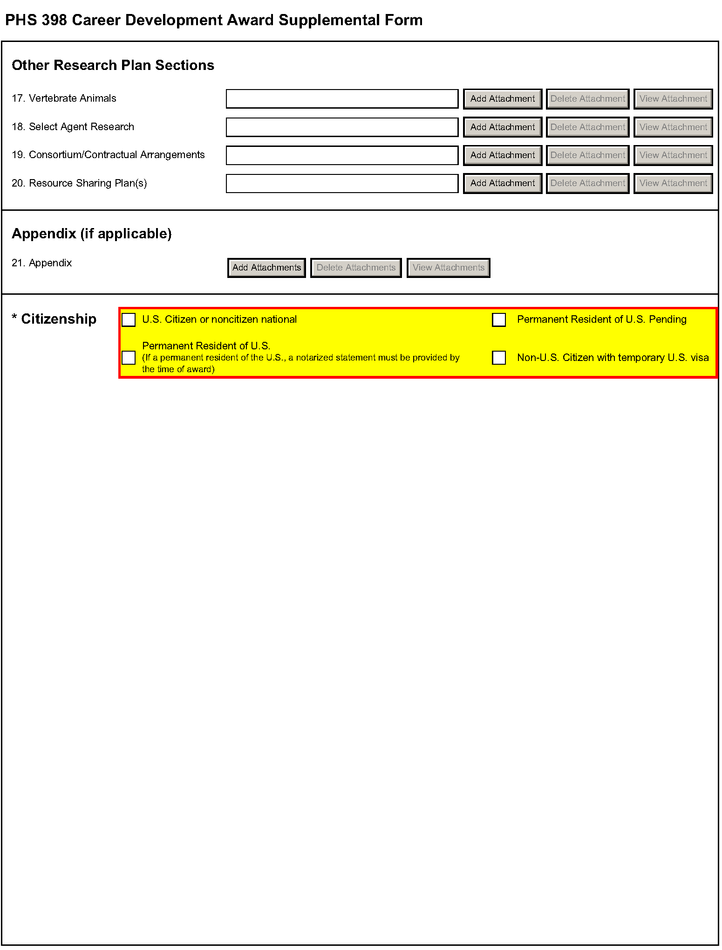

Other Research Plan Sections
Field Name | Instructions
17. Vertebrate Animals | Complete this section if you answered “yes” to the question “are Vertebrate Animals Used?” on the R&R Other Project Information Form.  If Vertebrate Animals are involved in the project, address each of the five points below. This section should be a concise, complete description of the animals and proposed procedures. While additional details may be included in the Research Strategy, the responses to the five required points below must be cohesive and include sufficient detail to allow evaluation by peer reviewers and NIH staff. If all or part of the proposed research involving vertebrate animals will take place at alternate sites (such as project/performance or collaborating site(s)), identify those sites and describe the activities at those locations. Although no specific page limitation applies to this section of the application, be succinct. Failure to address the following five points will result in the application being designated as incomplete and will be grounds for the PHS to defer the application from the peer review round. Alternatively, the application’s impact/priority score may be negatively affected.  If the involvement of animals is indefinite, provide an explanation and indicate when it is anticipated that animals will be used. If an award is made, prior to the involvement of animals the grantee must submit to the NIH awarding office detailed information as required in points 1-5 below and verification of IACUC approval. If the grantee does not have an Animal Welfare Assurance then an applicable Animal Welfare Assurance will be required (See Supplemental Instructions Part III Section 2.2 Vertebrate Animals for more information).  The five points are as follows:  1. Provide a detailed description of the proposed use of the animals in the work outlined in the Research Strategy section. Identify the species, strains, ages, sex, and numbers of animals to be used in the proposed work.  2. Justify the use of animals, the choice of species, and the numbers to be used. If animals are in short supply, costly, or to be used in large numbers, provide an additional rationale for their selection and numbers.  3. Provide information on the veterinary care of the animals involved.  4. Describe the procedures for ensuring that discomfort, distress, pain, and injury will be limited to that which is unavoidable in the conduct of scientifically sound research. Describe the use of analgesic, anesthetic, and tranquilizing drugs and/or comfortable restraining devices, where appropriate, to minimize discomfort, distress, pain, and injury.  5. Describe any method of euthanasia to be used and the reasons for its selection. State whether this method is consistent with the recommendations of the American Veterinary Medical Association (AVMA) Guidelines on Euthanasia. If not, include a scientific justification for not following the recommendations.  For additional information, see http://grants.nih.gov/grants/olaw/VASchecklist.pdf  Do not use the vertebrate animal section to circumvent the page limits of the research strategy.  Save this information in a single file in a location you remember. Click Add Attachment, browse to where you saved the file, select the file, and then click Open.
 | For those applicants familiar with the PHS 398, please note that the Literature Cited section of the Research Plan is now captured as “Bibliography & References Cited” in the Other Project Information Form.
18. Select Agent Research | Select agents are hazardous biological agents and toxins that have been identified by DHHS or USDA as having the potential to pose a severe threat to public health and safety, to animal and plant health, or to animal and plant products. CDC maintains a list of these agents. See http://www.cdc.gov/od/sap/docs/salist.pdf.  If the activities proposed in your application involve only the use of a strain(s) of select agents which has been excluded from the list of select agents and toxins as per 42 CFR 73.4(f)(5), the select agent requirements do not apply. Use this section to identify the strain(s) of the select agent that will be used and note that it has been excluded from this list. The CDC maintains a list of exclusions at http://www.cdc.gov/od/sap/sap/exclusion.htm.  If the strain(s) is not currently excluded from the list of select agents and toxins but you have applied or intend to apply to DHHS for an exclusion from the list, use this section to indicate the status of your request or your intent to apply for an exclusion and provide a brief justification for the exclusion.  If any of the activities proposed in your application involve the use of select agents at any time during the proposed project period, either at the applicant organization or at any other performance site, address the following three points for each site at which select agent research will take place. Although no specific page limitation applies to this section, be succinct.  1. Identify the select agent(s) to be used in the proposed research.  2. Provide the registration status of all entities* where select agent(s) will be used.  - If the performance site(s) is a foreign institution, provide the name(s) of the country or countries where select agent research will be performed.  *An “entity” is defined in 42 CFR 73.1 as “any government agency (Federal, State, or local), academic institution, corporation, company, partnership, society, association, firm, sole proprietorship, or other legal entity.”  3. Provide a description of all facilities where the select agent(s) will be used.  - Describe the procedures that will be used to monitor possession, use and transfer of the select agent(s).  - Describe plans for appropriate biosafety, biocontainment, and security of the select agent(s).  - Describe the biocontainment resources available at all performance sites.  If you are responding to a specific FOA, address any requirements specified by the FOA.  Reviewers will assess the information provided in this Section, and any questions associated with select agent research will need to be addressed prior to award.  Save this file in a location you remember. Click Add Attachment, browse to where you saved the file, select the file, and then click Open.
19. Consortium/Contractual Arrangements | Explain the programmatic, fiscal, and administrative arrangements to be made between the applicant organization and the consortium organization(s). If consortium/contractual activities represent a significant portion of the overall project, explain why the applicant organization, rather than the ultimate performer of the activities, should be the grantee. The signature of the Authorized Organization Representative on the SF424 (R&R) cover form signifies that the applicant and all proposed consortium participants understand and agree to the following statement:  The appropriate programmatic and administrative personnel of each organization involved in this grant application are aware of the agency’s consortium agreement policy and are prepared to establish the necessary inter-organizational agreement(s) consistent with that policy.  A separate statement is no longer required.  Save this information in a single file in a location you remember. Click Add Attachment, browse to where you saved the file, select the file, and then click Open.
20. Resource Sharing Plan(s) | NIH considers the sharing of unique research resources developed through NIH-sponsored research an important means to enhance the value and further the advancement of the research. When resources have been developed with NIH funds and the associated research findings published or provided to NIH, it is important that they be made readily available for research purposes to qualified individuals within the scientific community. See Supplemental Instructions Part III, 1.5 Sharing Research Resources.  1. Data Sharing Plan: Investigators seeking $500,000 or more in direct costs (exclusive of consortium F&A) in any year are expected to include a brief 1-paragraph description of how final research data will be shared, or explain why data-sharing is not possible. Specific Funding Opportunity Announcements may require that all applications include this information regardless of the dollar level. Applicants are encouraged to read the specific opportunity carefully and discuss their data-sharing plan with their program contact at the time they negotiate an agreement with the Institute/Center (IC) staff to accept assignment of their application. See Data-Sharing Policy or http://grants.nih.gov/grants/guide/notice-files/NOT-OD-03-032.html.  2. Sharing Model Organisms: Regardless of the amount requested, all applications where the development of model organisms is anticipated are expected to include a description of a specific plan for sharing and distributing unique model organisms or state why such sharing is restricted or not possible. See Sharing Model Organisms Policy, and NIH Guide NOT-OD-04-042.  3. Genome Wide Association Studies (GWAS): Applicants seeking funding for a genome-wide association study are expected to provide a plan for submission of GWAS data to the NIH-designated GWAS data repository, or an appropriate explanation why submission to the repository is not possible. GWAS is defined as any study of genetic variation across the entire genome that is designed to identify genetic associations with observable traits (such as blood pressure or weight) or the presence or absence of a disease or condition. For further information see Policy for Sharing of Data Obtained in NIH Supported or Conducted Genome-Wide Association Studies, NIH Guide NOT-OD-07-088, and http://gwas.nih.gov/.  Save this information in a single file in a location you remember. Click Add Attachment, browse to where you saved the file, select the file, and then click Open.
21. Appendix | Do not use the appendix to circumvent the page limits of the Candidate Information and the Research Strategy or any other section of the application for which a page limit applies. For additional information regarding Appendix material and page limits, please refer to the NIH Guide Notice NOT-OD-11-080, http://grants.nih.gov/grants/guide/notice-files/NOT-OD-11-080.html.  Only one copy of appendix material is necessary. Use the Add Attachments button to the right of this field to complete this entry.  Use the Add Attachments button to complete this entry. A maximum of 10 PDF attachments is allowed in the Appendix. If more than 10 appendix attachments are needed, combine the remaining information into attachment #10. Note that this is the total number of appendix items, not the total number of publications. When allowed there is a limit of 3 publications that are not publicly available (see below for further details and check the FOA for any specific instructions), though not all grant mechanisms allow publications to be included in the appendix.  Appendix material may not appear in the assembled application in the order attached, so it is important to use filenames for attachments that are descriptive of the content. A summary sheet listing all of the items included in the appendix is also encouraged but not required. When including a summary sheet, it should be included in the first appendix attachment. Applications that do not follow the appendix requirements may be delayed in the review process.  New, resubmission, renewal, and revision applications may include the following materials in the Appendix:  - Publications – No longer allowed as appendix materials except in the circumstances noted below. Applicants may submit up to 3 of the following types of publications:  - Manuscripts and/or abstracts accepted for publication but not yet published: The entire article should be submitted as a PDF attachment.  - Manuscripts and/or abstracts published, but a free, online, publicly available journal link is not available: The entire article should be submitted as a PDF attachment.  - Patents directly relevant to the project: The entire document should be submitted as a PDF attachment.  - Do not include unpublished theses, or abstracts/manuscripts submitted (but not yet accepted) for publication.)  - Surveys, questionnaires, and other data collection instruments; clinical protocols and informed consent documents may be submitted in the Appendix as necessary.  - For materials that cannot be submitted electronically or materials that cannot be converted to PDF format (e.g., medical devices, prototypes, DVDs, CDs), applicants should contact the Scientific Review Officer for instructions following notification of assignment of the application to a study section. Applicants are encouraged to be as concise as possible and submit only information essential for the review of the application.  Items that must not be included in the appendix:  - Photographs or color images of gels, micrographs, etc., are no longer accepted as Appendix material. These images must be included in the Research Plan PDF. However, images embedded in publications are allowed.  - Publications that are publicly accessible. For such publications, the URL or PMC submission identification numbers along with the full reference should be included as appropriate in the Bibliography and References cited section, the Progress Report Publication List section, and/or the Biographical Sketch section.

3. Citizenship
One selection is required. Please select the most appropriate response from the options provided. Other than for the K99/R00 award program, the candidate must be a citizen or non-citizen national of the United States or its possessions and territories, or must have been lawfully admitted to the United States for permanent residence by the time of award.
For those K award programs with a citizenship requirement, an individual who has applied for Permanent Residence and expects to have obtained such status prior to the time award, may submit an application recognizing that no award will be made until legal verification of permanent resident status is provided. If a candidate’s citizenship status changes after submission of the application, the new status should be reported in the candidate’s Personal Profile in the eRA Commons. Before an award is issued, a permanent resident will be required to submit a notarized statement that a licensed notary has seen the candidate’s current and valid Permanent Resident Card or some other valid verification from the U.S. Immigration and Naturalization Service of legal admission to the U.S. as a permanent resident.
It is the responsibility of the sponsoring institution to determine and retain documentation indicating that the individual candidate’s visa will allow him/her to reside in the proposed research training/career development setting for the period of time necessary to complete the approved career development program. Information may be requested by the NIH prior to issuance of an award.
Each candidate must check the applicable box, check only one:
- U.S. Citizen or non-citizen national: Check this box if the candidate is a U.S. Citizen or Noncitizen national. Noncitizen nationals are people, who, although not citizens of the United States, owe permanent allegiance to the United States. They generally are people born in outlying possessions of the United States (e.g., American Samoa and Swains Island).;
- Permanent Resident of U.S.: Check this box if the candidate has been lawfully admitted for permanent residence; i.e., is in the possession of a current and valid Permanent Resident Card or other legal verification of such status. A notarized statement will be required as part of the pre-award process.
- Permanent Resident of U.S. Pending: Check this box if the candidate has applied for Permanent Residence and expects to have obtained such status prior to the time of award. A notarized statement will be required as part of the pre-award process.
- Non-U.S. citizen with temporary U.S. visa: This box is applicable only to specific programs that do not require U.S. citizenship or permanent residency; e.g. K99/R00. The NIH awarding component may request verifying information as part of the pre-award process.

7.6 Career Development Award Peer Review Process
The goal of NIH-supported career development programs is to help ensure that diverse pools of highly trained scientists are available in adequate numbers and in appropriate research areas to address the Nation’s biomedical, behavioral, and clinical research needs. Each application must be tailored to the individual candidate.
The general process information (Overview, Streamlining, and Dual-Level Peer Review) found in Part I.6 applies to K applications as well. However, the actual review criteria and other review considerations are different. For K applications, the scientific review group will address individual career development award applications by considering information provided for each of the following elements in the application:
Review Criteria:
- Candidate
- Career Development Plan/Career Goals & Objectives/Plan to Provide Mentoring
- Research Plan
- Mentor(s), Co-Mentor(s), Consultant(s), Collaborator(s)
- Environment and Institutional Commitment to the Candidate
Additional Review Criteria include the following;
- Protection of Human Subjects from Research Risk
- Inclusion of Women, Minorities, and Children in Research
- Care and Use of Vertebrate Animals in Research
- Biohazards
- Resubmission Applications
- Renewal Applications (as applicable)
Additional Review Considerations include the following:
- Training in the Responsible Conduct of Research
- Select Agents
- Resource Sharing Plans
- Budget and Period of Support
Candidates should carefully review the applicable FOA for complete information associated with the peer review process. The FOA will describe essential information to be submitted for each of the above elements.

8. Supplemental Instructions to the SF424 (R&R) for Preparing Institutional Ruth L. Kirschstein National Research Service Award (NRSA) Application

8.1 Introduction
All applicants must use the SF 424 (R&R) Application for Federal Assistance, following the instructional information in this section. The supplemental instructions found in this section (8) are for Institutional National Ruth L. Kirschstein National Research Service Award (NRSA) applications and include guidance and instructional information only when there is a difference in the required information to be submitted or there is a need for more specificity for the institutional research training program. Therefore, these supplemental instructions must be used along with the information found in Part I.1 – I.6 (see specific training grant review process at the end of Section 8) of this document.
These instructions apply to NIH-supported NRSA institutional research training programs (e.g., T32, T34, T35, T90). Some training programs are funded through Requests for Applications (RFAs) and may have special instructions.
Additionally, there are non-NRSA programs (e.g. T15, T37, D43, D71) which include research training under different regulatory authorities, and, while some of the information may be the same, it is important for individuals interested in those programs to carefully read the applicable Funding Opportunity Announcement (FOA) for specific program information and special application instructions. These training programs may have different eligibility requirements, submission dates, award provisions, and review criteria.
It is imperative that applicants become familiar with the NIH Research Training Activity code for which support is being requested, and applicants should carefully review the applicable FOA which contains more specific information associated with the award mechanism and the names of individuals that may be contacted for additional or clarifying information prior to submission of an application. Announcements for various training programs are issued periodically in the NIH Guide for Grants and Contracts, a weekly publication (http://grants.nih.gov/grants/guide/index.html).
This section includes instructions to be used when applying for competing (New, Renewal, Resubmission or Revision) institutional training grants, including both PHS Institutional Ruth L. Kirschstein National Research Service Awards (Kirschstein-NRSA) and non-NRSA awards. The contents include substitute both budget pages, and instructions for the Research Training Program Plan. Begin by reading the previous Sections 4 and 5, and then follow both sets of instructions.
Prior to preparing an application, review the Funding Opportunity Announcement (FOA) to which you are responding and consult with the appropriate PHS awarding component identified in the FOA. Current NIH-wide T32, T34 or T35 Kirschstein-NRSA Program Announcements (PA) are available at (http://grants.nih.gov/training/nrsa.htm). Note especially the eligibility requirements, submission dates, review criteria, award provisions, and payback provisions (when applicable). PAs are also issued periodically by the individual NIH Institutes or Centers in the NIH Guide for Grants and Contracts. This information is available from the appropriate PHS agency, from grantee offices of sponsored programs, or equivalent offices.
Please note that for Kirschstein-NRSA programs that include postdoctoral trainees, the Program Director must explain the terms of the payback service requirement to all prospective postdoctoral training candidates. A complete description of the service payback obligation is available in the relevant NRSA Program Announcement or the NIH Grants Policy Statement.

8.2 Institutional Research Training Programs
Prospective applicants are encouraged to review the T Kiosk for the most current program information. The T Kiosk includes information on NIH-wide Parent FOAs as well as IC-specific FOAs for a particular T programs. In addition, non-NRSA training programs are described here: http://grants.nih.gov/training/F_files_non_nrsa.htm.

8.3 Reserved

8.4 Specific Instructions for Institutional Training Grant Applications using the SF424 (R&R) Application
Standard instructions found in Parts I.1 – I.6 should be followed with the exceptions found in this section. Section numbers referenced below (e.g. 4.2 - 5.6) reflect those found in Part I.

8.4.1 Special Instructions for 4.2 Cover Form

Proposed Project Start and Ending Dates
The usual starting date for an institutional Kirschstein-NRSA is July 1, but there are other possible starting dates. Consult the webpage of Standard Due Dates for Competing Applications (http://grants.nih.gov/grants/funding/submissionschedule.htm). Many PHS awarding components restrict submission and review dates to once a year. Applicants are strongly encouraged to contact the appropriate awarding component staff before submitting an application.

8.4.2 Special Instructions for 4.3 Research & Related Project/Performance Site Locations
List all of the locations where training, program management, and the research training experiences described in the Research Training Program Plan (8.7) will be performed. If a Project/Performance Site will be engaged in research involving human subjects, it is the responsibility of the applicant organization to assure that all Project/Performance Sites comply with the human subject protection regulations in 45 CFR part 46 and NIH policies for the protection of human subjects. For research involving live vertebrate animals, the applicant organization must supply information for all training sites where animals will be used by trainees. The applicant organization is responsible for assuring that all Project/Performance Sites have a current Animal Welfare Assurance and comply with the PHS Policy on Humane Care and Use of Laboratory Animals.

8.4.3 Special Instructions for 4.4 Research & Related Other Project Information Form

Are Human Subjects Involved?
Check “Yes” if training plans include or potentially will include involvement of trainees in projects that include human subjects as defined by 45 CFR 46. Check “Yes” even if the proposed project is exempt from Regulations for the Protection of Human Subjects. If no activities involving human subjects are planned, check the No box, and skip the rest of this block. This field is required.
The institution must ensure that trainees who will be involved in the design or conduct of research involving human subjects receive training in human subjects protections. It is the institution’s responsibility to ensure that trainees are properly supervised when working with human subjects.
In many instances, trainees supported by institutional training grants will be participating in research supported by research project grants for which the IRB approval or a determination of exemption exists. Existing IRB approval is sufficient for trainees, provided that the IRB determines the research would not be substantially modified by the participation of a trainee. The appropriate grants must be identified along with their IRB approval dates or exemption designation in Section 7 of the Research Training Program Plan.
Note that IRB approval information for the full training grant application is not required at the time of submission, but will be requested as Just-in-time (JIT) information prior to award. If an award is made and the research is not exempt from requirements stipulated in 45 CFR 46, and trainees will participate in research for which IRB review and approval does not otherwise exist, human subjects may not be involved and trainees may not participate in research involving human subjects unless the engaged institution has an approved FWA on file with OHRP, certification of the date of IRB approval has been submitted to and accepted by the PHS agency, and NIH requirements for human subjects protections have been addressed (see instructions in Part II, Supplemental Instructions for Preparing the Human Subjects Section of the Research Plan, and the NIH Grants Policy Statement (http://grants.nih.gov/grants/policy/nihgps_2012/index.htm)).
These policies apply to all Performance Sites.

Are Vertebrate Animals Used?
Check “Yes” if training plans include or potentially will include trainees in projects involving the use of live vertebrate animals at any time during the proposed project period.
Otherwise, check “No”, and skip the rest of this block. This field is required.
In many instances, trainees supported by institutional training grants will be participating in research supported by research project grants for which the IACUC review and approval exists. This existing IACUC approval is sufficient for trainees, provided that the research would not be substantially modified by the participation of a trainee. The appropriate grants must be identified along with their IACUC approval dates in Section 8 of the Research Training Program Plan.
Note that vertebrate animal approval information for the full training grant application is not required at the time of submission, but will be requested as Just-in-time (JIT) information prior to award. If an award is made and trainees will participate in research for which IACUC approval does not otherwise exist, vertebrate animals may not be involved and trainees may not participate in research utilizing vertebrate animals unless the institution has an OLAW-approved Animal Welfare Assurance, certification of the date of IACUC approval has been submitted to and accepted by the PHS agency, and NIH requirements for the use of vertebrate animals have been addressed.
The institution must ensure that trainees are enrolled in the institution's animal welfare training and occupational health and safety programs for personnel who have contact with animals. It is the institution's responsibility to ensure that trainees are properly supervised when working with live vertebrate animals.
These policies apply to all Performance Sites.

Project Summary/Abstract
Summarize the objectives, rationale and design of the research training program. Provide information regarding the research areas and scientific disciplines encompassed by the program. Include a brief description of the level(s) (i.e., undergraduate, predoctoral, postdoctoral, faculty) and duration of the proposed training, the projected number of participating trainees and their anticipated levels of experience. This section must be no longer than 30 lines of text and must follow the required font and margin specifications.

Project Narrative
Using no more than two or three sentences, describe the relevance of this research training program to public health. In this section, use plain language that can be understood by a general, lay audience.

Bibliography & References Cited
This item should be used only to cite references supporting the need, rationale, and approach for the training program described in the PHS 398 Research Training Program Plan. Note that the Literature Cited section of the Research Plan is captured in this section (unlike the placement in the PHS 398). Do not include lists of publications of project directors, mentors or trainees in this section, as this information will be included in the biosketches and Data Tables.

Facilities & Other Resources
Describe the facilities and resources that will be used in the proposed training program. Indicate in what ways the applicant organization will support the program, financial or otherwise (e.g., supplementation of stipends, protected time for mentoring, support for student activities). This could also include, for example, space, shared laboratory facilities and equipment, funds for curriculum development, release time for the PD/PI and participating faculty, support for additional trainees in the program, or any other creative ways to improve the climate for the establishment and growth of the research training program.

Other Attachments
Leave blank, unless specifically requested in the FOA.

8.4.4 Special Instructions for 4.5 Senior/Key Person Profile (Expanded) Form
Complete the Profile for the Program Director according to instructions in Section 4.5.
If multiple PD/PIs are proposed, explain in the Program Plan your rationale for how this will facilitate program administration. If your application involves Multiple PD/PIs, follow the directions in Section 4.5 to designate the Contact PI and to assign the PD/PI role to other senior/key persons. Additionally, the application must include a Multi-PD/PI Leadership Plan emphasizing how it will benefit the program and the trainees. Do not submit a leadership plan if you are not submitting a Multiple PD/PI application. See Part I Section 8.7 for information associated with Multiple Program Directors.
Complete the profiles for other senior/key persons according to instructions in Section 4.5.
The Program Director(s) (in case of multiple PD/PIs), training faculty and any other individuals whose contributions are critical to the development, management and execution of the Research Training Program Plan in a substantive, measurable way (whether or not salaries are reimbursed) should be identified as senior/key persons. These would include co-Director(s), if applicable, and program staff. Since these efforts are not project related research endeavors, they should not be identified in Other Support information. Do not include proposed mentors and training faculty members (other than senior/key persons) in this section. Biographical Sketches for mentors and participating faculty will be included in the PHS 398 Research Training Program Plan Form, Participating Faculty Biosketches.

8.4.5 Special Instructions for 4.7 Research & Related Budget
This form is required for use in conjunction with the PHS 398 Training Budget for the R90 portion of T90/R90 applications, and is the only budget form that should be used for K12 applications. Otherwise this form should only be used when allowed or required in an FOA or IC-specific notice or announcement. Follow instructions in Section 4.7.

8.4.6 Special Instructions for 4.6 PHS 398 Cover Page Supplement

Human Subjects
If you checked “Yes” to Human Subjects and “Yes” to Clinical Trial on the R&R Other Project Information form, you must check either “Yes” or “No” to indicate whether plans include or potentially include trainee participation in projects that are NIH-Defined Phase III Clinical Trials.

Inventions and Patents
Not applicable – leave blank.

Program Income
Check “No”.

Human Embryonic Stem Cells (hESC)
Check “Yes” if training plans include or potentially will include involvement of trainees in projects that include human embryonic stem cells.
If “Yes”, list the 4-digit NIH Registration Number of the specific cell line(s) from the NIH Human Embryonic Cell Registry, or check the box indicating that the specific stem cell line cannot be referenced at this time. Applications proposing the use of hESC must either specify a cell line(s) from the NIH Stem Cell Registry that will be used in the proposed research or, provide a strong justification for why an appropriate cell line cannot be chosen from the Registry at the time of application and a certification that one from the Registry will be used. The justification should be included in the Research Strategy section of the application. For additional guidance, see NIH Guide Notice NOT-OD-12-111 Notice of Impending Change in Peer Review Criteria and Submission Requirements for NIH Applications Involving Human Embryonic Stem Cells.
Note that individual project HESC information is not required at the time of application, but will be requested as Just-in-time (JIT) information prior to award. At that time, the NIH will require information regarding project title, mentor and specific cell line(s) from the registry (http://grants.nih.gov/stem_cells/registry/current.htm) for each trainee utilizing human embryonic stem cells in a research project. Trainees may not participate in human embryonic stem cell related research until this information is provided.

8.5 PHS 398 Training Budget
For NRSA training grant programs, use the PHS 398 Training Budget form pages and follow the instructions below. Refer to the relevant FOA or consult the PHS awarding component for current stipend levels and allowable costs.
For Non-NRSA training grant programs refer to the FOA for instructions regarding which Budget Form pages to use and how to complete them.
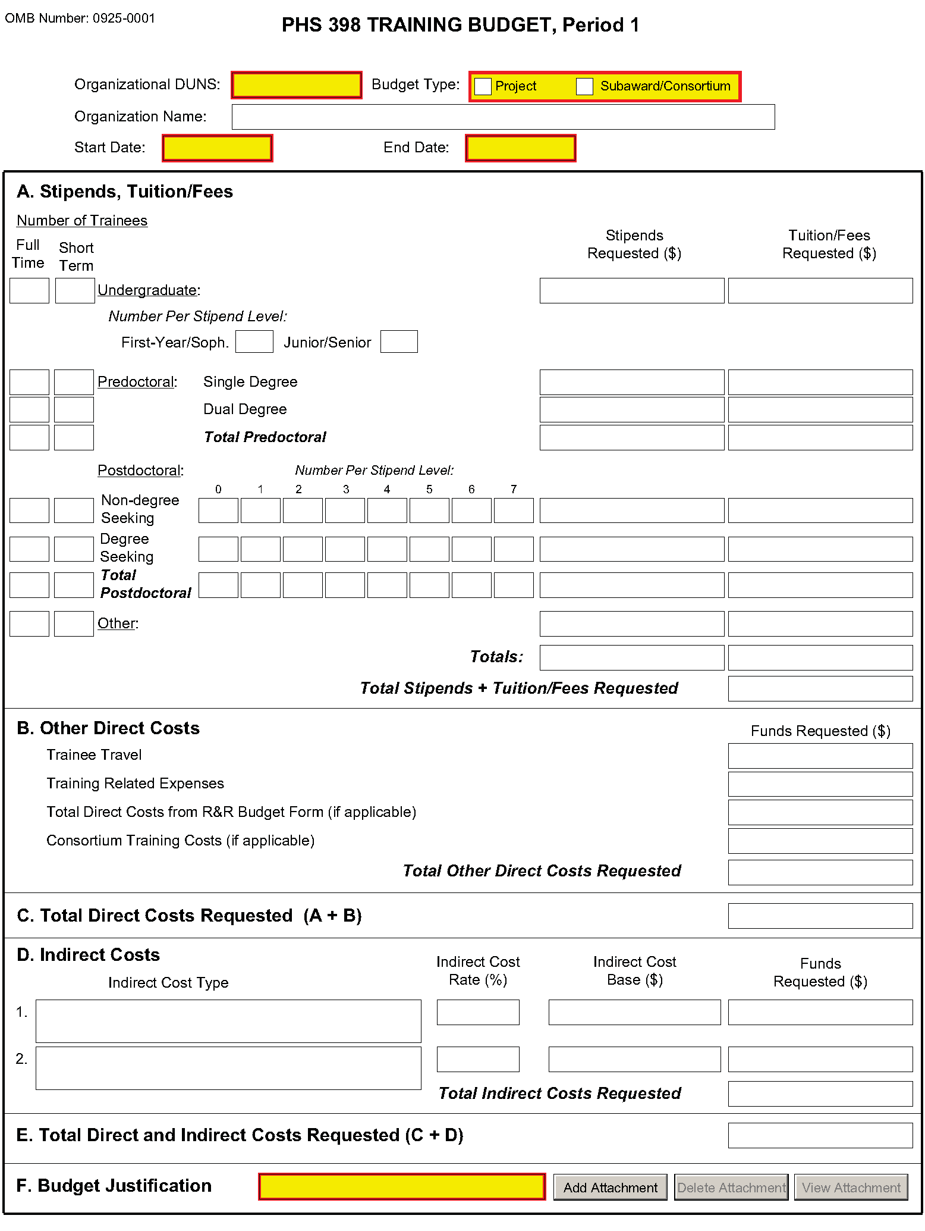
If you are requesting a budget of $500,000 direct costs or more for any year, contact the awarding component to determine whether you must obtain prior approval before submitting the application. Some Institutes/Centers do not require prior approval. (See Policy on the Acceptance for Review of Unsolicited Applications That Request $500,000 or More in Direct Costs.)

PHS 398 Training Budget, Periods 1 through 5

Part A. Stipends, Tuition/Fees
Enter the number of trainees, total stipend amount and total tuition/fees for each trainee category as appropriate. Use the current Institutional Kirschstein-NRSA stipend schedule, (http://grants.nih.gov/training/nrsa.htm). If a category contains different stipend levels, e.g., for varying levels of postdoctoral experience and/or varying appointment periods, itemize in the appropriate blocks. Enter the total stipends for all categories.
See http://grants.nih.gov/grants/guide/notice-files/NOT-OD-10-073.html for NIH policy regarding payment of tuition and fees. Tuition at the postdoctoral level is limited to that required for specified courses that are to be described in the Budget Justification (Part F.). Tuition and fees may be requested only to the extent that the same resident or nonresident tuition and fees are charged to regular non-Federally supported students and postdoctoral fellows. Where applicable, trainees should be divided into non-degree-seeking and degree-seeking categories. Note that health insurance is not included as part of this budget category. See the Training Related Expenses category below. Grantees should request full needs. The formula currently in effect will be applied by the NIH awarding component at the time an award is calculated.

Part B. Other Direct Costs
Enter the total costs for Trainee Travel, Training Related Expenses, Total Direct Costs from R&R Budget Form (if applicable) and Consortium Training Costs (if applicable).

Trainee Travel
Some NIH awarding components pay a flat rate per trainee for trainee travel for all long-term trainees. See the appropriate FOA and/or contact the awarding component to determine the amount provided for travel. In the budget justification, state the purpose of any travel, giving the number of trips involved, the destinations, and the number of trainees for whom funds are requested. PHS policy requires coach class air travel be used. Justify foreign travel in detail, describing its importance to the training experience. Enter the total amount requested in the Trainee Travel column.

Training Related Expenses (TRE)
Funds to defray other costs of training, such as health insurance (self-only or family), staff salaries, consultant costs, equipment, research supplies, staff travel, etc., are requested as a lump sum based on the amounts specified in the FOA and at http://grants.nih.gov/grants/guide/notice-files/NOT-OD-10-073.html for each predoctoral and postdoctoral trainee. Based on the number of trainees at the predetermined rate, enter the total dollar figure.
Health insurance (self-only or family, as applicable) is an allowable cost that may be requested as part of training related expenses, but only to the extent that the same health insurance fees are charged to regular non-Federally-supported students and postdoctoral fellows. The allowable TRE amount will be awarded as a lump sum. No further itemization or explanation is required.
The awarding Institute/Center will apply the Training Related Expenses level established for NRSA Institutional programs for the relevant fiscal year at the time of award.

Total Direct Costs from R&R Budget Form (if applicable)
Certain FOAs allow funds to cover costs for items other than those specified above. Use Research & Related Budget Pages, Sections A through I and K, to submit those costs. Total Direct Costs from the Research & Related Budget page should be inserted here. This line should not include any applicant indirect costs.

Consortium Training Costs (if applicable)
If training is occurring at more than one institution, and any transfer of funds between institutions occurs, the Training Subaward Budget Attachment Form should be used. (See Section 4.8). Total the direct costs from the Subaward Budget Attachment Forms and insert here. The applicant institution is responsible and accountable for any arrangements, expenditures, and submission of all required forms when more than one institution is involved in the research training program.

Part C. Total Direct Costs Requested
Total dollar amount of other direct costs requested (automatically calculated).

Part D. Indirect Costs
Facilities and Administrative (F&A) costs under Institutional Kirschstein-NRSAs, other than those issued to U.S., state, or local government agencies, will be awarded at 8%, excluding tuition/fees, equipment, and sub-grants and contracts in excess of $25,000. Equipment and consortium costs are also excluded from the F&A costs on those training grants where Training Related Expenses are not calculated and awarded on a lump-sum basis, such as the Minority Access to Research Careers Program (MARC) or Career Opportunities in Research (COR) Undergraduate Research Training Program. State and local government agencies will receive the full F&A cost rate.
Indirect Cost Type: Enter “F&A”
Indirect Cost Rate (%): Enter “8”
Indirect Cost Base ($): Enter the sum of Stipends and Total Other Direct Costs requested, regardless of whether those direct costs were listed on the PHS 398 Training Budget page or Research & Related Budget page. Indirect costs are not paid on Tuition/Fees, equipment, and sub-grants and contracts in excess of $25,000.
Funds Requested ($): Enter the product of Indirect Cost Rate multiplied by Indirect Cost Base.

Part E. Total Direct and Indirect Costs Requested (C+D)
The sum of Total Direct Costs Requested and Total Indirect Costs Requested will be calculated automatically.

Part F. Budget Justification
A detailed justification is to be attached only for the first budget period, but should reflect the entire budget period. Explain in detail the composition of any of the above items, as necessary. Itemize tuition and individual fees. If tuition varies, (e.g., in-state, out-of-state, student status) identify these separately. If tuition is requested for postdoctoral trainees, the specific courses must be described in the application. If trainee travel is not paid at a flat rate per trainee by the awarding component, state the purpose of any travel, giving the number of trips involved, the destinations, and the number of individuals for whom funds are requested, bearing in mind that PHS policy requires coach class air travel be used. For postdoctoral training slots, justify the stipend levels requested.
Any foreign travel must be justified in detail, describing its importance to the training experience and considering the type of opportunities available for training, how those opportunities differ from and complement those offered by the grantee institution, and the relationship of the proposed off-site training experience to the career stage of the grantee.
This budget justification should apply only to funds requested on the PHS 398 Training Budget form. When the Research & Related Budget Form is also used, two separate budget justifications are required, each covering the costs required in the particular budget form. Combining the information into a single upload is acceptable; however, each budget form requires a budget justification attachment so the same budget justification will need to be included in both budget forms.

PHS 398 Training Budget, Cumulative Budget
All values on this form are calculated automatically. They present the summations of the amounts that you have entered previously, for each of the individual budget periods. Therefore, no data entry is allowed or required.
If any of the amounts displayed on this form appears to be incorrect, you may correct it by adjusting one or more of the values that contribute to that total. To make any such adjustments, you will need to revisit the appropriate budget period form(s) to enter corrected values.
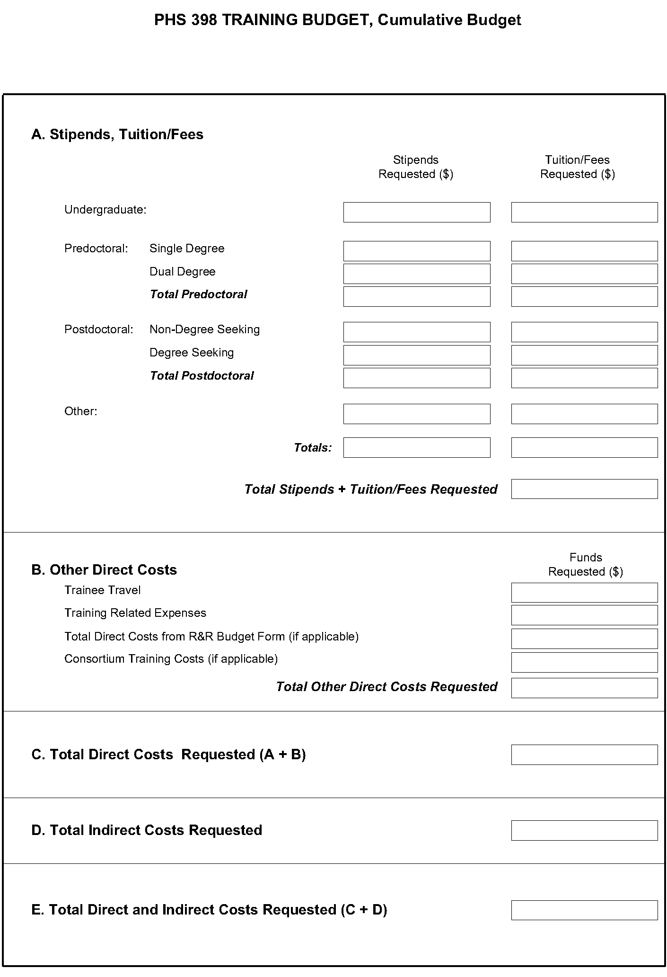

8.6 PHS 398 Training Subaward Budget Attachment(s) Form
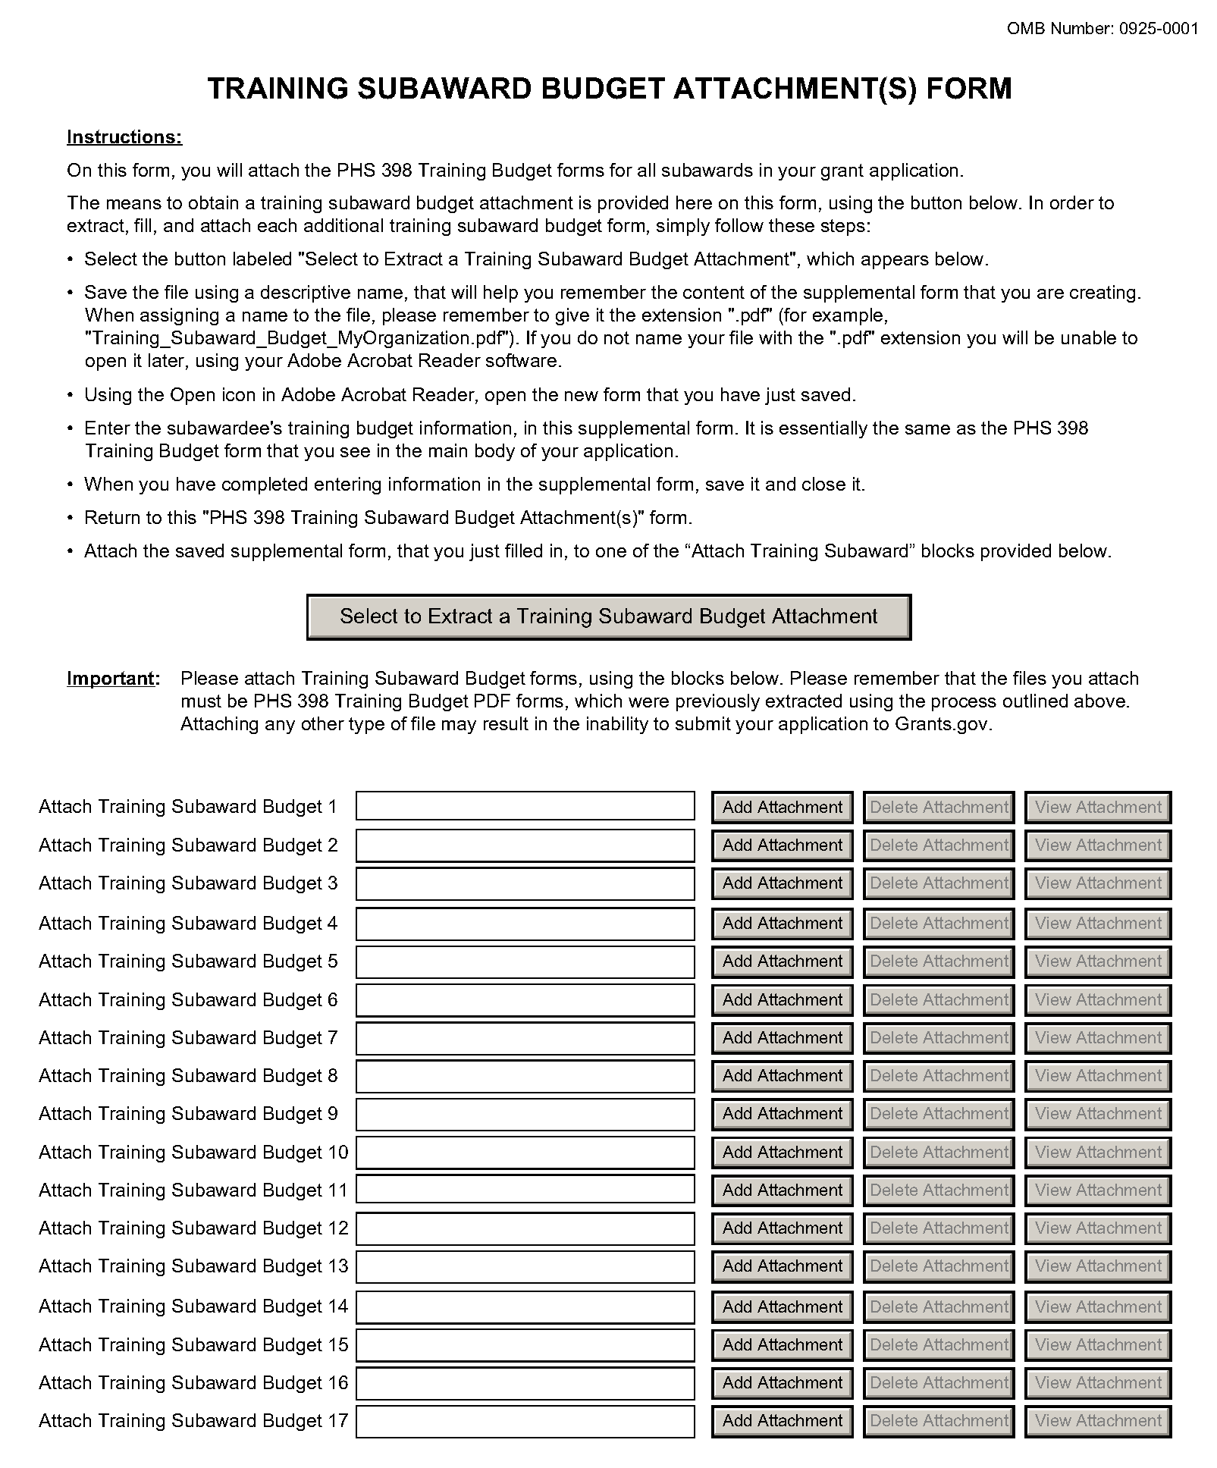
This form should be used when proposing subawards to other institutions. Complete the Subaward Budget for each contractor or collaborating institution. For NRSA programs, this is not common but is usually encountered when a portion of the training program takes place at a site other than the grantee institution via a collaborative or consortium arrangement. In such situations, the grantee institution is responsible and accountable for acceptable training arrangements, expenditure of funds and the submission of all required forms.
This form accommodates up to 30 separate subaward budgets. If you are submitting an application with >30 subaward budgets, budgets 31 and above should be converted to PDF and included as part of Section 8.5 Part F. Budget Justification, of the parent budget (PHS 398 Training Budget). Reminder, the sum of all subaward budgets; e.g., those attached separately and those provided as part of the budget justification, must be included in Part B. Consortium Training Costs on the PHS 398 Training Budget.
To start the process, the applicant organization should:
- Select the Subaward Budget Attachment Form from the Optional Documents in the Grant Application Package.
- Open the form, and click the “Select to Extract a Training Subaward Budget Attachment” button in the middle of the form. A “SAVE” dialog box appears.
- Save the file locally using the first ten letters of the consortium organization’s name and use “.pdf” as the file extension. (The extracted file is an Adobe PDF file.) Once you have saved the file there is no need to extract another budget attachment. Doing so may cause you to lose any data already stored in the saved file.
- E-mail the extracted, saved form to the consortium grantee. Note: consortium grantees must have installed Adobe Reader before they can complete the form. The consortium grantee should complete all the budget information as instructed in the R&R Budget form instructions in Section 4.7. Note: Organizational DUNS and Name of Organization fields must reflect that of the subaward/consortium grantee.
- The consortium grantee must complete the budget form and e-mail it back to the applicant organization.
- Return to the Subaward Budget Attachment Form and attach the consortium grantee’s budget to one of the blocks provided on the form.
Submitting Subaward Budgets that are not Active for all Periods of the Prime Grant
When submitting subaward budgets that are not active for all periods of the prime grant, fill out the subaward R&R Budget form and include only the number of periods for which the subaward is active. The budget period start/end dates reflected in each period should reflect the corresponding prime budget period start/end dates. This approach is the most workable solution to the limitations in existing forms that do not allow an “empty” budget period and do not allow submission of a subaward budget with zero effort to skip a budget period.
For example, suppose the prime has filled out a budget form with the following periods:
- period 1 Jan 1, 2010 – Dec 31, 2010
- period 2 Jan 1, 2011 – Dec 31, 2011
- period 3 Jan 1, 2012 – Dec 31, 2012
- period 4 Jan 1, 2013 – Dec 31, 2013
- period 5 Jan 1, 2014 – Dec 31, 2014
Now, suppose there is a subaward that performs in support year 1 and does not become active again until support year 4. The subaward can fill out the first two periods of their budget form as follows:
- period 1 Jan 1, 2010 – Dec 31, 2010 (dates correspond to prime period 1)
- period 2 Jan 1, 2013 – Dec 31, 2013 (dates correspond to prime period 4)
It is not necessary that the budget period numbers between the prime and subaward match; the correlation is reflected in the dates. Do be careful, however, that the dates exactly match what is listed for the period in the prime budget.
Note this approach may cause a validation warning regarding the NIH $500,000 per year limit on direct costs, therefore you should document in both the cover letter and the subaward budget justification that the subaward is only active for specific periods of the prime. Appropriate NIH staff has access to the cover letter and reviewers have access to the budget justification. This documentation will make the date correlation immediately apparent and will help avoid any confusion.

8.7 Research Training Program Plan Form
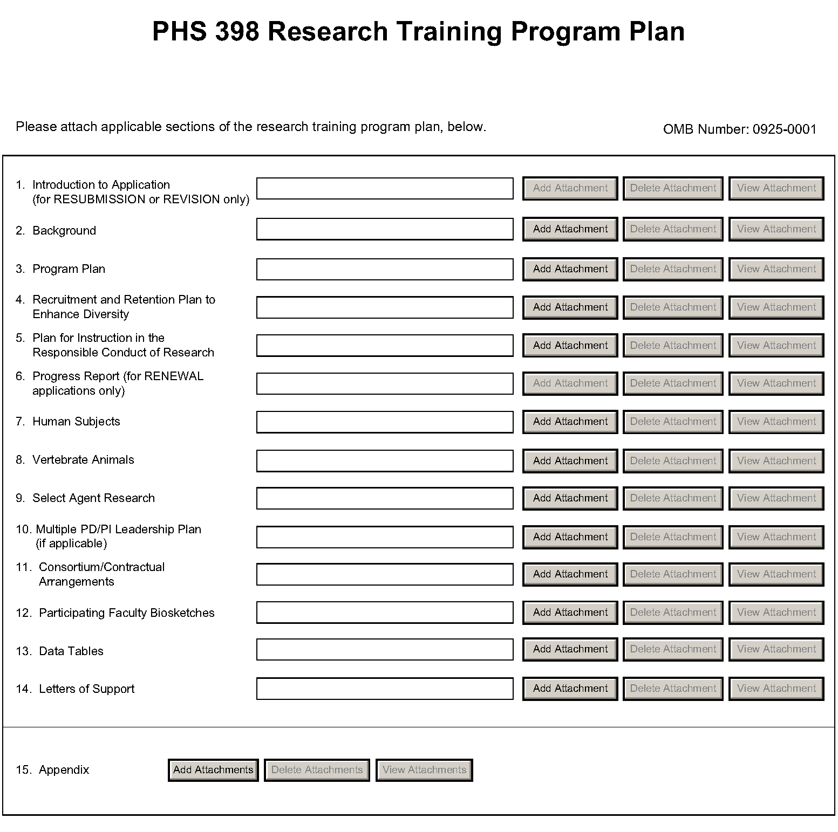
Before preparing the Research Training Program Plan, be sure to check the specific instructions in the Funding Opportunity Announcement (FOA) to which you are responding. Contact the appropriate PHS awarding component, which may have further advice or suggestions on completing your application, including the data tables mentioned below.
Note that there are page limits for certain sections. Follow the page limits for the Institutional Research Training and Career Development Applicants, Including Ruth L. Kirschstein NRSA Application in the table of page limits (Table 2.6-1), unless specified otherwise in the FOA. Please see NOT-OD-11-039 and NOT-OD-11-076. The information provided in required data tables (see below) will not be counted toward the page limitation. These tables should be numbered consecutively and titled as shown, even if some are not required by the PHS awarding component to which you are applying or in the FOA to which you are responding. Indicate by table number and title, those tables that are intentionally omitted. Additional tables that are not required may be included in the Research Training Program Plan, however, these tables will count as part of the page limit. Additional tables not specified in these instructions should be identified by letter, rather than number to avoid confusion with the sequentially numbered required tables.
The instructions for Data Tables 1-12 are located on the OER website at http://grants.nih.gov/grants/ funding/424/index.htm#datatables. Please read the Introduction to the Data Tables before beginning to prepare your application. This section includes important definitions that should be used consistently both in the Data Tables and in all other parts of the application. The data tables should be included in the application at the point indicated and should not be inserted in the narrative.
The Research Training Program Plan should include sufficient information needed for evaluation of the program, independent of any other document (e.g., previous application). Be specific and informative, and avoid redundancies.

Research Training Program Plan Attachments
(See also Section 2.3.2 Creating PDFs for Text Attachments.)
Although many of the sections of this application are separate PDF attachments, page limitations referenced in the instructions and/or funding opportunity announcement must still be followed. Agency validations will include checks for page limits (and use of appropriate font). Some accommodation will be made for sections that, when combined, must fit within a specified limitation.
Text attachments should be generated using word processing software and then converted to PDF using PDF generating software. Avoid scanning text attachments to convert to PDF since that causes problems for the agency handling the application. In addition, be sure to save files with descriptive file names.
Do not include any information in a header or footer of the attachments. A header will be system-generated that references the name of the PD/PI. Page numbers for the footer will be system-generated in the complete application, with all pages sequentially numbered.
Since a number of reviewers will be reviewing applications as an electronic document and not a paper version, applicants are strongly encouraged to use only a standard, single-column format for the text. Avoid using a two-column format since it can cause difficulties when reviewing the document electronically.
Full-sized glossy photographs must only be included within the page limitations of the Research Training Plan. The maximum size of images to be included should be approximately 1200 x 1500 pixels using 256 colors. Figures must be readable as printed on an 8.5 x 11 inch page at normal (100%) scale.
Investigators must use image compression such as JPEG or PNG. Do not include figures or photographs as separate attachments either in the Appendix or elsewhere in the application.

Separate Attachments
Separate attachments have been designed for the Research Training Program Plan sections to maximize automatic validations conducted by the eRA system. When the application is received by the agency, all of the Research Training Program Plan sections will be concatenated in the appropriate order so that reviewers and agency staff will see a single cohesive Research Plan.
When attaching a PDF document to the actual forms, please note you are attaching an actual document, not just pointing to the location of an externally stored document. Therefore, if you revise the document after it has been attached, you must delete the previous attachment and then reattach the revised document to the application form. Use the “View Attachment” button to determine if the correct version has been attached.
Follow page limitations as specified in Funding Opportunity Announcements.
All applications and proposals for NIH funding must be self-contained within specified page limitations. Agency validations will include checks for page limits. Note that while these computer validations will help minimize incomplete and/or non-compliant applications, they do not replace the validations conducted by NIH staff. Applications found not to comply with the requirements may be delayed in the review process. Unless otherwise specified in an NIH solicitation, internet website addresses (URLs) may not be used to provide information necessary to the review because reviewers are under no obligation to view the internet sites. Moreover, reviewers are cautioned that they should not directly access an internet site as it could compromise their anonymity.

Notice of Proprietary Information
Applicants are discouraged from submitting information considered proprietary unless it is deemed essential for proper evaluation of the application. However, when the application contains information that constitutes trade secrets, or information that is commercial or financial, or information that is confidential or privileged, make sure you have checked “Yes” in the “Other Project Information” form.
When information in the application constitutes trade secrets or information that is commercial or financial, or information that is confidential or privileged, it is furnished to the Government in confidence with the understanding that the information shall be used or disclosed only for evaluation of this application. However, if a grant is awarded as a result of or in connection with the submission of this application, the Government shall have the right to use or disclose the information to the extent authorized by law. This restriction does not limit the Government’s right to use the information if it is obtained without restriction from another source.
Although the grantee institution and the PD/PI will be consulted about any such release, the PHS will make the final determination. Any indication by the applicant that the application contains proprietary or privileged information does not automatically shield the information from release in response to a Freedom of Information Act (FOIA) request should the application result in an award (see 45 CFR Part 5). If an applicant fails to identify proprietary information at the time of submission as instructed in the application guide, a significant substantive justification will be required to withhold the information if requested under FOIA.
Begin each text section of the Research Training Program Plan with a section header (e.g., Introduction, Background, Program Plan, etc).
Field Name | Instructions
1. Introduction to Application (for Resubmission or Revision only) | Use only if Type of Application is Resubmission or Revision The Introduction may not exceed 3 pages for resubmissions (previously known as a revision or amendment) or 1 page for revisions (previously known as competing supplements). See specific instructions in Section 2.7 “Resubmission” Applications and 2.8 “Revision” Applications concerning the content of the Introduction.  Save this information in a single file in a location you remember. Click Add Attachment, browse to where you saved the file, select the file, and then click Open.
2. Background | The Background must fit within the page limits for Institutional Research Training and Career Development Applicants, Including Ruth L. Kirschstein NRSA Application in the table of page limits (Table 2.6-1), unless specified otherwise in the FOA. Please see NOT-OD-11-039 and NOT-OD-11-076.  Provide the rationale for the proposed research training program, relevant background history, and the need for the research training proposed. Indicate how the proposed program relates to current training activities at the applicant institution.  Summarize the research training activities of the major participating unit(s) and department(s) represented in the proposed program. Complete and refer to the data reported in Tables 1-3:  Table 1. Membership of Participating Departments/Programs  Table 2. Participating Faculty Members  Table 3. Institutional Training Grant Support Available to Participating Faculty Members, Departments, or Programs  Use this data to document the environment in which the proposed training program will take place.  Save this information in a single file in a location you remember. Click Add Attachment, browse to where you saved the file, select the file, and then click Open.
3. Program Plan | The Program Plan must fit within the page limit for Institutional Research Training and Career Development Applicants, Including Ruth L. Kirschstein NRSA Application in the table of page limits (Table 2.6-1), unless specified otherwise in the FOA.  Please see NOT-OD-11-039 and NOT-OD-11-076.  a. Program Administration. Describe the Program Director's qualifications for providing leadership of the program, including relevant scientific background, current research areas, and experience in research training. Indicate the Program Director's percent effort in the proposed program.  Describe the administrative structure of the program and the distribution of responsibilities within it, including the means by which the program director will obtain continuing advice with respect to the operation of the program.  If multiple PD/PIs are proposed, explain in this section your rationale for how this will facilitate program administration. In addition, you must complete the Multiple PD/PI Leadership Plan.  b. Program Faculty. Refer to the data presented in Table 2. Participating Faculty Members and elaborate as necessary to describe each faculty member's research that is relevant to the program and indicate how trainees will participate in the research. Describe the extent to which participating faculty members cooperated, interacted, and collaborated in the past, including joint publications and joint sponsorship of student research. Complete and refer to data in Tables 4-6:  Table 4. Grant and Contract Support of the Participating Faculty Members  Table 5. Pre and Postdoctoral Trainees of Participating Faculty Members  Table 6. Publications of Research Completed by Trainees (or Potential Trainees)  Use these tables to document the ability of the faculty to support the research activities of the proposed trainees, the training record of the faculty members, and the success of their trainees in generating publishable research results.  For new applications, see the instructions for Table 6A or 6B, as applicable, and list publications for trainees who are representative of those who would be appointed if the grant is awarded. For Renewal applications, this data constitutes part of the Progress Report (see Progress Report below).  c. Proposed Training. Describe the proposed training program. State the training level and number of trainees. For postdoctoral trainees, indicate the proposed distribution by degree (e.g., M.D., Ph.D.). Describe course work and research opportunities, the extent to which trainees will participate directly in research, and the duration of training, i.e., usual period of time required to complete the training offered.  Indicate how the individual disciplinary and/or departmental components of the program are integrated and coordinated and how they will relate to an individual trainee's experience.  For training programs that emphasize research training for clinicians, describe the interactions with basic science departments and scientists. Include plans for ensuring that the training of these individuals will provide a substantive foundation for a competitive research career. Generally, a minimum of 2 years of research training is required for all postdoctoral trainees with health professional degrees. Describe fully any trainee’s access to and responsibility for patients, including time commitment.  Provide representative examples of programs for individual trainees. Include curricula, degree requirements, didactic courses, laboratory experiences, qualifying examinations, and other training activities, such as seminars, journal clubs, etc. Describe how the preceptor and research problems are chosen, how each trainee's program will be guided, and how the trainee's performance will be monitored and evaluated. Include detailed mentoring plans as appropriate.  If research on Human Embryonic Stem Cells (hESCs) is proposed but an approved cell line from the NIH hESC Registry cannot be identified, provide a strong justification for why an appropriate cell line cannot be chosen from the Registry at this time  d. Training Program Evaluation. Describe an evaluation plan to review and determine the quality and effectiveness of the training program. This should include plans to obtain feedback from current and former trainees to help identify weaknesses in the training program and to provide suggestions for program improvements. In addition, describe plans for assessing trainee’s career development and progression, including publications, degree completion, and post-training positions. Evaluation results are to be included in renewal (competing continuation) applications and as part of the Final Progress Report.  e. Trainee Candidates. Describe recruitment plans, including the sources and availability of trainees; the qualifications of prospective trainees; and the criteria and procedures by which trainees will be selected.  f. Institutional Environment and Commitment to Training. The administration of the applicant institution as well as all participating units and departments should include information in the application that documents institutional support and commitment to the goals of the research training program. The application should include a description of support (financial and otherwise) to be provided to the proposed program. This could include, for example, space, shared laboratory facilities and equipment, funds for curriculum development, release time for the PD/PI and/or participating faculty, support for additional trainees in the program, or any other creative ways to improve the climate for the establishment and growth of the research training program.  Admissions and Completion Records  For programs that request only predoctoral trainee support, complete Table 7A. Admissions and Completion Records for the Participating Departments and Programs During the Past Five Years (Predoctoral Applicants).  For programs that request only postdoctoral trainee support, complete Table 7B. Admissions and Completion Records for the Participating Departments and Programs During the Past Five Years (Postdoctoral Applicants).  Programs requesting support for both predoctoral and postdoctoral trainees need to complete both Table 7A and Table 7B. Applicant institutions do not need to submit pre-enrollment data for individuals with disabilities and individuals from disadvantaged backgrounds in the first two data columns of these tables. However, all other information requested in the Table 7A and Table 7B must be provided as instructed.  Use these tables to document the ability of the participating departments/programs to recruit and retain predoctoral and/or postdoctoral trainees through the completion of their training, the selectivity of the admissions process, the success of the departments/programs in recruitment and retention of trainees from diverse backgrounds, and to defend the requested number of training positions to be awarded.  Qualifications of Applicants  For programs that request only predoctoral trainee support, complete Table 8A. Qualifications of Recent Predoctoral Applicants.  For programs that request only postdoctoral trainee support, complete Table 8B. Qualifications of Recent Postdoctoral Applicants.  Programs requesting support for both predoctoral and postdoctoral trainees need to complete both Table 8A and Table 8B.  Use these tables to document the quality and depth of the applicant pools, including both Kirschstein-NRSA training grant eligible and non-Kirschstein-NRSA eligible applicants; the selectivity of the admissions process; the competitiveness of the program; and to justify the number of number of training positions requested.  Current Trainee Qualifications  For programs that request only predoctoral trainee support, complete Table 9A. Qualifications of the Current Predoctoral Trainees Clearly Associated with the Training Program.  For programs that request only postdoctoral trainee support, complete Table 9B. Qualifications of the Current Postdoctoral Trainees Clearly Associated with the Training Program.  Programs that request both predoctoral and postdoctoral trainee support need to complete both Table 9A and Table 9B.  Use these tables to document the number and quality of all trainees currently enrolled in the program, and their distribution by department and mentor; the selectivity of enrollment appointments to the training grant over the time period represented by the current program participants; and to defend the number of training positions to be awarded.  Save this information in a single file in a location you remember. Click Add Attachment, browse to where you saved the file, select the file, and then click Open.
4. Recruitment and Retention Plan to Enhance Diversity | This section must fit within the combined 25-page limit for sections 2.2-2.4. Please see NOT-OD-11-039 and NOT-OD-11-076.  A Recruitment and Retention Plan to Enhance Diversity is required for all training grant activity codes except T34, T36, U2R, and all D-series activity codes.  The NIH recognizes a unique and compelling need to promote diversity in the biomedical, behavioral, clinical and social sciences workforce. The NIH expects efforts to diversify the workforce to lead to the recruitment of the most talented researchers from all groups; to improve the quality of the educational and training environment; to balance and broaden the perspective in setting research priorities; to improve the ability to recruit subjects from diverse backgrounds into clinical research protocols; and to improve the Nation’s capacity to address and eliminate health disparities.  Accordingly the NIH continues to encourage institutions to diversify their student and faculty populations and thus to increase the participation of individuals currently underrepresented in the biomedical, clinical, behavioral, and social sciences such as: individuals from underrepresented racial and ethnic groups, individuals with disabilities, and individuals from socially, culturally, economically, or educationally disadvantaged backgrounds that have inhibited their ability to pursue a career in health-related research. Institutions are encouraged to identify candidates who will increase diversity on a national or institutional basis.  Definition of Diversity Recruitment Groups  The NIH is particularly interested in encouraging the recruitment and retention of the following classes of candidates:  A. Individuals from racial and ethnic groups that have been shown by the National Science Foundation to be underrepresented in health-related sciences on a national basis (see data at http://www.nsf.gov/statistics/showpub.cfm?TopID=2&SubID=27 and the report Women, Minorities, and Persons with Disabilities in Science and Engineering, 2007, p. 262). The following racial and ethnic groups have been shown to be underrepresented in biomedical research: African Americans, Hispanic Americas, Native Americans, Alaskan Natives, Hawaiian Natives, and natives of the U.S. Pacific Islands. In addition, it is recognized that under-representation can vary from setting to setting and individuals from racial or ethnic groups that can be convincingly demonstrated to be underrepresented by the grantee institution should be included in the recruitment and retention plan.  B. Individuals with disabilities, who are defined as those with a physical or mental impairment that substantially limits one or more major life activities.  C. Individuals from disadvantaged backgrounds who are defined as:  1. Individuals who come from a family with an annual income below established low-income thresholds. These thresholds are based on family size, published by the U.S. Bureau of the Census; adjusted annually for changes in the Consumer Price Index; and adjusted by the Secretary for use in all health professions programs. The Secretary periodically publishes these income levels at http://aspe.hhs.gov/poverty/index.shtml. For individuals from low income backgrounds, the institution must be able to demonstrate that such candidates (a) have qualified for Federal disadvantaged assistance; or (b) have received any of the following student loans: Health Professional Student Loans (HPSL), Loans for Disadvantaged Student Program; or have received scholarships from the U.S. Department of Health and Human Services under the Scholarship for Individuals with Exceptional Financial Need.  2. Individuals who come from a social, cultural, or educational environment such as that found in certain rural or inner-city environments that have demonstrably and recently directly inhibited the individual from obtaining the knowledge, skills, and abilities necessary to develop and participate in a research career.  Recruitment and retention plans related to a disadvantaged background (C1 and C2) are most applicable to high school and perhaps undergraduate candidates, but would be more difficult to justify for individuals beyond that level of achievement. Under extraordinary circumstances the PHS may, at its discretion, consider an individual beyond the undergraduate level to be from a disadvantaged background. Such decisions will be made on a case-by-case basis, based on appropriate documentation.  New applications must include a description of plans to enhance recruitment of a diverse trainee pool and may wish to include data in support of past accomplishments. Renewal applications must include a detailed account of experiences in recruiting individuals from underrepresented groups during the previous funding period. Information should be included on both successful and unsuccessful recruitment strategies.  History and Achievements. Describe efforts to recruit trainees from Diversity groups A, B, and C into the existing training program. For competing continuation/renewal applications, also describe past efforts to recruit and retain underrepresented minority students into training grant funded positions. Refer to the data presented in Table 1 and Table 7A and Table 7B that provided statistics on applications and admissions of these groups in comparison to the overall trainee pool.  For Renewal applications, complete Table 10 Admissions and Completion Records for Underrepresented Minority (URM), Trainees with Disabilities, and Trainees from Disadvantaged Backgrounds Clearly Associated with the Training Program. New applicants may provide this data if they wish; however, it is not required of new applicants.  Use this data to document the success of the program in recruiting and retaining trainees who are under-represented minorities, provide analysis of their support, and begin to establish a record of NIH training of other Diversity Recruitment groups.  Proposed plans. Describe steps to be taken during the proposed award period regarding the identification, recruitment, and retention of graduate students and postdoctorates from underrepresented groups. Consider the success and/or failures of recruitment strategies used in the past. In particular, describe the specific efforts to be undertaken by the training program and how these might relate to the recruitment efforts of the medical school, graduate school, and/or the university at large. In most cases, institutional efforts alone will not satisfy the requirement to recruit individuals from underrepresented groups.  Applications without a description of diversity recruitment efforts will be considered incomplete and may be delayed in the peer review process.  Save this information in a single file in a location you remember. Click Add Attachment, browse to where you saved the file, select the file, and then click Open.
5. Plan for Instruction in the Responsible Conduct of Research | Follow the page limits for Plan for Instruction in the Responsible Conduct of Research in the table of page limits (Table 2.6-1), unless specified otherwise in the FOA.  Please see NOT-OD-11-039.  A plan for Instruction in the Responsible Conduct of Research (RCR) is required for all training grant activity codes except T36. Every trainee must receive instruction in the responsible conduct of research. See Supplemental Instructions Part III Section 1.16 for information on the NIH Policy on Training in the Responsible Conduct of Research (RCR).  New applications must include a plan for instruction in the responsible conduct of research. The plan should address how applicants plan to incorporate the five instructional parts outlined in the NIH Policy on Training in the Responsible Conduct of Research: format, subject matter, faculty participation, duration, and frequency. In addition, the plan must describe how participation in RCR instruction will be monitored.  In addition, Renewal applications must describe any changes in formal instruction over the past project period and plans for the future that address any weaknesses in the current RCR instruction. All training faculty who served as course directors, speakers, lecturers, and/or discussion leaders during the past project period must be named in the application.  Save this information in a single file in a location you remember. Click Add Attachment, browse to where you saved the file, select the file, and then click Open.  This is a required attachment unless the FOA specifies otherwise.
6. Progress Report (Renewal Applications Only) | State the period covered and briefly describe the accomplishments of the training program. Describe any specific effects of this training program on curriculum and/or research directions. Describe how the funds provided under Training Related Expenses were used to benefit the program. For each trainee supported during the period covered, indicate their preceptor/mentor, and briefly summarize the research conducted by the trainee. For previous trainees appointed to the training grant and continuing in training, provide a brief statement of their status and progress toward completion of their training program. Refer to data presented in Table 6 Publications of Research Completed by Trainees (or Potential Trainees) and include in the table publications of trainees through the time that they complete their training for all trainees currently or previously supported by the training grant program regardless of whether support from this training grant is cited in the publication.  Complete Table 11 Appointments to the Training Grant For Each Year of the Past Award (Renewal Applications Only).  Use this table to document the utilization of awarded training positions. If any trainee positions were not filled, provide an explanation.  For programs that request only predoctoral trainee support, complete Table 12A Predoctoral Trainees Supported by this Training Grant (Renewal Applications Only).  For programs that request only postdoctoral trainee support, complete Table 12B Postdoctoral Trainees Supported by this Training Grant (Renewal Applications Only).  Programs requesting support (or reporting on prior support) for both predoctoral and postdoctoral trainees need to complete both Table 12A and Table 12B.  Use these tables to document how predoctoral training positions are used (i.e., distribution by mentor, year in program, years of support per trainee) and the success of the program in achieving the training objectives of the prior award period(s) for up to 10 years. Summarize this data in the text.  If any postdoctoral trainee with a health professional degree appointed to the grant during the most recent award period received less than 2 years of research training, explain why. Where possible for past trainees, describe the extent of their current involvement in research, including research grant support and representative recent publications. Use the progress report narrative to provide information that is not readily presented in the required tables.  Renewal applications must include a detailed account of experiences in recruiting individuals from underrepresented groups during the previous funding period. Information should be included on both successful and unsuccessful recruitment strategies.  Renewal applications must describe the type of instructions provided in the current project period, the degree of student participation, the results of any assessments, and other relevant information.  Save this information in a single file in a location you remember. Click Add Attachment, browse to where you saved the file, select the file, and then click Open.
7. Human Subjects | Complete this section if you answered “yes” to the question “are human subjects involved?” on the R&R Other Project Information Form.  If trainee participation in research involving human subjects is solely as part of other research projects that have received or will receive IRB review and approval, and no portion of the Training Grant Award will be used to support this research; provide a list of previously approved research projects (grant number, PD/PI, and project title) and their IRB approval dates or exemption designations. If plans are indefinite provide an explanation and prior to trainee participation in other research project grants, provide a list as indicated.  If the training program involves definite plans for the participation of human subjects as defined in Supplemental Instructions Part III.3, Human Subjects Research Definitions and Terms, outside of research projects that have received or will receive IRB review, follow the instructions in Supplemental Instructions Part II, Supplemental Instructions for Preparing the Protection of Human Subjects Section of the Research Plan.  The appropriate grants must be identified along with their IRB approval dates or exemption designation.  Save this information in a single file in a location you remember. Click Add Attachment, browse to where you saved the file, select the file, and then click Open.
8. Vertebrate Animals | Complete this section if you answered “yes” to the question “are Vertebrate Animals Used?” on the R&R Other Project Information Form.  If the training program involves the use of live vertebrate animals solely as part of other research project grants, and no portion of the Training Grant Award will be used to support the purchase, use, or husbandry of live vertebrate animals in this research; provide a list of previously approved research projects (grant number, PD/PI, and project title) and IACUC approval dates. If plans are indefinite provide an explanation and prior to trainee participation in other research project grants, provide a list as indicated.  If the training program involves definite plans to use live vertebrate animals outside of research projects that have received or will receive IACUC approval, follow the instructions in Part I, 5.5, (Research Plan Form), Vertebrate Animals.  The appropriate grants must be identified along with their IACUC approval dates.  Save this information in a single file in a location you remember. Click Add Attachment, browse to where you saved the file, select the file, and then click Open.
9. Select Agent Research | If participating faculty proposed in the training program are conducting or plan to conduct research involving select agents in which trainees may participate, follow the instructions in Section 5.5, (Research Plan Form), Select Agent Research.  Save this information in a single file in a location you remember. Click Add Attachment, browse to where you saved the file, select the file, and then click Open.
10. Multiple PD/PI Leadership Plan | If you wish to submit a multiple PD/PI application, you must provide a Leadership Plan. Do not submit a leadership plan if you are not submitting a Multiple PD/PI application. For applications designating multiple PD/PIs, all such individuals must be assigned the PD/PI role on the Senior/Key Profile form, even those at organizations other than the applicant organization. Refer to the instructions in Section 5.5 (Research Plan Form), Multiple PD/PI Leadership Plan. However, the emphasis in a training grant multiple PD leadership plan should be on how it will benefit the program and the trainees. A single Contact PD must be designated for the purpose of communicating with the NIH, although other individuals may contact the NIH on behalf of the Contact PD when necessary. Because training programs are intended to be coherent, NIH will not allocate the budget or training positions between multiple PDs. A single award will be made. Multiple PD plans should include reasonable numbers of PDs and each should be included for a specific purpose. Multiple-PD applications should not include all mentors of the training grant as PDs, except in unusual cases.  For background information on the Multi-PD/PI initiative, see: http://grants.nih.gov/grants/multi_pi/index.htm.  Save this information in a single file in a location you remember. Click Add Attachment, browse to where you saved the file, select the file, and then click Open.
11. Consortium and Contractual Arrangements | Describe any programmatic, fiscal, or administrative arrangements between the applicant organization and other participating organizations. See Section 5.5, Consortium/Contractual Arrangements for additional guidance.  Save this information in a single file in a location you remember. Click Add Attachment, browse to where you saved the file, select the file, and then click Open.
12. Participating Faculty Biosketches | Faculty Biosketches for participating faculty should follow the Additional NIH and other PHS Agencies Instructions for a Biographical Sketch, except that a personal statement is not required for participating faculty. These should be attached as a single document to avoid having to upload large numbers of separate documents. However, the Biosketches of the Program Director and other Senior/key Personnel should also be entered as described under SF424 (R&R) Section 4.5 Senior/Key Person Profile (Expanded) Form.  Save this information in a single file in a location you remember. Click Add Attachment, browse to where you saved the file, select the file, and then click Open.
13. Data Tables | Instructions for Data Tables 1-12 mentioned above are located on the OER website at the following URL http://grants.nih.gov/grants/funding/424/index.htm#datatables. These instructions include an Introduction to the Data Tables that provides instructions applicable to all tables, specific instructions for each table, and Sample Data Tables. The Sample Data Tables illustrate the kind of data to include in each table for Kirschstein-NRSA training grant applications. Be sure to choose the Instruction and Blank Data Table set that corresponds to the type of application you are submitting, e.g., New, Renewal, or Revision Application, and the kind of training to be provided, e.g., predoctoral only, postdoctoral only, or pre and postdoctoral mixed. Modification of these instructions for use in non-Kirschstein-NRSA training grant applications will be included in relevant FOAs.  Save this information in a single file in a location you remember. Start each numbered table on a new page. Bookmark the first page of each table by its table number (Table 1, Table 2, etc.) before you upload the file. Click Add Attachment, browse to where you saved the file, select the file, and then click Open.
14. Letters of Support | Attach appropriate letters here from all individuals confirming their roles in the project. Letters documenting any agreements between the Program Director(s) and senior administration officials or other institutional officials are not required but may be included. For consultants, letters should include rate/charge for consulting services.  The Program Director should check the FOA (particularly for non-NRSA programs) to determine if any program-specific letters of support are required.  Save this information in a single file in a location you remember. Click Add Attachment, browse to where you saved the file, select the file, and then click Open.
15. Appendix | Do not use the appendix to circumvent the page limitations of the Training Plan. All appendix material must be submitted as PDF attachments. A summary listing all of the items included in the appendix is required, and should be the first PDF file of the Appendix. Applications that do not follow the appendix requirements may be delayed in the review process.  Research publications of trainees and mentors are not normally included as part of the Training Grant applications, but are allowed. Other types of publications reflecting on the activities of the program as a whole may also be included. When publications are allowed, appendix materials should be limited to those which are not publicly available, such as:  - Manuscripts and/or abstracts accepted for publication but not yet published.  - Published manuscripts and/or abstracts where a free, online, publicly available journal link is not available.  - Patents directly relevant to the project.  Publications that are publicly accessible must not be included in the appendix. For such publications, the URL or PMC submission identification numbers along with the full reference should be included as appropriate in the Progress Report section of the Research Training Program Plan, and/or in the Biographical Sketch.  Do not include unpublished theses or abstracts/manuscripts submitted but not yet accepted for publication.  Some materials other than publications that are unique to training grant applications (but not typically included in research grant applications) may be included as appendices. In general, the appendix may be used to provide samples of materials that are referred to in the body of the application, but are too cumbersome to include in the Research Training Program Plan without disrupting the narrative flow. Examples include:  i. Syllabi for key courses, core courses and electives, including courses in Responsible Conduct of Research, Survival Skills for Research, etc.;  ii. Retreat, seminar series, and other program activity agendas, rosters, and schedules;  iii. Examples of forms used to document trainee progress and monitoring by the program;  iv. Examples of materials used in recruitment and particularly recruitment and retention to enhance diversity of the student pool;  v. Lists of meetings attended by students and their presentations; and  vi. Student biosketches.  As a reminder, tables other than the required Data Tables 1-12, must be incorporated into the page limit of the Research Training Program Plan. Follow the page limits for the Institutional Research Training and Career Development Applicants, Including Ruth L. Kirschstein NRSA Application in the table of page limits (Table 2.6-1), unless specified otherwise in the FOA. These additional tables must not be included in the appendix materials.

8.8 Training Grant Peer Review Process
The goals of NIH-supported research training are to help ensure that a diverse pool of highly trained scientists is available in adequate numbers and in appropriate research areas to address the Nation’s biomedical, behavioral, and clinical research needs. The scientific review group will address and consider each of criteria below in assigning the application’s overall score, weighting them as appropriate for each application. Reviewers will first determine the quality of the proposed research training program, including information presented in the data tables and appendix, and then consider whether the requested number of trainee positions is appropriate for the program.
The general process information (Overview, Streamlining, and Dual-Level Peer Review) found in Part I.6 applies to training grant applications as well. However, the actual review criteria and other review considerations are different.

Review Criteria:
- Training Program and Environment
- Training Program Director/Principal Investigator (PD/PI)
- Preceptors/Mentors
- Trainees
- Training Record

Additional Review Criteria:
- Protection of Human Subjects from Research Risk
- Inclusion of Women, Minorities and Children in Research
- Care and Use of Vertebrate Animals in Research
- Biohazards
- Resubmission Applications
- Renewal Applications

Additional Review Considerations:
- Training in the Responsible Conduct of Research
- Recruitment and Retention Plan to Enhance Diversity
- Budget and Period of Support
Applicants should carefully review the applicable FOA for complete information associated with the peer review process. The FOA will describe essential information to be submitted for each of the above elements.

9. Supplemental Instructions to the SF 424 (R&R) for Preparing a Multi-Project Application

9.1 Introduction
The supplemental instructions found in this Section are for Multi-Project Applications (MPA) and include guidance and instructional information only when there is a difference in the required information to be submitted or there is a need for more specificity for an MPA. Therefore, these supplemental instructions must be used along with the information found in Parts I.1 – I.6 of this document.
In FY2013 NIH began to transition multi-project applications to electronic submission using the SF424 (R&R) application packages. This transition is done by activity code. As each code is added (see the transition timeline), all applications submitted in response to Funding Opportunity Announcements (FOAs) for programs using that code will require electronic submission (including new, resubmission, renewal and revision types of application). The requirement for electronic submission will be stated in the FOA.

9.2 Multi-Project Applications
A Multi-Project Application is a single submission with multiple, interrelated components that share a common focus or objective. A component is a distinct, reviewable part of a multi-project application for which there is a business need to gather detailed information as defined in a particular FOA. Each component includes the data collection identified for its specific component type. Components typically include general information (component organization, project period, project title, etc.) performance sites, personnel, and budget. They may also be referred to as cores or projects. The construction of the application and naming convention will be defined by the FOA.
Although MPAs submitted electronically will use application packages that use the SF424 (R&R) and PHS 398 forms, there are some differences in the way the multi-project application is structured. Every application will include:
- A Single Overall Component: The Overall component describes the entire application and provides an overview of how each of the additional components fit together.
- Other Components: Other component types (e.g., Admin Core, Project, Core) will vary by opportunity. The component types will be specified in the FOA. Within ASSIST, only the specified types of components will be available to choose from a drop-down menu during the application preparation process.
- Summaries: Information automatically compiled from the data provided by the applicant in the individual components and included in the agency assembled application (e.g., component and categorical budget data) to help reviewers and staff work with the application. These are system-generated summaries and will be presented in the assembled application as part of the Overall Component. Summaries will be generated for the follow information when applicable: Performance Sites; Human Subjects, Clinical Trials, Human Embryonic Stem Cells, and Vertebrate Animals; Budgets; and Senior/Key Personnel, including Biosketches.
It is imperative that applicants become familiar with the FOA for the specific MPA for which support is being requested. Before applying for an MPA, applicants should carefully review the applicable FOA noting the special application instructions. When the instructions in the FOA differ from the instructions given in the SF 424 (R&R) Application Guide or the ASSIST User Guide, the FOA instructions should be followed. The FOA will specify the types of Other Components that should be used when preparing the application, whether each component is optional or required and any restrictions on the number of times each component can be included in a responsive application (e.g., 2-3 Projects are required). The FOA will include specific information associated with the application and the names of individuals who may be contacted prior to submission of an application for additional or clarifying information.

9.2.1 Collaborating with Other Organizations
Components may be developed by the applicant institution or another organization. Applicants using ASSIST will be able to delegate application preparation responsibilities to multiple users within and outside the applicant organization while maintaining appropriate access control and security. Refer to the ASSIST User Guide for additional guidance.
Depending on the role of the collaborating organization in the overall project, there are two approaches to constructing the application.
1. Collaborating Organization as the Lead in an Other Component: The applicant organization is always identified in the Overall component. However, when an entire Other Component is led by a different subaward/consortium organization complete, all the forms for that Other Component (including the R&R Cover Form and Budget Form) using the subaward/consortium organization’s information. On the Budget Form, use the Budget Type “Project” (marked on top of the form) and the subaward/consortium organization’s DUNS and Name. ASSIST will automatically calculate the budget information as a consortium/subaward to the Overall Component’s applicant organization.
2. Collaborating Organization as a Consortium in an Other Component: When a collaborating organization is not the lead in an Other Component, then that organization will be represented as a consortium/subaward. In this scenario the applicant organization is the lead on the Other Component. Therefore, complete all the forms for the Other Component (including the R&R Cover Form and Budget Form) using the applicant organization’s information. On the Budget Form, use the Budget Type “Project” (marked on the top of the form) and the applicant organization’s information. To add the subaward/consortium budget, on the “Summary” tab for the component use the “Add Optional Form” action to add another R&R budget form. Indicate Budget Type “Subaward/Consortium”, and complete this form using the information for the subaward/consortium organization. ASSIST will automatically calculate this information as a subaward to the applicant organization.

9.3 Application Submission System & Interface for Submission Tracking (ASSIST)
ASSIST is a web-based interface for the preparation and submission of multi-project applications. ASSIST is accessed using existing eRA Commons credentials with any of the following roles: Signing Official (SO), Administrative Official (AO), Principal Investigator (PI), Assistant (ASST) or Account Administrator (AA). Most applicants do not need to complete additional registrations to use the system.
ASSIST allows applicants to:
- Use current eRA Commons credentials to access ASSIST
- Populate data from established eRA Commons profiles
- Run federal-wide and agency business rule validations prior to submission
- Take advantage of automatic generation of the table of contents, headers, footers, page numbers, etc.
- Print/preview applications in the format used by the agency prior to submission including system-generated data summaries
- Present to reviewers clear, color PDF images, rather than scanned versions of the application
- Avoid the hassle of preparing and shipping multiple paper copies
Applicant organizations that use system-to-system solutions will be able to use those services, in lieu of ASSIST, for submitting multi-project applications into Grants.gov if their provider offers the service.
The ASSIST User Guide contains detailed instructions for using ASSIST to complete the MPA application. Instructions for the specific requirements of an MPA (e.g. types of components, page limits) are found in the individual FOA. In addition to the guidance included in this application guide and the ASSIST User Guide, the following resources are also available:
- Multi-Project Applications section of the Applying Electronically website
- Electronic Multi-Project Application: Annotated SF424 (R&R) Form Set
- Frequently Asked Questions
- “Tips” section at the top of each form tab in ASSIST
ASSIST uses a combination of web-based data entry screens and PDF file attachments to compile the required data elements of an application. The information entered in the data screens is the same as the information requested in the SF424 (R&R) and PHS 398 forms and the instructions for completing the data elements are the same, unless noted otherwise in this section of the application guide or within the FOA.
Table 9.3-1 ASSIST Data Forms
data collection | overall component | other component
SF424 R&R Cover | Yes | Yes (some data items)
PHS 398 Cover Page Supplement | Yes | Yes
SF424 R&R Other Project Information | Yes | Yes
SF424 R&R Project/Performance Sites | Yes | Yes
SF424 R&R Senior/Key Person Profile | Yes | Yes
SF424 R&R Budget | No | Yes
SF424 R&R Subaward Budget Attachment | No | Optional
PHS 398 Research Plan | Yes | Yes
Planned Enrollment Report | No | Optional
PHS398 Cumulative Inclusion Enrollment Report | No | Optional
Special Note on Structuring the Application: The assembled application image created for an MPA application has a predetermined order. The Overall Component is always first and includes the system-generated data summaries. Other component types follow in alphabetical order (e.g., Cores before Projects). Components of the same type are grouped together in the order created in ASSIST and given sequential numbers (e.g., Core-001, Core-002, Project-001, Project-002). Applicants do not have the ability to reorder components within ASSIST. Therefore, some planning should be done before initiating components. For more information on MPA application assembly, see http://grants.nih.gov/grants/ElectronicReceipt/files/Electronic_Multi-project_Application_Image_Assembly.pdf.

9.4 Special Instructions to the SF424 R&R for Multi-Project Applications
Standard instructions found in Parts I.4 – I.5 apply to the Overall Component and all Other Components with the exceptions found in this section. For each Form, follow the detailed corresponding instructions in Part I. Sections 4 & 5 as well as the exceptions noted below.

9.4.1 Special Instructions for 4.2 Cover Form
data item/field name | overall component | other components
General Instructions | All the SF424 (R&R) Cover form fields are collected for the Overall Component. | Only a subset of data fields from the Cover Component is collected for the Other Components. These are:  5. Applicant Information  7. Type of Applicant (optional)  11. Descriptive Title  12. Proposed Project  ASSIST: Fields are not automatically populated. Use Expand All to expose the fields available for data entry. Fields that are grayed out do not need to be completed.
- Applicant Information  This information is for the Applicant Organization, not a specific individual. | ASSIST: Applicant Information DUNS and address fields are populated from the Commons Institutional Profile for the organization selected when the application was initiated and are not editable.  The Contact email is required by NIH for the Overall Component. If not included, or improperly formatted, the AOR e-mail address will be used. | ASSIST: Fields that are grayed out do not need to be completed.
- Type of Applicant  This information is for the Applicant Organization, not a specific individual AOR or PD/PI. | Required for Overall Component. | Optional for Other Components.
- Project Director/Principal Investigator Contact Information | ASSIST: The PD/PI information for the Overall Component is automatically populated from the PD/PI section of the SF 424 (R&R) Senior/Key Person Profile (Expanded) form. The information is not editable in the SF424 (R&R) Cover form. Any changes must be made on the Senior/Key Person Profile form. | Not collected for Other Components.
- Estimated Project Funding | Required for Overall Component  ASSIST: Data must be manually entered. | Not collected for Other Components.

9.4.2 Special Instructions for 4.3 Project/Performance Site Locations
A summary of Performance Sites for all Components will appear in the Overall section of the assembled application image in eRA Commons and will be generated upon submission.
data item/field name | overall component | other components
General Instruction | Include only the Primary Site in the Overall Component.  A summary of Project/Performance Sites in the Overall section of the assembled application image in eRA Commons compiled from data collected in the other components will be generated upon submission.  ASSIST: Summary Performance Site information is available when using “Preview Application.” | List all performance sites that apply to the specific component.
DUNS Number | The DUNS is a required field for the primary performance site in both the Overall and Other Components. | The DUNS is a required field for the primary performance site in both the Overall and Other Components.

9.4.3 Special Instructions for 4.4 Other Project Information Component
When applicable, a summary of Human Subjects, Clinical Trials, Human Embryonic Stem Cells, and Vertebrate Animals for all Components will appear in the Overall section of the assembled application image in eRA Commons and will be generated upon submission.
data item/field name | overall component | other components
- Are human subjects involved? | If activities involving human subjects are planned at any time during the proposed project at any performance site and/or on any Other Component, check Yes for the Overall Component and complete the remaining questions as instructed in 4.4 using the unique guidance below for selected data items. | Answer only the “Are Human Subjects Involved?” and “Is the Project Exempt from Federal regulations?” questions for Other Components.
If yes, check appropriate exemption number 1, 2, 3, 4, 5, 6 | Complete for both the Overall and Other Components. If the Overall Component exemption is E4 then no other exemption number can be set for any Other Component. | Complete for both the Overall and Other Components. If the Overall Component exemption is E4 then no other exemption number can be set for any Other Component.
IRB Approval Date | Complete only for the Overall Component when applicable. | Not collected for Other Components.
Human Subject Assurance Number | Complete only for the Overall Component when applicable. | Not collected for Other Components.
- Are Vertebrate Animals Used? | If activities involving vertebrate animals are planned at any time at the Overall Component or at any Other Component, at any performance site, check yes on the Overall component and complete the remaining questions as instructed in 4.4 using the unique guidance below for selected data items. If no, skip the rest of block 2. | Answer only the “Are Vertebrate Animals Used?” question.
Is the IACUC review Pending? | Complete only for the Overall Component when applicable. | Not collected for Other Components.
IACUC Approval Date | Complete only for the Overall Component when applicable. | Not collected for Other Components.
Animal Welfare Assurance Number | Complete only for the Overall Component when applicable. | Not collected for Other Components.
- Does this project involve activities outside of the United States or partnerships with international collaborators? | Complete at both the Overall and Other Component Levels. However, if Yes on any Other Component, then the answer must be Yes for the Overall Component. | Complete at both the Overall and Other Component Levels. However, if Yes on any Other Component, then the answer must be Yes for the Overall Component.
- Project Narrative | Required for Overall Component. | Optional for Other Components. See specific FOA to see if this is required for any Other Components.

9.4.5 Special Instructions for 4.5 Senior/Key Person Profile (Expanded)
A summary of Senior/Key Persons followed by their Biographical Sketches will appear in the Overall section of the assembled application image in eRA Commons and will be generated upon submission.
data item/field name | overall component | other components
General Instruction | Only list the Contact PD/PI and any Multi-PD/PIs; all with role PD/PI on the Overall Component. Do not list any other Senior/Key personnel for the Overall Component. | List all personnel who are Senior/Key to the specific component.  The PD/PI role should not be used for any personnel in Other Components.
Organization Name | Required by NIH for the Overall and Other Components.  ASSIST: Overall Component contact PD/PI Organization name is pre-populated from SF 424 (R&R) organization. | Required by NIH for the Overall and Other Components.  ASSIST: Overall Component contact PD/PI Organization name is pre-populated from SF 424 (R&R) organization.
Project Role | Must be PD/PI on Overall Component. | Unless otherwise specified in the FOA, in the Project Director/Principal Investigator section of the form, use Project Role of “Other” with Category of “Project Lead.”
Credential, e.g. agency login | Must provide the eRA Commons username for all PD/PIs. | Provide the eRA Commons username for person identified in the Profile – Project Director/Principal Investigator section of the form (typically Project Lead).
Attach Biographical Sketch | Each Senior/Key individual, including the PD/PI, is allowed one biosketch for the entire application. If an individual will participate on multiple components, chose any single entry to attach the biosketch, make sure it reflects participation on each relevant component.  The PD/PI(s) may include the biosketch in the Overall Component or any Other Component.  Biosketches will not be repeated within each component in the application image.  ASSIST: Summary information available when using “Preview Application.”

9.4.6 Special Instructions for 4.7 R&R Budget
The only budget information included in the Overall component is the Estimated Project Funding section of the SF424 (R&R) Cover form. Complete a budget, including appropriate subaward budgets when applicable, for the Other Components.
For information on preparing budgets when collaborating organizations are involved, see Section 9.2.1.
Budget summaries will appear in the Overall section of the assembled application image in eRA Commons, will be compiled from detailed budget data collected in the Other Components, and will be generated upon submission.
ASSIST: Summary budget information is available when using “Preview Application.”

9.4.7 Special Instructions for 5.3 PHS 398 Cover Page Supplement
When applicable, a summary of Human Subjects, Clinical Trials, Human Embryonic Stem Cells, and Vertebrate Animals for all Components will appear in the Overall section of the assembled application image in eRA Commons and will be generated upon submission.
data item/field name | overall component | other components
- Project Director/Principal Investigator | ASSIST: Not editable. Section is populated from SF 424 (R&R) Sr/Key Person Profile PD/PI section. Any changes must be made on that form for the Overall Component. | Not Applicable to Other Components. Note this field reflects the PD/PI for the entire application, not the project lead for the Other Component.
- Human Subjects/Clinical Trial? | Complete at both the Overall and Other Component Levels. However, if Yes on any Other Component, then the answer must be Yes on the Overall Component. | Complete at both the Overall and Other Component Levels. However, if Yes on any Other Component, then the answer must be Yes on the Overall Component.
Agency-Defined Phase III Clinical Trial? | Complete at both the Overall and Other Component Levels. However, if Yes on any Other Component, then the answer must be Yes on the Overall Component. | Complete at both the Overall and Other Component Levels. However, if Yes on any Other Component, then the answer must be Yes on the Overall Component.
- Human Embryonic Stem Cell Does the proposed project involve human embryonic stem cells? | Complete at both the Overall and Other Component Levels. However, if Yes on any Other Component, then the answer must be Yes on the Overall Component. | Complete at both the Overall and Other Component Levels. However, if Yes on any Other Component, then the answer must be Yes on the Overall Component.
Cell Lines | All cell lines from Other Components must be manually entered in the Overall Component cell line table. | List all cell lines that pertain to the specific component.

9.4.8 Special Instructions for 5.5 PHS 398 Research Plan
data item/field name | overall component | other components
1. Introduction to Application | For Resubmission and Revision applications, an Introduction to Application is required on the Overall Component, but may be allowed for each Other Component unless otherwise stated in the FOA. | For Resubmission and Revision applications, an Introduction to Application is required on the Overall Component, but may be allowed for each Other Component unless otherwise stated in the FOA.
10. Multiple PD/PI Leadership Plan | Required if more than one PD/PI is specified on R&R Senior/Key Person Profile form of the Overall Component. | Not applicable.

