Steps to Find Opportunities in the NIH Guide and Download Application Package

- The NIH Guide for Grants and Contracts (often referred to as the NIH Guide) is the official publication for NIH medical and behavioral research grant policies, guidelines and funding opportunities. NIH simultaneously posts Funding Opportunity Announcements (FOAs) in the NIH Guide and in Grants.gov. The NIH Guide can be found off of the Office of Extramural Research (OER) home page or directly at http://grants.nih.gov/grants/guide/index.html.
- Once in the NIH Guide, you will see a search screen. You can enter search criteria directly on this screen or go to the Advanced Search feature. For illustrative purposes, choose Advanced Search.
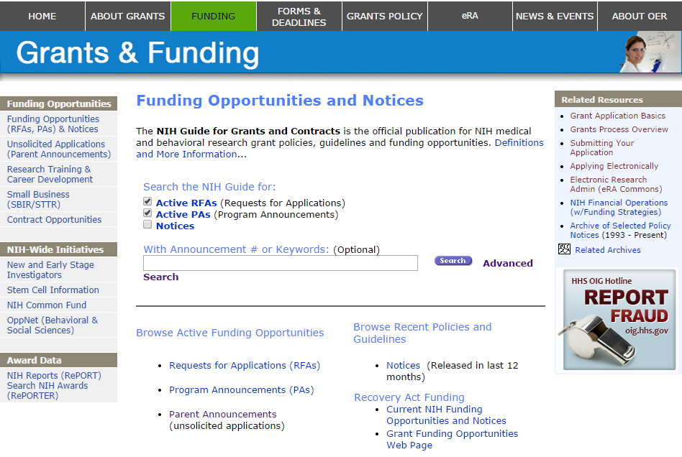
The Advanced Search feature provides many options to narrow your search. Enter your search criteria and click on the Search button.

Example: Find all R01 opportunities posted by the National Cancer Institute (NCI).

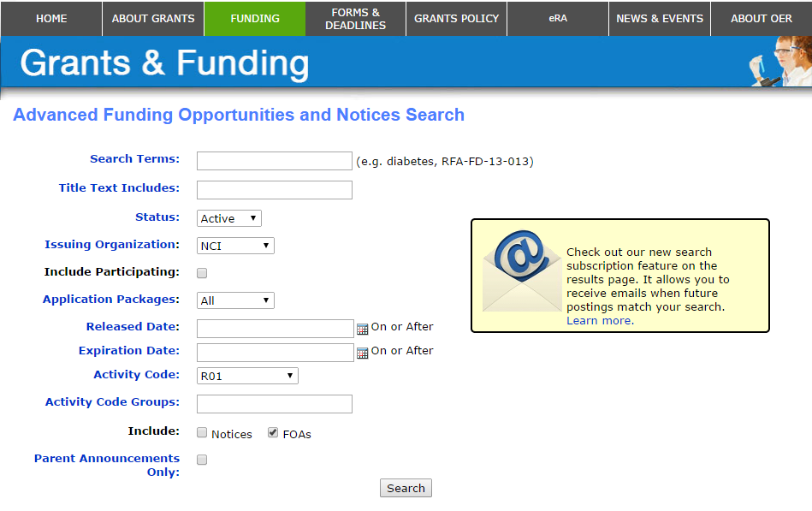

- Identify an FOA of interest and click on the FOA number to open the announcement.
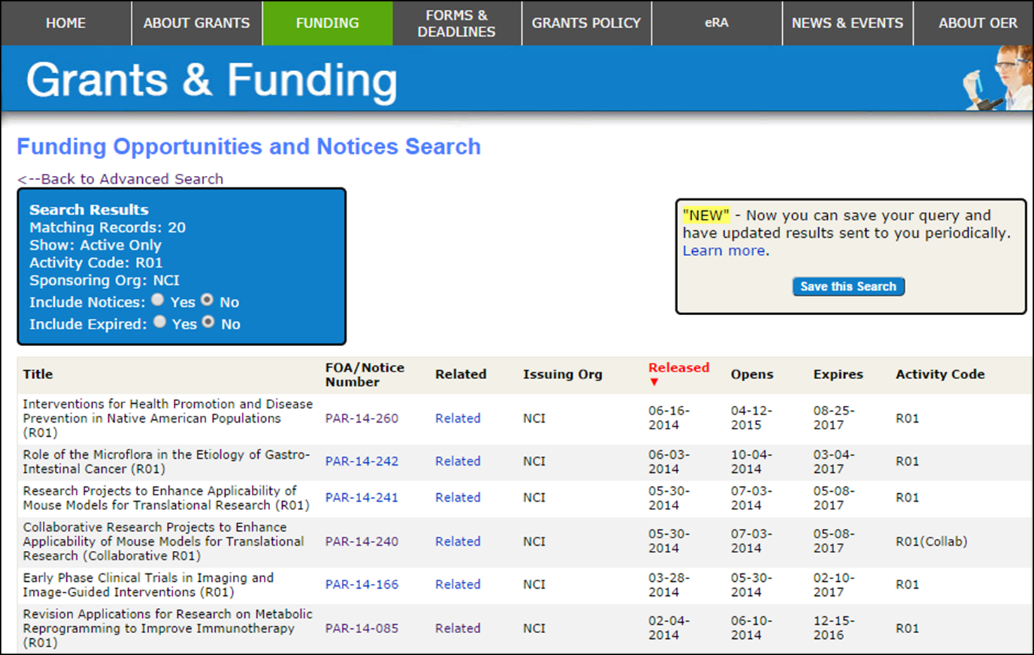

- Carefully read the announcement. Application packages are opportunity-specific (i.e., you cannot use an application completed for one opportunity to apply for another), so be sure you have chosen the correct FOA before you download and complete the application package. A button added to the NIH Guide announcements allows applicants to access the Grants.gov application package directly from the NIH Guide. Find and click on the Apply for Grant Electronically button contained in the FOA.

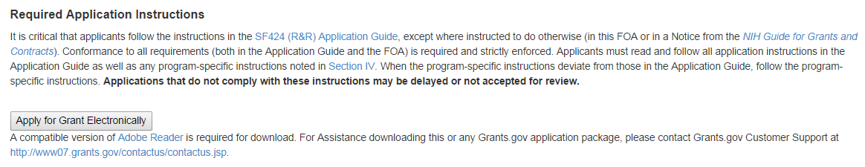

- Click on download under the Instructions and Applications header to access the Grants.gov Download Application Package page for that FOA.

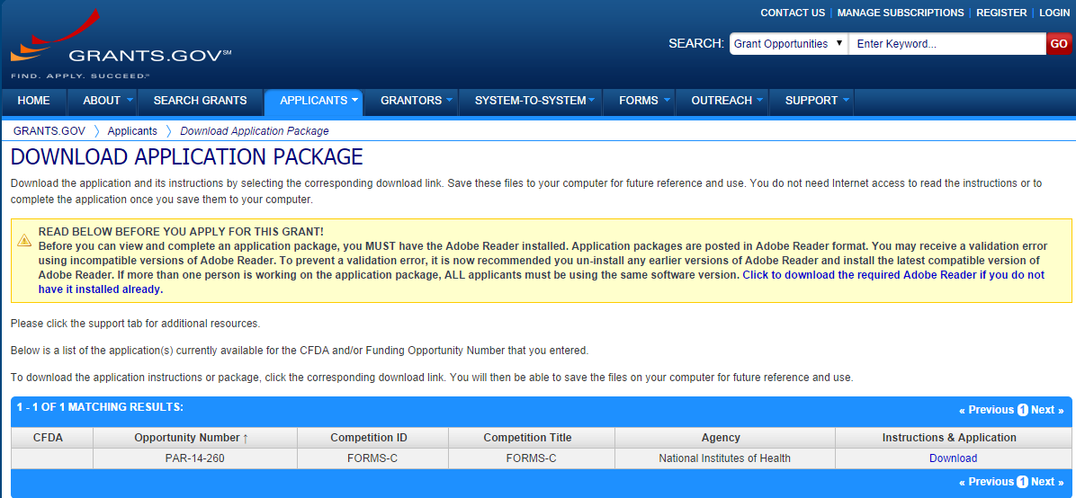
After clicking Download you will have the opportunity to sign-up to receive notifications of changes to the application package.

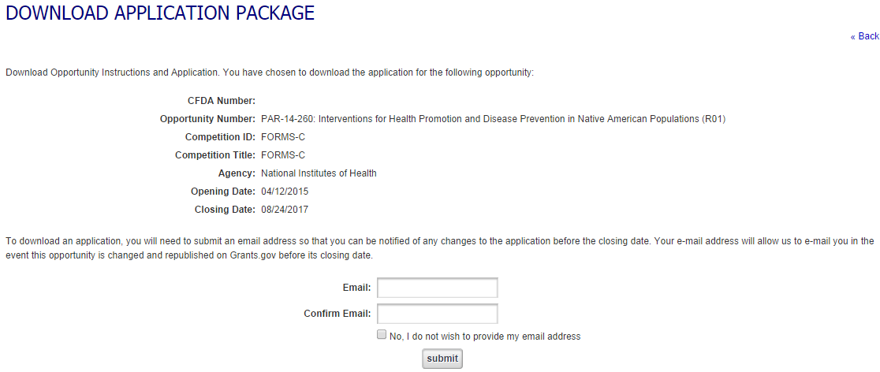

- After signing up for updates, you will be presented with links to downlonad the application instructions and package.

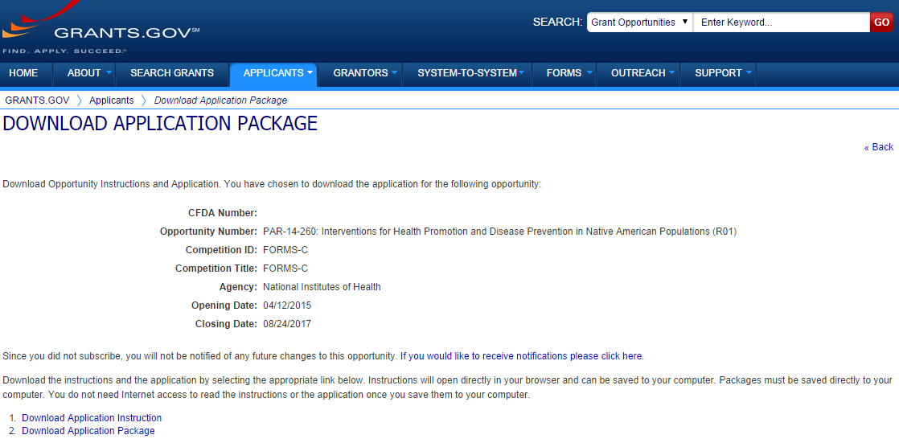

- Save the application to your local computer and start preparing your application.

